Effects of C-L services on depression and anxiety: Supplemental Digital Content

Overview
Table S-1. Levels of integration (adapted from Heath, Wise Romero, & Reynolds, 2013 [24]).
Table S-2. Electronic Search Strategy for Ovid Medline®.
Table S-3: Risk of Bias Assessment.
Table S-4. Characteristics of the studies included in the review.
Table S-5: Risk of Bias for individual studies.
Table S-6. Measures and outcomes for the studies included in the review.
Figure S-1. Study Flow Chart.
Figure S-2. Summary of Risk of Bias.
Figure S-3. Forest Plot for Protocol-Based Studies with Depression as an Outcome.
Figure S-4. Contour-Enhanced Funnel Plot for Protocol-Based Studies with Depression as an Outcome.
Figure S-5. Forest Plot for Integrated/Collaborative Care Studies with Depression as an Outcome.
Figure S-6. Contour-Enhanced Funnel Plot for Integrated/Collaborative Care Studies with Depression as an Outcome.

Table S-1. Levels of integration (adapted from Heath, Wise Romero, & Reynolds, 2013 [24]).
Type of Cooperation | Level | Description | Examples
Coordinated Care | Level 1 | Minimal Collaboration  Patients referred between providers on different sites | Consultation on Different Sites  Not included in the review
 | Level 2 | Basic Collaboration at a Distance  Providers periodically communicate about shared patients | Consultation on Different Sites  Burton et al. (1995) [53]: Intervention by clinical psychologist who is based at a different site
Co-located Care | Level 3 | Basic Collaboration On-Site  Providers based at the same site & communicate but have separate cultures & records | Consultation On-Site  Jantschek et al. (1998) [66]: Psychotherapy provided by clinical psychologists from Dept. of Psychosomatic Medicine
 | Level 4 | Close Collaboration with Some System Integration  Providers have some face-to-face communication about shared patients (screening) and feel part of team | Liaison  Baldwin et al. (2004) [51]: screening of all patients, multi-faceted intervention led by mental health liaison nurse
Integrated Care | Level 5 | Close Collaboration Approaching Integration  Treatment planning for shared patients (screening), but separate planning for other patients | Enhanced Liaison, collaborative care  Huffman et al. (2014) [64]: collaborative care  Hubschmid et al. (2015) [63]: Patient needs are treated as a team for shared patients
 | Level 6 | Full Collaboration in a Transformed/Merged Practice  Single team with a single treatment plan. Patients experience their care as single system treating the whole person. | Interdisciplinary treatment team  Not included in the review

Table S-2. Electronic Search Strategy for Ovid Medline®.
# | Searches | Notes
1 | ("19446712" or "19555794" or "18597695" or "15217778" or "11509898" or "10514955" or "7872852" or "1518313").ui. | Test data
2 | "Referral and Consultation"/ | MeSH
3 | ((consult* or liaison* or consil* or inter-disciplin* or interdisciplin* or collaborat* or cooperat* or co-operat* or referr*) adj6 (psych* or mental*)).ti,ab. | Text words in title, abstract
4 | collaborative care.ti,ab.
5 | or/2-4 | OR-combination MeSH and text words for consultation
6 | exp "Psychiatry and Psychology"/ | All MeSH-terms for this category
7 | (psych* or mental*).ti. | Text words in title
8 | or/6-7 | OR-combination MeSH and text words for psych*
9 | Inpatients/ | MeSH-terms for hospital
10 | exp Hospitals/
11 | exp Hospitalization/
12 | inpatient*.ti,ab. | Text words in title, abstract for hospital
13 | hospital*.ti,ab.
14 | or/9-13 | OR-combination MeSH and text words for hospital
15 | exp Prognosis/ | MeSH-terms incl. sub-terms for research, study design, treatment outcome etc.
16 | exp epidemiologic studies/
17 | exp empirical research/
18 | practice guideline.pt. | Guideline: publication type
19 | (guideline* or consensus).ti. | Text words in title
20 | randomized controlled trial.pt. | Cochrane sensitivity-specificity maximizing search filter for randomized controlled trials (for the indexed part): Source: Cochrane Handbook Version 5.0.2., chapter 6.4.11.1.  www.cochrane-handbook.org.
21 | controlled clinical trial.pt.
22 | (randomized or randomised).ab.
23 | placebo.ab.
24 | clinical trials as topic.sh.
25 | randomly.ab.
26 | trial.ti.
27 | 21 or 26 or 23 or 20 or 22 or 25 or 24
28 | exp animals/ not humans.sh.
29 | 27 not 28
30 | (meta-analy* or metaanaly*).ti. | Metaanalysis: terms in title
31 | meta-analysis.pt. | Metaanalysis: publication type
32 | (systematic and (review or overview)).ti. | Systematic review
33 | review.pt. and systematic.ti.
34 | or/15-17 | Aspect: research, study design
35 | or/18-19 | Aspect: guideline
36 | or/30-31 | Aspect: meta-analysis
37 | or/32-33 | Aspect: systematic review
38 | 5 and 8 | Aspects: consultation + psych*
39 | 14 and 38 | Aspect: consultation + psych* + hospital  too many hits. Narrow search in next steps
40 | (consult* or liaison* or consil* or inter-disciplin* or interdisciplin* or collaborative care or cooperat* or co-operat*).ti. | Several terms for the aspect consultation in title
41 | (referr* and (psych* or mental*)).ti.
42 | or/40-41
43 | 39 and 42 | Aspect consultation in title + psych* + hospital (this step will not be used in further searches
44 | 34 and 39 | Aspect consultation + psych* + hospital, narrowed using aspect research
45 | 42 and 44 | Aspects psych* + hospital + research + terms for the aspect consultation in title (specific search, risk of exclusion of relevant studies)
46 | 29 and 39 | Aspects consultation + psych* + hospital + Cochrane RCT-filter
47 | 42 and 46 | Aspects consultation + psych* + hospital + Cochrane RCT-filter + terms for the aspect consultation in title (specific search)
48 | 35 and 39 | Aspects consultation + psych* + hospital + aspect guideline
49 | 42 and 48 | Aspects consultation + psych* + hospital + aspect guideline + aspect consultation in title (specific search, risk of exclusion of relevant studies)
50 | 36 and 39 | Aspects consultation + psych* + hospital + aspect Meta-Analysis no relevant hits
51 | 42 and 50 | Narrowing down with terms in title
52 | 37 and 39 | Aspects consultation + psych* + hospital + aspect systematic review
53 | 42 and 52 | Aspects psych* + hospital + aspect systematic review + consultation in title
54 | 45 or 47 or 49 or 51 or 53 | Overall result when combining interim findings by OR
55 | general hospital psychiatry.jn. | Search for this journal
56 | 39 and 55 | Aspects consultation + psych* + hospital + journal
57 | 42 and 56 | Aspects psych* + hospital + journal + consultation in title
58 | "archives of general psychiatry".jn. | Search for this journal
59 | 39 and 58 | Aspects consultation + psych* + hospital + journal
60 | 42 and 59 | Aspects psych* + hospital + journal + consultation in title
61 | 54 or 57 or 60 | Overall result combining interim results
62 | 1 or 61 | Combination with known articles from #1.
63 | remove duplicates from 62 | Final result after removal of duplicates

Table S-3: Risk of Bias Assessment.
Adapted from: O’Donnell A, McParlin C, Robson SC, et al. (2016) [33].

Domain | Description | Review author’s judgment
Randomization | Describe the method used to generate the allocation sequence in sufficient detail to allow an assessment of whether or not it should produce comparable groups | Was the allocation sequence adequately generated?
Allocation Concealment | Describe the method used to conceal the allocation sequence in sufficient detail to determine whether or not intervention allocations could have been foreseen in advance of, or during, enrolment | Was the allocation adequately concealed?
Incomplete Outcome Data | Describe the completeness of outcome data for each main outcome, including attrition and exclusions from the analysis. State whether attrition and exclusions were reported, the numbers in each intervention group (compared with total randomized participants), reasons for attrition/exclusions where reported, and any re-inclusions in analyses performed by the review authors | Were incomplete outcome data adequately addressed?
Selective Outcome Reporting | State how the possibility of selective outcome reporting was examined by the review authors, and what was found | Are reports of the study free of suggestion of selective outcome reporting?

Table S-4. Characteristics of the studies included in the review.
Author(s), year | Country | Target group | N | Intervention(s) | Psychotropic drugs as part of intervention | Control | Setting | Profession | Level of Integration¹ | Intensity
 |  | Brief interventions tailored to the patient
Baldwin et al. 2004 [51] | UK | Geriatrics | 153 | Multi-faceted nurse-led intervention (assessment, direct interventions, liaison support) | yes | TAU (referral to C-L service possible) | Indiv. | Nurse | Level 4 | Adaptive (to medium)
Burton et al. 1995 [53] | UK | Cancer (breast) | 215 | Preoperative interview &  1) 30-min. PT intervention (client-centered counseling)  2) 30-min. chat  3) interview only | no | TAU | Indiv. | Psych. | Level 2 | Short
Callaghan & Cheung Li 2002 [54] | China (Hong Kong) | Surgery (hysterectomy) | 96 | Preoperative information and counseling (cognitive distraction & reappraisal) | no | TAU & Information only | Indiv. | Unclear | Level 2 | Short
Cole et al. 1991 [55] | Canada | Geriatrics | 80 | Consultation | yes | TAU | Indiv. | Psych. | Level 4 | Adaptive (Short to medium)
Leon-Pizarro et al. 2007 [70] | Spain | Cancer (breast, gynecological) | 66 | 1 session relaxation training, guided imagery & information before radiotherapy | no | TAU & Attention placebo (1 session without relaxation) | Indiv. | Nurse | Level 3 | Short
McArdle et al. 1996 [74] | UK | Cancer (breast) | 272 | Supportive counseling from  1) breast care nurse  2) voluntary organization  3) both | no | TAU & information booklet | Indiv. | Nurse | Level 5 | Adaptive (Short to medium)
Roykulcharoen & Good 2004 [80] | Thailand | Surgery (abdominal) | 102 | Relaxation training (pre- and post-surgery) (direct instruction & tape) | no | TAU (no relaxation but instruction to lie in bed quietly) | Indiv. | Nurse | Level 3 | Short
Shah et al. 2001 [83] | UK | Geriatrics | 47 | Formal psychogeriatric consultation 24 h after screening | yes | TAU & no consultation after screening | Indiv. | Psych. | Level 3 | Short
 |  | Interventions based on specific treatment manuals
Austin et al. 2007 [50] | Australia | Pregnancy | 277 | CBT | no | TAU & Booklet (advice to GP) | Group | Multiprof. | Level 4 | Medium
Blumenthal et al. 2006 [52] | USA | Transplantation (lung disease) | 328 | Telephone-based coping skills training | no | TAU (medical) | Indiv. | Multiprof. | Level 3 | Long
Given et al. 2004 [59] | USA | Cancer (general) | 237 | CBT | yes | TAU ("conventional") | Indiv. | Psych. | Level 3 | Medium
Gruen 1975 [60] | USA | Heart disease | 73 | PT | no | TAU (medical) | Indiv. | Psych. | Level 3 | Long
Guthrie et al. 1993 [61] | UK | Gastro-intestinal disease | 102 | PT (focus on client-therapist relationship) | no | TAU & attention placebo (same therapist) | Indiv. | Unclear | Level 3 | Medium
Herrmann-Lingen et al. 2016 [62] | Germany | Heart disease | 570 | Stepwise PT (with psychodynamic & CBT elements) | no | TAU & 1 information session | Both | Psych. | Level 4 | Long
Hubschmid et al. 2015 [63] | Switzerland | Neurology | 23 | Brief psychodynamic PT | yes | TAU (diagnosis and "advice to seek treatment in private practice") | Both | Multiprof. | Level 5 | Medium
Jantschek et al. 1998 [66] | Germany | Gastro-intestinal disease | 108 | Short-term psychodynamic PT & relaxation | no | TAU: Drug treatment only | Indiv. | Psych. | Level 3 | Long
Kalaitzi et al. 2007 [67] | Greece | Cancer (breast) | 40 | Brief psychosexual intervention for couples | no | TAU (medical) | Indiv. | Unclear | Level 3 | Medium
Koertge et al. 2008 [68] | Sweden | Heart disease | 247 | Stress management training | no | TAU (medical) | Indiv. | Multiprof. | Level 3 | Long
Lincoln & Flannaghan 2003 [71] | USA | Neurology | 123 | CBT | no | 1) TAU & attention placebo  2) TAU (no contact) | Indiv. | Nurse | Level 3 | Medium
Linn et al. 1982 [72] | USA | Cancer (general) | 120 | Counseling (based on Kubler-Ross) | no | TAU | Indiv. | Nurse | Level 3 | Long
Mayou et al. 2002 [73] | UK | Heart disease | 80 | 1 hour CBT intervention & FU & outpatient sessions | no | TAU (no contact) | Indiv. | Nurse | Level 4 | Adaptive
Moorey et al. 1998 [76] | UK | Cancer (general) | 57 | Problem-focused CBT ("Adjuvant Psychological Therapy") | no | TAU & attention control (Supportive counseling) | Indiv. | Psych. | Level 3 | Medium
Napolitano et al. 2002 [77] | USA | Transplantation (lung disease) | 71 | Telephone-based supportive counseling & CBT | no | TAU (medical) | Indiv. | Multiprof. | Level 3 | Medium
Schofield et al. 2016 [81] | Australia | Cancer (prostate) | 331 | Group consultation with uro-oncology nurse | no | Best practice supportive care (nurse-led clinic) | Group | Nurse | Level 5 | Medium
Schweickhardt et al. 2007 [82] | Germany | Somatoform disorders | 91 | PT based on modified reattribution, CBT, and PD | no | TAU & psychoeducational reading material | Indiv. | Psych. | Level 3 | Medium
Simson et al. 2008 [84] | Germany | Diabetes | 30 | Supportive PT | no | TAU (medical; "psychosomatic input was possible, but not requested") | Indiv. | Nurse | Level 3 | Medium
Watkins et al. 2007 [87] | UK | Neurology | 411 | Motivational interviewing | no | TAU (medical, referral possible) | Indiv. | Multiprof. | Level 3 | Medium
 |  | Integrated and collaborative care
Cole et al. 2006 [56] | Canada | Geriatrics | 157 | Psychiatric assessment, supportive PT/drug tx & FU visits | yes | TAU (advice to GP, referral possible) | Indiv. | Multiprof. | Level 5 | Long
Cullum et al. 2007 [57] | UK | Geriatrics | 121 | Assessment and treatment plan by C-L nurse, co-operation with other MH specialists, monitoring) | yes | TAU (referral possible) | Indiv. | Multiprof. | Level 4 | Adaptive
Davidson et al. 2010 [58] | USA | Heart disease | 237 | Assessment by clinical nurse specialist, monitoring and stepped-care approach (psychiatric tx and/or PT, counseling by SW) | yes | TAU ("as defined by the treating physicians") | Indiv. | Multiprof. | Level 5 | Adaptive
Huffman et al. 2011 [65] | USA | Heart disease | 175 | Assessment and treatment (incl. depression education) by social-work case manager collaborating with a psychiatrist | yes | TAU, CM informs physician & treatment team & recommends treatment | Indiv. | Multiprof. | Level 5 | Adaptive
Huffman et al. 2014 [64] | USA | Heart disease | 183 | Assessment and treatment planning by social-work case manager collaborating with a psychiatrist, psychoeducation, telephone-based CBT | yes | As Huffman 2011 | Indiv. plus group | Multiprof. | Level 5 | Adaptive
Kominski et al. 2001 [69] | USA | C-L (general) | 1687 | Psychogeriatric assessment, treatment by multiprofessional MH team coordinated by case manager | yes | TAU (referral possible) | Indiv. | Multiprof. | Level 5 | Adaptive
McCorkle et al. 2009 [75] | USA | Cancer (ovarian) | 123 | Assessment by C-L nurse, monitoring and supportive counseling from oncology advanced practice nurse | no | TAU & attention control (contact with research assistant) | Indiv. | Nurse specialists | Level 5 | Long
Oslin et al. 2004 [78] | USA | Geriatrics | 2637 | Psychogeriatric assessment, case manager monitored symptoms and coordinated treatment by multiprofessional MH team | yes | TAU (referral possible) | Indiv. | Multiprof. | Level 5 | Adaptive
Rollmann et al. 2009 [79] | USA | Heart disease | 452 | Assessment by nurse specialist collaborating with psychiatrist and cardiologist, telephone-based monitoring of symptoms and counseling | yes | TAU (diagnosis, no treatment advice) | Indiv. | Multiprof. | Level 5 | Adaptive
Sneed et al. 1997 [85] | USA | Heart disease | 34 | Assessment & intervention (counseling, relaxation) by psychiatric nurse, weekly telephone after discharge by nurse case manager, c) 2 sessions support group | no | TAU w/ in-hospital cardiovascular case manager; after discharge: 24 hour beeper access to CM | Indiv., signify-cant others & group | Multiprof. | Level 4 | Long
Stiefel et al. 2008 [86] | Switzerland | Rheumatism/ Diabetes | 247 | Assessment and multifaceted intervention by C-L nurse: Supportive counseling, referral to psychiatrist, and/or advice to treating physician/multidisciplinary case conference) | yes | TAU (usual care, referral possible) | Indiv. | Multiprof. | Level 5 | Adaptive
¹Level of Integration: According to the Standard Framework for Levels of Integrated Healthcare [24] (cf. also Table 1)
²short: 1-3 sessions; medium: 4-10 sessions; long: > 10 sessions; adaptive: intensity of interventions is adaptive to patients’ needs
CBT: Cognitive Behavioral Therapy; C-L: Psychiatric and psychosomatic consultation-liaison service; CM: Care manager; FU: Follow-up; PT: Psychotherapy; SSRI: Selective serotonin reuptake inhibitor; TAU: Treatment as usual (routine hospital care)
Table S-5: Risk of Bias for Individual Studies.
Study | Randomization | Allocation Concealment | Incomplete Outcome Data | Risk of Selective Outcome Reporting | Overall Risk of Bias¹
- Brief interventions tailored to the patient
Baldwin et al. 2004 [51] | Low Risk | Low Risk | Low Risk | Unclear Risk | Unclear Risk
Burton et al. 1995 [53] | Low Risk | High Risk | High Risk | Unclear Risk | High Risk
Callaghan et al. 2002 [54] | Unclear Risk | Unclear Risk | Low Risk | Low Risk | Unclear Risk
Cole 1991 [55] | Low Risk | Low Risk | High Risk | Unclear Risk | High Risk
Leon-Pizarro et al. 2007 [70] | Unclear Risk | Unclear Risk | High Risk | Unclear Risk | High Risk
McArdle et al. 1996 [74] | Unclear Risk | Unclear Risk | Unclear Risk | Unclear Risk | Unclear Risk
Roykulcharoen & Good 2004 [80] | Unclear Risk | Unclear Risk | Low Risk | Unclear Risk | Unclear Risk
Shah et al. 2001 [83] | Unclear Risk | Unclear Risk | High Risk | Unclear Risk | High Risk
- Interventions based on specific treatment manuals
Austin et al. 2007 [50] | Low Risk | High Risk | Low Risk | Unclear Risk | High Risk
Blumenthal et al. 2006 [52] | Low Risk | Low Risk | High Risk | Unclear Risk | High Risk
Given et al. 2004 [59] | Low Risk | High Risk | High Risk | Unclear Risk | High Risk
Gruen 1975 [60] | Unclear Risk | Unclear Risk | Unclear Risk | High Risk | High Risk
Guthrie et al. 1993 [61] | Unclear Risk | Unclear Risk | High Risk | High Risk | High Risk
Herrmann-Lingen et al. 2016 [62] | Low Risk | Low Risk | Low Risk | Low Risk | Low Risk
Hubschmid et al. 2015 [63] | Low Risk | Low Risk | Low Risk | Low Risk | Low Risk
Jantschek et al. 1998 [66] | Low Risk | Unclear Risk | Unclear Risk | Unclear Risk | Unclear Risk
Kalaitzi et al. 2007 [67] | Unclear Risk | Unclear Risk | Unclear Risk | Unclear Risk | Unclear Risk
Koertge et al. 2008 [68] | Low Risk | Low Risk | Low Risk | Unclear Risk | Unclear Risk
Lincoln & Flannaghan 2003 [71] | Low Risk | Low Risk | High Risk | Unclear Risk | High Risk
Linn et al. 1982 [72] | Low Risk | Low Risk | High Risk | Unclear Risk | High Risk
Mayou et al. 2002 [73] | Low Risk | Low Risk | Low Risk | Unclear Risk | Unclear Risk
Moorey et al. 1998 [76] | Low Risk | Low Risk | High Risk | Unclear Risk | High Risk
Napolitano et al. 2002 [77] | Unclear Risk | Unclear Risk | High Risk | Unclear Risk | High Risk
Schofield et al. 2016 [81] | Low Risk | Low Risk | Low Risk | High Risk | High Risk
Schweickhardt et al. 2007 [82] | Low Risk | Low Risk | Low Risk | Unclear Risk | Unclear Risk
Simson et al. 2008 [84] | Unclear Risk | Unclear Risk | Unclear Risk | Unclear Risk | Unclear Risk
Watkins et al. 2007 [87] | Low Risk | Low Risk | Low Risk | Low Risk | Low Risk
- Integrated and collaborative care
Cole et al. 2006 [56] | Low Risk | Low Risk | High Risk | Unclear Risk | High Risk
Cullum et al. 2007 [57] | Low Risk | Low Risk | Low Risk | Unclear Risk | Unclear Risk
Davidson et al. 2010 [58] | Low Risk | Low Risk | Low Risk | Low Risk | Low Risk
Huffman et al. 2011 [65] | Low Risk | Low Risk | Low Risk | Unclear Risk | Unclear Risk
Huffman et al. 2014 [64] | Low Risk | Low Risk | Low Risk | Low Risk | Low Risk
Kominski et al. 2001 [69] | Unclear Risk | Unclear Risk | Unclear Risk | Unclear Risk | Unclear Risk
McCorkle et al. 2009 [75] | Low Risk | Low Risk | High Risk | Unclear Risk | High Risk
Oslin et al. 2004 [78] | Unclear Risk | Unclear Risk | Low Risk | Unclear Risk | Unclear Risk
Rollmann et al. 2009 [79] | Low Risk | Low Risk | Low Risk | Low Risk | Low Risk
Sneed et al. 1997 [85] | Low Risk | Low Risk | High Risk | Unclear Risk | High Risk
Stiefel et al. 2008 [86] | Low Risk | High Risk | Low Risk | Unclear Risk | High Risk
¹Overall risk of bias is a function of the highest risk of bias in any of the four categories.

Table S-6. Measures and Outcomes for the Studies Included in the Review.
Author, year | Depression Measure | Depression:  d (95% CI) | Anxiety Measure | Anxiety:  d (95% CI)
- Brief interventions tailored to patients
Baldwin et al. 2004 [51] | GDS-30 | -0.28 (-0.65, 0.09)
Burton et al. 1995 [53] | HADSD | NA | HADSA | -0.31 (-0.61, -0.01)
Callaghan et al. 2002 [54] |  |  | STAI-S | -0.42 (-0.83, -0.02)
Cole 1991 [55] | GDS-30 | NA | ASI | NA
Leon-Pizarro et al. 2007 [70] | HADSD | -0.54 (-1.04, -0.05) | HADSA | -0.55 (-1.04, -0.05)
McArdle et al. 1996 [74] | HADSD | -0.33 (-0.69, 0.02) | HADSA | -0.15 (-0.49, 0.19)
Roykulcharoen & Good 2004 [80] |  |  | STAI-S | -0.18 (-0.57, 0.21)
Shah et al. 2001 [83] | BAS-DEP; MADRS; GDS | NA
- Interventions based on specific treatment manuals
Austin et al. 2007 [50] | EPDS | 0.02 (-0.32, 0.38) | STAI-S | 0.03 (-0.33, 0.40)
Blumenthal et al. 2006 [52] | BDI | -0.33 (-0.55, -0.11) | STAI-S | -0.23 (-0.45, -0.01)
Given et al. 2004 [59] | CES-D | -0.25 (NA)
Gruen 1975 [60] | Physician notes | -0.46 (-0.92, 0.00)
Guthrie et al. 1993 [61] | BDI | NA
Herrmann-Lingen et al. 2016 [62] | HADSD | -0.05 (-0.21, 0.01)
Hubschmid et al. 2015 [63] | BDI | -0.19 (-0.83, 0.23)
Jantschek et al. 1998 [66] | BDI | 0.00 (-0.46, 0.46) | STAI-X2 | -0.05 (-0.52, 0.42)
Kalaitzi et al. 2007 [67] | CES-D | -0.77 (-1.41, -0.13) | STAI-S | -0.50 (-1.13, 0.13)
Koertge et al. 2008 [68] | BDI | 0.09 (-0.23, 0.41)
Lincoln & Flannaghan 2003 [71] | BDI | 0.02 (-0.36, 0.41)
Linn et al. 1982 [72] | POMS-Depression | -0.80 (NA)
Mayou et al. 2002 [73] | BDI | -0.26 (-0.72, 0.20) | STAI-S | -0.02 (-0.48, 0.44)
Moorey et al. 1998 [76] | HADS | -0.25 (-0.83, 0.32) | HADSA | -0.37 (-0.95, -0.21)
Napolitano et al. 2002 [77] | GHQ | -0.36 (-0.83, 0.11)
Schofield et al. 2016 [81] | HADSD | -0.37 (-0.59, -0.16) | HADSA | -0.09 (-0.36, 0.18)
Schweickhardt et al. 2007 [82] | HADSD | NA
Simson et al. 2008 [84] | HADSD | -0.24 (-0.95, 0.48) | HADSA | -0.14 (-0.86, 0.52)
Watkins et al. 2007 [87] | MMSE | -0.26 (-0.50, -0.02)
- Integrated and collaborative care
Cole et al. 2006 [56] | HAMD | -0.18 (-0.75, 0.15)
Cullum et al. 2007 [57] | GDS-15 | -0.27 (-0.69, 0.16)
Davidson et al. 2010 [58] | BDI | -0.59 (-1.00, -0.18)
Huffman et al. 2011 [65] | PHQ-9 | -0.69 (-0.99, -0.38) | HADSA | -0.26 (-0.55, 0.04)
Huffman et al. 2014 [64] | PHQ-9 | -0.45 (-0.88, -0.02) | HADSA | -0.10 (-0.43, 0.23)
Kominski et al. 2001 [69] | MHI-D | NA | MHI-A | NA
McCorkle et al. 2009 [75] | CES-D | -0.55 (-0.91, -0.19)
Oslin et al. 2004 [78] | MHI-D | -0.02 (-0.13, 0.10) | MHI-A | -0.13 (-0.53, 0.27)
Rollmann et al. 2009 [79] | HAMD | -0.42 (-0.65, -0.19)
Sneed et al. 1997 [85] | POMS-Depression | 0.45 (-0.23, 1.13) | POMS-Anxiety | 0.39 (-0.29, 1.07)
Stiefel et al. 2008 [86] | CES-D | -0.29 (-0.60, 0.02)
ASI: Anxiety Status Inventory; BDI: Beck Depression Inventory; CES-D: Center for Epidemiological Studies Depression Scale; DSI: Depression Status Inventory; EPDS: Edinburgh postnatal depression scale; GDS-15: Geriatric Depression Scale-15; GDS-30: Geriatric Depression Scale-30; GHQ: General Health Questionnaire; HADSA: Hospital Anxiety and Depression Scale: Anxiety; HADSD: Hospital Anxiety and Depression Scale: Depression; HAMD: Hamilton Depression Scale; MHI-D: Mental Health Inventory: Depression; MHI-A: Mental Health Inventory: Anxiety; MMSE: Mini-Mental State Examination; NA: not available, i.e. the value could not be calculated from available data; PHQ-9: Patient Health Questionnaire-9; POMS: Profile of Mood States; SRD: Zung Self-Rating Depression Scale; STAI-S: Spielberger State Trait Anxiety Inventory: State Component; STAI-X2: State Trait Anxiety Inventory: Trait Component)

Figure S-1. Study Flow Chart.
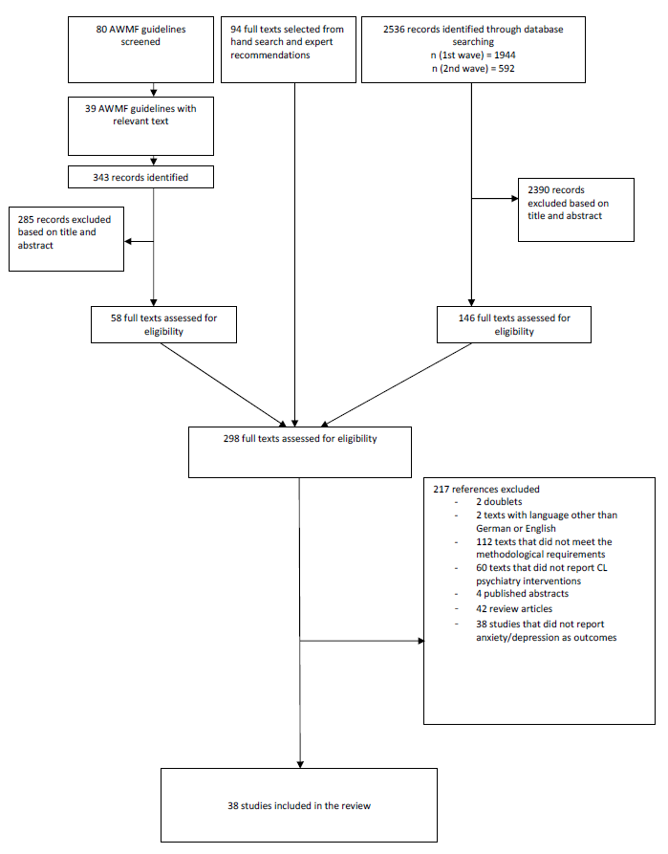

Figure S-2. Summary of Risk of Bias.
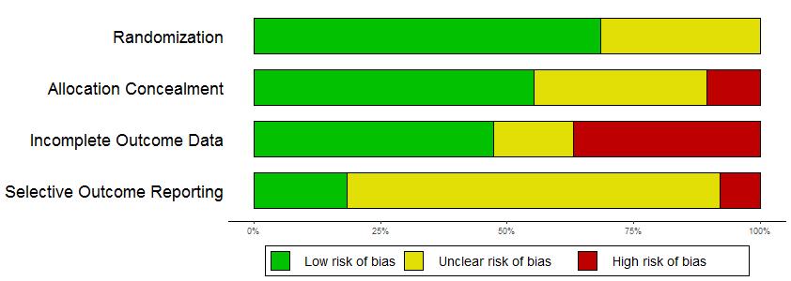

Figure S-3. Forest Plot for Studies Reporting Interventions Based on Specific Treatment Manuals with Depression as an Outcome.
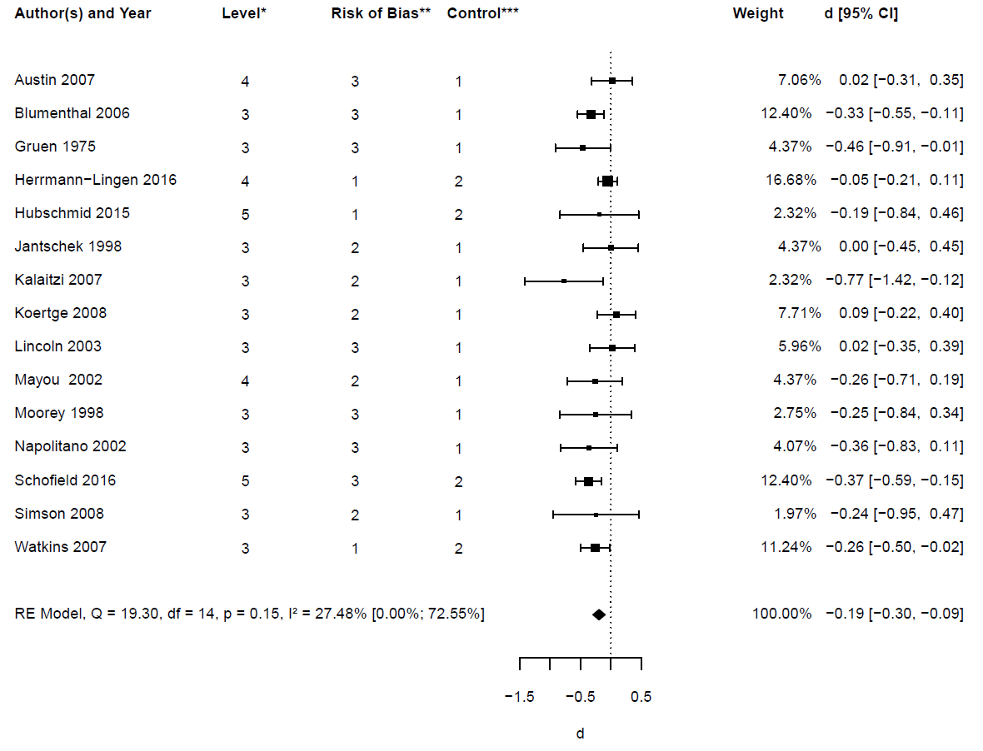
*Level of Integration (cf. Table 1)
**Risk of Bias: 1 = low; 2 = unclear; 3 = high
***Control: 1 = TAU; 2 = TAU with possible consultation (active control)

Figure S-4. Contour-Enhanced Funnel Plot for Studies Reporting Interventions Based on Specific Treatment Manuals Depression as an Outcome.
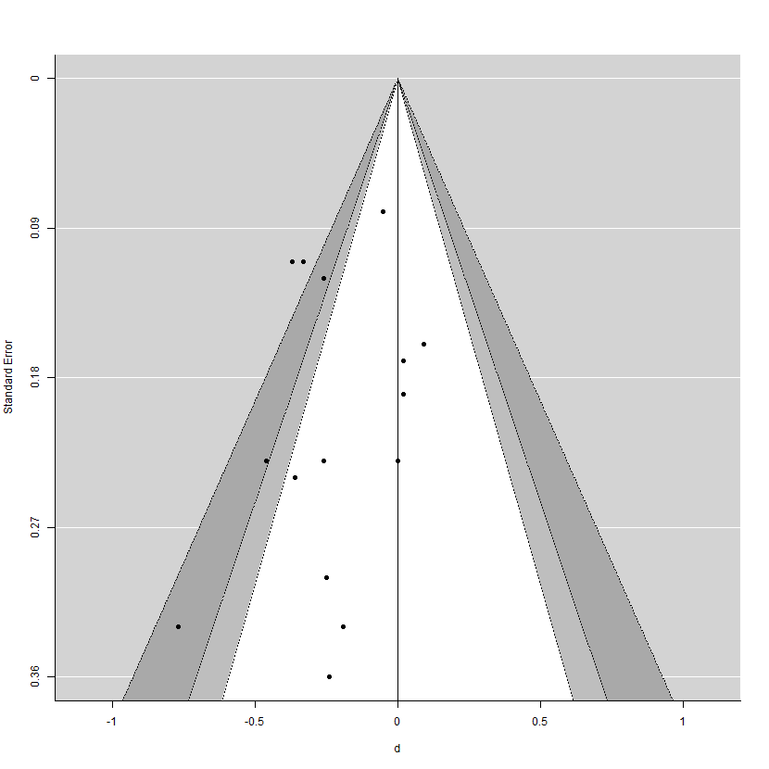

Figure S-5. Forest Plot for Integrated and Collaborative Care Studies with Depression as an Outcome.
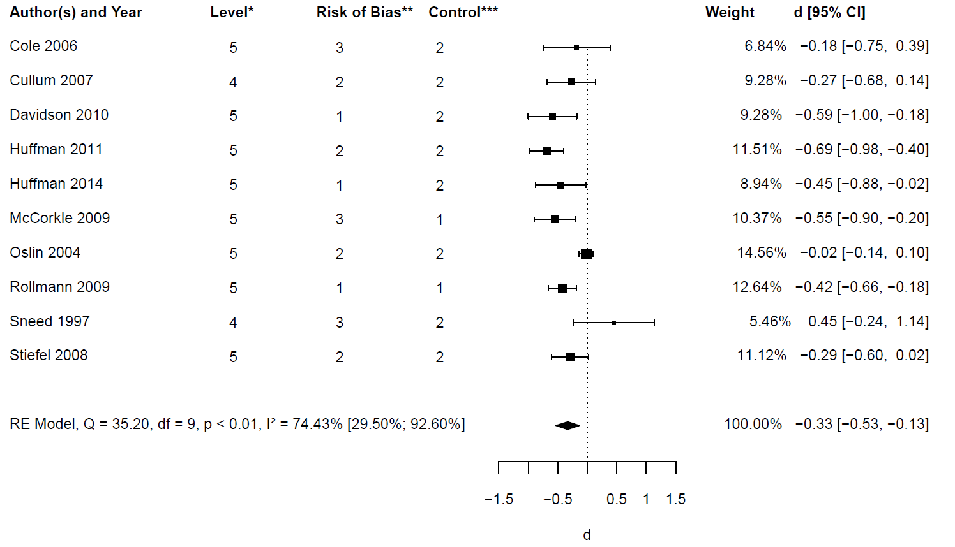
*Level of Integration (cf. Table 1)
**Risk of Bias: 1 = low; 2 = unclear; 3 = high
***Control: 1 = TAU; 2 = TAU with possible consultation (active control)

Figure S-6. Contour-Enhanced Funnel Plot for Integrated and Collaborative Care Studies with Depression as an Outcome.
