Supplementary material 1 (Table) Search strategy used for the PubMed database.
#1 | randomized controlled trial [pt]
#2 | controlled clinical trial [pt]
#3 | randomized [tiab]
#4 | randomly [tiab]
#5 | trial [tiab]
#6 | placebo [tiab]
#7 | groups [tiab]
#8 | randomized controlled trials as topic [mh]
#9 | randomi*ed [tiab]
#10 | animals [mh] NOT (humans [mh] and animals [mh])
#11 | #1 OR #2 OR #3 OR #4 OR #5 OR #6 OR #7 OR #8 OR #9 NOT#10
#12 | pediatric obesity [mh]
#13 | child* [tiab]
#14 | adolescent* [tiab]
#15 | adolescent [mh]
#16 | obesity [tiab]
#17 | overweight [tiab]
#18 | obes* [tiab]
#19 | teens [tiab]
#20 | teen [tiab]
#21 | teenagers [tiab]
#22 | youth* [tiab]
#23 | #12 OR #13 OR #14 OR #15 OR #16 OR #17 OR #18 OR #19 OR #20 OR #21 OR #22
#24 | exercise [mh]
#25 | exercises [tiab]
#26 | exercise*, physical [tiab]
#27 | physical exercise* [tiab]
#28 | aerobic [tiab]
#29 | exercise*, aerobic [tiab]
#30 | aerobic axercises* [tiab]
#31 | resistance [tiab]
#32 | resistance training [mh]
#33 | training, resistance [tiab]
#34 | strength* [tiab]
#35 | strengthening program* [tiab]
#36 | #24 OR #25 OR #26 OR #27 OR #28 OR #29 OR #30 OR #31 OR #32 OR #33 OR #34 OR #35
#37 | cytokines [mh]
#38 | inflammatory* [tiab]
#39 | pro-inflammatory* [tiab]
#40 | chemokine* [tiab]
#41 | Interleukins [mh]
#42 | # 37 OR #38 OR #39 OR #40 OR #41
#43 | #11 AND #23 AND #36 AND #42

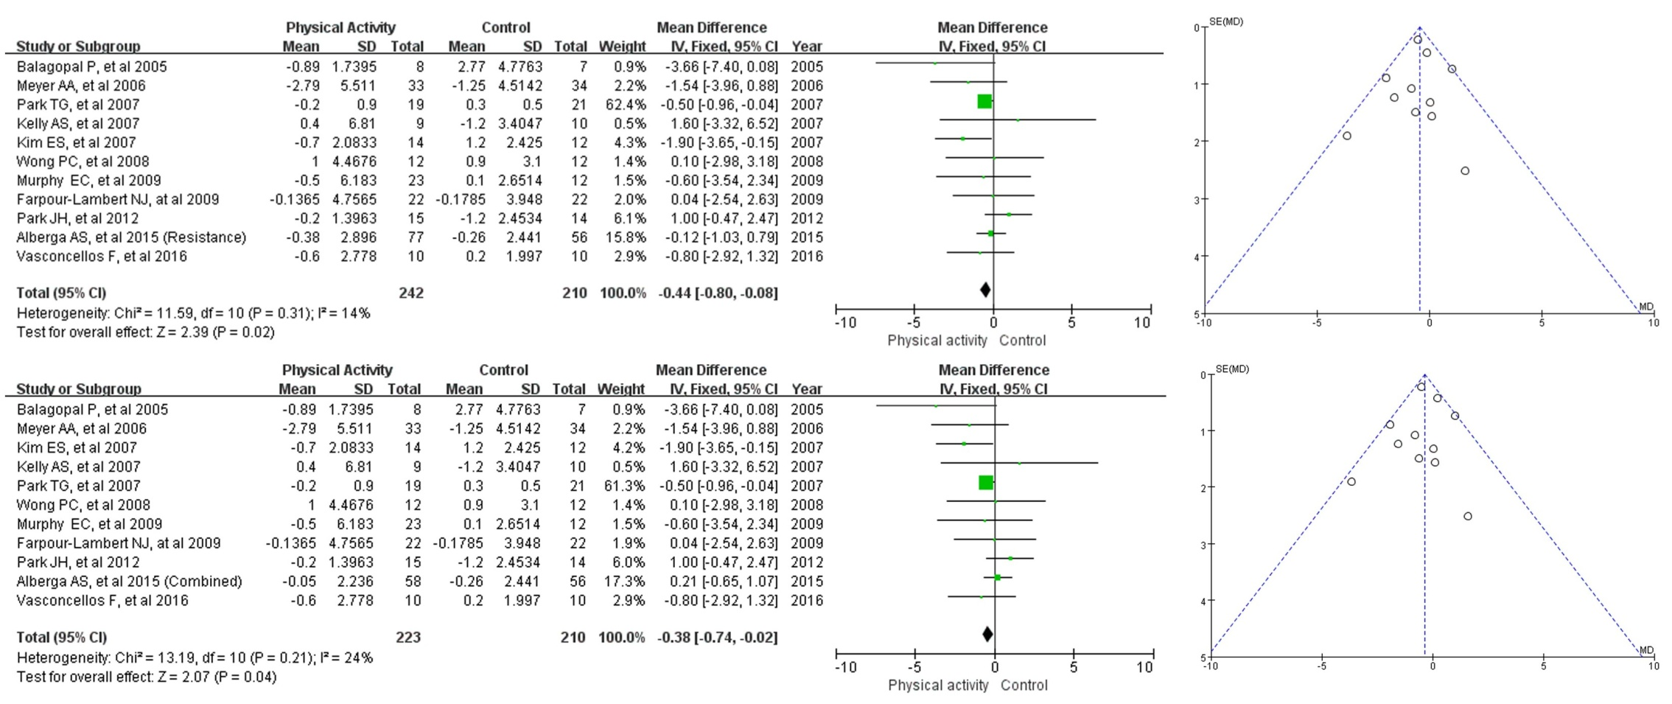

Supplementary material 2. Absolutes changes in CRP in individual subgroup e.g. Resistance vs Control (A) and Aerobic plus Resistance (combined) vs Control (B) in obesity or overweight children or adolescents.

