**Online Supplementary Appendix**

Appendix A

Sample Size

The sample size calculation was performed to decide on the number of required correctly and misplaced umbilical catheter positions needed to be presented to the physicians in order to attain estimates of the sensitivity and specificity (accuracy) with acceptable confidence intervals (CI). The expected accuracy of physician-performed ultrasonography (US) examination of umbilical catheter tip placement was derived from the one study evaluating UVC detection by “house-staff physicians” compared to US experts (sensitivity 0.86 and specificity 0.75)[2]. As no 95% CI was estimated in the study, we decided to require a lower 95% CI > 0.70 for the accuracy with a probability of 0.95 (type I error <0.05 and a power of 80%). To achieve a sensitivity and specificity of 0.85 each with a lower 95% CI > 0.70, we required 85 correctly positioned catheters and 85 misplaced catheters to be evaluated. The calculation was performed by use of tabulated sample size calculations for assessing diagnostic procedures as described in by Flahault *et al*[1].

1 Flahault A, Cadilhac M, Thomas G. Sample size calculation should be performed for design accuracy in diagnostic test studies. J Clin Epidemiol. 2005 Aug;58(8):859–62.

2 Pulickal AS, Charlagorla PK, Tume SC, Chhabra M, Narula P, nadroo AM. Superiority of targeted neonatal echocardiography for umbilical venous catheter tip localization: accuracy of a clinician performance model. J Perinatol. 2013 Dec;33(12):950–3.

Appendix B

On a single study day two piglets (piglet A and piglet B) were available for four physicians (physician 1 to 4) who performed twelve consecutive 10-minutes hands-on ultrasonography (US) sessions each. Between each US session the physician spent 10 minutes alone in a waiting room to record the conclusion on umbilical venous (UVC) and artery catheter (UAC) tip placement on a structured coding sheet, and to rate self-confidence by use of a Likert scale from 1 to 5 (1 *not confident*, 5 *very confident*). The rotation of the four physicians’ US sessions between the two piglets during a study day is illustrated in the figure below. The position of the UAC and UVC tip was changed every fourth time (two cycles) the physician was in the waiting room as shown.

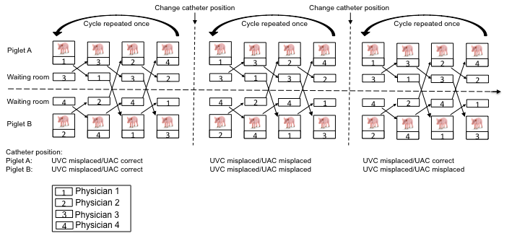

Appendix C

Guiding questions (only provided on request to the physician)

1. Is the orientation marker on the correct side of the screen?
2. Is the sector correctly orientated up-side down on the screen?
3. Which vessel do you want to visualize?
4. How would you position the orientation indicator on the transducer for this particular ultrasonography view?
5. Describe the course of the vessel and how you would expect it to show on this ultrasonography view?
6. Are you aiming at visualizing the vessel in a longitudinal or transverse view?
7. How would you place the transducer to visualize the vessel in a transverse plane?
8. How would you place the transducer to visualize the vessel in a longitudinal plane?
9. Do you need to slide the transducer cranially or caudally to identify the structure or vessel you are looking for?
10. Do you need to slide the transducer to the left or the right side to identify the structure or vessel you are looking for?
11. If you are going to visualize the aorta and inferior vena cava in a transverse plane: how are you going to place the transducer?
12. If you are going to visualize the inferior vena cava in a longitudinal plane: how are you going to place the transducer?
13. If you are going to visualize the aorta in a longitudinal plane: how are you going to place the transducer?
14. To be in a correct position, where would you expect the catheter tip?

Appendix D

Planned and performed overall number of targeted ultrasonography (US) sessions for US examinations of umbilical artery (UAC) and umbilical venous catheter (UVC) position by 21 physicians and results comparing US by all physicians to expert US.

Reason 1: two participants left the experiment after 9 and 10US sessions due to clinical obligations. Reason 2: one participant left after 11 US sessions due to pregnancy related illness.

Appendix E

The median number (with interquartile range) of structured guiding questions prompted by 21 physicians’ request during each consecutive targeted ultrasonography session for umbilical catheter placement in piglets by number of ultrasound session.

