Supplemental Figure 1. Station numbers, names, and boundaries of lymph node as defined by the General Rules for the Study of Pancreatic Cancer (partially modified, Fourth English Edition).

Supplemental Figure 1. Station numbers, names, and boundaries of the lymph node as defined by General Rules for the Study of Pancreatic Cancer (Fourth English Edition).

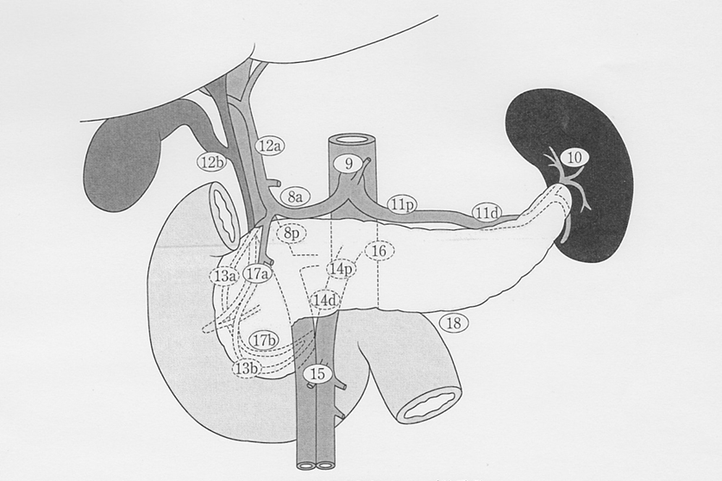
(We have permission to reprint from the Japan Pancreas Society and Kanehara-shuppan)

1: Right cardiac lymph nodes
2: Left cardiac lymph nodes
3: Lymph nodes along the lesser curvature of the stomach
4: Lymph nodes along the greater curvature of the stomach
5: Superpyloric lymph nodes
6: Infrapyloric lymph nodes
7: Lymph nodes along left gastric artery
8a: LNs along the common hepatic artery (Anterosuperior group)
8p: LNs along the common hepatic artery (Posterior group)
9: LNs along the celiac artery
10: LNs at the splenic hilum
11p: LNs along the proximal splenic artery
11d: LNs along the distal splenic artery
12a: LNs in the hepatoduodenal ligament (hepatic artery group)
12p: LNs in the hepatoduodenal ligament (portal vein group)
12b: LNs in the hepatoduodenal ligament (bile duct group)
13a: LNs on the superior posterior surface of the pancreatic head
13b: LNs on the inferior posterior surface of the pancreatic head
14p: LNs along the proximal superior mesenteric artery
14d: LNs along the distal superior mesenteric artery
15: LNs along the middle colic artery
16a1: LNs in the aortic hiatus
16a2: LNs around the abdominal aorta (from the upper margin of the celiac trunk to the lower margin of the left renal vein)
16b1: LNs around the abdominal aorta (from the lower margin of the left renal vein to the upper margin of the inferior mesenteric artery)
16b2: LNs around the abdominal aorta (from the upper margin of the inferior mesenteric artery to the aortic bifurcation)
17a: LNs on the superior anterior surface of the pancreatic head
17b: LNs on the inferior anterior surface of the pancreatic head
18: LNs along the inferior margin of the pancreas

Regional lymph nodes of pancreas
5, 6, 7, 8a, 8p, 9, 10, 11p, 11d, 12a, 12b, 13a, 13b, 14p, 14d, 17a, 17b, 18

