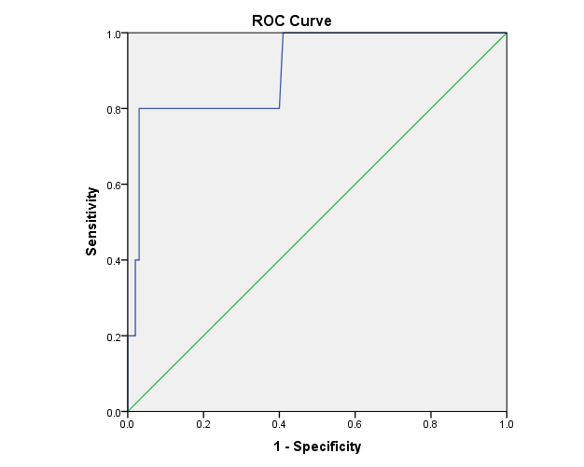

Supplementary figure: ROC Curve to differentiate the pseudo-malabsorption from true malabsorption patients by increment in Free T4 from baseline to 3 hrs (AUC 0.904, P<0.001). An increment of 0.4 ng/dl in free T4 at three hours gives a sensitivity of 80 % and specificity of 97% to exclude true malabsorption.

