**Online Supplementary Content**

Supplementary methods: Clinical and histopathological re–assessment

Clinical data was obtained from the medical health records and the baseline variables were obtained at the time of histopathologic diagnosis. Tumor stage was determined according to the Union for International Cancer Control Classification (UICC) of Malignant Tumors, 8th edition[16]. Presence of a hormonal syndrome was determined as previously described[9]. Death or last follow-up was last updated on the 19th of February 2018. Tissue source, method of tissue acquisition (surgery/biopsy) and the indication for the follow-up tissue sample were also assessed. The parameter designated “change in disease behavior” was considered positive when a suspicion of a change in the disease behavior was noted in the medical records.

Available tumor slides were reviewed independently by two histopathologists (JB and VL). Confirmation of a PanNET diagnosis was based on morphological criteria and expression of differentiation markers (synaptophysin and/or chromogranin A) by immunohistochemistry according to the current WHO classification of endocrine tumors[7]. Proliferation index was assessed on slides stained for Ki-67 with calculation according to ENETS/WHO criteria[7] by manual microscopic counting, in 40x magnification aided by an ocular grid, of at least 500–2000 tumor cell nuclei. Cases with a discordant index between reviewers were discussed to reach a joint consensus. In addition, morphological features of high-grade progression were noted, i.e. presence of tumor cell necrosis and/or nuclear atypia, defined as nuclear pleomorphism and conspicuous nucleoli. We could not reliably evaluate mitotic count and growth patterns in this set of samples dominated by small core needle biopsies that often exhibited compression artifacts and degenerative sclerotic changes, presumably due to treatment effects.

For cases without available tumor material, data from the original pathology report was used: Ki-67 values were used to grade tumors according to the WHO 2017 classification[7]. These data on Ki-67 index were generated in the clinical practice by different pathologists using contemporary guidelines. If the pathology report described the Ki-67 index as a range, the mid–range value was used. If multiple specimens were obtained during the same phase in the clinical treatment evaluation, or primary diagnostic process, the highest Ki-67 index was used.

Supplementary results:

**sTable 1** Results of pathology re-evaluation

|  |  |
| --- | --- |
| Number of samples available for pathology re-evaluation | 56 |
| Delta Ki-67 index, old to new evaluation (range) | 0 (-8 – +29) |
| Change in grade WHO 2017 |  |
| Grade 1🡪2 | 1 (1.8%) |
| Grade 2🡪1 | 1 (1.8%) |
| Grade 2🡪3 | 1 (1.8%) |
| Grade 3🡪2 | 1 (1.8%) |

**sTable 2** Tumor morphology assessment

|  |  |
| --- | --- |
| Nuclear atypia at baseline, yes/no/NA | 5/15/26 |
| Necrosis at baseline yes/no/NA | 2/18/26 |
| Nuclear atypia at first available follow-up sample | 14/12/20 |
| Necrosis at first available follow-up | 8/18/20 |
| Change of nuclear atypia baseline🡪follow-up | 6 new nuclear atypia, 13 unchanged, 1 loss of nuclear atypia and 26 NA |
| Change of necrosis baseline🡪follow-up | 3 new necrosis, 16 unchanged, 1 loss of necrosis, 26 NA |

Abbreviations: NA, Not available.

**sTable 3** Prognostic factors at baseline

|  |  |  |  |  |  |  |
| --- | --- | --- | --- | --- | --- | --- |
|  | Survival from diagnosis | | | Survival from first follow-up sample | | |
|  | Median | HR (95% CI) Cox Regression | Cox Regression *p*–value | Median | HR (95% CI) Cox Regression | Cox Regression *p*–value | |
| All patients | 67.6 (52.1–83.5) | NA |  | 22.2 (12.2–35.5) |  |  | |
| Age (continuous variable) | NA | 1.06 (1.02–1.09) | 0.002 | NA | 1.04 (1.01–1.08) | 0.019 | |
| Gender | | | | | | | |
| Female (*n*=18) | 67.5 (46.2–115.1) | 1 (Ref) |  | 12.6 (8.4–35.5) | 1 (Ref) |  | |
| Male (*n*=28) | 73.3 (50.1–91.5) | 0.91 (0.47–1.74) | 0.770 | 25.6 (10.7–38.7) | 0.74 (0.38–1.42) | 0.360 | |
| Hormonal syndrome | | | | | | | |
| Non–functioning | 75.8 (52.1–92.0) | 1 (Ref) |  | 20.9 (12.2–35.5) | 1 (Ref) |  | |
| Functioning | 71.1 (5.8–73.9) | 0.96 (0.46–1.98) | 0.905 | 26.8 (8.9–49.8) | 0.72 (0.35–1.49) | 0.383 | |
| Nuclear atypia, baseline sample | | | | | | | |
| Yes (*n*=5) | 55.3 (34.9–91.0) | 1.32 (0.43–4.08) | 0.628 | 8.4 (2.7–NR) | 1.20 (0.39–3.75) | 0.750 | |
| No (*n*=15) | 45.8 (13.8–NR) | 1 (Ref) |  | 17.9 (2.6–25.0) | Ref |  | |
| Necrosis, baseline sample | | | | | | | |
| Yes (*n*=2) | 13.8 (13.8–NR) | 14.52 (2.01–104.99) | 0.008 | 5.7 (5.7–NR) | 3.65 (0.70–19.02) | 0.124 | |
| No (*n*=18) | 52.1 (45.8–92.0) | 1 (Ref) |  | 12.9(5.9–25.0) | Ref |  | |
| Disease stage, UICC 8th edition | | | | | | | |
| I–III (*n*=5) | 255.6 (52.1–NR) | 1 (Ref) |  | 158.9 (5.9–NR) | 1 (Ref) |  | |
| IV (*n*=38) | 71.1 (50.1–80.8) | 3.16 (0.94–10.69) | 0.064 | 17.9 (10.7–25.0) | 4.55 (1.08–19.22) | 0.039 | |

Prognostic factors of survival (risk of poor OS) from diagnosis and first follow-up sample. NA, Not available; NR, Not reached; Ref, Reference.

**sTable 4** Multivariate analysis of overall survival

|  |  |  |  |  |
| --- | --- | --- | --- | --- |
|  | Model 1 (n=44) | | Model 2 (n=26) | |
| Variable | Hazard ratio (95% CI) | *p*–value | Hazard ratio (95% CI) | *p*–value |
| Age | 1.057 (1.015–1.1) | 0.007 | 1.036 (0.98-1.09) | 0.178 |
| High-grade progression | 3.87 (1.72-8.69) | 0.001 | 3.89 (0.98-15.41) | 0.053 |
| Change in disease behavior | 2.47 (1.042-5.87) | 0.04 | 2 (0.59-6.78) | 0.264 |
| Necrosis in follow-up sample | - | - | 1.531 (0.56-4.2) | 0.41 |

Multivariate analysis included characteristics that were significant in univariate analysis, at baseline (age) and follow-up (high-grade progression and change in disease behavior). Only one variable related to Ki-67 index (i.e. high-grade progression) was selected to avoid over fitting. Baseline necrosis was excluded as this information was available for only 26 out of the 44 described patients.

**sTable 5** Survival from time of first follow-up sample

|  |  |  |  |
| --- | --- | --- | --- |
|  | Median survival | HR (95% CI) log–rank test | Log–rank *P* |
| Patients with metachronous samples (*n*=46) | 22.2 (12.2–35.5) | NA |  |
|  |  |  |  |
| Ki-67 index, absolute change between diagnostic and 1st follow-up | NA | 1.04 (1.02–1.05) | <0.001 |
|  |  |  |  |
| NET G3 progression |  |  |  |
| NET G3 progression (*n*=24) | 12.2 (5.9–22.2) | 4.34 (2.02–9.35) | <0.001 |
| No G3 progression (*n*=20) | 51.6 (20.9–158.9) | Ref |  |
|  |  |  |  |
| Grade increase |  |  |  |
| Grade increase (*n*=27) | 12.9 (8.8–25.0) | 2.95 (1.37–6.34) | 0.006 |
| No grade increase (*n*=17) | 51.6 (20.9–NR) | Ref |  |
|  |  |  |  |
| Nuclear atypia in follow-up sample |  |  |  |
| Yes (*n*=14) | 11.5 (5.9–26.8) | 1.18 (0.52–2.69) | 0.695 |
| No (*n*=12) | 17.9 (1.8–40.8) | Ref |  |
|  |  |  |  |
| Necrosis in follow-up sample |  |  |  |
| Yes (*n*=8) | 9.5 (2.8–17.4) | 2.41 (0.95–6.12) | 0.065 |
| No (*n*=18) | 22.2 (5.9–35.5) | Ref |  |
|  |  |  |  |
| Indication for second biopsy |  |  |  |
| Change in disease behavior (*n*=25) | 12.9 (8.8–25.0) | 4.17 (1.90–9.13) | <0.001 |
| No change in disease behavior (*n*=21) | 51.6 (20.9–NR) | Ref |  |

Abbreviations: CI, Confidence interval; G3, grade 3 neuroendocrine tumor; HR, Hazard ratio; NA, Not available; NR, Not reached; Ref, Reference.

**sTable 6** Patient characteristics in patients with NET G3 progression versus patients without NET grade 3 progression.

|  |  |  |  |  |
| --- | --- | --- | --- | --- |
|  | No NET G3 progression (*n*=20) | NET G3 progression (*n*=24) | OR for prediction of progression into NET G3 (logistic regression (OR, 95% CI) | Multivariate logistic regression (OR (95% CI)) |
| Median age at diagnosis, years (range) | 57 (31–73) | 57 (42–70) | 1.01 (0.95–1.07); *P*=0.697 | **-** |
| Gender |  |  |  |  |
| Male | 14 (70%) | 14 (58.3%) | 0.70 (0.21–2.36); *P*=0.566 | **-** |
| Female | 6 (30%) | 8 (41.7%) | 1 (Ref) |  |
| Hormonal syndrome |  |  |  |  |
| Functioning | 6 (30%) | 6 (25%) | 0.83 (0.22–3.12); *P*=0.787 | - |
| Non-functioning | 14 (70%) | 18 (75%) | 1 (Ref) |  |
| UICC 8 stage |  |  |  |  |
| Stage IV | 13 (76.5%) | 23 (95.8%) | 6.57 (0.67–64.88); *P*=0.107 | **–** |
| Stage I–III | 4 (23.5%) | 1 (4.2%) | 1 (Ref) |  |
| Median baseline Ki-67 index, % (range) | 5 (1–15) | 10 (2–20) | 1.12 (0.99–1.26); *P*=0.063 | - |
| Tumor grade, baseline |  |  |  |  |
| Grade 1 | 6 (30%) | 2 (8.3%) | 1 (Ref) |  |
| Grade 2 | 14 (70%) | 22 (91.7%) | 4.71 (0.83–26.72); *P*=0.080 | - |
| Follow-up sample from metastasis | 20 (100%) | 24 (100%) | NA |  |
| Follow-up sample method |  |  |  |  |
| Surgery | 4 (20%) | 1 (4.2%) | 1 (Ref) | 1 (Ref) |
| Core needle biopsy | 16 (80%) | 23 (95.8%) | 5.07 (1.37–18.79); *P*=0.015 | 4.09 (1.03–16.26); 0.045 |
| Indication for follow-up sample |  |  |  |  |
| No change in disease behavior | 13 (65%) | 6 (25%) | 1 (Ref) | 1 (Ref) |
| Change of disease behavior | 7 (35%) | 18 (75%) | 4.88 (1.36–17.47); *P*=0.015 | 3.95 (1.03–15.17); 0.045 |
| Prior treatment lines |  |  |  |  |
| 0 | 8 (40%) | 0 (0%) | 1 (Ref) | - |
| 1 | 6 (30%) | 7 (29.2%) | 2.33 (0.31–17.54); *P*=0.410 | - |
| 2 | 2 (10%) | 7 (29.2%) | 7.0 (0.69–70.74); *P*=0.099 | - |
| 3 | 1 (5%) | 7 (29.2%) | 14.0 (0.94–207.59); *P*=0.055 | - |
| 4 | 3 (15%) | 2 (8.2%) | Cannot calculate due to few observations | - |
| 5 | 0 (0%) | 1 (4.2%) | Cannot calculate due to few observations | - |
| Prior treatment |  |  |  |  |
| Alkylating chemotherapy | 14 (70%) | 13 (53.2%) | 9.20 (1.01–84.26); *P*=0.050 | - |
| PRRT | 6 (30%) | 11 (45.8%) | 1.69 (0.50–5.68); *P*=0.395 | - |

Abbreviations: NA, Not available; OR, Odds ratio; PRRT, Peptide Receptor Radionuclide Therapy; Ref, Reference**.**

**sFigure 1**

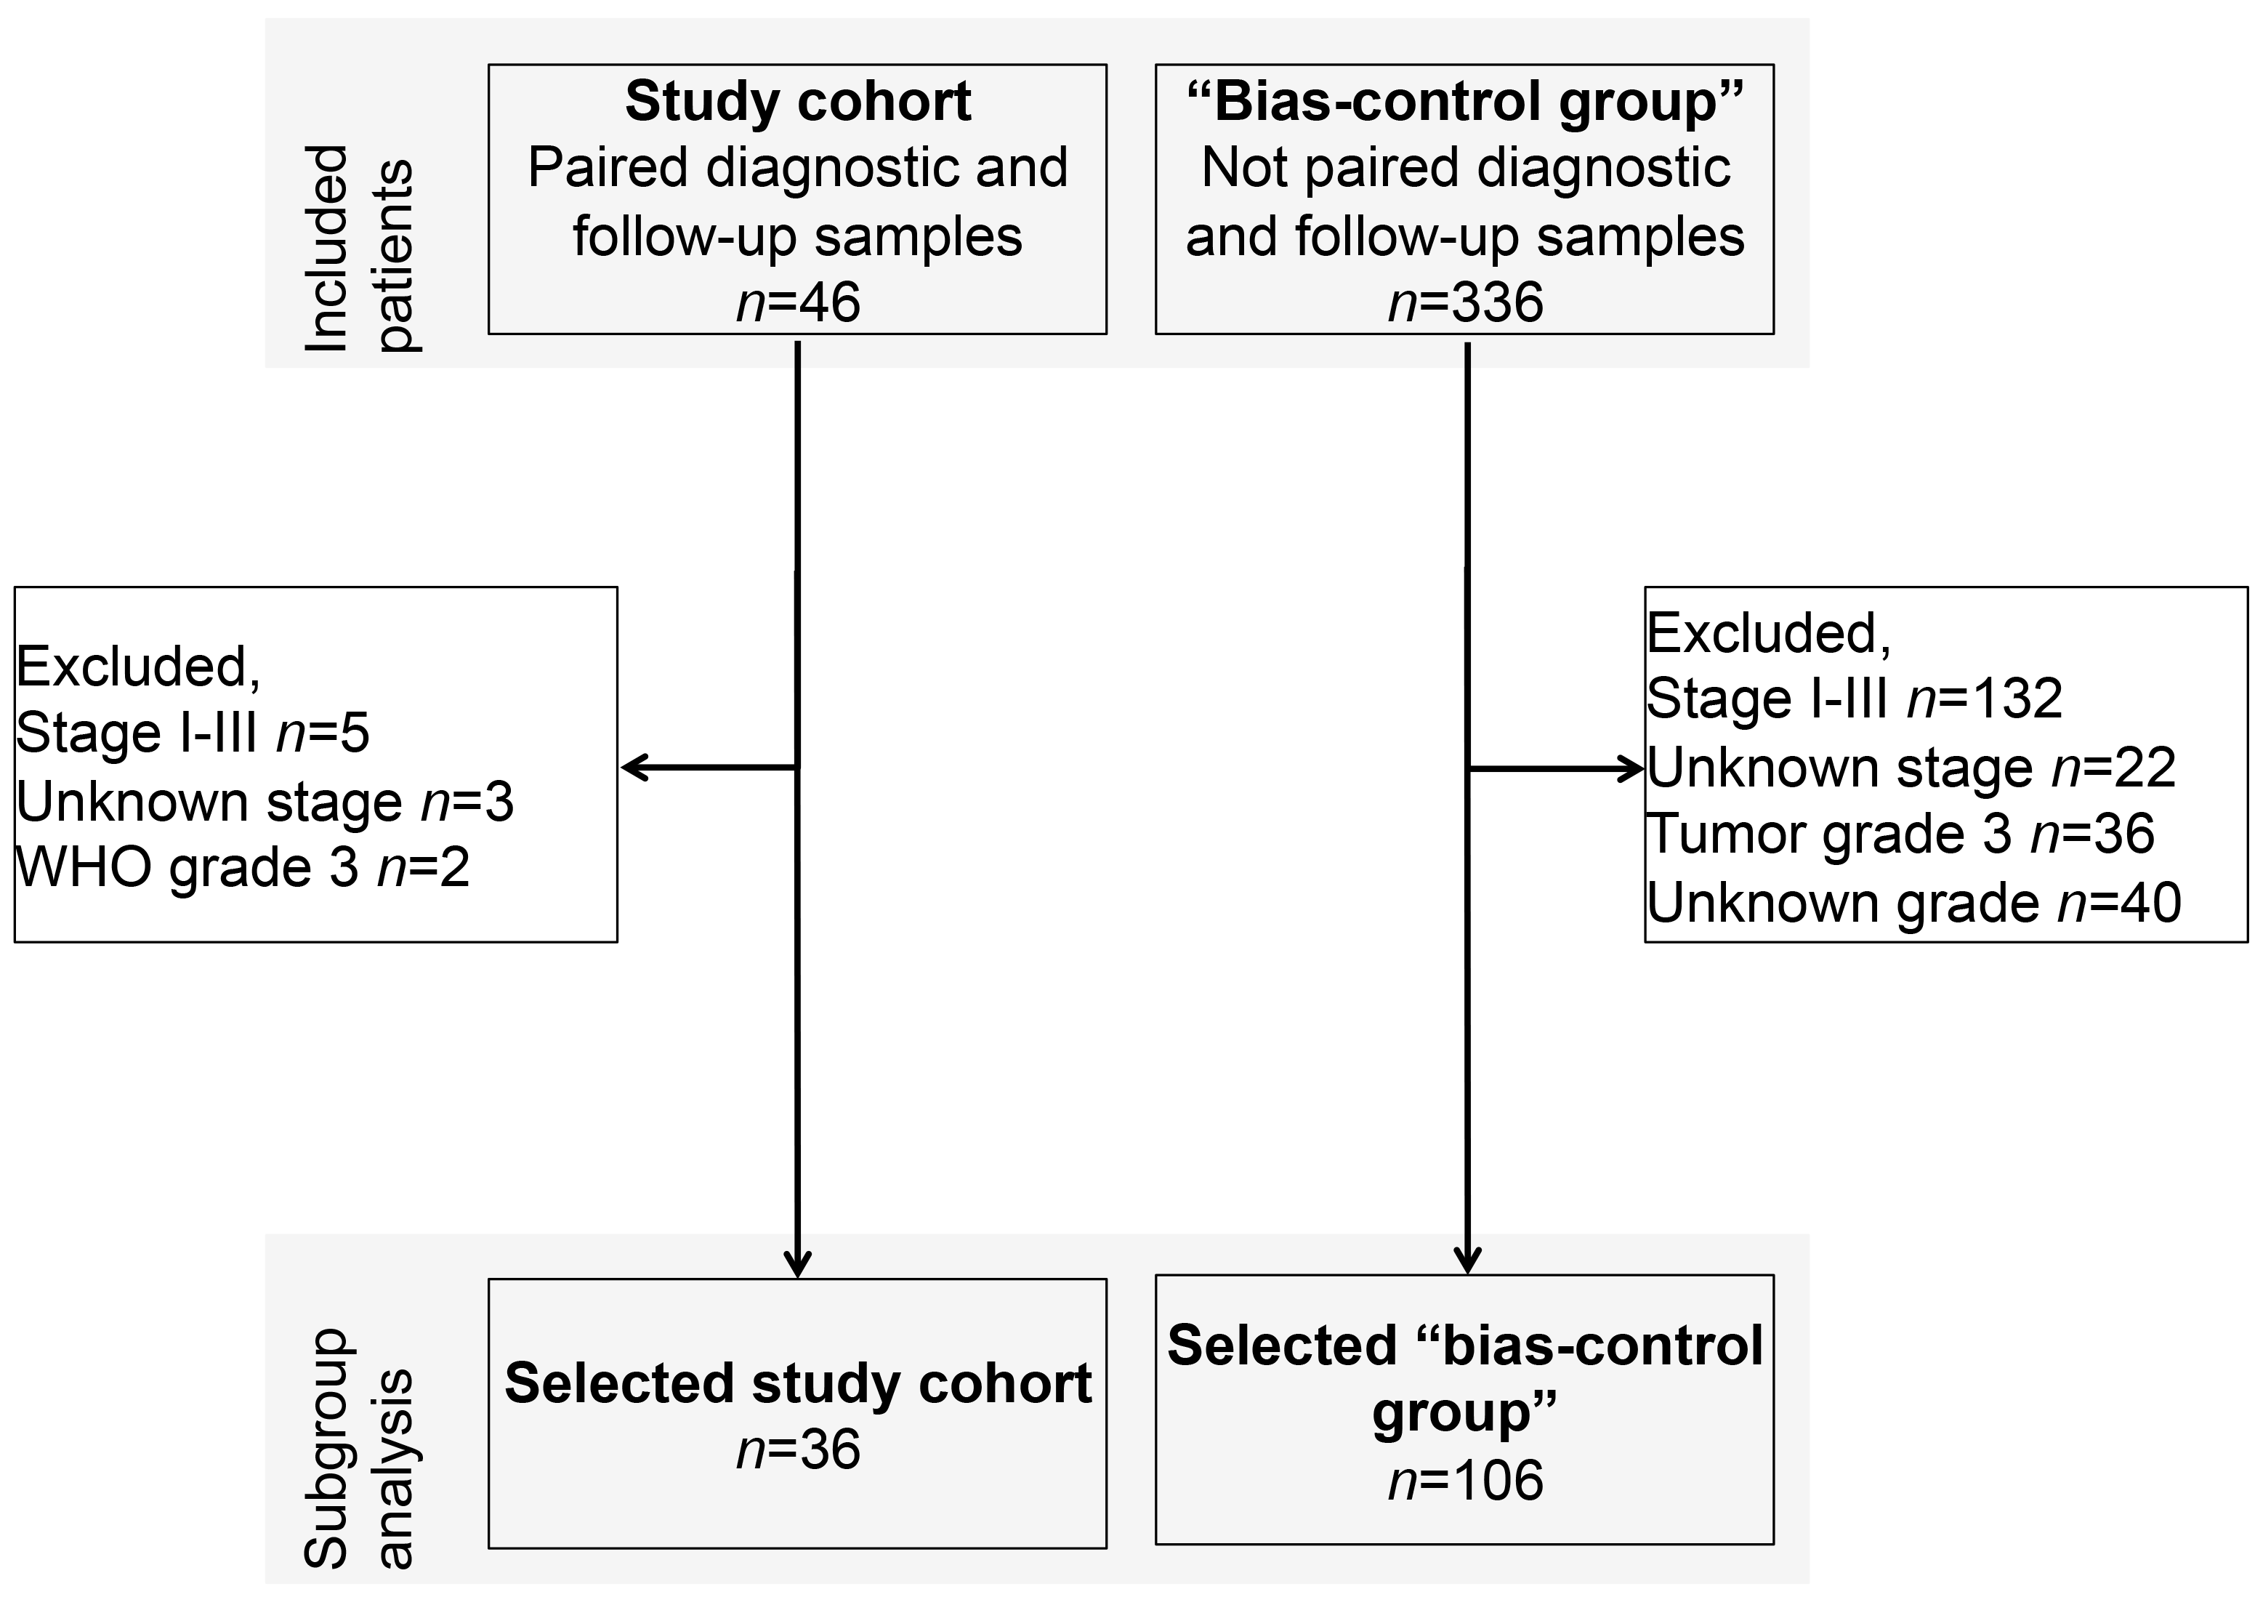

Assessment of selection bias through comparison of case–control cohort to a bias–control group. Among study cohort and control group patients with grade 1–2 and stage IV at baseline were selected for analysis. Thirty-six patients remained. In the bias control cohort, 119 were excluded due to stage (I–III 104 patients and unknown 15 patients), 27 had unknown grade, and 26 were grade 3 at diagnosis. One hundred and six patients remained in the control group.

**sFigure 2**



Kaplan-Meier curve of overall of the study cohort and bias–control (Control) group. Median survival of the study cohort was 71.1 (95% CI 50.1–83.5) months and median survival of the control cohort was 55.6 (95% CI 45.9–68.3) months. Cox Regression HR 0.96 (95% CI 0.63–1.46) *p*=0.840.