SUPPLEMENTAL MATERIAL
Risk stratification for ischemic cerebrovascular events and mortality among intracerebral haemorrhage patients with and without atrial fibrillation: a cohort study

Peter Brønnum Nielsen^{1,4} MSc, PhD
Thure Filskov Overvad^{1,2} MD, PhD
Søren Due Andersen^{1,3} MD, PhD
Torben Bjerregaard Larsen^{1,4} MD, PhD
Flemming Skjøth^{1,6} MSc, PhD
Mette Søgaard^{1,4} DVM, PhD
Gregory Y. H. Lip^{1,4} MD

List of contents:
Online Table I: Definitions on comorbidity and concomitant medication according to ICD-10 codes and ATC-codes.
Online Figure I: Receiver Operating Curves (ROC) for CHA₂DS₂-VASc score level and associated outcome

Online Table I: Definitions on comorbidity, outcome, and concomitant medication according to ICD-10 codes and ATC-codes.
 | International Classification of Diseases 10th revision (ICD-10) code | Anatomical Therapeutic Chemical (ATC) code
Condition
Congestive heart failure | I11.0; I13.0; I13.2; I42.0; I50 | CO3C
Left ventricular dysfunction | I50.1; I50.9
Hypertension |  | See specified definition*
Diabetes mellitus | E10.0; E10.1; E10.9; E11.0; E11.1; E11.9 | A10
Ischemic stroke** | I63; I64
Systemic embolism | I74
Transient ischemic disease** | G45
Aortic plaque | I70.0
Peripheral arterial disease | I70.2-I70.9; I71; I73.9; I74
Myocardial infarction | I21-I23
Abnormal renal function | I12; I13; N00-N05; N07; N11; N14; N17-N19; Q61
Prior Bleeding | I60-I62; D62; J94.2; H11.3; H35.6; H43.1; N02; N95; R04; R31; R58; K25.0; K26.0; K27.0; K28.0; K29.0; S06.3C; S06.4; S06.5; S06.6
Atrial fibrillation | I48
Intracranial bleeding** | I61
Medication
Dabigatran  Rivaroxaban  Apixaban |  | B01AE07  B01AE07  B01AF02
Coumarin derivatives |  | B01AA
Aspirin |  | B01AC06
Beta-blockers  Calcium channel blockers  Renin-angiotensin system  inhibitors (ACEi/ARBs)  Loop diuretics  Statin |  | C07  C07F; C08; C09BB; C09DB  C09  C03C  C10
Selective serotonin reuptake inhibitors |  | N06AB
* We identified subjects with hypertension from combination treatment with at least two of the following classes of antihypertensive Drugs:
I. Alpha adrenergic blockers (C02A, C02B, C02C)
II. Non-loop diuretics (C02DA, C02L, C03A, C03B, C03D, C03E, C03X, C07C, C07D, C08G, C09BA, C09DA, C09XA52)
III. Vasodilators (C02DB, C02DD, C02DG, C04, C05)
IV. Beta blockers (C07)
V. Calcium channel blockers (C07F, C08, C09BB, C09DB)
VI. Renin-angiotensin system inhibitors (C09).
** Determined from the Danish Stroke Registry

Online Figure 1: Receiver Operating Curves (ROC) for CHA₂DS₂-VASc score level and associated outcome
Atrial fibrillation
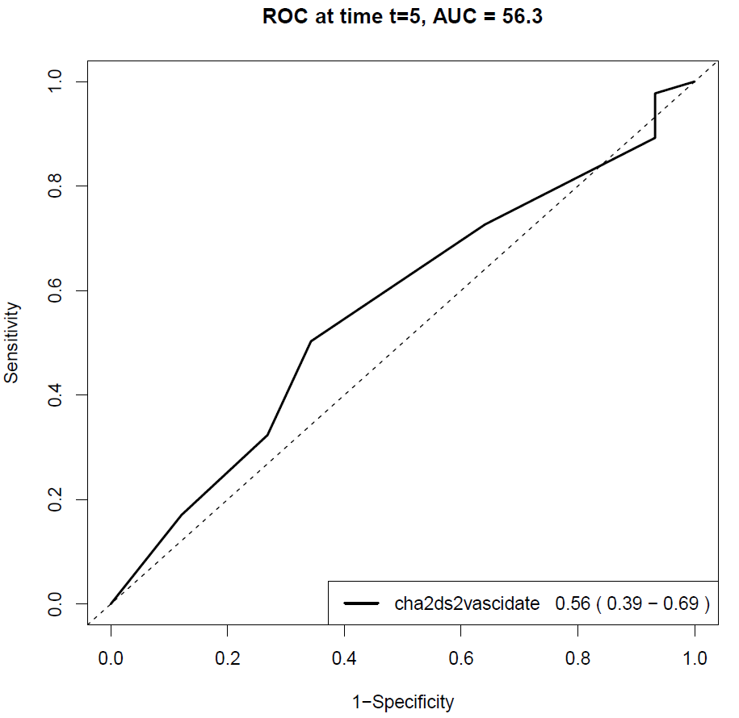
No atrial fibrillation
