Supplementary figures/tables

Study | Qu.1 | Qu.2 | Qu.3 | Qu.4 | Qu.5 | Qu.6 | Qu.7 | Qu.8 | Qu.9 | Qu.10 | Qu.11 | Qu.12 | Qu.13 | Qu.14 | Total
Adam 2014(6) | ✔ | ✔ | ✔ | ✔ | - | ✔ | ✔ | ✔ | ✔ | - | ✔ | - | - | ✔ | 10
Adam 2015(35) | ✔ | ✔ | ✔ | ✔ | - | ✔ | ✔ | ✔ | ✔ | - | ✔ | - | - | ✔ | 10
Baek 2010(36) | ✔ | ✔ | ✔ | ✔ | - | ✔ | ✔ | ✔ | ✔ | - | ✔ | - | ✔ | ✔ | 11
Bilimoria 2007(2) | ✔ | ✔ | ✔ | ✔ | - | ✔ | ✔ | ✔ | ✔ | - | ✔ | - | - | ✔ | 10
Choi 2019(37) | ✔ | ✔ | ✔ | ✔ | - | ✔ | ✔ | ✔ | ✔ | - | ✔ | - | - | ✔ | 10
Ebina 2014(28) | ✔ | ✔ | ✔ | ✔ | - | ✔ | ✔ | ✔ | ✔ | - | ✔ | - | ✔ | ✔ | 11
Farrar 1980(38) | ✔ | ✔ | ✔ | ✔ | - | ✔ | ✔ | ✔ | ✔ | - | ✔ | - | - | - | 9
Gemsenjäger 1997(39) | - | ✔ | ✔ | ✔ | - | ✔ | ✔ | ✔ | ✔ | - | ✔ | - | ✔ | - | 9
Grogan 2013(40) | ✔ | ✔ | ✔ | ✔ | - | ✔ | ✔ | ✔ | ✔ | - | ✔ | - | ✔ | ✔ | 11
Haigh 2005(41) | ✔ | ✔ | ✔ | ✔ | - | ✔ | ✔ | ✔ | ✔ | - | ✔ | - | ✔ | ✔ | 11
Hay 1998(23) | ✔ | ✔ | ✔ | ✔ | - | ✔ | ✔ | ✔ | ✔ | - | ✔ | - | ✔ | ✔ | 10
Huang 2017(8) | ✔ | ✔ | ✔ | ✔ | - | ✔ | ✔ | - | ✔ | - | ✔ | - | ✔ | ✔ | 10
Hwangbo 2017(14) | ✔ | ✔ | ✔ | ✔ | - | ✔ | ✔ | - | ✔ | - | ✔ | - | ✔ | ✔ | 10
Ito 2010(42) | ✔ | ✔ | ✔ | ✔ | - | ✔ | ✔ | ✔ | ✔ | - | ✔ | - | ✔ | - | 10
Kim 2012(43) | ✔ | ✔ | ✔ | ✔ | - | ✔ | ✔ | ✔ | ✔ | - | ✔ | - | ✔ | ✔ | 11
Kim 2017(44) | ✔ | ✔ | ✔ | ✔ | - | ✔ | ✔ | ✔ | ✔ | - | ✔ | - | ✔ | ✔ | 11
Kuba 2016(45) | ✔ | ✔ | ✔ | ✔ | - | ✔ | ✔ | ✔ | ✔ | - | ✔ | - | ✔ | ✔ | 11
Lim 2002(46) | ✔ | ✔ | ✔ | ✔ | - | ✔ | ✔ | ✔ | ✔ | - | ✔ | - | ✔ | ✔ | 11
Liu 2019(47) | ✔ | ✔ | ✔ | ✔ | - | ✔ | ✔ | ✔ | ✔ | - | ✔ | - | - | ✔ | 10
Matsuzu 2013(10) | ✔ | ✔ | ✔ | ✔ | - | ✔ | ✔ | - | ✔ | - | ✔ | - | ✔ | - | 9
Mendelsohn 2010(48) | ✔ | ✔ | ✔ | ✔ | - | ✔ | ✔ | ✔ | ✔ | - | ✔ | - | ✔ | ✔ | 11
Nixon 2012(7) | ✔ | ✔ | ✔ | ✔ | - | ✔ | ✔ | ✔ | ✔ | - | ✔ | - | ✔ | ✔ | 11
Rajjoub 2018(49) | ✔ | ✔ | ✔ | ✔ | - | ✔ | ✔ | ✔ | ✔ | - | ✔ | - | ✔ | ✔ | 11
Robinson 2016(50) | ✔ | ✔ | ✔ | - | - | ✔ | ✔ | ✔ | ✔ | - | ✔ | - | ✔ | - | 9
Sanders 1998(51) | ✔ | ✔ | ✔ | ✔ | - | ✔ | ✔ | ✔ | ✔ | - | - | - | ✔ | - | 9
Shah 1993(9) | ✔ | ✔ | ✔ | ✔ | - | ✔ | ✔ | ✔ | ✔ | - | ✔ | - | ✔ | - | 10
Shaha 1997(22) | ✔ | ✔ | ✔ | ✔ | - | ✔ | ✔ | ✔ | ✔ | - | ✔ | - | ✔ | ✔ | 11
Song 2018(52) | ✔ | ✔ | ✔ | ✔ | - | ✔ | ✔ | ✔ | ✔ | - | ✔ | - | ✔ | ✔ | 11
Sugino 2014(53) | ✔ | ✔ | ✔ | ✔ | - | ✔ | ✔ | ✔ | ✔ | - | ✔ | - | ✔ | ✔ | 11
Tsui 2019(54) | ✔ | ✔ | ✔ | ✔ | - | ✔ | ✔ | ✔ | ✔ | - | ✔ | - | - | ✔ | 10
Vaisman 2011(12) | ✔ | ✔ | ✔ | ✔ | - | ✔ | ✔ | ✔ | ✔ | - | ✔ | - | ✔ | ✔ | 11

Table S1 – Quality assessment using the NIH Quality Assessment Tool for Observational Cohort and Cross-Sectional Studies. The quality of the studies was overall deemed to be good within the remit of observational cohort studies, where three of the questions largely did not apply (sample size justification, repeated exposure assessment and assessor blinding not being applicable)

Study | T1 |  | T2 |  | T3+
 | TT | HT | TT | HT | TT | HT
Adam 2014 | 59% | 60% | 41% | 40% | 0% | 0%
Bilimoria 2007 | 51% | 66% | 37% | 25% | 12% | 9%
Ebina 2014 | 34% | 36% | 11% | 16% | 55% | 48%
Huang 2017 | 0% | 69% | 0% | 6% | 0% | 25%
Liu  2019 | 55% | 55% | 30% | 30% | 15% | 15%
Matsuzu 2013 | 0% | 48% | 0% | 42% | 0% | 10%
Nixon 2011 | 73% | 69% | 27% | 31% | 0% | 0%
Shah 1993 | 0% | 0% | 64% | 61% | 36% | 39%
Sugino 2014 | 0% | 0% | 42% | 43% | 58% | 57%
Untch 2014 | 22% | 0% | 45% | 0% | 33% | 0%
Vaisman 2011 | 73% | 53% | 12% | 31% | 14% | 13%
Kim 2017 | 85% | 86% | 15% | 14% | 0% | 0%
Song 2018 | 86% | 86% | 14% | 14% | 0% | 0%
Average | 64.4% | 62.7% | 27.8% | 28.1% | 26.9% | 21.0%

Table S2 – Studies that defined surgical extent by tumour size, data demonstrated is proportion (%) of each group

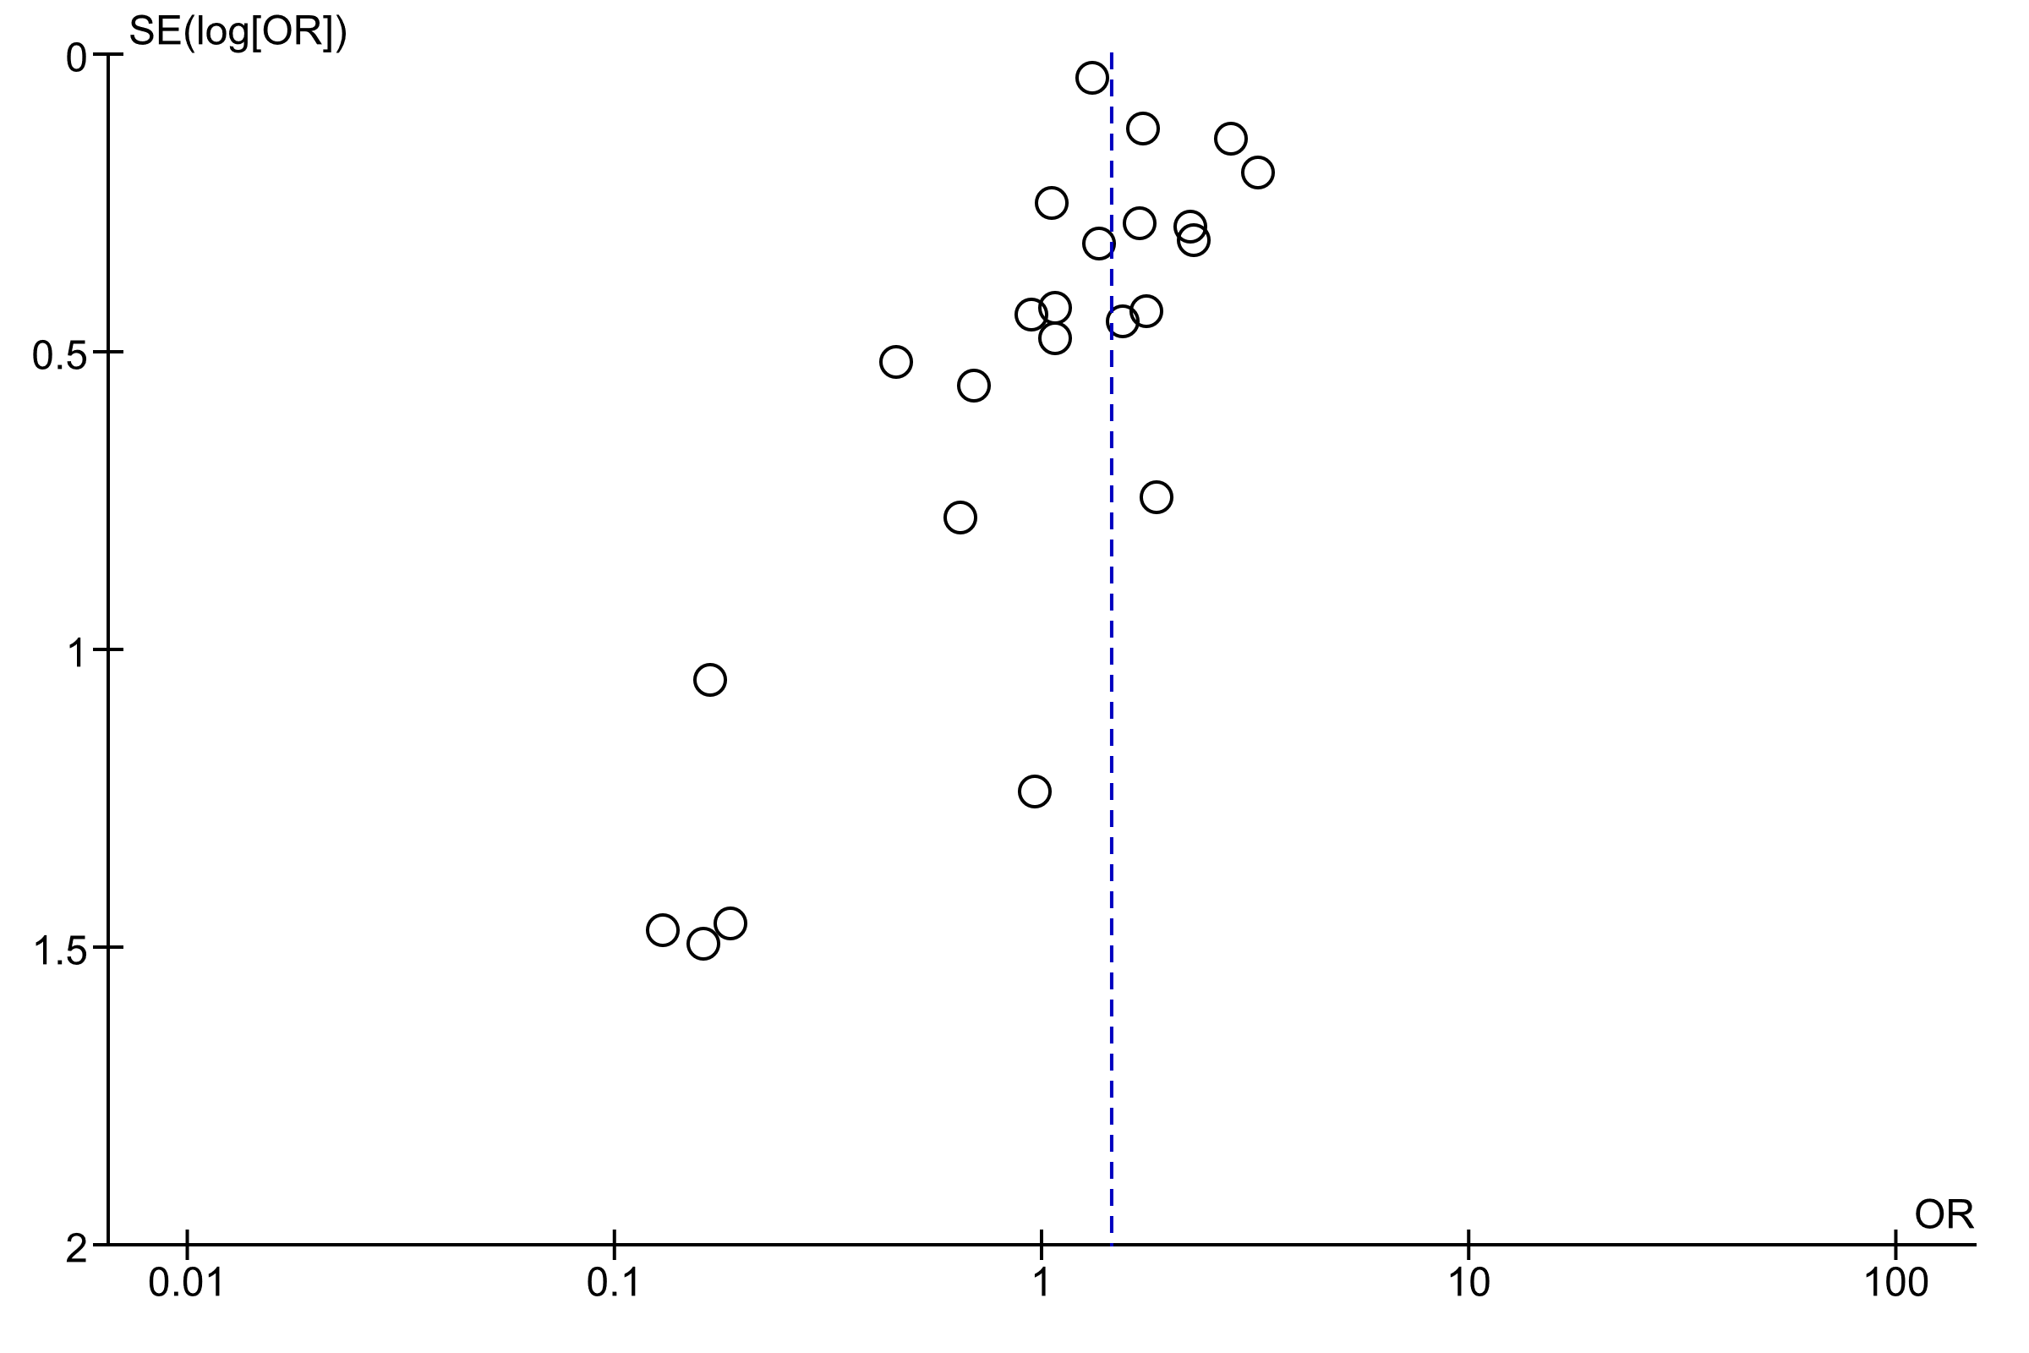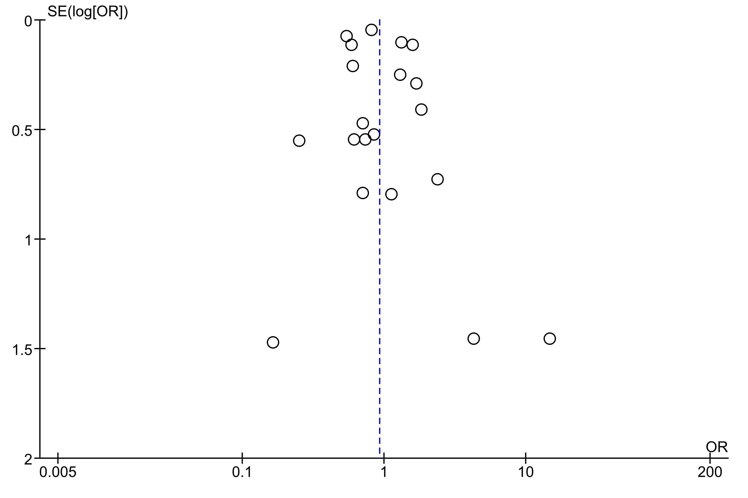

Figure S1 – Funnel plots for studies with pooled recurrence rate (above) and 10-year survival data (below)

