Cardiac-specific caveolin-3 overexpression prevents post-myocardial infarction ventricular arrhythmias by inhibiting ryanodine receptor-2 hyperphosphorylation

Zhihao Zhang, Qin Fang, Tingyi Du, Guangzhi Chen*, Yan Wang*, and Dao Wen Wang

Division of Cardiology, Departments of Internal Medicine and Hubei Key Laboratory of Genetics and Molecular Mechanisms of Cardiological Disorders, Tongji Hospital, Tongji Medical College, Huazhong University of Science and Technology, Wuhan, China.

Short Title: Caveolin-3 and ventricular arrhythmias

*Corresponding authors:

Guangzhi Chen and Yan Wang
Division of Cardiology, Department of Internal Medicine

Tongji Hospital, Tongji Medical College

Huazhong University of Science and Technology
1095# Jiefang Ave. Wuhan 430030, China
Tel. & Fax: 86-27-8366-3280

Email: chengz2003@163.com; newswangyan@tjh.tjmu.edu.cn

Keywords: myocardial infarction, ventricular arrhythmias, caveolin-3, Pkp2, RyR2

Supplemental methods:

Evaluation of cardiac function
A high-resolution ultrasound with a 30-MHz scan head was used to measure ventricular dimensions (Vevo1100; VisualSonics, Toronto, Canada). A pressure-volume catheter (Millar 1.4 Fr, SPR 835, Millar Instruments, Inc., Houston, TX, USA) was used to record intraventricular pressure and volume by insertion into the left ventricle through the right carotid artery. All measurements were performed as described previously [1].

Determination of infarct size
At the end of 24 h PMI, the mice were anesthetised and the hearts were excised quickly and sliced into five sections uniformly from the apical to the basal segments perpendicularly to the long axis of the heart. The sections were incubated with 1% triphenyltetrazolium chloride (TTC, Sigma, St. Louis, MO, USA) in phosphate-buffered saline (PBS; pH 7.4) for 20 min in a 37°C water bath and then photographed. TTC-stained (non-infarcted myocardium) and TTC-negative (infracted myocardial) areas were measured using ImageJ software (NIH, Bethesda, MD, USA). Myocardial infarct size was calculated as a percentage of the total LV mass as previously described [2].
References:
1 Wu L, Wang K, Wang W, Wen Z, Wang P, Liu L, Wang DW: Glucagon-like peptide-1 ameliorates cardiac lipotoxicity in diabetic cardiomyopathy via the PPARalpha pathway. AGING CELL 2018;17:e12763.
2 Most P, Seifert H, Gao E, Funakoshi H, Volkers M, Heierhorst J, Remppis A, Pleger ST, DeGeorge BJ, Eckhart AD, Feldman AM, Koch WJ: Cardiac S100A1 protein levels determine contractile performance and propensity toward heart failure after myocardial infarction. CIRCULATION 2006;114:1258-1268.

Supplemental results:
Cardiac-specific overexpression of Cav3 rescued cardiac dysfunction in the post-MI mice
We also assessed cardiac function of mice while detecting ventricular arrhythmias after myocardial infarction. Echocardiography at 24h after MI or sham operations demonstrated that LVs were enlarged and LV systolic function was impaired in MI groups compared with sham groups (Supplementary Fig.2A). Interestingly, rAAV-Cav3 mice had an increased ejection fraction of 36±3% compared with 29±2% in rAAV-RFP mice (Supplementary Fig.2B). Detailed measurement of heart function was performed by invasive pressure-volume analyses. We found that the cardiac function of MI mice was significantly decreased compared with the sham controls, as evidenced by decreases in dp/dtmax and dp/dtmin; cardiac-specific overexpression of Cav3 reversed these impairments (Supplementary Fig.2, C and D). Based on our measurements of cardiac function, infarct sizes in the rAAV-Cav3 mice were decreased relative to those of the rAAV-RFP mice (42.3±3.5% in rAAV-Cav3 versus 54.1±1.6% in rAAV-RFP, Supplementary Fig. 2, E and F). In conclusion, our data demonstrated that overexpression of Cav3 improved cardiac function in PMI mice.

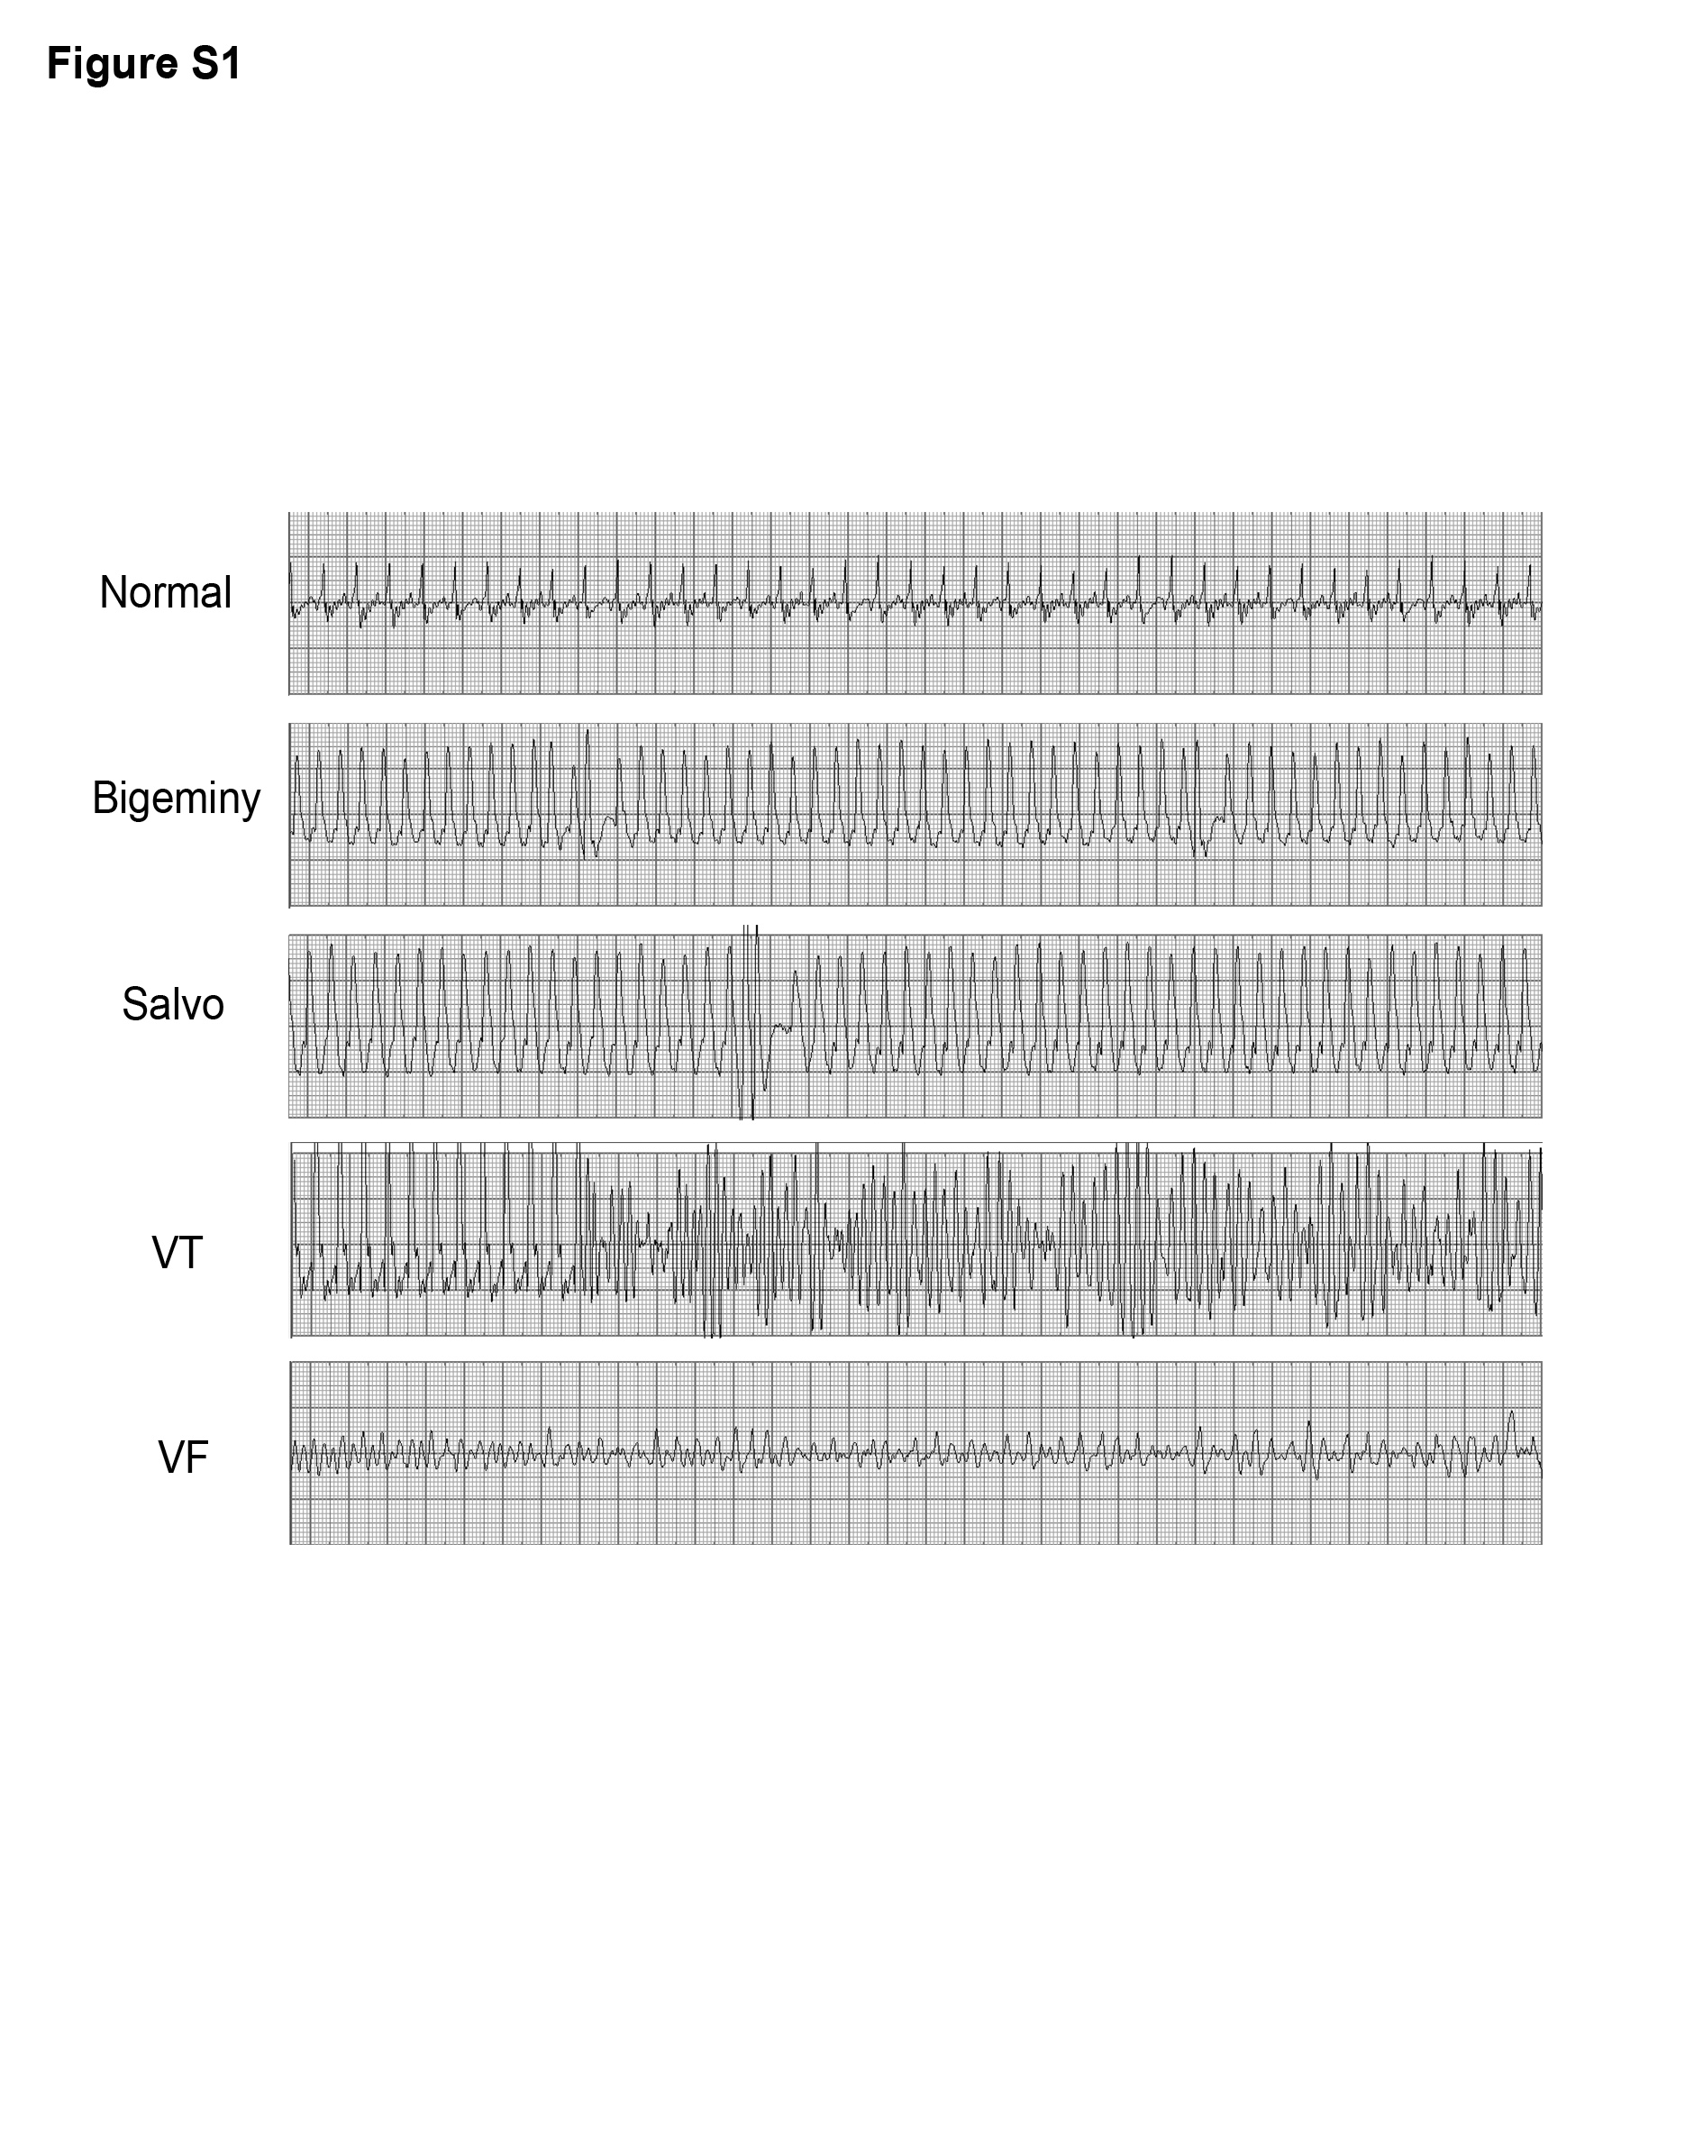
Supplementary Fig.1. Representative surface ECG recordings after ISO stimulation of sham and MI mice 24 h PMI.

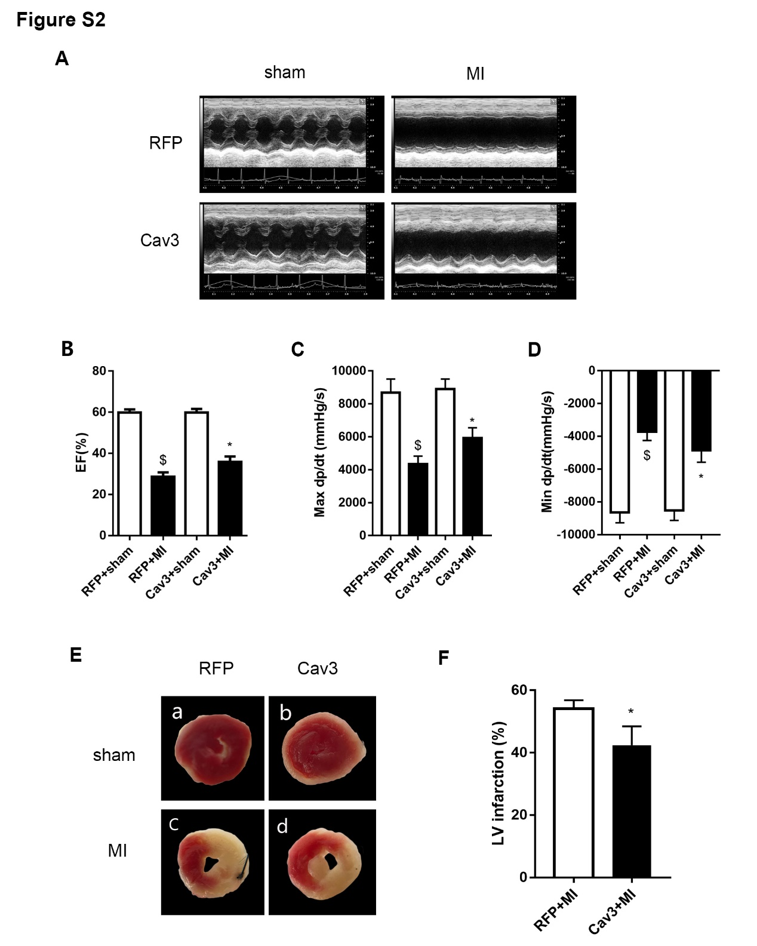
Supplementary Fig.2. Cardiac-specific overexpression of Cav3 rescues PMI cardiac dysfunction in mice. A: Representative M-mode trace, B: ejection fraction calculated from echocardiography, n = 10 for each sham group and n = 11 for each MI group. C–F: quantification of (C) max dp/dt, peak rate of pressure increase, (D) quantification of min dp/dt, peak rate of pressure decline, n = 7. (E) TTC staining, and (F) percentage of LV infarct size. n = 3. $p < 0.01 vs. RFP+sham, *p < 0.05 vs. RFP+MI, Data are presented as the means ±SEM.

