**A**

|  |  |
| --- | --- |
| **Cambridge Classification** | **Endoscopic ultrasound findings** |
| Cambridge 0 | None |
| Cambridge I | Honeycomb-like lobulated texture, duct <3 mm |
| Cambridge II | Hyperechogenic duct and foci, echo-dense contour, duct <3 mm |
| Cambridge III | Honeycomb-like lobulated texture, septated, hyperechogenic foci, duct >3 mm, irregular duct, no duct stones |
| Cambridge IV | As in 3, with calcifications, duct stones, cysts |

**B**

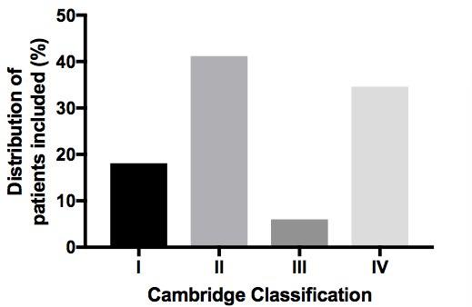

**Supplemental Figure 1.** (**A**)Definition of Cambridge Classification adapted for endoscopic ultrasound [1, 2]. (**B**) Percentage distribution of the 182 patients included into analysis related to Cambridge Classification.

**A**

|  |  |
| --- | --- |
| **Staging/classification of CP** | **Definition** |
| Stage A | Pain of any type and degree and/or attacks of acute pancreatitis, no complications (see Table 2), no steatorrhea, no insulin-dependent diabetes mellitus. |
| Stage B | Patients with complications (Table 2) but without steatorrhea or diabetes mellitus. |
| Stage C | C1: Patients with endocrine function impairment |
|  | C2: Patients with exocrine function impairment |
|  | C3: Patients with exocrine/endocrine function impairment and/or complications as they are defined in table 2. |

**B C**



**Supplemental Figure 2. (A)** Definition of chronic pancreatitis stages according to Büchler et al. [3]. (**B**) Clinical classification of chronic pancreatitis patients according to Büchler et al. [3]. **(C)** Patient distribution in view of clinical classification and etiology of chronic pancreatitis.

1. Mayerle J, Hoffmeister A, Werner J et al. Chronic pancreatitis--definition, etiology, investigation and treatment. Dtsch Arztebl Int 2013; 110: 387-393.

2. Chronic Pancreatitis German Society of D, Metabolic D, Hoffmeister A et al. [S3-Consensus guidelines on definition, etiology, diagnosis and medical, endoscopic and surgical management of chronic pancreatitis German Society of Digestive and Metabolic Diseases (DGVS)]. Z Gastroenterol 2012; 50: 1176-1224.

3. Buchler MW, Martignoni ME, Friess H, Malfertheiner P. A proposal for a new clinical classification of chronic pancreatitis. BMC Gastroenterol 2009; 9: 93.