Supplementary Material

Serum Alkaline Phosphatase Level Predicts Cardiac Valve Calcification
in Maintenance Hemodialysis Patients

Blood Purification
Jing Guo^{1*}, Ming Zeng^{1*}, Yanjuan Zhang², Hui Huang³,Guang Yang¹,Fangyan Xu¹,
Wenkai Ren¹,Jing Wang¹, Yaoyu Huang¹, Ningning Wang^{1#},Changying Xing^{1#}

¹ Department of Nephrology, The First Affiliated Hospital of Nanjing Medical University,
Jiangsu Province Hospital, Nanjing, People’s Republic of China
² Department of Cardiology, The First Affiliated Hospital of Nanjing Medical University,
Jiangsu Province Hospital, Nanjing, People’s Republic of China
³ Department of Epidemiology and Biostatistics, School of Public Health,
Nanjing Medical University, Nanjing, People’s Republic of China

Corresponding Authors :
Changying Xing, Email: cyxing62@126.com
Ningning Wang, Email: wangnn@njmu.edu.cn

Table S1 Components of the Global cardiac calcium scoring system [24]

Components | Score
Posterior annulus | (by thirds, score 0–3)
Posterior mitral leaflet restriction | (0, 1)
Anterior mitral leaflet restriction | (0, 1 [valve opening on long-axis  view ≤10 mm])
Mitral valve calcification (either leaflet) | (0, 1 [mild], 2 [greater than mild])
Subvalvular apparatus calcification | (0, 1)
Aortic valve calcification | (0,1[nodule(s) in fewer than three leaflets], 2 [nodules in three leaflets but nonrestrictive], 3 [restrictive*])
Aortic root calcification | (0, 1)

* Reduced motion of one or more leaflets or a meangradient ≥ 15 mm Hg

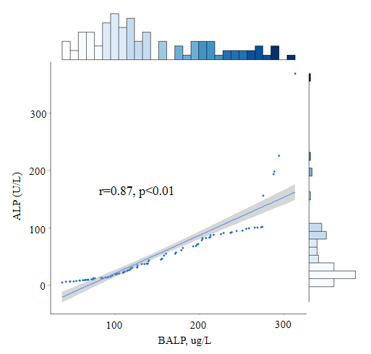
Fig. S1 Correlations between serum concentration of ALP
and bone-specific alkaline phosphatase (BALP)

