Supplementary table 1. Comparisons of the patient selection criteria for relevant published RCTs.
Author (year) | Study design | Sample size TACE/TACE-S | Patient selection
 |  |  | Tumor burden | Liver function | Performance status
Kudo M, et al. (2011) [1] | PhaseⅢ | 229/229 | Tumor size ≤7cm Tumor number ≤10 | Child-Pugh A | ECOG 0-1 score
Lencioni R, et al. (2016) [2] | PhaseⅡ | 153/154 | Unresectable multinodular | Child-Pugh A (without ascites) | ECOG 0 score
Meyer T, et al (2017) [3] | PhaseⅢ | 156/157 | Not a candidate for resection or transplantation | Child-Pugh A | ECOG 0-1 score
Kudo M, et al. (2018) [4] | PhaseⅡ | 76/80 | Tumor size ≤10cm Tumor number ≤10 | Child-Pugh A/B7 | ECOG 0-1 score
Abbreviations: RCTs, randomized controlled trials; TACE, transarterial chemoembolization; TACE-S, the combination therapy of TACE and sorafenib; ECOG, Eastern Cooperative Oncology Group.

Supplementary table 2. Baseline characteristics for the study patients with available TTP.
Baseline characteristics | Total | TACE | TACE-S
Patients, n | 516 | 307 | 209
Age, mean ± sd | 54.0 ± 12.1 | 54.5 ± 12.0 | 53.2 ± 12.2
Gender, n (%)
Male | 426 (82.6) | 252 (82.1) | 174 (83.3)
Female | 90 (17.4) | 55 (17.9) | 35 (16.7)
Etiology, n (%)
HBV | 434 (84.1) | 262 (85.3) | 172 (82.3)
HCV | 23 (4.5) | 12 (3.9) | 11 (5.3)
Others | 59 (11.4) | 33 (10.7) | 26 (12.4)
Antiviral treatment, n (%) | 422 (81.3) | 249 (81.1) | 173 (82.8)
BCLC stage, n (%)
A | 61 (11.8) | 34 (11.1) | 27 (12.9)
B | 285 (55.2) | 185 (60.2) | 100 (47.8)
C | 170 (32.9) | 88 (28.7) | 82 (39.2)
Performance status, ECOG score, n (%)*
0 | 346 (67.1) | 219 (71.3) | 127 (60.8)
1 | 170 (32.9) | 88 (28.7) | 82 (39.2)
Child-Pugh score, n (%)
5 | 391 (75.8) | 229 (74.6) | 162 (77.5)
6 | 99 (19.2) | 62 (20.2) | 37 (17.7)
7 | 26 (5.0) | 16 (5.2) | 10 (4.8)
Ascites, n (%)
Negative | 476 (92.2) | 283 (92.2) | 193 (92.3)
Positive | 40 (7.8) | 24 (7.8) | 16 (7.7)
AFP, ng/mL, n (%)
≤200 | 273 (52.9) | 167 (54.4) | 106 (50.7)
>200 | 243 (47.1) | 140 (45.6) | 103 (49.3)
Tumor number, median [IQR]* | 1 [1-2] | 1[1-2] | 1 [1-2]
Tumor size, cm, mean ± sd* | 7.8 ± 3.9 | 7.5 ± 3.7 | 8.3 ± 3.7
International normalized ratio, mean ± sd | 1.12 ± 0.15 | 1.13 ± 0.16 | 1.10 ± 0.13
Alanine aminotransferase, U/L, mean ± sd | 44.9 ± 34.0 | 43.7 ± 29.8 | 46.7 ± 39.4
Aspartate aminotransferase, U/L, mean ± sd | 53.2 ± 37.3 | 52.0 ± 36.9 | 55.0 ± 37.8
Albumin, g/L, mean ± sd | 39.4 ± 5.1 | 39.1 ± 5.1 | 39.7 ± 5.1
Total bilirubin, μmol/L, mean ± sd | 16.8 ± 7.5 | 16.9 ± 7.9 | 16.5 ± 6.9
Urea nitrogen, mmol/L, mean ± sd* | 5.2 ± 1.5 | 5.4 ± 1.5 | 5.0 ± 1.4
Serum creatinine, umol/L, mean ± sd | 85.5 ± 19.6 | 85.3 ± 19.2 | 85.8 ± 20.2
Abbreviations: TTP, time to progression; TACE, transarterial chemoembolization; TACE-S, combining transarterial chemoembolization and sorafenib; sd, standard deviation; HBV, hepatitis B virus; HCV, hepatitis C virus; BCLC, Barcelona Clinic Liver Cancer; ECOG, Eastern Cooperative Oncology Group; IQR, interquartile range; AFP, alpha-fetoprotein; TACE, transarterial chemoembolization; TACE-S, the combination therapy of TACE and sorafenib.
*Variables with significantly difference between patients treated with TACE and TACE-S (P<0.05).

Supplementary table 3. Baseline characteristics for the candidates and non-candidates.
Study cohort | OS Analyses | TTP Analyses
Candidates
Patients, n | 1051 | 330
Age, years, mean ± sd | 55.9 ± 12.3 | 53.8 ± 12.1
Gender, male/female, n (%) | 889 (84.6)/162 (15.4) | 278 (84.2)/52 (15.8)
Etiology, HBV/HCV/others, n (%) | 860 (81.8)/34 (3.2)/157 (14.9) | 272 (82.4)/12 (3.6)/46 (13.9)
Performance status, ECOG score 0/1, n (%) | 744 (70.8)/307 (29.2) | 235 (71.2)/95 (28.8)
Child-Pugh, A5/A6/B7, n (%) | 863 (82.1)/138 (13.1)/50 (4.8) | 273 (82.7)/42 (12.7)/15 (4.5)
Ascites, negative/positive, n (%) | 1008 (95.9)/43 (4.1) | 302 (91.5)/28 (8.5)
AFP, ≤200/>200 ng/mL, n (%) | 563 (53.6)/488 (46.4) | 171 (51.8)/159 (48.2)
Tumor number, median [IQR] | 2.1 ± 1.9/1 [1-2] | 1.9 ± 1.2/1 [1-2]
Tumor size, cm, mean ± sd | 7.6 ± 3.1 | 7.7 ± 2.7
International normalized ratio, mean ± sd | 1.15 ± 0.11 | 1.09 ± 0.13
Alanine aminotransferase, U/L, mean ± sd | 47.9 ± 37.2 | 43.8 ± 28.8
Aspartate aminotransferase, U/L, mean ± sd | 53.3 ± 36.2 | 49.8 ± 36.7
Albumin, g/L, mean ± sd | 40.6 ± 5.2 | 40.9 ± 5.1
Total bilirubin, μmol/L, mean ± sd | 16.3 ± 7.6 | 15.7 ± 6.8
Urea nitrogen, mmol/L, mean ± sd | 5.3 ± 1.6 | 5.3 ± 1.5
Serum creatinine, umol/L, mean ± sd | 77.3 ± 19.3 | 88.0 ± 218.6
Treatment, TACE alone/TACE-S, n (%) | 845 (80.4)/206 (19.6) | 192 (58.2)/138 (41.8)
Non-candidates
Patients, n | 668 | 186
Age, years, mean ± sd | 56.5 ± 11.9 | 54.2 ± 12.1
Gender, male/female, n (%) | 561 (84.0)/107 (16.0) | 148 (79.6)/38 (20.4)
Etiology, HBV/HCV/others, n (%) | 641 (82.3)/26 (3.3)/112 (14.4) | 162 (87.1)/11 (5.9)/13 (7.0)
Performance status, ECOG score 0/1, n (%) | 407 (60.9)/261 (39.1) | 111 (59.7)/75 (40.3)
Child-Pugh, A5/A6/B7, n (%) | 416 (62.3)/201 (30.1)/51 (7.6) | 118 (63.4)/57 (30.6)/11 (5.9)
Ascites, negative/positive, n (%) | 638 (95.5)/30 (4.5) | 174 (93.5)/12 (6.5)
AFP, ≤200/>200 ng/mL, n (%) | 379 (56.1)/289 (43.3) | 102 (54.8)/84 (45.2)
Tumor number, median [IQR] | 2.5 ± 2.5/1 [1-3] | 2.2 ± 2.3/1 [1-2]
Tumor size, cm, mean ± sd | 7.9 ± 5.1 | 8.1 ± 5.0
International normalized ratio, mean ± sd | 1.12 ± 0.15 | 1.16 ± 0.16
Alanine aminotransferase, U/L, mean ± sd | 51.8 ± 46.8 | 46.9 ± 41.7
Aspartate aminotransferase, U/L, mean ± sd | 63.2 ± 47.7 | 59.3 ± 37.5
Albumin, g/L, mean ± sd | 36.5 ± 3.9 | 36.6 ± 3.9
Total bilirubin, μmol/L, mean ± sd | 19.1 ± 9.1 | 18.7 ± 8.3
Urea nitrogen, mmol/L, mean ± sd | 5.3 ± 1.7 | 5.2 ± 1.5
Serum creatinine, umol/L, mean ± sd | 75.0 ± 20.9 | 81.2 ± 20.6
Treatment, TACE alone/TACE-S, n (%) | 561 (84.0)/107 (16.0) | 115 (61.8)/71 (38.2)
Abbreviations: OS, overall survival; TTP, time to progression; sd, standard deviation; HBV, hepatitis B virus; HCV, hepatitis C virus; BCLC, Barcelona Clinic Liver Cancer; ECOG, Eastern Cooperative Oncology Group; IQR, interquartile range; AFP, alpha-fetoprotein; TACE, transarterial chemoembolization; TACE-S, the combination therapy of TACE and sorafenib.
Patients with either moderate tumor burden or low ALBI score were defined as candidates; otherwise, none-candidates.

Supplementary figure 1. Comparisons of TACE sessions between patients treated with TACE and TACE-S.
TACE, transarterial chemoembolization; TACE-S, combining TACE and sorafenib.
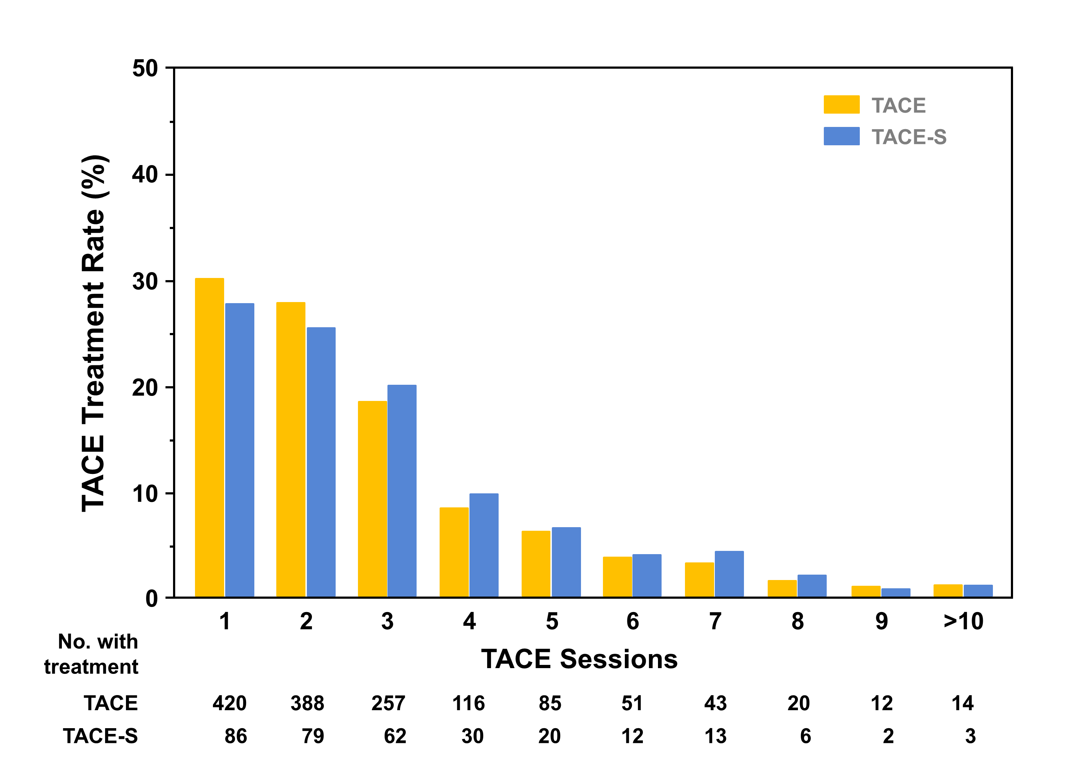

Supplementary figure 2. Outcome comparisons between TACE and TACE-S for subsets with different tumor burden in terms of OS unadjusted (A) and adjusted for propensity score (B), as well as TTP unadjusted (C) and adjusted for propensity score (D).
TACE, transarterial chemoembolization; TACE-S, combining TACE and sorafenib; OS, overall survival; TTP, time to progression; HR, hazard ratio; CI, confidence intervals.
Low tumor burden, ≤7, moderate tumor burden, >7 and ≤12, high tumor burden, >12.

Supplementary figure 3. Outcome comparisons between TACE and TACE-S for subsets with different ALBI score in terms of OS unadjusted (A) and adjusted for propensity score (B), as well as TTP unadjusted (C) and adjusted for propensity score (D).
TACE, transarterial chemoembolization; TACE-S, combining TACE and sorafenib; ALBI, albumin-bilirubin; OS, overall survival; TTP, time to progression; HR, hazard ratio; CI, confidence intervals.
Low ALBI score, ≤-2.8, high ALBI score, >-2.8.

Supplementary figure 4. Imaging assessments after 4-8 weeks of first TACE (532 available patients in TACE alone and 209 in TACE-S) varied with tumor burden.
ALBI, albumin-bilirubin; TACE, transarterial chemoembolization; TACE-S, combining TACE and sorafenib.

Supplementary figure 5. Comparisons of sorafenib duration in different ALBI score (122 and 191 TACE-S treated patients in low and high ALBI subsets).
TACE, transarterial chemoembolization; TACE-S, combining TACE and sorafenib; objective response, complete or partial response; disease control, free of progression.

Supplementary figure 6. Correlations between the final findings and the patient selection (ratio of the candidates) in previous studies, namely, Post-TACE (negative), SPACE (negative), TACE-2 (negative), TACTICS (positive), as well as our study (negative for the whole cohort).

REFERENCES
1 Kudo M, Imanaka K, Chida N, Nakachi K, Tak WY, Takayama T, Yoon JH, Hori T, Kumada H, Hayashi N, Kaneko S, Tsubouchi H, Suh DJ, Furuse J, Okusaka T, Tanaka K, Matsui O, Wada M, Yamaguchi I, Ohya T, Meinhardt G, Okita K: Phase III study of sorafenib after transarterial chemoembolisation in Japanese and Korean patients with unresectable hepatocellular carcinoma. Eur J Cancer 2011;47:2117-2127.
2 Lencioni R, Llovet JM, Han G, Tak WY, Yang J, Guglielmi A, Paik SW, Reig M, Kim do Y, Chau GY, Luca A, del Arbol LR, Leberre MA, Niu W, Nicholson K, Meinhardt G, Bruix J: Sorafenib or placebo plus TACE with doxorubicin-eluting beads for intermediate stage HCC: The SPACE trial. J Hepatol 2016;64:1090-1098.
3 Meyer T, Fox R, Ma YT, Ross PJ, James MW, Sturgess R, Stubbs C, Stocken DD, Wall L, Watkinson A, Hacking N, Evans TRJ, Collins P, Hubner RA, Cunningham D, Primrose JN, Johnson PJ, Palmer DH: Sorafenib in combination with transarterial chemoembolisation in patients with unresectable hepatocellular carcinoma (TACE 2): a randomised placebo-controlled, double-blind, phase 3 trial. Lancet Gastroenterol Hepatol 2017;2:565-575.
4 Kudo M: Randomized, open label multicenter, Phase II trial comparing transarterial chemoembolization (TACE) plus sorafenib with TACE alone in patients with hepatocellular carcinoma. ASCO GI 2018 [abstract 206]

