**SUPPLEMENTAL DATA**

Table S1. Coefficient of variation (%) for TTE (aortic VTI) and BR at specific time points

|  |  |  |  |  |  |  |
| --- | --- | --- | --- | --- | --- | --- |
| Patient | Time point 0 | | Time point: 48hrs | | Time point: 72hrs | |
|  | BR | TTE | BR | TTE | BR | TTE |
| 1 | 4.7 | 5.6 | 7.2 | 3.4 | 5.3 | 2 |
| 2 | 5.2 | 4.9 | 3.6 | 9 | 5.4 | 1.3 |
| 3 | 12.6 | 4.9 | 5.5 | 11.4 | 9.9 | 6.5 |
| 4 | 9.2 | 3.3 | 13.1 | 16.1 | 10 | 5.5 |
| 5 | 4.5 | 9.3 | 9.8 | 8.2 | 7.7 | 5.6 |
| 6 | 8.1 | 14.6 | 6.3 | 4.9 | 1.8 | 8.9 |
| 7 | 7.9 | 3.9 | 6.7 | 7.1 | 3.1 | 7.4 |
| 8 | 2.6 | 6.9 | 7.5 | 3.8 | 4.2 | 9.8 |
| 9 | 4.7 | 2.6 | 3.6 | 5.8 | 2.6 | 5.2 |
| 10 | 10.7 | 2.5 | 7.5 | 11 | 10.4 | 8.9 |
| 11 | 3.3 | 10 | 2.9 | 15.4 | 6.9 | 7.9 |
| 12 | 2.3 | 11.3 | 7.4 | 7.8 | 5.9 | 8.3 |
| 13 | 5.3 | 12.2 | 4 | 4.9 | 6.9 | 4.8 |
| 14 | 3.2 | 21 | 6.7 | 7.3 | 4.8 | 3.3 |
| 15 | 4.4 | 5.4 | 3.5 | 5.4 | 9.7 | 19.1 |
| Mean ±SD  (%) | 5.91±3.09 | 7.89±5.20 | 6.35±2.72 | 8.10±3.90 | 6.31 ±2.81 | 6.97±4.21 |
| p | 0.213 | | 0.165 | | 0.617 | |

Fig S1: Underestimation of (a) SV and (b) CO over time between BR and TTE

~~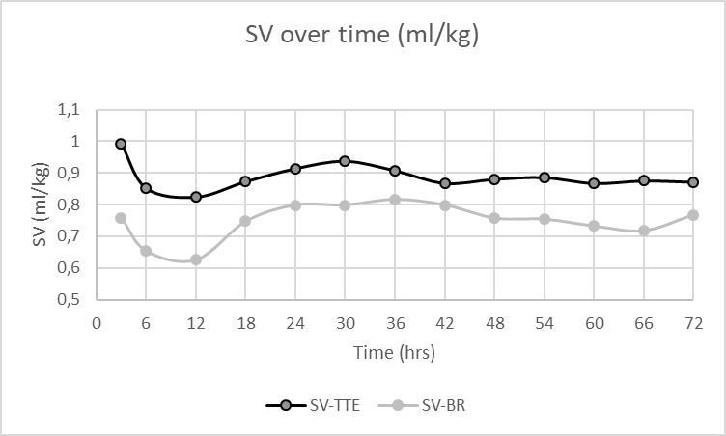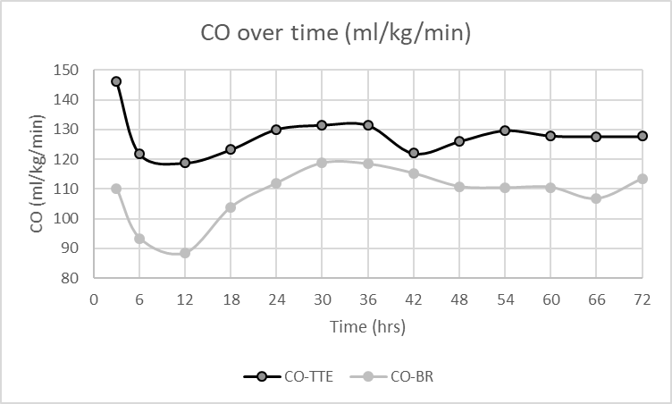~~

Table S2. Agreement between BR and TTELVO derived hemodynamic variables (n=63 patients, 754 repeated measurements)

|  |  |  |  |  |  |  |  |  |
| --- | --- | --- | --- | --- | --- | --- | --- | --- |
| **Measurement** | **BR**  Median  (IQR) | **TTE**  Median (IQR) | **Mean**  **(BR+TTE/2)** | **Bias**  Mean  ±SD | **Limits of agreement**  (lower limit; upper limit) | **Bias %** | **Percentage error**  (%) | **Mean error**  (%) |
| SV  (ml/kg) | 0.73  (0.58-0.88) | 0.87  (0.74-1.03) | 0.80 | 0.13  ± 0.30 | 0.72; -0.47 | 16.3 | 67.5 | 60.4 |
| CO (ml/kg/min) | 105.6  (85.1-126.2) | 124.4  (103.5-149.4) | 115.0 | 18.5  ± 45.5 | 106.2; -69.1 | 16.0 | 71.6 | 69.8 |

Fig. S2: Stroke volume (a & b) bias and cardiac output (c & d) bias for postnatal age <42hrs and ≥ 42hours

(b)

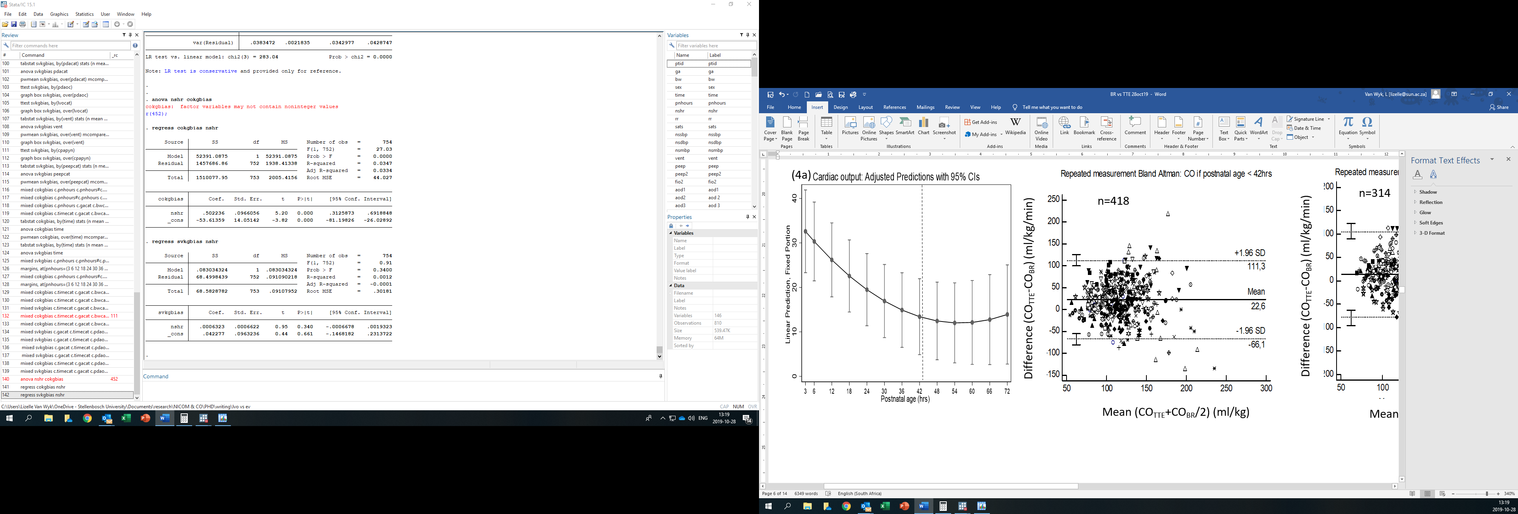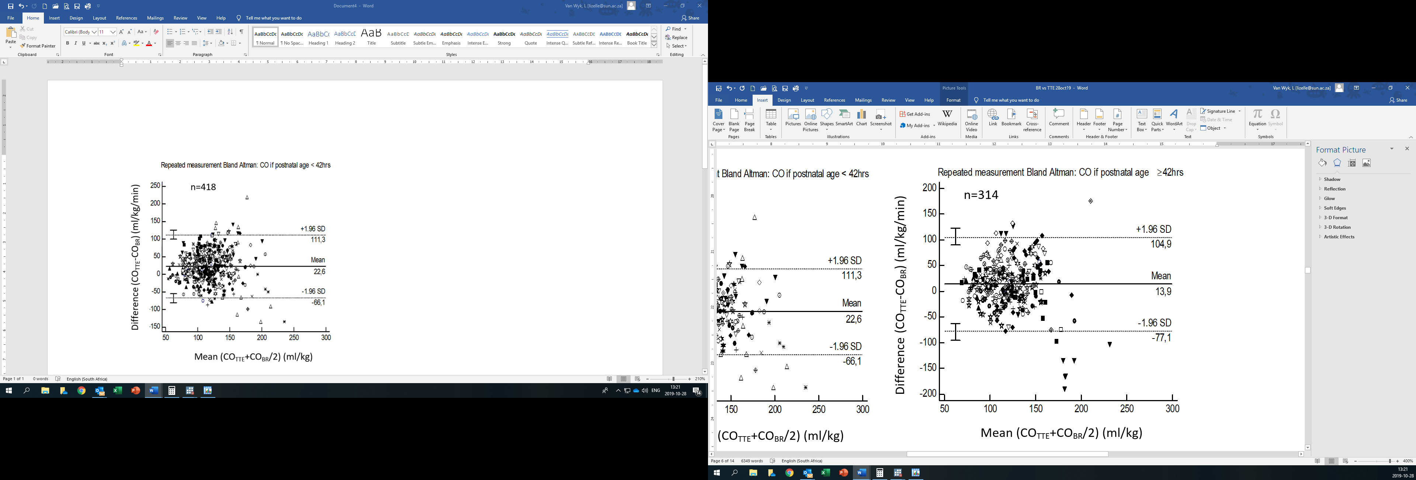

(a)

(d)

(c)



Table S3. Bias at different postnatal ages

|  |  |  |  |  |
| --- | --- | --- | --- | --- |
| Postnatal age (hrs) | CO Bias  (ml/kg/min) | p-value | SV bias  (ml/kg) | p-value |
| 3 | 34.4±48.9 | 0.018 | 0.23±0.30 | 0.050 |
| 6 | 28.4±43.2 | 0.19±0.31 |
| 12 | 30.4±42.8 | 0.19±0.28 |
| 18 | 19.6±39.0 | 0.12±0.33 |
| 24 | 18.4±47.1 | 0.11±0.35 |
| 30 | 19.7±45.0 | 0.15±0.29 |
| 36 | 10.3±40.8 | 0.08±0.26 |
| 42 | 5.6±42.5 | 0.05±0.27 |
| 48 | 15.0±39.8 | 0.11±0.26 |
| 54 | 16.0±48.1 | 0.10±0.31 |
| 60 | 14.4±45.5 | 0.11±0.26 |
| 66 | 20.1±40.4 | 0.14±0.29 |
| 72 | 10.7±51.5 | 0.07±0.32 |

Table S4. Univariate and multivariate analysis of variables affecting bias of body-weight indexed cardiac output and stroke volume bias

|  |  |  |  |  |  |  |  |  |
| --- | --- | --- | --- | --- | --- | --- | --- | --- |
| Variable | Category | n | CO bias  (ml/kg/min) | Uni-p# | Multi-p## | Bias SV  (ml/min) | Uni-p# | Multi-p## |
| Gestational age category | < 28 weeks | 95 | 24.2±39.1 | 0.000 | 0.698 | 0.15±0.24 | 0.000 | 0.375 |
| 29-30 weeks | 225 | 22.7±42.9 | 0.14±0.31 |
| 31-32 weeks | 155 | 33.4±40.5 | 0.23±0.27 |
| 33-34 weeks | 152 | -2.3±53.9 | 0.02±0.34 |
| 35-36 weeks* | 126 | 16.1±34.4 | 0.11±0.24 |
| Birth weight category | ≤1000g | 57 | 26.5±47.3 | 0.088 | 0.769 | 0.15±0.30 | 0.490 | na |
| 1001-1500g | 271 | 22.7±40.7 | 0.15±0.29 |
| 1501-2500g | 413 | 15.8±47.1 | 0.12±0.30 |
| ≥2501g* | 13 | 7.0±28.6 | 0.05±0.20 |
| Postnatal age category | 0-24hrs* | 304 | 26.3±44.5 | 0.000 | 0.536 | 0.17±0.32 | 0.009 | 0.200 |
| 25-48hrs | 232 | 12.8±42.1 | 0.10±0.27 |
| 49-72hrs | 218 | 15.2±46.5 | 0.11±0.29 |
| PFO Category | <0.5* | 240 | 33.4±44.7 | 0.017 | Excluded$ | 0.23±0.29 | 0.042 | Excluded$ |
| ≥0.5 | 19 | 7.5±50.1 | 0.09±0.30 |
| PDA category | Closed* | 442 | 12.5±44.6 | 0.000 | 0.042 | 0.10±0.29 | 0.000 | 0.015 |
| Open | 304 | 28.7±43.7 | 0.18±031 |
| CO category | <150ml/kg/min | 570 | 6.5±37.6 | 0.000 | 0.000 | 0.05±0.25 | 0.000 | 0.000 |
| ≥150ml/kg/min* | 184 | 57.4±43.3 | 0.36±0.32 |
| Respiratory support method | None* | 419 | 15.7±43.7 | 0.026 | 0.009 | 0.11±0.28 | 0.113 | na |
| CPAP | 335 | 23.0±45.8 | 0.15±0.32 |
| PEEP category | ≤5cmH2O | 329 | 23.2±44.3 | 0.034 | Excluded$$ | 0.15±0.31 | 0.101 | na |
| >5cmH2O | 20 | 0.8±64.3 | 0.03±0.39 |

Data as mean ±SD,

*reference category

# univariate regression p-value; ## multivariate regression p-value

$ Excluded due to large portion missing data; $$ due excluded to interaction variable with RS support method

CO – cardiac output; na – not applicable (univariate p>0.1); PDA – patent ductus arteriosus; PEEP – positive end expiratory pressure; PFO – patent foramen ovale; SV – stroke volume

Fig. S2. Cardiac output (a&b) and stroke volume (c&d) bias for open and closed PDA

(b)

(a)



(d)

(c)



Fig. S3. Cardiac output (a) and stroke volume (b) bias per LVO category

(a)



(b)