**Enhanced fermentable sugar production from** ***Enteromorpha* polysaccharides by the crude enzymes of *Vibrio* sp. H11**

Jin Li1#, Yan Xu1#, Tao Peng1, Mingqi Zhong1, Zhong Hu1*

Table S1. The main identified monosaccharide composition of EP.

|  |  |  |
| --- | --- | --- |
| Number | Time | Name |
| 1 | 24.01 | arabinose |
| 2 | 24.86 | rhamnose |
| 3 | 25.99 | lyxose |
| 4 | 26.25 | mannopyranose |
| 5 | 26.47 | rhamnose |
| 6 | 26.77 | lyxose |
| 7 | 32.28 | xylose |
| 8  9 | 35.32  35.54 | glucose  glucose |

Table S2. The biochemical characterization of *Vibrio* sp. H11

|  |  |  |  |
| --- | --- | --- | --- |
| Characterization | Property | Characterization | Property |
| Starch | + | H2S | - |
| Pullulan | + | Indol test | - |
| Gelatin liquefaction | - | V.P. test | + |
| Citric acid | + | D-Glucose | + |
| Mannitol | + | D-Galactose | + |
| Sucrose | + | D-Xylose | + |
| Lactose | - | D-Fructose | + |
| Melibiose | - | Rhamnose | + |
| Amygdalin | - | Sorbitol | - |



Fig. S1 GC–MS results of the monosaccharide of derivatized EP.

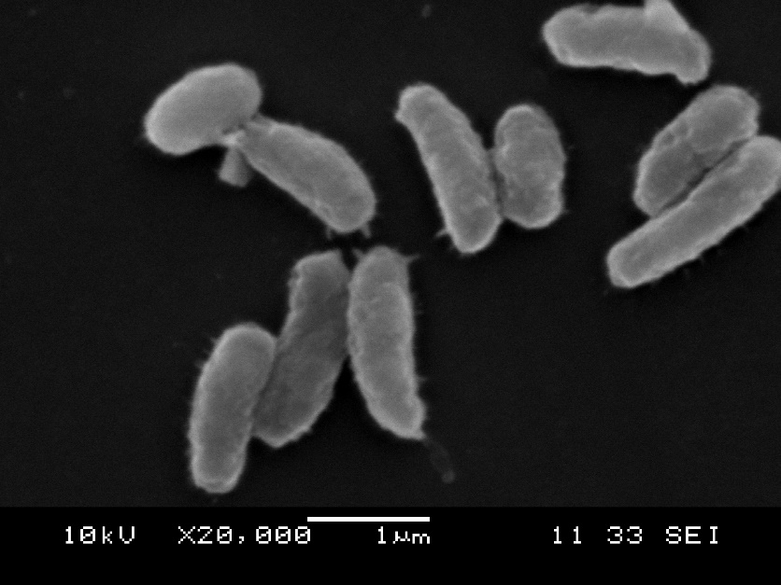

Fig. S2. Scanning electron micrograph of strain H11 grown on the basic mineral medium with EP as sole carbon source at 25 oC for 12 h.

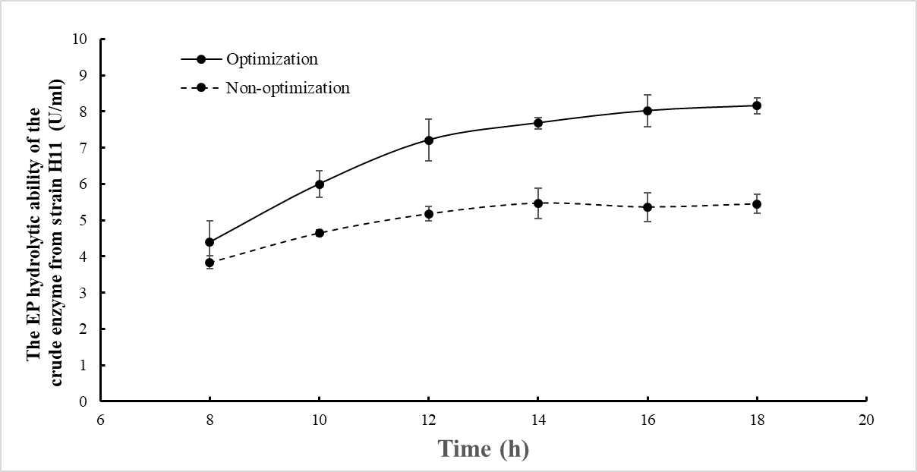

Fig. S3 The comparative analysis of optimized and non-optimized crude enzyme activity.

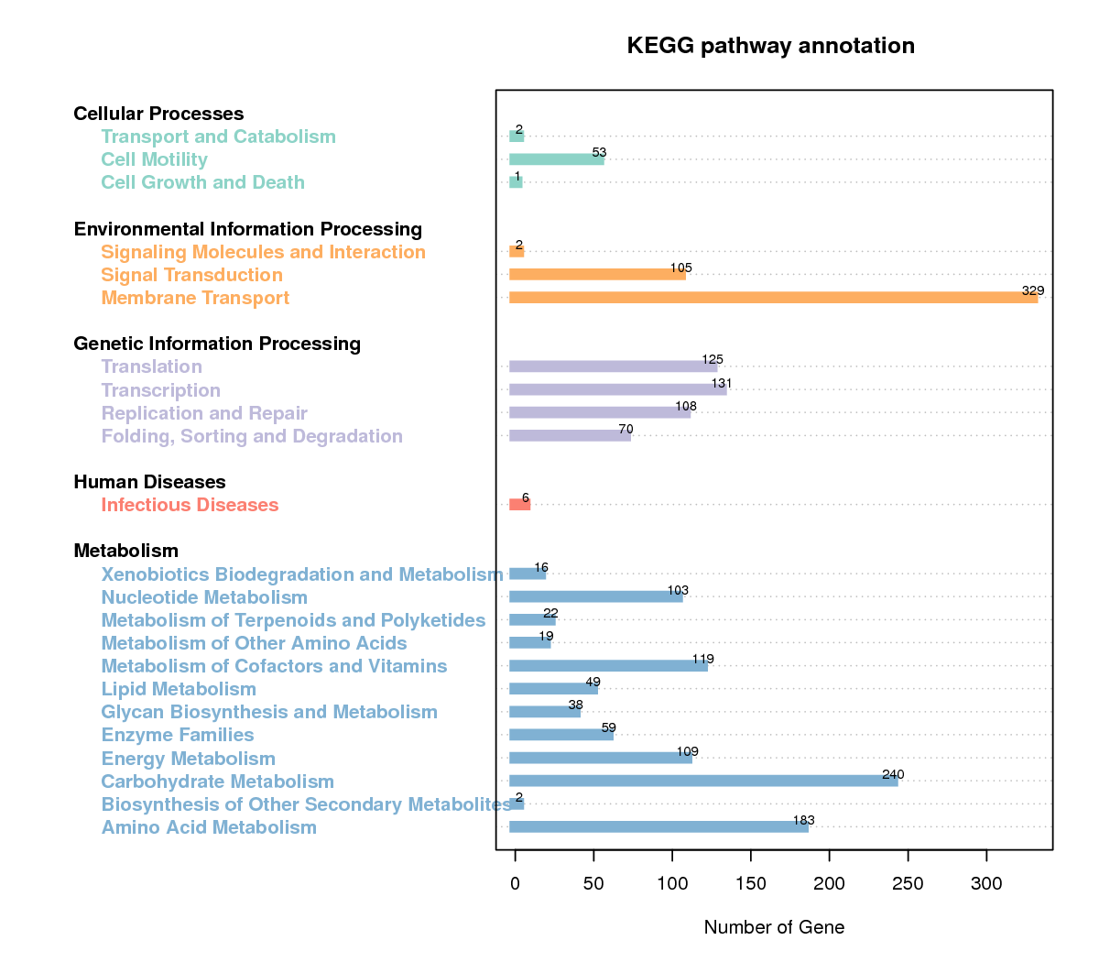

Fig. S4 The secondary classification of KEGG metabolic pathway of strain H11.