Association of copeptin, a surrogate marker of arginine vasopressin, with decreased kidney function in sugarcane workers in Guatemala

Supplemental Material

Table of Contents
A. Study Flowchart

S1 Figure: Study Flowchart.

B. Methods: Data Collection and Analyses

C. Copeptin concentrations

S2 Figure: Plasma copeptin concentrations (pmol/L) at each study time point.

D. Univariate analysis

S1 Table: Univariate analysis of copeptin with kidney biomarkers.

E. Models between change in hydration indices, change in copeptin, and change in eGFR

S2 Table: Results from LME regression models* examining the relationships between change in hydration indices, change of copeptin, and change in eGFR over the study period.

S3 Figure: Three-dimensional scatter plot showing the relationships between change in specific gravity (+, increasing specific gravity), change in eGFR (+, decreasing eGFR), and change in copeptin (+, increasing copeptin) between two subsequent time points.

- Study Flowchart
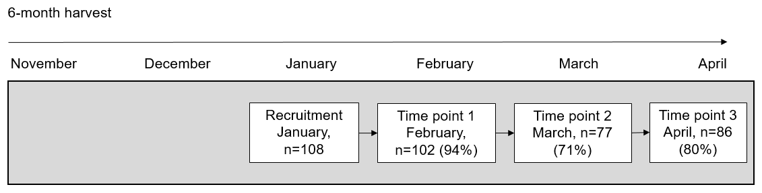
S1 Figure: Study Flowchart

- Methods: Data Collection and Analyses
B.1) Sample Collection and Analyses: Uurine samples were collected in the field, immediately after each work shift into single use sterile cups (Nipro 120 mL polypropylene). End of shift blood samples were collected from each participant by a trained phlebotomist. Hydration was evaluated using urine indices (specific gravity and sodium concentration), blood indices (osmolality and sodium concentration), and change in bodyweight across the work shift ¹. Specific gravity was measured using a digital refractometer (ATAGO PAL-10S digital refractometer, Tokyo, Japan) within 10 minutes of urine sample collection. Serum osmolality was calculated based on the equation: osmolality = (Na * 2) + (Glucose / 18) + (Blood urea nitrogen (BUN)/ 2.8) ². Bodyweight was measured using a scale (Microlife WS 100 digital scale, Clearwater, FL) that was placed on a stable platform and calibrated prior to each data collection session. Workers were weighed in work clothing with shin guards and boots removed. To adjust for the additional weight of the clothes at the end of the day due to sweat and dirt, we weighed the clothes and shoes of 20 workers pre- and post-shift using a scale (Ranger 3000 digital scale, Ohaus, Parsippany, NJ). A correction factor was calculated by averaging the difference of the pre- and post-shift weights, separately for cane cutters and production workers (cane cutter correction factor: 244.57 grams, range -52 to 906 grams; production correction factor: 36.17, range -104 to 178 grams).

B.2) Covariate Data Collection: Structured interviewer-administered survey data, clinical measurements, and measures of work intensity were collected as potential risk factors that may have acted as confounders of copeptin and kidney function variables. Data on demographic and clinical characteristics included age, job type, body mass index (BMI), blood pressure, and hemoglobin A1c (HbA1c). In addition, we evaluated muscle damage using serum creatine kinase, and work intensity, defined as the number of tons of cane each individual cut during the study work shift. The company provided data on each cane cutter’s daily amount of cane production.
Blood pressure was collected after 3 minutes of sitting at pre-employment in November and HbA1c was measured at the start of the study in February.
Survey data collected at the end of the work shift inquired about the study participant’s past 24-hour behaviors including self-reported sugar-sweetened beverage and electrolyte solution intake since waking up on the study day. Sugar-sweetened beverages included energy drinks, juice, and soda. The sugar-sweetened beverage question was “Number of sugar drinks since woke up this morning?” and the electrolyte intake question was: “How many 500-ml electrolyte bags have you had since you woke up?”
The workers were distributed electrolyte fluid in pre-mixed 500-ml bags. The electrolyte fluid intake question was: “How many electrolyte bags have you had since you woke up?” Two electrolyte bags (500ml each) contain 4.6 g NaCl, 34 g carbohydrates (26 g sucrose) and 2 g KCl.
B.3) Laboratory Analysis: Urinary creatinine was measured via kinetic alkaline picrate and urine sodium concentrations using an automatic biochemical analyzer (Roche Cobas Integra 400 Plus) with the ion-selective method. Urinary albumin was measured with florescence immunoassay (Boditech, I-Chroma). NGAL was measured using Quantikine ELISA kits, human lipocalin-2/NGAL (R&D Systems, Minneapolis, MN, USA) with two-fold diluted urine. To account for urine concentration, values were corrected for urinary albumin relative to urinary creatinine (ACR).
Blood samples were analyzed for BUN and creatinine by automated standard techniques (Abbot, Architect CI4100) using kinetic urease and kinetic alkaline picrate, respectively. Creatine kinase was analyzed using CK-NAC serum start (DGKC) (Roche Cobas Integra 400 Plus). HbA1c was determined with ionic exchange high-pressure liquid chromatography (Biorad, D-10). Sodium concentration was determined by ion selective electrode techniques (I-Sens, I-Smart 30 Pro). For biomarkers below the limit of detection, we substituted the limit of detection/ √2. Creatinine was used to calculate eGFR using the Chronic Kidney Disease Epidemiology Collaboration (CKD-EPI) equation for all participants (21).

Copeptin Concentrations

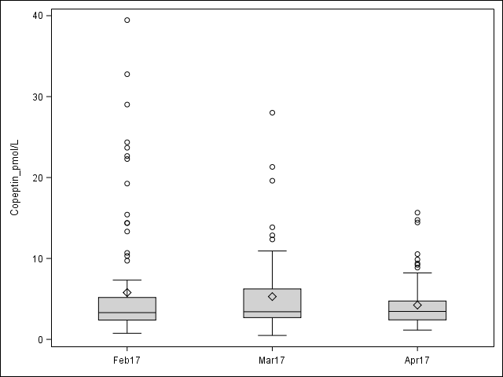
S2 Figure: Plasma copeptin concentrations (pmol/L) at each study time point.
*The box plot spans the first quartile to the third quartile. The line inside the rectangle shows the median and "whiskers" above and below the box show ± 1.5 the interquartile range. The diamond shape represents the mean. Circles show outliers.

Univariate analysis

S1 Table: Univariate analysis of copeptin with kidney biomarkers.
Kidney Marker | N | Estimate (95% CI) | p-value
Creatinine | 265 | 1.51 (0.84, 2.18) | <0.01
eGFR | 265 | -1.12 (-1.53, -0.70) | <0.01
NGAL | 253 | -0.02 (-0.22, 0.19) | 0.88
ACR | 252 | -0.02 (-0.10, 0.07) | 0.71

Models between change in hydration indices, change in copeptin, and change in eGFR

S2 Table: Results from LME regression models* examining the relationships between change in hydration indices, change of copeptin, and change in eGFR over study.
Parameter | Estimate (95% CI) | p-value
Model 1: Impact of change in hydration indices related to change in copeptin
Change in specific gravity (per 0.01) | 2.68 (1.41, 3.94) | <0.01
Change in serum osmolality | 0.23 (0.09, 0.38) | <0.01
Change in blood sodium | 0.32 (0.07, 0.57) | 0.01
Change in urine sodium | 0.03 (-0.01, 0.06) | 0.11
Model 2: Impact of change in copeptin related to change in eGFR
Change in copeptin | -1.08 (-1.62, -0.54) | <0.01
Model 3a: Impact of change in copeptin and specific gravity on change in eGFR
Change in specific gravity (per 0.01) | -0.93 (-3.67, 1.79) | 0.50
Change in copeptin | -1.03 (-1.60, -0.45) | <0.01
Model 3b: Impact of change in copeptin and serum osmolality on change in eGFR
Change in serum osmolality | 0.08 (-0.19, 0.36) | 0.54
Change in copeptin | -1.15 (-1.69, -0.61) | <0.01
Model 3c: Impact of change in copeptin and blood sodium on change in eGFR
Change in blood sodium | 0.49 (-0.06, 1.05) | 0.08
Change in copeptin | -1.18 (-1.70, -0.66) | <0.01
Model 3d: Impact of change in copeptin and urine sodium on change in eGFR
Change in urine sodium | 0.05 (-0.01, 0.10) | 0.11
Change in copeptin | -0.97 (-1.52, -0.43) | <0.01
* Models control for age, HbA1c, systolic and diastolic blood pressure. Bolded p-values < 0.05.

S3 Figure: Three-dimensional scatter plot showing the relationships between change in specific gravity (+, increasing specific gravity), change in eGFR (+, decreasing eGFR), and change in copeptin (+, increasing copeptin) between two subsequent time points.
*Green shows individuals with an increase in eGFR, decrease in copeptin, and decrease in specific gravity. Red shows individuals with a decrease in eGFR, increase in copeptin, and increase in specific gravity. Gray shows individuals with neither combination.

REFERENCES

1. Kavouras, S. A., Assessing hydration status. Current Opinion in Clinical Nutrition and Metabolic Care 2002, 5 (5), 519-524.
2. Rasouli, M., Basic concepts and practical equations on osmolality: Biochemical approach. Clinical Biochemistry 2016, 49 (12), 936-941.

