Supplemental Table 1: Summary of DLBCL cohorts
Number of patients | 105
Sex: M | 54 (51%)
Age at Diagnosis: y  Median (range) | 55 ( 16 - 81)
Low IPI Score 0-2 | 46 (44%)
High IPI Score 3-5 | 59 (56%)
R-CHOP  CHOP | 84 (80%)  21 (20%)

Patients were staged by PET/CT, or PET and CT separately; with iliac crest marrow biopsy. As the study commenced in 2008 before establishment of the Deauville Scale, the 5-point London Criteria (modified to combine Deauville equivalent scores) was employed [1].
Following standardised protocols, for multicentre PET-stratification studies, scans were reviewed by the 4 lead nuclear medicine physicians working together on a common platform at the final collaborator meeting. Reviewers were masked to clinical details and patient outcomes. Classification of PET response was by consensus [1].
Independent predictive variables were determined with univariate and multivariate regression analyses.

Supplemental Figure 1A:
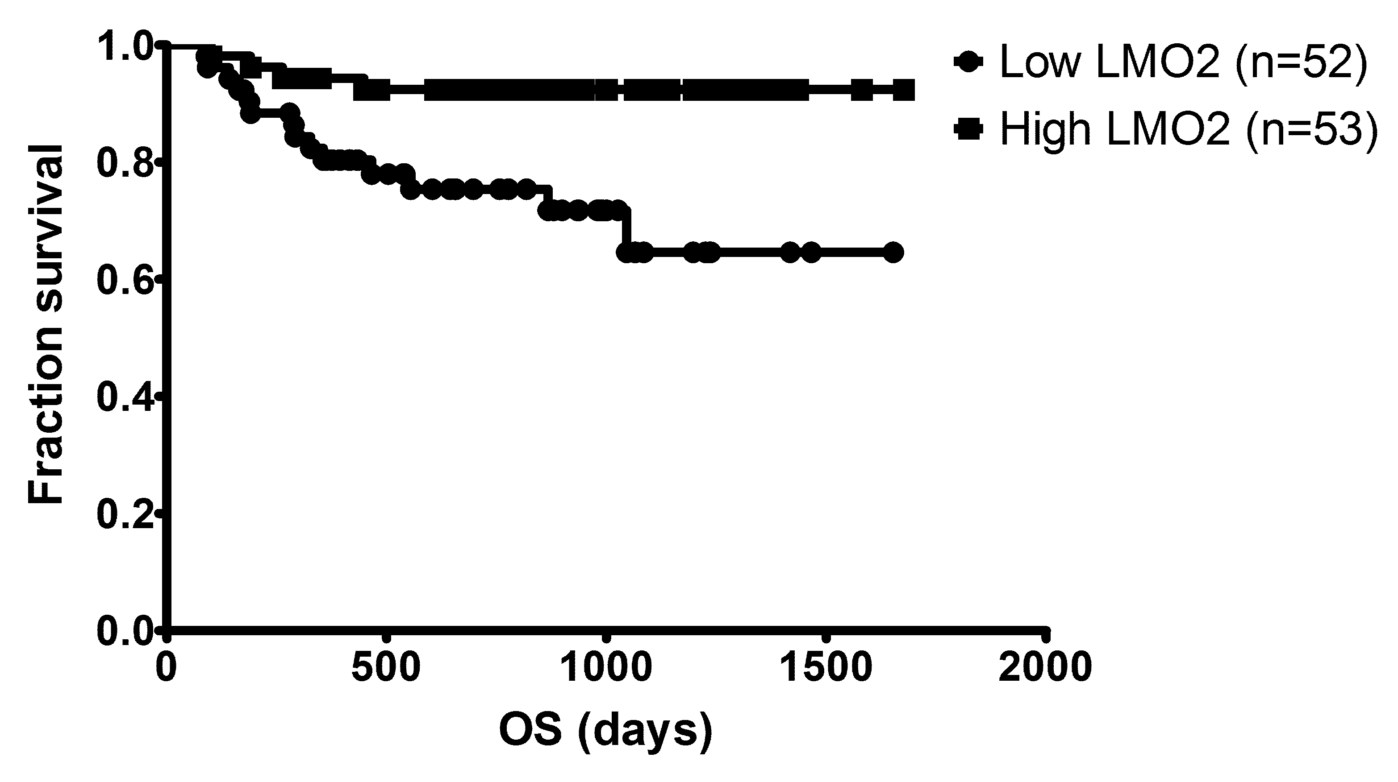

Supplemental Figure 1B:
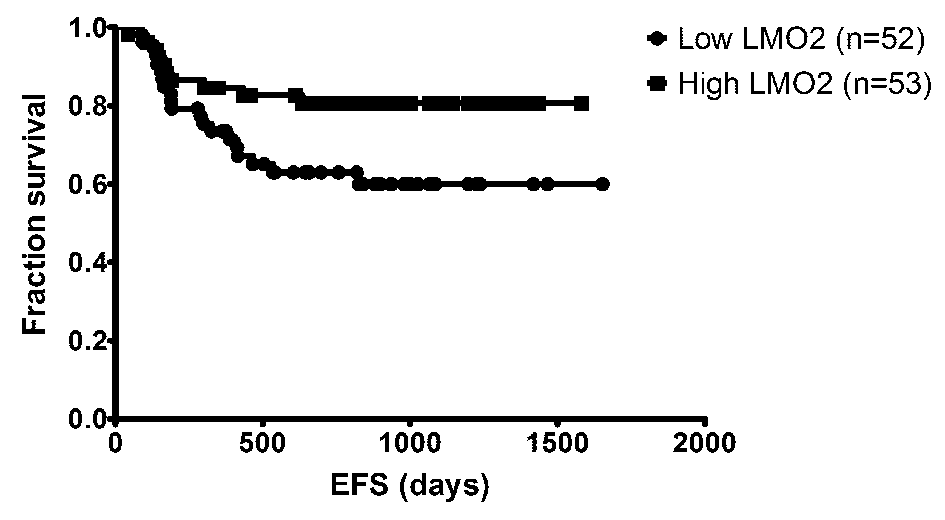

Supplemental Figure 1C:
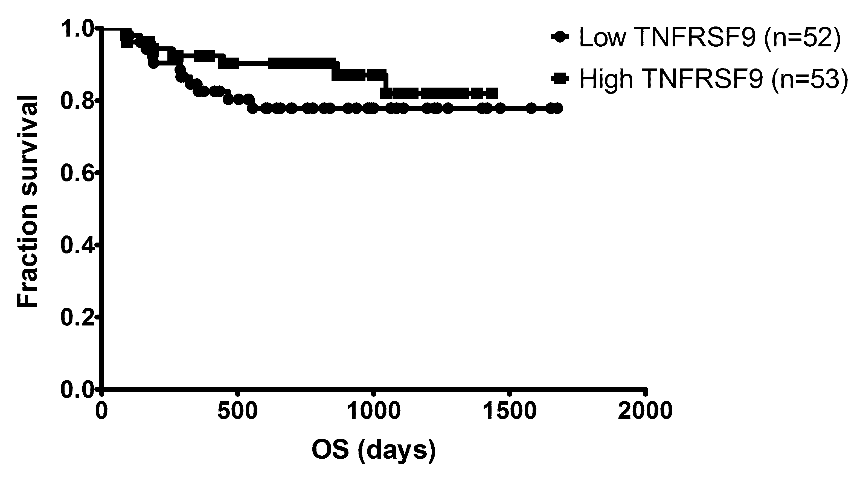

Supplemental Figure 1D: Overall Survival of 2-gene score groups (2-gene score = (-0.32xLMO2)+(-0.29xTNFRSF9))
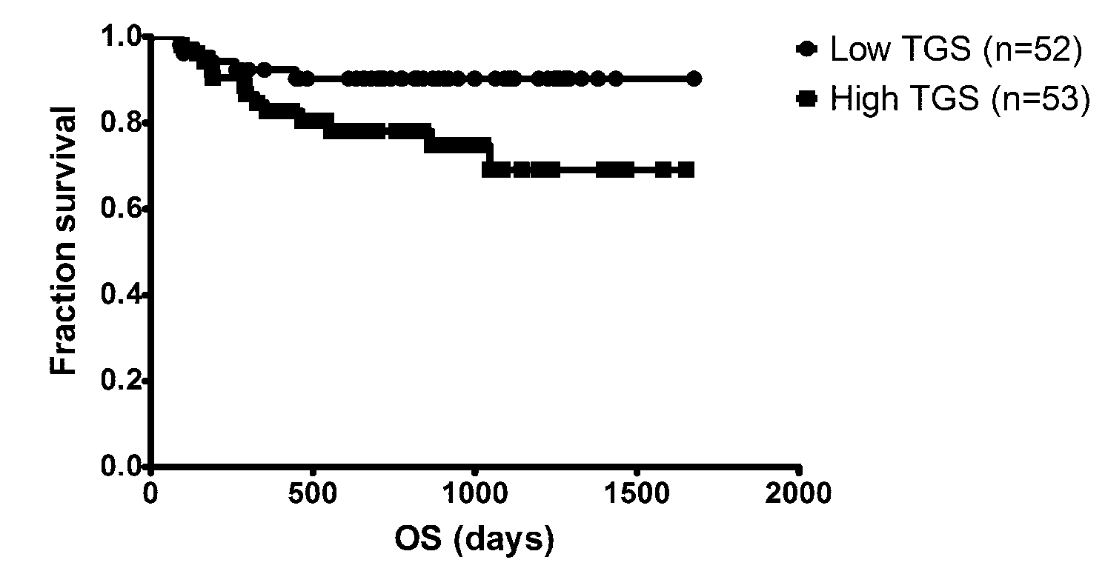

Supplemental Figure 1E: Event-Free Survival of 2-gene score groups (2-gene score = (-0.32xLMO2)+(-0.29xTNFRSF9))
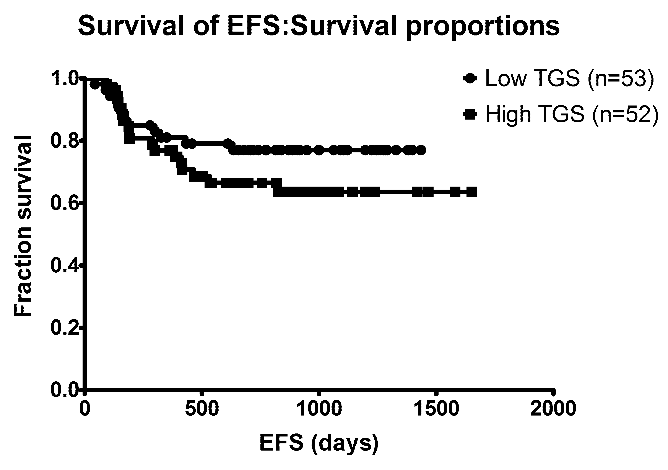

Reference List

1 Carr R, Fanti S, Paez D, Cerci J, Gyorke T, Redondo F, Morris TP, Meneghetti C, Auewarakul C, Nair R, Gorospe C, Chung JK, Kuzu I, Celli M, Gujral S, Padua RA, Dondi M: Prospective international cohort study demonstrates inability of interim PET to predict treatment failure in diffuse large B-cell lymphoma. J Nucl Med 2014;55:1936-1944.

