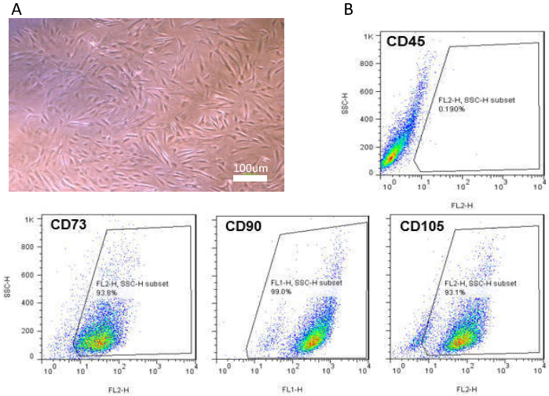
Supplementary Figure 1. Characterization of hBM‐MSCs. A) Representative image of hBM‐MSCs in the third passage. B) Immunophenotyping of hBM‐MSCs by flow cytometry showed that the cells at passage 3 were negative for CD45, while expressed mesenchymal markers (CD73, CD90, and CD105) more than 90%.

Supplementary Table 1. Details of clinical diagnosis and sample size obtained from the donors.
Code No. | Age (Year) | Surgery | Diagnosis | Tissue dimensions
1 | 20 | Total Abdominal hysterectomy | Trans Sexual (FTM) | 1$×$ total ovary
2 | 18 | Total Abdominal hysterectomy | Trans Sexual (FTM) | 1$×$ total ovary
3 | 40 | Total Abdominal hysterectomy | Endometrial Cancer | 3$×$4 ${cm}^{2}$
4 | 42 | Total Abdominal hysterectomy | Endometrial Cancer | 1$×$ total ovary

Supplementary Table 2. The impact of co-culturing of hBM-MSCs on follicular reserve and their early development of cryopreserved human OCTs. Initially, the ovarian follicles in mono-culture and co-culture groups on day 2 were compared to non-cultured ones (Day 0), and the statistically significant differences (p˂0.05) are shown by #. Furthermore, * is considered to be statistically significant (p˂0.05) when co-culture group compared to the mono-culture group at the same time point.
Groups |  | Total follicle No. | Normal follicles  No. (% Mean ± SD) | Primordial follicles  No. (% Mean ± SD) | Transitional follicles  No. (% Mean ± SD) | Primary follicles  No. (% Mean ± SD) | Secondary follicles  No. (% Mean ± SD)
Day 0 | Non-cultured | 188 | 168 (87.34±5.18) | 92 (54.16±6.72) | 56 (32.52±6.12) | 19 (13.08±4.61) | 1 (0.22±0.44)
Day 2 | Mono-culture | 72 | 54 (75.84±7.31) | 8 (14.36±3.66) # | 18 (32.79±7.51) | 25 (46.78±6.82) # | 3 (6.08±4.29)
 | Co-culture | 72 | 59 (79.49±5.83) | 4 (5.73±3.86) *# | 21(37.79±4.69) | 27 (49.38±7.90) # | 8 (9.17±8.55)
Day 4 | Mono-culture | 56 | 41 (71.87±8.27) | 4 (11.2±4.49) | 16 (37.73±4.37) | 19 (47.30±3.19) | 2 (3.38±4.57)
 | Co-culture | 69 | 49 (69.34±4.7) | 0 * | 3 (5.83±6.87) * | 37 (76.10±3.33) * | 9 (18.05±7.71) *
Day 8 | Mono-culture | 83 | 61 (71.27±7.1) | 9 (15.55±4.16) | 21 (29.78±9.63) | 25 (46.20±10.97) | 6 (8.45±6.19)
 | Co-culture | 72 | 48 (66.71±4.88) | 0 * | 1(2.28±4.16) * | 38 (76.78±9.98) | 9 (18.86±5.96)

