Supplement
- Materials and methods
1.1 Participants and recruitment
We enrolled 288 participants between March 2018 and July 2018. Among the participants, 64 individuals who had a lifetime history of central nervous system disease, alcohol or drug abuse, mental retardation, or head injury with loss of consciousness were excluded. A total of 224 participants were divided into a patient group or a healthy group based on the Mini-International Neuropsychiatric Interview (MINI; version 5.0.0) administered by trained interviewers. The patient group included 98 individuals who were suffering from depression and/or anxiety disorders. Among them, 23 individuals had only depressive disorder (major depressive disorder, dysthymia, or premenstrual dysphoric disorder), 14 individuals had only anxiety disorder (panic disorder, agoraphobia, specific phobia, social phobia, or generalized anxiety disorder), and 61 individuals had a comorbidity of both depression and anxiety disorders. About 60.2% of the individuals in the patient group were being treated with medication (e.g., SSRIs (escitalopram (n=25), fluoxetine (n=4), sertraline (n=3)); Benzodiazepines (alprazolam (n=21), lorazepam (n=19), buspirone (n=14), etizolam (n=7), diazepam (n=4)); Quetiapine (n=16); Clonazepam (n=11), Vortioxetine (n=7)). The healthy group included 124 individuals. However, 15 individuals who were suffering from other psychiatric disorder (i.e., adjustment disorder, pain disorder) were excluded, thereby a total of 111 individuals were included in the healthy group. All of the participants who were fully informed and signed a written consent approved by the Ilsan Paik Hospital Institutional Review Board participated in the study.
1.2 Measures

1.2.1 Post-Traumatic Embitterment Disorder Self-Rating Scale (PTED Scale) [1]
PTED was measured using the responses to the PTED Scale about embittered reactions to (perceived) negative life events. The PTED Scale has 19 items with response options on a five-point Likert-type scale ranging from zero to four, with higher scores indicating more embitterment. The Korean version of the PTED scale [2] was used for this study. A mean score of 2.5 on the PTED scale is a recommended cut-off score to indicate the clinically significant intensity of reactive embitterment [1]. The Cronbach’s alpha reliability coefficient was 0.97 in this study’s sample.

1.2.2 Beck Anxiety Inventory (BAI) [3]
Responses to the BAI were used to evaluate the severity of anxiety symptoms. The BAI consists of 21 items with response options on a four-point Likert-type scale ranging from zero to three. The respondents rated the extent of their discomfort caused by anxious feelings during the past week. The Cronbach’s alpha coefficient in this sample was 0.97.

1.2.3 Beck Depression Inventory II (BDI-II) [4]
The BDI was used to evaluate depressive symptoms. The BDI has 21 items with response options on a five-point Likert-type scale ranging from zero to four. Total scores on the BDI range from zero to 63, with higher scores indicating more severe depressive symptoms. The Cronbach’s alpha coefficient in this sample was 0.96.

1.2.4 Suicidal Behavior Questionnaire-Revised (SBQ-R) [5]
The SBQ-R’s four items are intended to measure four dimensions of suicidality: (1) lifetime suicide ideation and suicide attempt, (2) frequency of suicidal ideation over the past 12 months, (3) threat of suicidal behavior, and (4) self-reported likelihood of suicidal behavior. The total scores on the SBQ-R range from three to 18. The Cronbach’s alpha reliability coefficient in this study’s sample was 0.84.
1.3 Statistical analysis
All of the statistical analysis was performed using SPSS 21 (SPSS, Inc., Chicago, IL, USA). The group differences in demographic and psychological characteristics were tested using Chi-squared for contingency or independent samples t-tests. Preliminary analysis confirmed the normality of the distributions of all the variables by group [6]. Pearson’s correlation coefficients were computed by group to examine the bivariate associations between psychological variables.
The mediation analysis was performed using AMOS 20.0. Two mediation models (Figure 1) were suggested to determined which model most suitable for explaining the relationships among embitterment, anxiety, depression, and suicidality. Model 1 hypothesized that anxiety and depression predict suicidality through embitterment, and Model 2 hypothesized that embitterment predicts suicidality through anxiety or through depression. The proposed mediation models were evaluated controlling for the effects of age, gender, educational attainment, and medications to assess the net influences of the key independent variables on suicidality based on previous studies [7-9]. Preliminary analyses of alternative models, including a model with suicidality as an independent variable and one in which suicidality was a mediator, eliminated other modeling options because of poor model fit or non-significant mediation effects.
The calculated fit indices were the Comparative Fit Index (CFI), Tucker-Lewis Index (TLI), and Root Mean Square Error of Approximation (RMSEA). CFI and TLI values greater than .95 indicate excellent model fit[10], and an RMSEA value less than .08 is considered acceptable [11]. For accurate estimates of standard errors of indirect (mediation) effects, Shrout and Bolger (2002)[12] suggested using a bootstrapping procedure. When the 95% CI of the estimated indirect effects do not include zero, then the indirect effects are statistically significant at p < .05 level [12]. Sobel tests were performed to confirm the statistical significance of the mediation effects. The groups were separately analyzed.
- Results

2.1 Demographic characteristics and correlation analysis
Table 1 describes the variation in the demographic and psychological variables used in this study. There was no significant gender difference between the two groups, but there was a significant age difference. There also were significant differences in PTED, BDI, BAI, and SBQ-R scores between the two groups and the patient group scored significantly higher on the PTED, BDI, BAI, and SBQ-R. The percentage of participants with a mean PTED score of 2.5 or higher was 37.8% in the patient group, which was the cut-off score to indicate the clinically significant intensity of reactive embitterment; however, none of the participants in the healthy group had a mean PTED score as high as 2.5. Table 2 shows that there were positive and statistically significant correlations between all the psychological variables in both groups. In particular, suicidality was significantly and positively associated with anxiety, depression, and embitterment in both groups.

Table 1. Demographic characteristics of the sampleª
Variable | Patient group  (n = 98) | Healthy group  (n = 111) | p-value
 | Mean ± standard deviation or n (%) | Mean ± standard deviation or n (%)
Age (years) | 42.68 ± 16.10 | 37.61 ± 14.64 | .018
Gender |  |  | .568
Male: n (%) | 30 (30.6) | 30 (27.0)
Female: n (%) | 68 (69.4) | 81 (73.0)
Education (years) | 13.00 ± 4.16 | 15.50 ± 2.63 | < .001
Diagnosis
Depressive disorder (%) | 23 (23.5)
Anxiety disorder (%) | 14 (14.3)
Comorbidity (%) | 61 (62.2)
Medication
No medication: n (%) | 39 (39.8)
Medication: n (%) | 59 (60.2)
PTED: n (%) | 37 (37.8) | Zero
Embitterment | 41.15 ± 18.09 | 13.25 ± 11.58 | < .001
BDI | 26.08 ± 15.25 | 8.29 ± 6.51 | < .001
BAI | 20.57 ± 15.58 | 4.54 ± 4.82 | < .001
SBQ-R | 8.50 ± 4.19 | 3.73 ± 1.35 | < .001
ª PTED: Post-traumatic Embitterment disorder; BDI: Beck Depression Inventory; BAI: Beck Anxiety Inventory; SBQ-R: Suicidal Behavior Questionnaire-Revised.

Table 2. Bivariate correlations among the key variables in the study: embitterment, depression, anxiety, and suicidality by group (bootstrapping = 5000).
Patient group (n = 98)
 | BDI | BAI | SBQ
PTED | .709*** | .684*** | .591***
BDI |  | .787*** | .583***
BAI |  |  | .561***
Healthy group (n = 111)
 | BDI | BAI | SBQ
PTED | .556*** | .606*** | .475***
BDI |  | .766*** | .371***
BAI |  |  | .346***
*** = p < .001

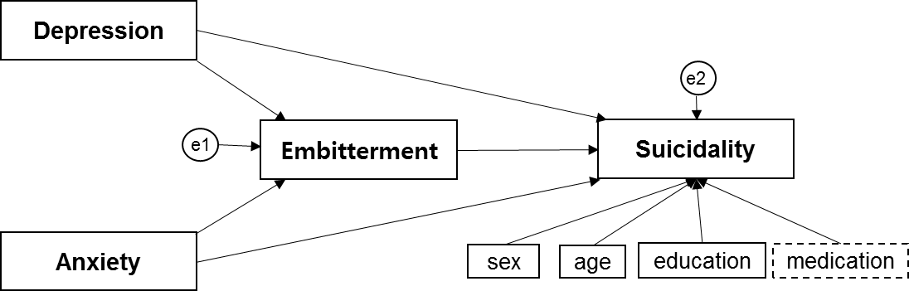
(a) Model 1 (adequate model fit in both groups)
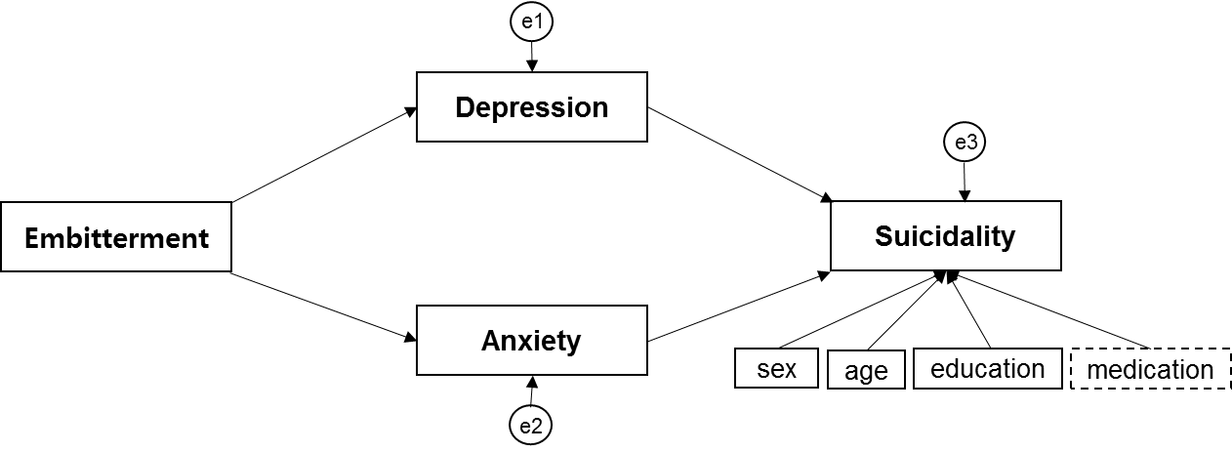
(b) Model 2 (poor model fit in both groups)
Fig. 1. (a) The hypothesized model (Model 1) and (b) the alternative model (Model 2).

References
1 Linden M, Baumann K, Lieberei B, Rotter M: The post‐traumatic embitterment disorder self‐rating scale (pted scale). Clinical Psychology & Psychotherapy: An International Journal of Theory & Practice 2009;16:139-147.
2 Shin C, Han C, Linden M, Chae J-H, Ko Y-H, Kim Y-K, Kim S-H, Joe S-H, Jung I-K: Standardization of the korean version of the posttraumatic embitterment disorder self-rating scale. Psychiatry investigation 2012;9:368.
3 Beck AT, Epstein N, Brown G, Steer RA: An inventory for measuring clinical anxiety: Psychometric properties. Journal of consulting and clinical psychology 1988;56:893.
4 Beck AT, Steer RA, Brown GK: Beck depression inventory-ii. San Antonio 1996;78:490-498.
5 Osman A, Bagge CL, Gutierrez PM, Konick LC, Kopper BA, Barrios FX: The suicidal behaviors questionnaire-revised (sbq-r): Validation with clinical and nonclinical samples. Assessment 2001;8:443-454.
6 Brown TA: Confirmatory factor analysis for applied research. Guilford Publications, 2014.
7 Conrad R, Walz F, Geiser F, Imbierowicz K, Liedtke R, Wegener I: Temperament and character personality profile in relation to suicidal ideation and suicide attempts in major depressed patients. Psychiatry Research 2009;170:212-217.
8 Lorant V, Kunst AE, Huisman M, Bopp M, Mackenbach J, Group EW: A european comparative study of marital status and socio-economic inequalities in suicide. Social science & medicine 2005;60:2431-2441.
9 Gibbons RD, Hur K, Bhaumik DK, Mann JJ: The relationship between antidepressant medication use and rate of suicide. Archives of general psychiatry 2005;62:165-172.
10 Bentler PM: Comparative fit indexes in structural models. Psychological bulletin 1990;107:238.
11 Browne MW, Cudeck R: Alternative ways of assessing model fit. Sage focus editions 1993;154:136-136.
12 Shrout PE, Bolger N: Mediation in experimental and nonexperimental studies: New procedures and recommendations. Psychological methods 2002;7:422.

