Table S1. Comparison of physical performance test according to the tertiles of vitamin D level
 | Lowest T | Middle T | Highest T | P-value
GS | 0.89 ± 0.21 | 0.91 ± 0.19 | 0.95 ± 0.19 | 0.442
SPPB | 10.4 ± 2.0 | 11.0 ± 1.6 | 11.3 ± 1.0 | 0.094
STS5 | 10.5 ± 9.9 | 8.3 ± 2.7 | 7.7 ± 2.5 | 0.203
STS530 | 16.4 ± 5.2 | 17.7 ± 5.8 | 19.4 ± 5.9 | 0.152
6MWT | 430.5 ± 140.4 | 459.0 ± 103.8 | 487.5 ± 84.4 | 0.169
TUG | 7.9 ± 2.5 | 7.1 ± 1.9 | 7.0 ± 1.4 | 0.149
Average step | 4264 ± 3602 | 5244 ± 3254 | 5199 ± 3514 | 0.502
Low SPPB group | 12 (42.9%) | 8 (28.6%) | 5 (17.9%) | 0.042
Low GS group | 20 (71.4%) | 19 (67.9%) | 16 (57.1%) | 0.264
Frailty | 11 (39.3%) | 9 (32.1%) | 4 (14.3%) | 0.040
Sarcopenia | 5 (17.9%) | 4 (14.3%) | 1 (3.6%) | 0.101
Data are expressed as mean ± standard deviation for continuous variables and as number (percentage) for categorical variables. P-values were tested using one-way analysis of variance for continuous variables and Pearson’s χ² or Fisher’s exact tests for categorical variables. Abbreviations: Lowest T, lowest tertile; Middle T, middle tertile; Highest T, highest tertile; GS, gait speed; SPPB, Short Physical Performance Battery; STS5, sit-to-stand test performed 5 times; STS30, sit-to-stand for 30 s test; 6-MWT, 6-min walk test; TUG, timed up-and-go test.

Table S2. Comparison of muscle mass indices and nutritional markers according to the presence of vitamin D deficiency
 | Deficiency group  (n = 76) | Non-deficiency group  (n = 8) | P-value
Handgrip strength (kg) | 25.3 ± 6.9 | 32.8 ± 8.5 | 0.006
ALM/Ht² (kg/m²) | 6.6 ± 1.0 | 6.9 ± 0.9 | 0.396
SGA score | 5.6 ± 1.0 | 6.1 ± 1.1 | 0.211
Serum albumin (mg/dL) | 3.8 ± 0.3 | 3.9 ± 0.2 | 0.259
Body mass index (kg/m²) | 23.8 ± 3.8 | 22.7 ± 2.1 | 0.414
TMA/Ht² (cm²/m²) | 36.5 ± 7.1 | 40.5 ± 6.1 | 0.127
Data are expressed as mean ± standard deviation. Abbreviations: ALM/Ht², appendicular lean mass per height squared; SGA, subjective global assessment; TMA/Ht², thigh muscle area per height squared; Lowest T, lowest tertile; Middle T, middle tertile; Highest T, highest tertile.

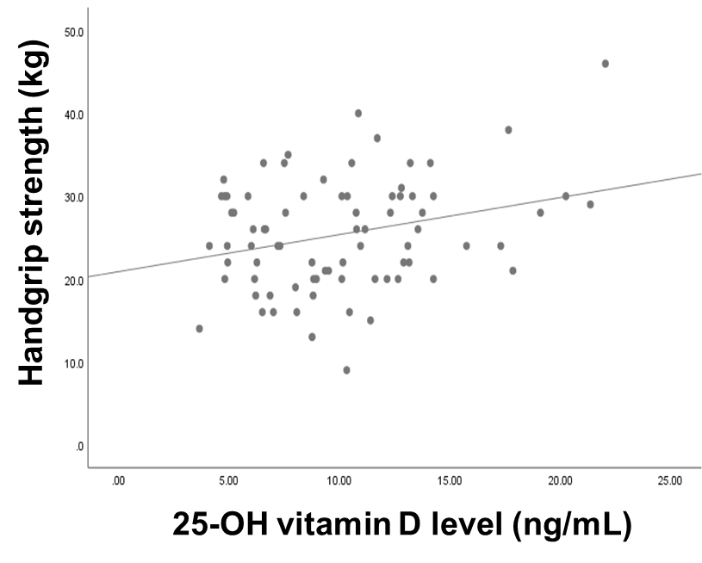
Figure S1. Correlation between 25-OH vitamin D level (ng/mL) and handgrip strength (kg) after exclusion of outliers.

