Supplement
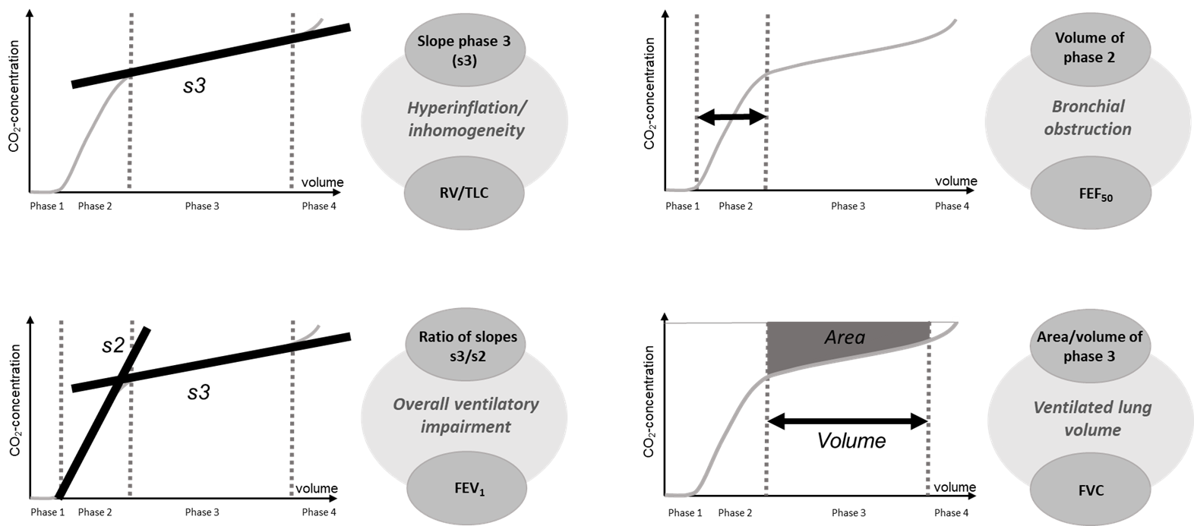

Figure S1. Illustration of the correspondences shown in table 3. Each of the four panels shows the correspondence on the right side and the meaning of the respective capnovolumetric parameters within the CO₂-volume-curves on the left side. On the right side, the upper ellipse shows the capnovolumetric parameter and the lower ellipse the conventional lung function parameter that was found to be best corresponding to the capnovolumetric parameter. The middle ellipse shows the respective pathophysiological entity. Of course, these entities have additional indicators beyond those shown, for example derived from the forced oscillation technique, but the present analysis had the topic of capnovolumetry. FEV₁ = forced expiratory volume in 1 s, FVC = forced vital capacity, FEF₅₀ = forced expiratory flow at 50% of the forced vital capacity, RV/TLC = ratio of residual volume to total lung capacity as determined by bodyplethysmography.

Tables
Table S1: Regression weights for the model given in figure 1.
Relationship |  |  | Estimate | S.E. | p-value
COPD | ← | Airway obstruction | 0.467 | 0.022 | <0.001
Airway obstruction | ← | Ratio s3/s2 | 1.207 | 0.144 | <0.001
Asthma | ← | Ratio s3/s2 | -0.499 | 0.080 | <0.001
COPD | ← | Ratio s3/s2 | 0.642 | 0.093 | <0.001
Slope s3 | ← | Ratio s3/s2 | 1.296 | 0.024 | <0.001
AreaVol s3 | ← | Ratio s3/s2 | 0.061 | 0.006 | <0.001
Airway obstruction | ← | Slope s3 | -0.671 | 0.095 | <0.001
COPD | ← | Slope s3 | -0.216 | 0.055 | <0.001
AreaVol s3 | ← | Slope s3 | 0.014 | 0.004 | <0.001
Airway obstruction | ← | Volume s2 | -0.003 | 0.001 | <0.001
Asthma | ← | Volume s2 | -0.002 | 0.001 | <0.001
Slope s3 | ← | Volume s2 | -0.004 | 0.000 | <0.001
Airway obstruction | ← | AreaVol s3 | 6.105 | 0.601 | <0.001
COPD | ← | AreaVol s3 | 2.505 | 0.441 | <0.001

The table describes the unstandardized regression coefficients of the path analysis model comprising the capnovolumetric parameters (continuous variables) and the binary variables asthma, COPD and airway obstruction. The first column shows the dependent and independent variables, the next two the non-standardized estimate and its standard error (S.E.), and the last one the corresponding p value. The standardized regression coefficients corresponding to the non-standardized estimates are indicated in figure 1. Ratio s3/s2 = ratio between slopes of phases 3 and 2, Slope s3 = slope of expiratory phase 3, Volume s2 = volume of phase 2, AreaVol s3 = ratio between the area of phase 3 and the volume of phase 3.

Table S2: Regression weights for the model given in figure 2.
Relationship |  |  | Estimate | S.E. | p-value
COPD | ← | Airway Obstruction | 0.272 | 0.031 | <0.001
Airway obstruction | ← | FEV₁ | -0.367 | 0.012 | <0.001
COPD | ← | FEV₁ | -0.139 | 0.017 | <0.001
Asthma | ← | FEV₁ | 0.111 | 0.018 | <0.001
RV/TLC | ← | FEV₁ | -0.784 | 0.028 | <0.001
FVC | ← | FEV₁ | 1.090 | 0.023 | <0.001
Airway obstruction | ← | FVC | 0.238 | 0.014 | <0.001
COPD | ← | FVC | 0.071 | 0.016 | <0.001
Airway obstruction | ← | RV/TLC | 0.025 | 0.007 | <0.001
COPD | ← | RV/TLC | 0.034 | 0.007 | <0.001
FVC | ← | RV/TLC | -0.052 | 0.013 | <0.001
Asthma | ← | FEF₅₀ | -0.131 | 0.023 | <0.001
FEV₁ | ← | FEF₅₀ | 1.067 | 0.023 | <0.001
FVC | ← | FEF₅₀ | -0.720 | 0.027 | <0.001

The table describes the unstandardized regression coefficients of the path analysis model of conventional lung function parameters (continuous variables) and the binary variables asthma, COPD and airway obstruction. The first column shows the dependent and independent variables, the next two the non-standardized estimate and its standard error (S.E.), and the last one the corresponding p value. The standardized regression coefficients corresponding to the non-standardized estimates are indicated in figure 2. FEV₁ = forced expiratory volume in 1 s, FVC = forced vital capacity, FEF₅₀ = forced expiratory flow at 50% of the forced vital capacity, RV/TLC = ratio of residual volume to total lung capacity as determined by bodyplethysmography.

