Online Electronic Supplementary Material
Developing Smartphone-based Objective Assessments of Physical Function in Rheumatoid Arthritis Patients: the PARADE Study

Valentin Hamy¹, Luis Garcia-Gancedo¹, Andrew Pollard², Anniek Myatt², Jingshu Liu³, Andrew Howland³, Philip Beineke³, Emilia Quattrocchi⁴, Rachel Williams⁵ and Michelle Crouthamel⁶

¹ Digital Biomarkers, Advanced Biostatistics and Data Analytics, R&D Development, GlaxoSmithKline, Stevenage, UK
² Tessella, Altran World Class Center for Analytics, Stevenage, UK
³ Data Science, Medidata Solutions, New York City, NY, USA
⁴ Discovery Medicine, R&D Development, GlaxoSmithKline, Stockley Park, UK
⁵ Epidemiology, R&D Development, GlaxoSmithKline, Collegeville, PA, USA
⁶ Digital Clinical Trials, R&D Development, GlaxoSmithKline, Collegeville, PA, USA

*Corresponding Author
Valentin Hamy
Digital Biomarkers, Advanced Biostatistics and Data Analytics, R&D Development
GlaxoSmithKline,
Gunnels Wood Road,
Stevenage, SG1 2NY, Hertfordshire, United Kingdom
E-mail: valentin.x.hamy@gsk.com

Contents
Table of Contents

Contents 2
Supplement A 3
A1. Introduction 3
A2. Wrist joint motion test guidance screenshots 3
A3. Wrist joint motion test guidance video 3
A4. Walk test guidance video 3
Supplement B 4
B1. Introduction 4
B2. Wrist range of motion computation 4
B3. Gait parameters computation 5
Supplement C 7
C1. Introduction 7
C2. Wrist joint movement orientation formalism 7
C3. Effect of time window-based re-labeling of walk test data 8
C4. logistic regression applied to walk test data 9
Supplement D 10
D1. Introduction 10
D2. Tests non-adherence summary tables 10

Supplement A

A1. Introduction
This supplementary material provides information on guidance to study participants available in the PARADE app. The aim is to make information on the context of acquisition available to readers for improved clarity.

A2. Wrist joint motion test guidance screenshots
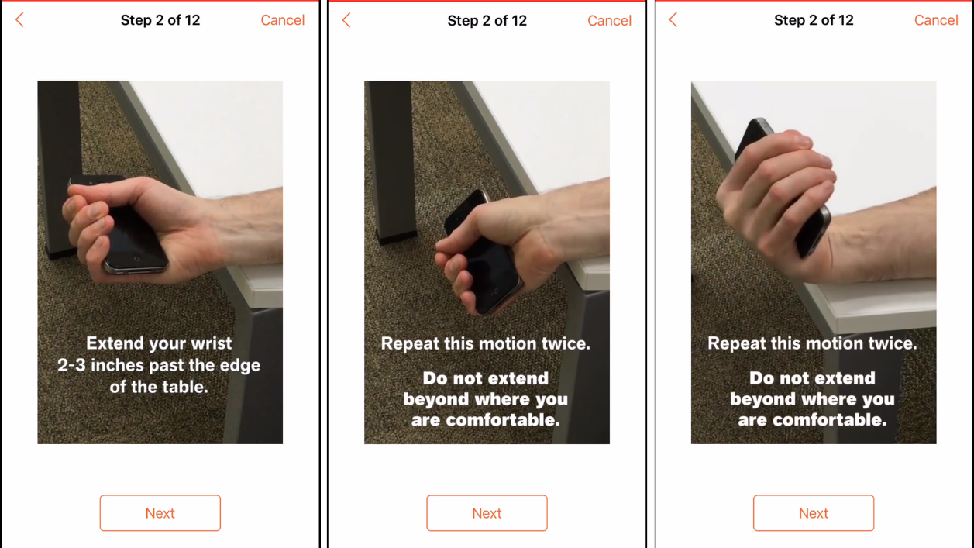
Fig. A2: Wrist joint motion test guidance screenshots

A3. Wrist joint motion test guidance video
See Video A3_Wrist joint motion test guidance video (separate file)

A4. Walk test guidance video
See Video A4_Walk test guidance video (separate file)

Supplement B

B1. Introduction
This supplementary material provides information on validity assessments conducted for the wrist range of motion and gait parameterization.

B2. Wrist range of motion computation
Test data were collected for the wrist joint motion exercise in order to assess the accuracy of the algorithm used to compute wrist range of motion in flexion-extension from sensor data. Four healthy volunteers repeatedly performed the task (7 to 10 times each) in a controlled setting. Each run was filmed using a transparent plastic screen of goniometer measures to provide visual “ground truth” data on the range of motion, as shown in Fig. B2.1. The experiment was designed to capture both samples fully compliant with the guidance instructions as well as non-compliant samples including (i) wrist pronation-supination and deviation in addition to flexion-extension, and (ii) holding the iPhone incorrectly (with the longer edge not perpendicular to the direction of the forearm). A total of 31 samples were collected, including 24 with high quality (or full compliance) and 9 low quality (non-compliance).
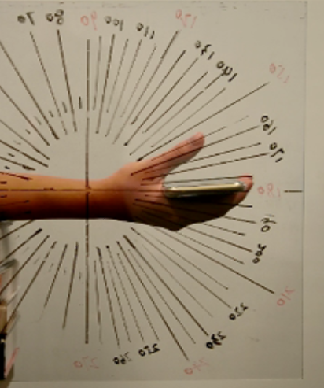
Fig. B2.1: Photograph of the experiment setting with goniometer angle measures overlaid on the wrist motion
Boxplot diagrams summarizing the error in the computed ranges of motion versus the goniometer measures are presented in Fig. B2.2. All non-compliant samples were successfully identified by the QC criteria developed for the task.

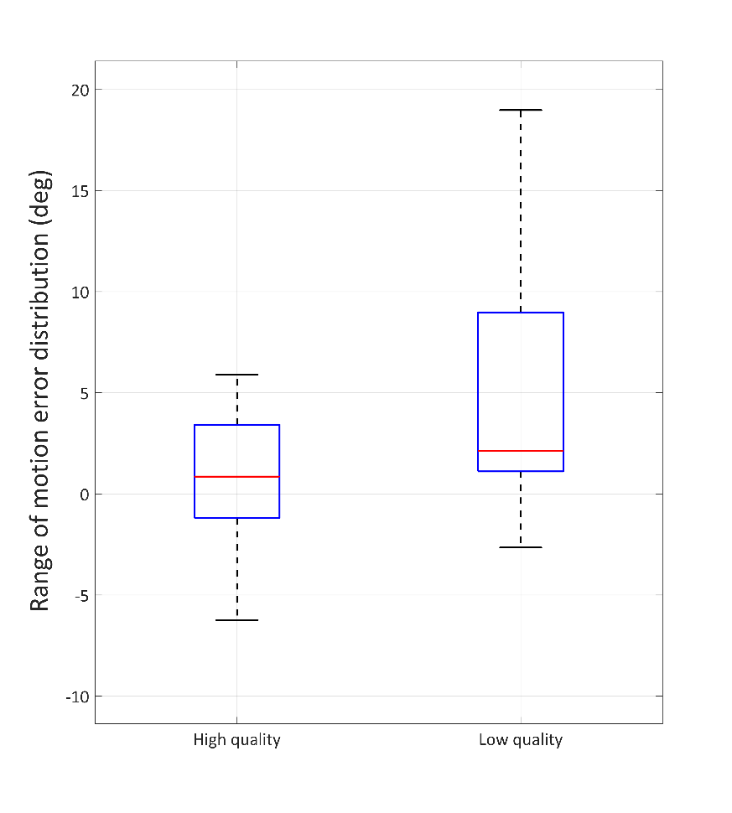
Fig. B2.2: Boxplots for ranges of motion error with respect to goniometer measures. In each box the central mark indicates the median, and the bottom and top edges of the box indicate the 25th and 75th percentiles, respectively. The whiskers extend to the most extreme data points.
The results of this experiment provide some information with respect to the algorithm accuracy and applicability. with the caution that there may be additional non-compliant cases not included in the supervised experiment

B3. Gait parameters computation
Test data were collected for the walk test in order to assess the accuracy of the algorithm for the computation of gait parameters (i.e. step time and step length). In this experiment, 10 patients with rheumatoid arthritis repeatedly (10 to 12 times each) walked 10 steps on a GAITRite® mat (CIR Systems, NJ, USA) while recording sensor data, see Fig. B3.1. Gold standard measurements provided by the GAITRite® system were used as reference for comparison with the sensor derived gait parameters. A total of 114 samples were collected. For each sample the average step time and step length were extracted.
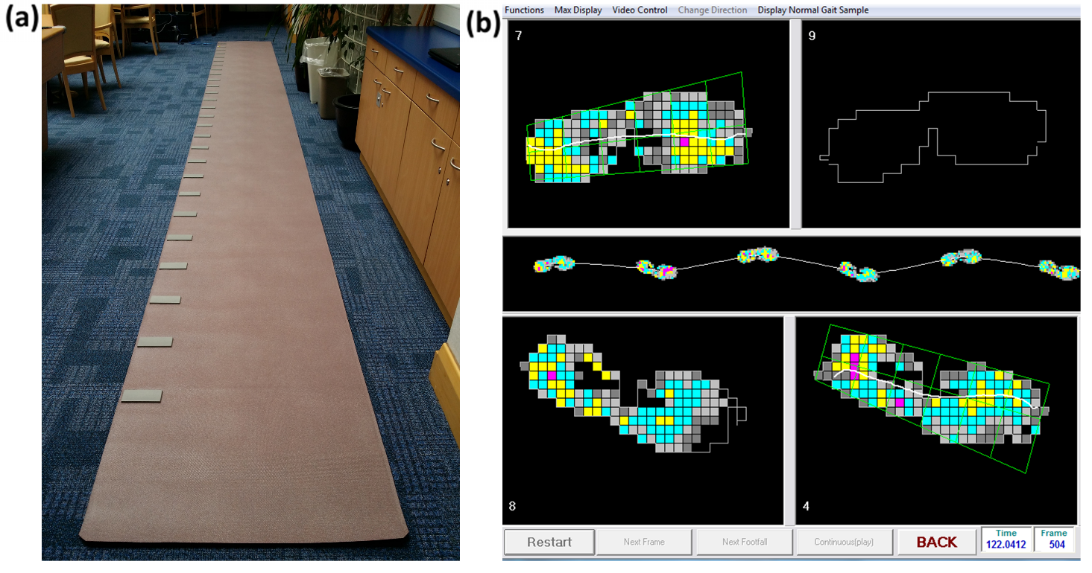
Fig. B3.1: Photograph of the experiment setting with the GAITRite mat (a) and GAITRite software screenshot showing steps detail (b)
Boxplot diagrams summarizing the error in the computed step times and step lengths versus the gold standard measures are presented in Fig. B3.2.
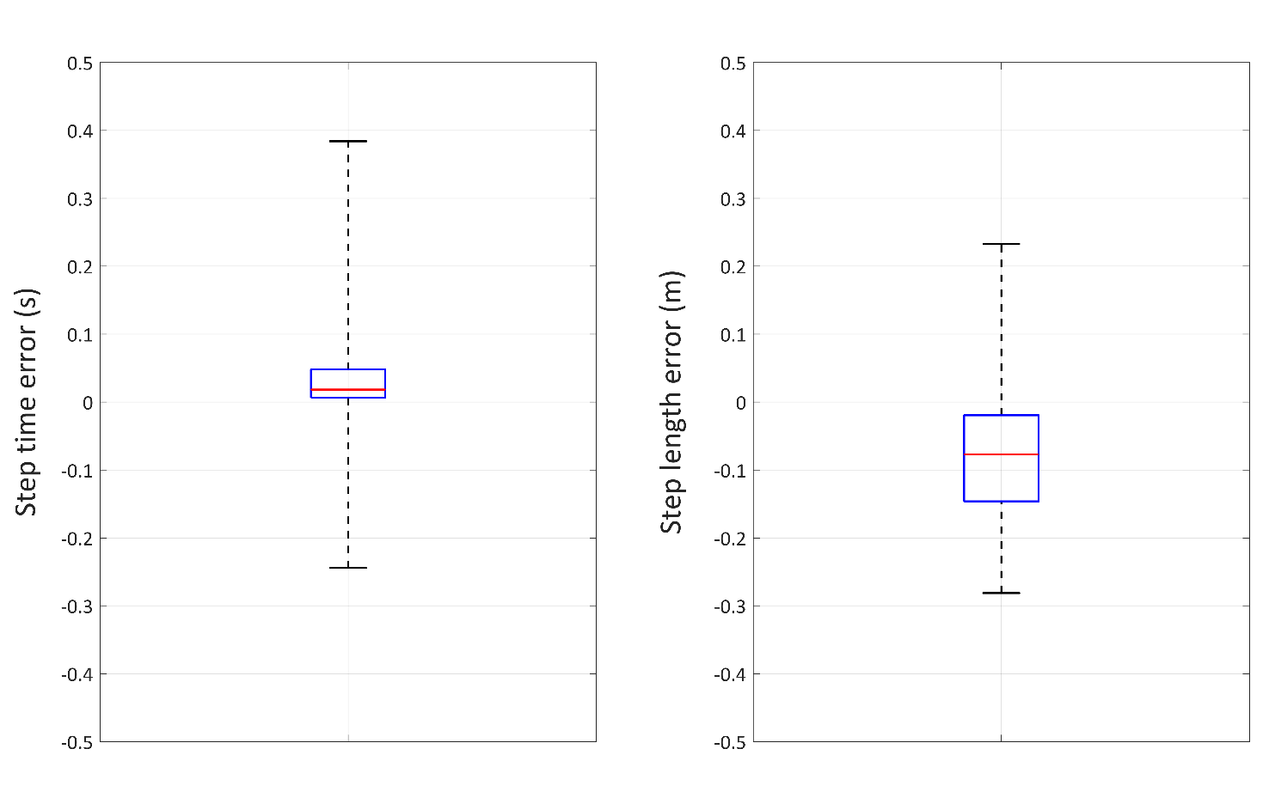
Fig. B3.2: Boxplots for step time and step length errors with respect to GAITRite mat measures. In each box the central mark indicates the median, and the bottom and top edges of the box indicate the 25th and 75th percentiles, respectively. The whiskers extend to the most extreme data points.

Supplement C

C1. Introduction
This supplementary material provides additional information on the data analytics methodologies including: specific details on the different types of wrist joint movement and the classification as walking versus not walking.

C2. Wrist joint movement orientation formalism
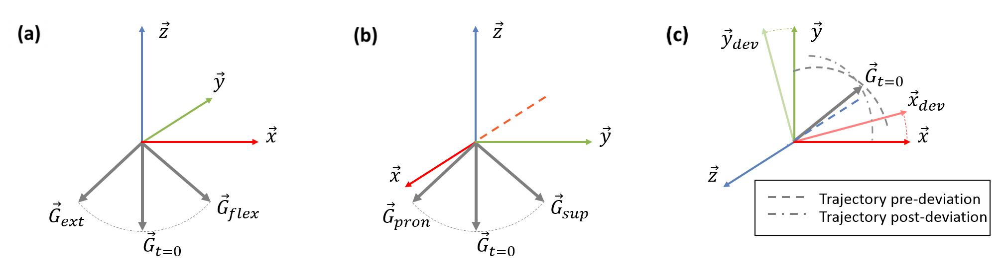
Fig. C2: Wrist joint movement orientation formalism
Fig. C2 provides a description of the different types of changes in gravity orientation during the wrist motion task, with respect to each axis in the iPhone’s reference frame: rotation about $\vec{y}$ directly reflects changes due to flexion-extension motion Fig. C2 (a), rotation about $\vec{x}$ directly reflects changes due to pronation-supination motion Fig. C2 (b), rotation about $\vec{z}$ reflects changes due to radial-ulnar deviation motion with indirect effect on the trajectory of the gravity orientation through time Fig. C2 (c). This is due to the experimental setting in which $\vec{z}$ is assumed to be initially aligned with the gravity vector $\vec{G}$.

C3. Effect of time window-based re-labeling of walk test data
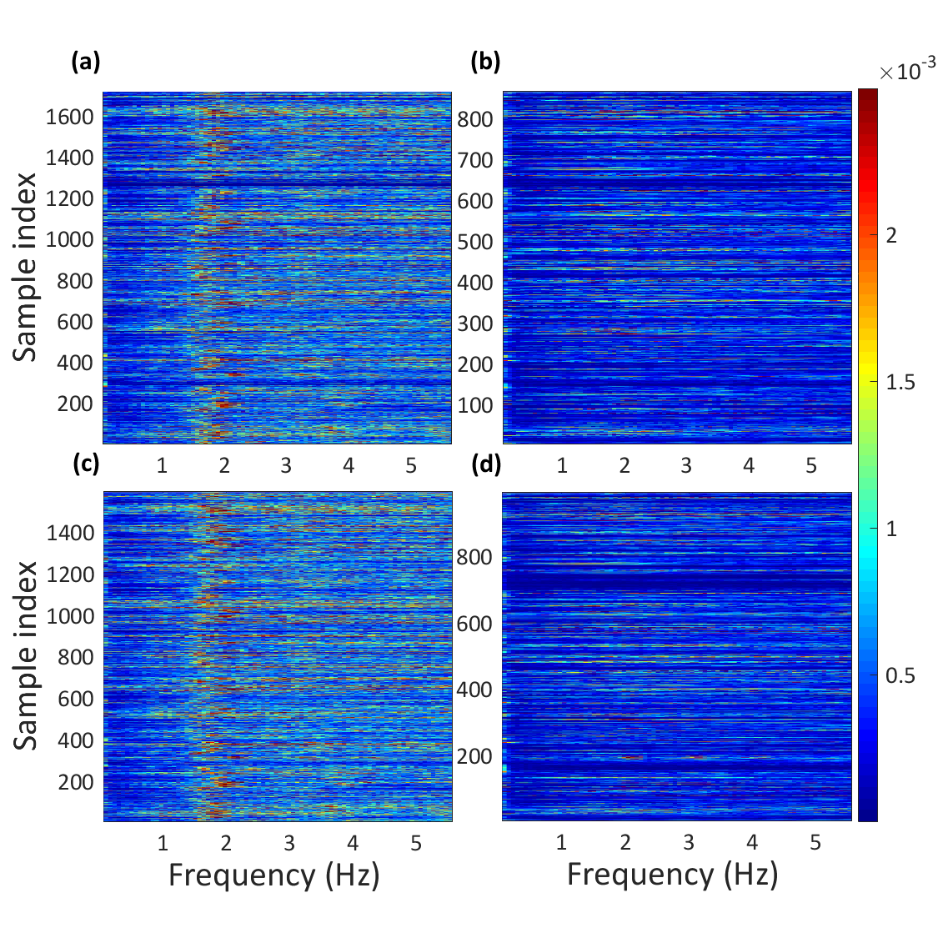
Fig. C3: Amplitude spectra of full samples originally labeled "Walking" (a) and "Not walking" (b) along with the amplitude spectra of trimmed, re-labeled samples for "Walking" (c) or "Not walking" (d). In each plot, rows correspond to Fourier spectra per samples, color-coded by magnitude and for increasing frequencies all the X-axis.
A clear feature appears in Fig. C3 (a) at a frequency around 1.5 - 2Hz (typical of walking) not present in most of the data in Fig. C3 (b), although a significant number of samples labeled as "Walking" did not show a high amplitude at these frequencies. The re-labeling step is efficiently moving samples from left to right. However, some samples appear to remain mis-labeled which suggests that further relabeling is appropriate.

C4. logistic regression applied to walk test data
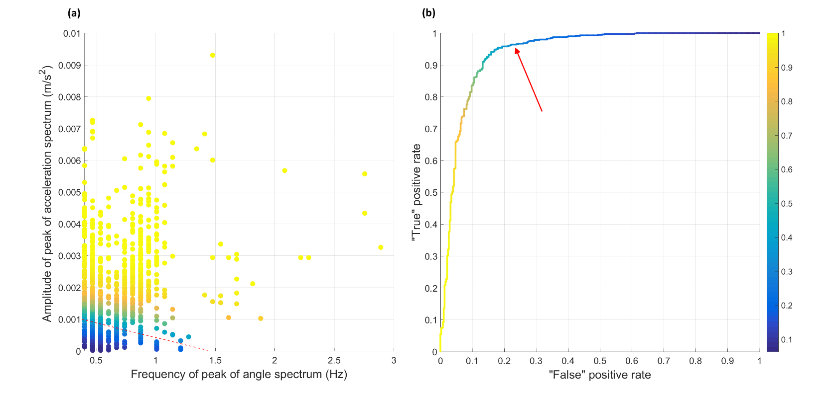
Fig. C4: Feature space representation of in pocket data input to logistic regression model (a), ROC curve for Logistic regression trained on in pocket data (b). The color bar indicates the probability of walking.
Fig. C4 provides details of the feature space representation of the data input to the logistic regression model and the model’s ROC curve. The selected operating point is indicated by a red arrow in Fig. C4 (b) and simplistically symbolized by a dotted line in Fig. C4 (a) marking the separation between the two classes. It should be noted that "true" and "false" in Fig. C4 (b) axis labels are in quotes because the assignments from the logistic regression are compared with the labels used for training which are not necessarily correct.

Supplement D

D1. Introduction
This supplementary material provides information on non-adherence in the study through comparison in terms of volume of low quality versus high quality data in both objective tasks for each symptom severity group.

D2. Tests non-adherence summary tables

Table D2.1. Repartition of high- and low-quality wrist joint motion data across Pain/Discomfort and Mobility group
 | No reported pain | Mild pain | Moderate pain | Severe pain
High quality | 99 (38.2%) | 59 (50.9%) | 63 (50.0%) | 36 (52.9%)
Low quality | 160 (61.8%) | 57 (49.1%) | 63 (50.0%) | 32 (47.1%)

Table D2.2 Repartition of high- and low-quality walk data across Pain/Discomfort and Mobility groups
 |  | Mobility | Pain/Discomfort
Level 1 | High quality | 70 (46.1%) | 10 (38.5%)
 | Low quality | 82 (53.9%) | 16 (61.5%)
Level 2 | High quality | 69 (45.1%) | 87 (54.0%)
 | Low quality | 84 (54.9%) | 74 (46.0%)
Level 3 | High quality | 39 (40.2%) | 68 (38.9%)
 | Low quality | 58 (59.8%) | 107 (61.1%)
Level 4 | High quality | 6 (33.3%) | 17 (34.7%)
 | Low quality | 12 (66.7%) | 32 (65.3%)
Level 5 | High quality | 1 (100.0%) | 3 (30.0%)
 | Low quality | 0 (0.0%) | 7 (70.0%)

