Supplemental material for Predictors for Augmented Renal Clearance in a Heterogeneous ICU Population as Defined by Creatinine and Cystatin C

Figure S1. Calibration Plot. Calibration curve depicting performance of the multivariable model for predication of augmented renal clearance (ARC).
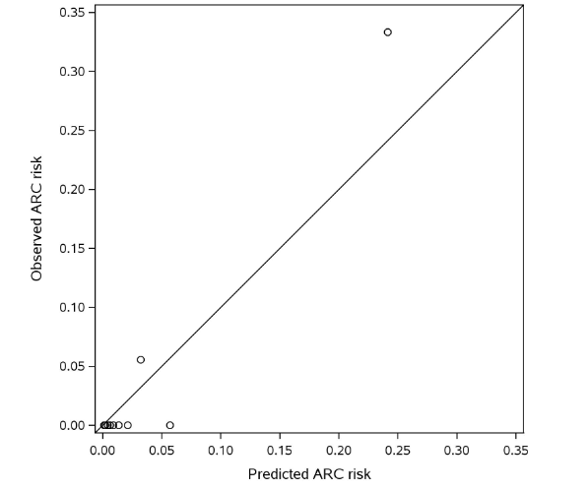

Table S1. Univariate Predictors of ARC, adjusted for BSA (defined >130 ml/min/1.73m²), n=6
Characteristic | OR (95% CI) | p-value
Charlson Comorbidity Index | 0.46(0.25-0.73) | <0.001
APACHE III | 0.96(0.91-1) | 0.051
TBI | 4.91(0.25-33.04) | 0.231
Major Trauma | 4.82(0.65-25.59) | 0.11
Intracerebral Hemorrhage | 4.59(0.23-30.73) | 0.248
Age | 0.92(0.87-0.96) | <0.001
SOFA Score (ICU Admit) | 0.70(0.45-0.97) | 0.028
Operative Admission Diagnosis | 6.27(1-120.57) | 0.05
BMI | 0.9(0.75-1.04) | 0.168
Vasopressors (ICU Admit) | 0.61(0.03-3.82) | 0.632
Mechanical Ventilation (ICU Admit) | 1.14(0.21-6.22) | 0.874
Sepsis | 3.11(0.6-22.6) | 0.178
Male Gender | 0.37(0.05-1.9) | 0.233

