Supplementary Figures

GitHub Repository: https://github.umn.edu/niede026/Deep-Brain-Stimulation-Factors-Influencing-Electrode-Position-and-Bending-of-the-Proximal-Lead
Figure Captions

Figure 1: The distribution of radiographic measures of electrode translocation was approximately normal. Electrode translocation was modeled as the response variable in our first linear mixed-effects model.

Figure 2: Residuals vs fitted plot from our first linear mixed-effects model. No distinct patterns are observed that would suggest a non-linear trend.

Figure 3: Normal Q-Q plot from our first linear mixed-effects model. Residuals follow a relatively straight line without significant deviation and are approximately normally distributed.

Figure 4: Electrode translocation (mm) attributable to ICA volume (cm³) as estimated by our first linear mixed-effects model.

Figure 5: Electrode translocation along the electrode trajectory comparison across vendors. Data points with a red cross through them indicate outliers. ABT = Abbott/SJM. BSC = Boston Scientific. MDT = Medtronic.

Figure 6: The distribution of radiographic measures of proximal lead bowing were not normally distributed.

Figure 7: Natural log transformed values of proximal lead bowing were approximately normally distributed. Natural log transformed values of proximal lead bowing were modeled as the response variable in our second linear mixed-effects model.

Figure 8: Residuals vs fitted plot from our second linear mixed-effects model. No distinct patterns are observed that would suggest a non-linear trend.

Figure 9: Normal Q-Q plot from our second linear mixed-effects model. Residuals follow a relatively straight line without significant deviation and are approximately normally distributed.

Figure 10: Exponentiation of the linear slope given for ICA volume in our second linear mixed-effects model gives an exponential relationship between proximal lead bowing and ICA volume. The plot depicts proximal lead bowing (mm) attributable to ICA volume (cm³) as estimated by our second mixed model. The relationship can be expressed as Y = e^{0.045X}.

Figures
Figure 1:
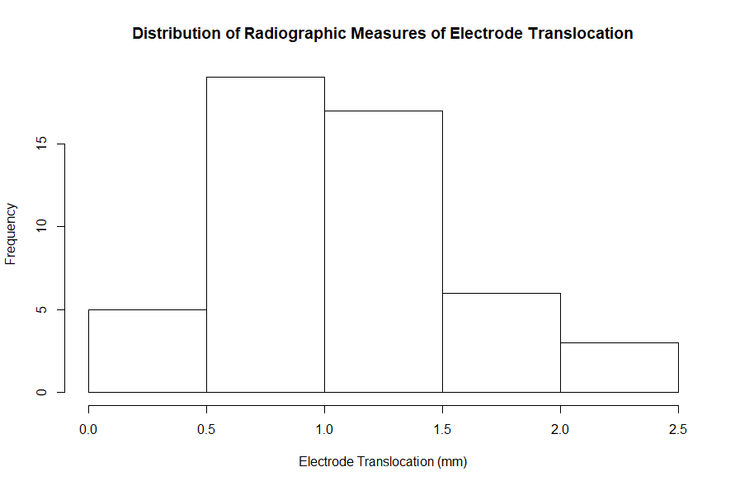

Figure 2:
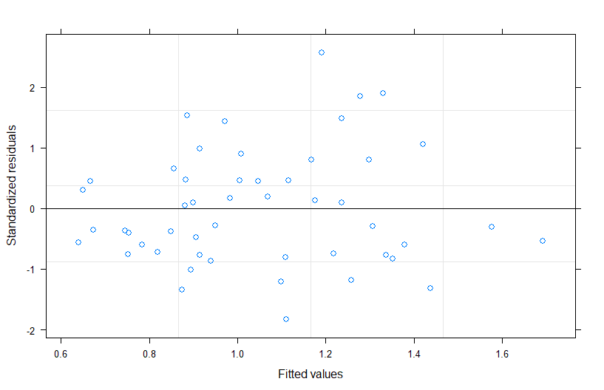

Figure 3:
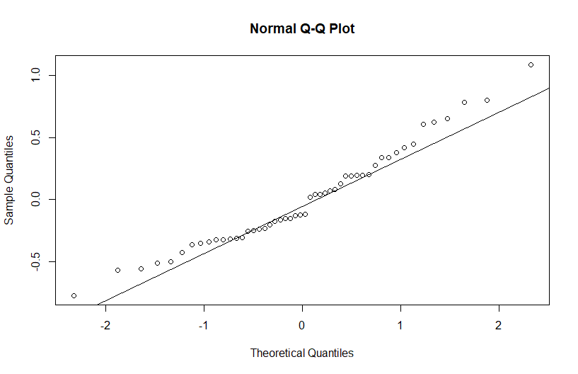

Figure 4:
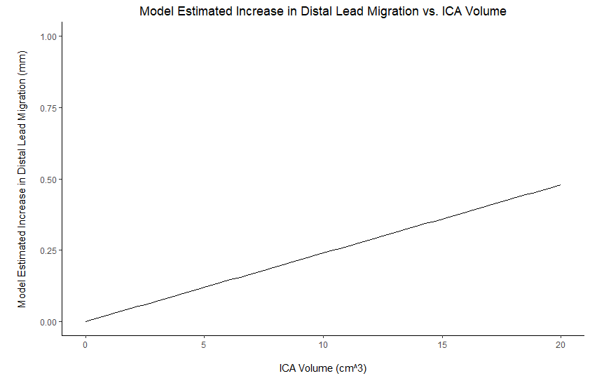
Figure 5: 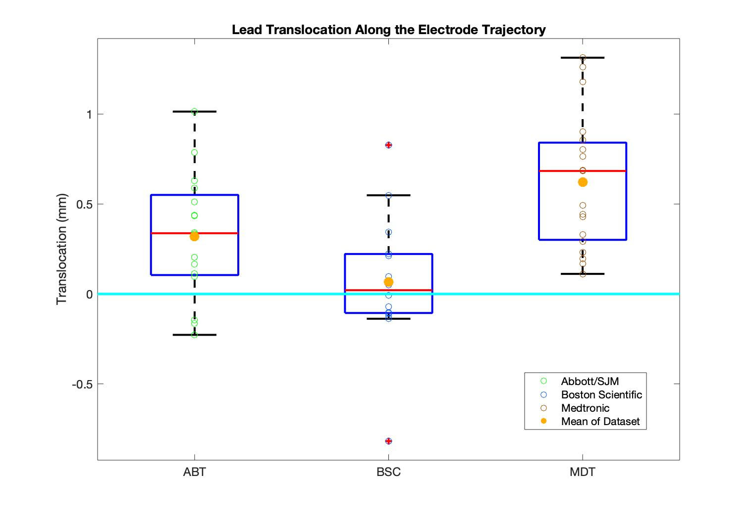

Figure 6:
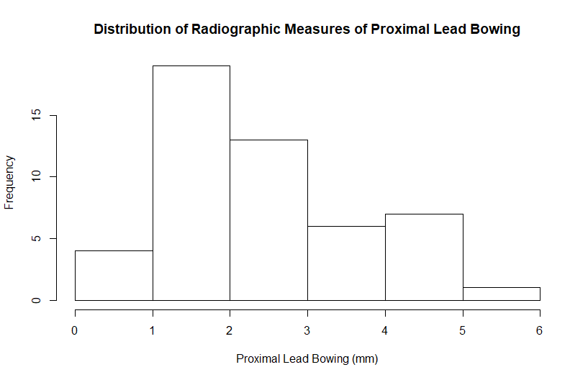

Figure 7:
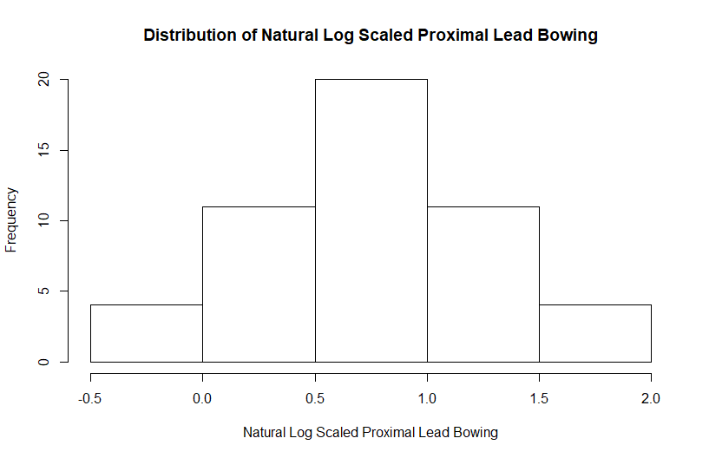

Figure 8:
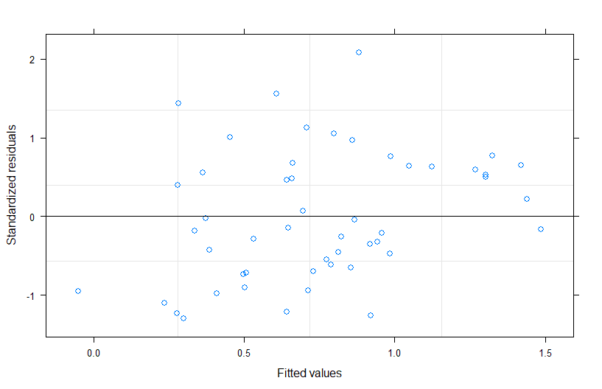

Figure 9:
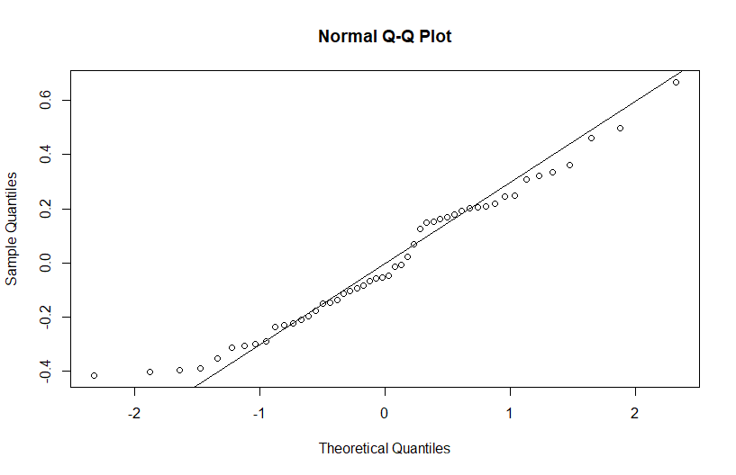

Figure 10:
