Online-Supplement
Supplement 1: Deviations from the protocol:
Details according to the protocol | Deviations from the protocol
The aim of the planned study was to examine the short-term and long-term as well as moderator effects of psychological interventions compared with control groups in adults with subthreshold depression. | In this IPD-MA we focus on internet-based psychological interventions only.
Next to outcomes like depressive symptom severity, treatment response, remission, symptom deterioration and MDD onsets it is planned to focus on quality of life, suicidal thoughts and behaviour, and anxiety as well. | We did not include quality of life, suicidal thoughts and behaviour, and anxiety into our analyses because most of the included trials did not provide data to these outcomes.
There was a long list of potential moderators in the protocol. | The planned list of moderators was much longer than those that have been eventually evaluated. When going through the relevant articles we noticed that several potential moderators have not been included in most of the trials. Therefore we had to shorten the list (see Supplement 2).

Supplement 2: Requested data to be included in the IPD dataset
Relevant authors were asked to provide the following data (if available):
Demographics | age, sex, ethnicity, country of birth, education, employment, marital status, income, children
Intervention details | randomised group, number of treatment sessions completed, number of weeks of treatment,
Clinical indicators | current diagnosis of depression, prior diagnosis of depression, number of previous depressive episodes, currently receiving antidepressants, previous psychotherapy, comorbid anxiety disorder, specific anxiety disorder, comorbid mental health disorder, comorbid physical health disorder, chronic medical condition
Outcome measures | diagnosed depression (baseline, post, follow ups), depressive symptom severity (baseline, post, follow ups), anxiety (baseline, post, follow ups), other symptom scales
Psycho-social measures | Quality of life, measures of interpersonal functioning
Other | measures of attitude, mastery

Supplement 3: Flowchart inclusion of studies
Studies included in meta-analysis for online-based treatment of subthreshold depression (n=7)
Supplement 4: Demographics and clinical characteristics
 | Intervention (N = 1088) |  |  |  | Control (N = 1098) |  |  |  | All (N = 2186)
 | N | % | Mean | S.D. | N | % | Mean | S.D. | N | % | Mean | S.D.
Age, years |  |  | 44.12 | 11.60 |  |  | 44.12 | 11.67 |  |  | 44.12 | 11.63
Gender, female | 637 | 58.5 |  |  | 644 | 58.7 |  |  | 1281 | 58.6
Currently in a relationship | 646 | 59.4 |  |  | 628 | 57.2 |  |  | 1273 | 58.2
Currently employed | 866 | 79.6 |  |  | 852 | 77.6 |  |  | 1718 | 78.6
Current use of antidepressants | 276 | 25.4 |  |  | 287 | 26.1 |  |  | 563 | 25.8
Previous psychotherapy | 485 | 44.6 |  |  | 503 | 45.8 |  |  | 988 | 45.2
Comorbidities | 369 | 33.9 |  |  | 364 | 33.2 |  |  | 733 | 33.5
Comorbid anxiety | 428 | 39.3 |  |  | 452 | 41.1 |  |  | 880 | 40.3
Chronic medical conditions | 560 | 51.5 |  |  | 564 | 51.4 |  |  | 1124 | 51.4
Education
> none (0-5 years) | 6 | 0.5 |  |  | 16 | 1.5 |  |  | 22 | 1.0
> low (6-9 years) | 74 | 6.8 |  |  | 70 | 6.4 |  |  | 144 | 6.6
> middle (10-12 years) | 291 | 26.7 |  |  | 272 | 24.8 |  |  | 563 | 25.8
> high (13-17 years) | 685 | 63.0 |  |  | 711 | 64.8 |  |  | 1396 | 63.9
> very high (18+ years) | 32 | 2.9 |  |  | 29 | 2.6 |  |  | 61 | 2.8
Note: Percentages and absolute numbers are estimated based on multiple imputation.
Abbreviations: N = number of participants; S.D. = standard deviation

Supplement 5: Missing data patterns
N_{p} | format | num sess | age | sex | dss pre | empl | relat | educ | comorb | dss post | dep med | dss FU1 | comorb anx | PPT | dss_FU2 | CMC | N_{a}
320 |  |  |  |  |  |  |  |  |  |  |  |  |  |  |  |  | 3
283 |  |  |  |  |  |  |  |  |  |  |  |  |  |  |  |  | 1
203 |  |  |  |  |  |  |  |  |  |  |  |  |  |  |  |  | 2
149 |  |  |  |  |  |  |  |  |  |  |  |  |  |  |  |  | 2
118 |  |  |  |  |  |  |  |  |  |  |  |  |  |  |  |  | 3
114 |  |  |  |  |  |  |  |  |  |  |  |  |  |  |  |  | 5
84 |  |  |  |  |  |  |  |  |  |  |  |  |  |  |  |  | 4
83 |  |  |  |  |  |  |  |  |  |  |  |  |  |  |  |  | 1
74 |  |  |  |  |  |  |  |  |  |  |  |  |  |  |  |  | 2
69 |  |  |  |  |  |  |  |  |  |  |  |  |  |  |  |  | 5
60 |  |  |  |  |  |  |  |  |  |  |  |  |  |  |  |  | 3
54 |  |  |  |  |  |  |  |  |  |  |  |  |  |  |  |  | 4
40 |  |  |  |  |  |  |  |  |  |  |  |  |  |  |  |  | 4
38 |  |  |  |  |  |  |  |  |  |  |  |  |  |  |  |  | 6
34 |  |  |  |  |  |  |  |  |  |  |  |  |  |  |  |  | 4
32 |  |  |  |  |  |  |  |  |  |  |  |  |  |  |  |  | 7
28 |  |  |  |  |  |  |  |  |  |  |  |  |  |  |  |  | 8
27 |  |  |  |  |  |  |  |  |  |  |  |  |  |  |  |  | 7
23 |  |  |  |  |  |  |  |  |  |  |  |  |  |  |  |  | 4
22 |  |  |  |  |  |  |  |  |  |  |  |  |  |  |  |  | 5
17 |  |  |  |  |  |  |  |  |  |  |  |  |  |  |  |  | 6
17 |  |  |  |  |  |  |  |  |  |  |  |  |  |  |  |  | 6
16 |  |  |  |  |  |  |  |  |  |  |  |  |  |  |  |  | 4
15 |  |  |  |  |  |  |  |  |  |  |  |  |  |  |  |  | 3
13 |  |  |  |  |  |  |  |  |  |  |  |  |  |  |  |  | 2
12 |  |  |  |  |  |  |  |  |  |  |  |  |  |  |  |  | 3
12 |  |  |  |  |  |  |  |  |  |  |  |  |  |  |  |  | 5
11 |  |  |  |  |  |  |  |  |  |  |  |  |  |  |  |  | 5
10 |  |  |  |  |  |  |  |  |  |  |  |  |  |  |  |  | 3
10 |  |  |  |  |  |  |  |  |  |  |  |  |  |  |  |  | 6
9 |  |  |  |  |  |  |  |  |  |  |  |  |  |  |  |  | 4
9 |  |  |  |  |  |  |  |  |  |  |  |  |  |  |  |  | 6
8 |  |  |  |  |  |  |  |  |  |  |  |  |  |  |  |  | 5
8 |  |  |  |  |  |  |  |  |  |  |  |  |  |  |  |  | 3
7 |  |  |  |  |  |  |  |  |  |  |  |  |  |  |  |  | 3
7 |  |  |  |  |  |  |  |  |  |  |  |  |  |  |  |  | 6
7 |  |  |  |  |  |  |  |  |  |  |  |  |  |  |  |  | 4
7 |  |  |  |  |  |  |  |  |  |  |  |  |  |  |  |  | 3
6 |  |  |  |  |  |  |  |  |  |  |  |  |  |  |  |  | 5
6 |  |  |  |  |  |  |  |  |  |  |  |  |  |  |  |  | 4
6 |  |  |  |  |  |  |  |  |  |  |  |  |  |  |  |  | 2
5 |  |  |  |  |  |  |  |  |  |  |  |  |  |  |  |  | 2
5 |  |  |  |  |  |  |  |  |  |  |  |  |  |  |  |  | 3
5 |  |  |  |  |  |  |  |  |  |  |  |  |  |  |  |  | 4
4 |  |  |  |  |  |  |  |  |  |  |  |  |  |  |  |  | 3
4 |  |  |  |  |  |  |  |  |  |  |  |  |  |  |  |  | 2
4 |  |  |  |  |  |  |  |  |  |  |  |  |  |  |  |  | 7
4 |  |  |  |  |  |  |  |  |  |  |  |  |  |  |  |  | 8
4 |  |  |  |  |  |  |  |  |  |  |  |  |  |  |  |  | 5
4 |  |  |  |  |  |  |  |  |  |  |  |  |  |  |  |  | 5
4 |  |  |  |  |  |  |  |  |  |  |  |  |  |  |  |  | 5
3 |  |  |  |  |  |  |  |  |  |  |  |  |  |  |  |  | 6
3 |  |  |  |  |  |  |  |  |  |  |  |  |  |  |  |  | 3
3 |  |  |  |  |  |  |  |  |  |  |  |  |  |  |  |  | 2
3 |  |  |  |  |  |  |  |  |  |  |  |  |  |  |  |  | 4
2 |  |  |  |  |  |  |  |  |  |  |  |  |  |  |  |  | 4
2 |  |  |  |  |  |  |  |  |  |  |  |  |  |  |  |  | 4
2 |  |  |  |  |  |  |  |  |  |  |  |  |  |  |  |  | 5
2 |  |  |  |  |  |  |  |  |  |  |  |  |  |  |  |  | 6
2 |  |  |  |  |  |  |  |  |  |  |  |  |  |  |  |  | 5
2 |  |  |  |  |  |  |  |  |  |  |  |  |  |  |  |  | 2
2 |  |  |  |  |  |  |  |  |  |  |  |  |  |  |  |  | 4
2 |  |  |  |  |  |  |  |  |  |  |  |  |  |  |  |  | 4
2 |  |  |  |  |  |  |  |  |  |  |  |  |  |  |  |  | 3
2 |  |  |  |  |  |  |  |  |  |  |  |  |  |  |  |  | 5
2 |  |  |  |  |  |  |  |  |  |  |  |  |  |  |  |  | 3
2 |  |  |  |  |  |  |  |  |  |  |  |  |  |  |  |  | 5
2 |  |  |  |  |  |  |  |  |  |  |  |  |  |  |  |  | 5
2 |  |  |  |  |  |  |  |  |  |  |  |  |  |  |  |  | 5
2 |  |  |  |  |  |  |  |  |  |  |  |  |  |  |  |  | 6
2 |  |  |  |  |  |  |  |  |  |  |  |  |  |  |  |  | 6
2 |  |  |  |  |  |  |  |  |  |  |  |  |  |  |  |  | 6
1 |  |  |  |  |  |  |  |  |  |  |  |  |  |  |  |  | 4
1 |  |  |  |  |  |  |  |  |  |  |  |  |  |  |  |  | 1
1 |  |  |  |  |  |  |  |  |  |  |  |  |  |  |  |  | 7
1 |  |  |  |  |  |  |  |  |  |  |  |  |  |  |  |  | 5
1 |  |  |  |  |  |  |  |  |  |  |  |  |  |  |  |  | 3
1 |  |  |  |  |  |  |  |  |  |  |  |  |  |  |  |  | 5
1 |  |  |  |  |  |  |  |  |  |  |  |  |  |  |  |  | 5
1 |  |  |  |  |  |  |  |  |  |  |  |  |  |  |  |  | 4
1 |  |  |  |  |  |  |  |  |  |  |  |  |  |  |  |  | 4
1 |  |  |  |  |  |  |  |  |  |  |  |  |  |  |  |  | 6
1 |  |  |  |  |  |  |  |  |  |  |  |  |  |  |  |  | 7
1 |  |  |  |  |  |  |  |  |  |  |  |  |  |  |  |  | 7
1 |  |  |  |  |  |  |  |  |  |  |  |  |  |  |  |  | 2
1 |  |  |  |  |  |  |  |  |  |  |  |  |  |  |  |  | 3
1 |  |  |  |  |  |  |  |  |  |  |  |  |  |  |  |  | 4
1 |  |  |  |  |  |  |  |  |  |  |  |  |  |  |  |  | 5
1 |  |  |  |  |  |  |  |  |  |  |  |  |  |  |  |  | 4
1 |  |  |  |  |  |  |  |  |  |  |  |  |  |  |  |  | 3
1 |  |  |  |  |  |  |  |  |  |  |  |  |  |  |  |  | 4
1 |  |  |  |  |  |  |  |  |  |  |  |  |  |  |  |  | 5
1 |  |  |  |  |  |  |  |  |  |  |  |  |  |  |  |  | 5
1 |  |  |  |  |  |  |  |  |  |  |  |  |  |  |  |  | 5
1 |  |  |  |  |  |  |  |  |  |  |  |  |  |  |  |  | 6
1 |  |  |  |  |  |  |  |  |  |  |  |  |  |  |  |  | 7
1 |  |  |  |  |  |  |  |  |  |  |  |  |  |  |  |  | 6
1 |  |  |  |  |  |  |  |  |  |  |  |  |  |  |  |  | 5
1 |  |  |  |  |  |  |  |  |  |  |  |  |  |  |  |  | 9
1 |  |  |  |  |  |  |  |  |  |  |  |  |  |  |  |  | 5
1 |  |  |  |  |  |  |  |  |  |  |  |  |  |  |  |  | 11
 | 0 | 0 | 1 | 2 | 32 | 46 | 61 | 97 | 318 | 426 | 469 | 664 | 1083 | 1238 | 1268 | 1282 | 6987
Note: light grey = no missing data; dark grey = missing data; The left column (Np) tells the number of participants matching the pattern of the respective line; The bottom line (Nv) tells the number of missing data per variable; The right column (Na) tells the number of missing variables in that specific pattern;
Abbreviations: num sess = number of sessions; dss pre = depressive symptom severity at pre-treatment; empl = employment; relat = relationship status; educ = education; comorb = comorbidities; dss post = depressive symptom severity at post-treatment; dep med= depression medication; dss FU1 = depressive symptom severity at follow-up-1; comorb anx = comorbid anxiety; PPT = previous psychotherapy; dss FU2 = depressive symptom severity at follow-up-2; CMC = chronic medical conditions;

Supplement 6: Multilevel regression analyses predicting depressive symptom severity scores from treatment group of studies that provided original data for FU1 (n = 1984) and FU2 (n = 1331)
 |  |  | FU1 |  |  |  | FU2
 |  | Est. | S.E. | p |  | Est. | S.E. | p
DSS
Fixed Effects
Intercept ($b_{0}$) |  | 16.981 | 2.598 | <0.001 |  | 27.845 | 5.693 | <0.001
Condition ($b_{1}$) |  | -3.269 | 0.819 | <0.001 |  | -2.688 | 1.078 | 0.055
Baseline DSS ($b_{2}$) |  | 0.681 | 0.039 | <0.001 |  | 0.53 | 0.051 | <0.001
Random effects (var.)
Intercept ($τ_{0}^{2}$) |  | 1.723 |  |  |  | 65.753
Condition ($τ_{1}^{2}$) |  | 2.599 |  |  |  | 2.606
Covariance Intercept- Condition (${τ2}_{1}^{0}$) |  | -0.728 |  |  |  | 12.573
Note: The multilevel regression analyses were controlled for initial depressive symptom severity. $b_{0}$: Y-intercept; $b_{1}$: treatment condition; $b_{2}$: initial depressive symptom severity. $τ_{0}^{2}$: intercept variance; $τ_{1}^{2}$: slope variance;
Abbreviations: Est. = estimate; S.E. = standard error; p = probability

Supplement 7: Kaplan-Meier survival estimates of time to onset of major depressive disorder by study group
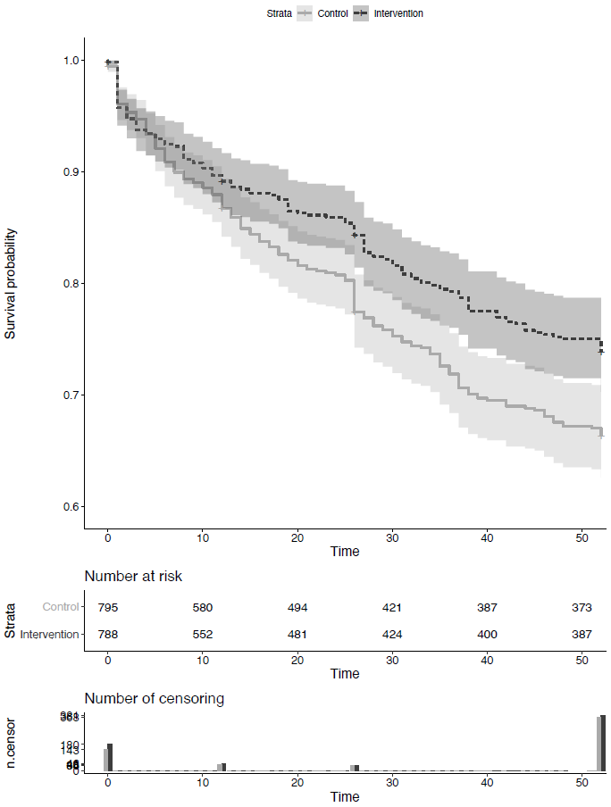
Note: The primary endpoint was time to onset (in weeks) of a major depressive disorder in the intervention relative to the control group according to DSM-IV criteria. Follow-up time was truncated at 52 weeks. The log-rank test and Cox proportional hazard regression analysis controlling for baseline depressive symptom severity were used to test for group differences. The shaded areas illustrate 95% CIs.

Supplement 8: Interaction effect of group and baseline symptom severity on depressive symptoms at post-treatment

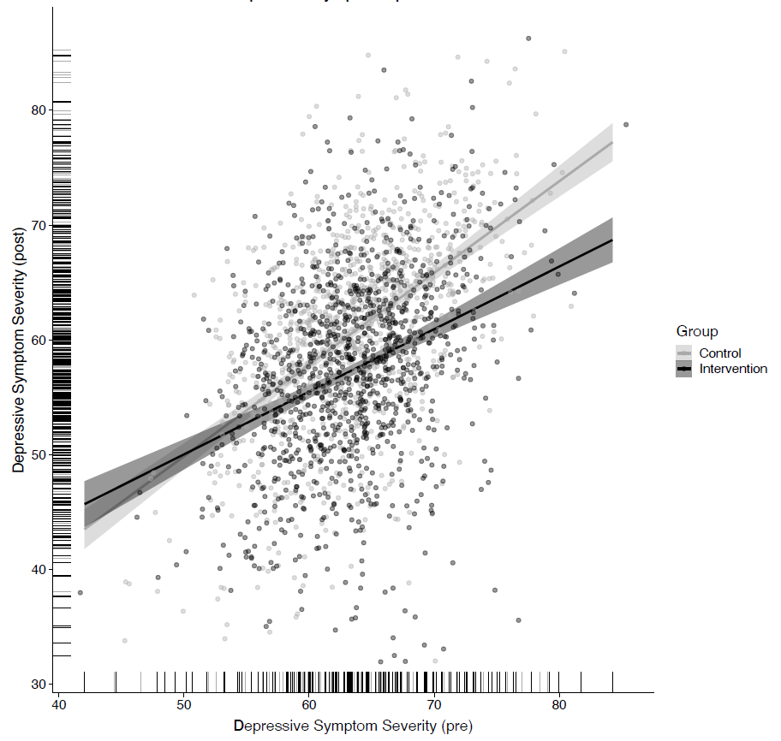
Note: The light grey and dark grey dots represent the individual values of depressive symptom severity at post-treatment of participants in the control and intervention group, respectively. The shaded areas illustrate 95% CIs.

Supplement 9: Interaction effect of group and age on depressive symptoms at post-treatment
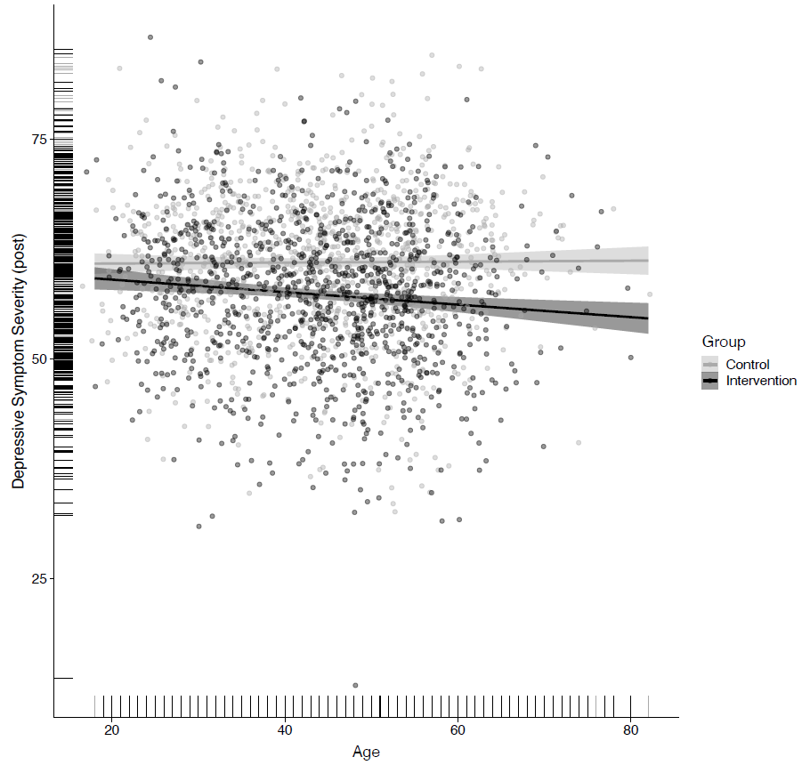
Note: The light grey and dark grey dots represent the individual values of depressive symptom severity at post-treatment of participants in the control and intervention group, respectively. The shaded areas illustrate 95% CIs.

Supplement 10: Results from multiple multilevel regression analyses on the effects of putative moderators on differential change in depression severity from baseline to post-treatment
Baseline variable | Main effect |  |  |  | Interaction: baseline variable x treatment condition
 | Estimate | Std. Error | t. value | p(<|t|) | Estimate | Std. Error | t. value | p(<|t|)
Group | 11.188 | 4.661 | 2.400 | 0.016
Age | 0.222 | 0.222 | 0.985 | 0.325 | -0.069 | 0.033 | -2.110 | 0.035
Initial symptom severity | 0.774 | 0.046 | 16.942 | 0.000 | -0.185 | 0.069 | -2.702 | 0.007

