Supplementary Material

Supplementary table S1: Search terms
The first search was performed on 20/01/2019 in PubMed (1901-present) and on 24/01/2019 in Cochrane (1991-present), Scopus (1980-present) and ScienceDirect (2000-present). A second search, thus updated search, was added on 31/01/2020 (20/01/2019 respectively 24/01/2019 until present) in the same databases. The following search terms according to the PICOS process (patients, interventions, comparison, outcome, study design) were used:

Patients: mild TBI, mild traumatic brain injury, mild traumatic brain injuries, mTBI, (brain) concussion, CT AND negative computertomography AND negative, negative AND CT AND scan, negative AND scan, white AND matter AND lesion, white AND matter AND lesions
Interventions: MRS, magnetic resonance spectroscopy, magnetic resonance spectroscopies, magnetic resonance imaging, NAA, N-Acetylaspartic acid, N-acetylaspartate, N acetylaspartate, N acetylaspartic acid, NAA/Cr, NAA/Creatin, NAA/Creatine, N-acetylaspartate/Creatine, N-acetylaspartate/Creatin, Cho, choline, cholin, Cho/Cr, Cho/Creatin, Cho/Creatine, Choline/Creatine, Choline/Creatin, Cholin/Creatine, Cholin/Creatin, lactate, lactic acid, mIns, myoinositol, m-inositol, mIns/Cr, mIns/Creatin, mIns/Creatine, myoinositol/Creatine, myoinositol/Creatin, m-inositol/Creatine, m-inositol/Creatin, change in metabolism

Comparison: healthy, control, control, controls, controls, controlled, controlled
Outcome: not defined
Study design: not defined
Searches performed for each single database can be provided upon request.

Supplementary table S2: Risk of bias assessment in individual studies using the ROBINS-I tool

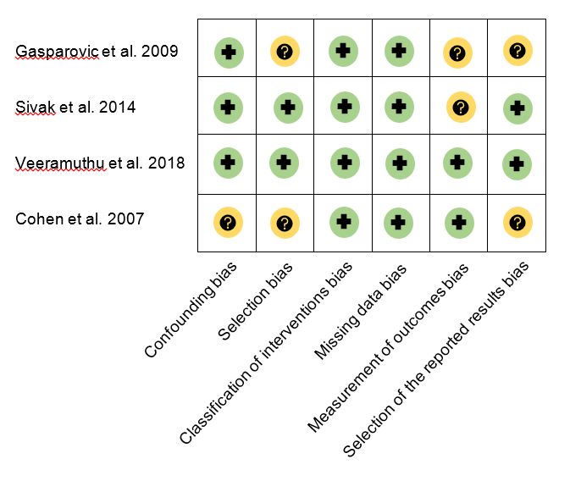

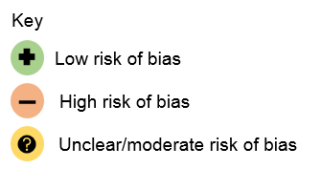

Detailed individual study assessment as well as the across-studies risk of bias assessment with GRADE (Grading of Recommendations, Assessment, Development and Evaluation) will be provided upon request.

