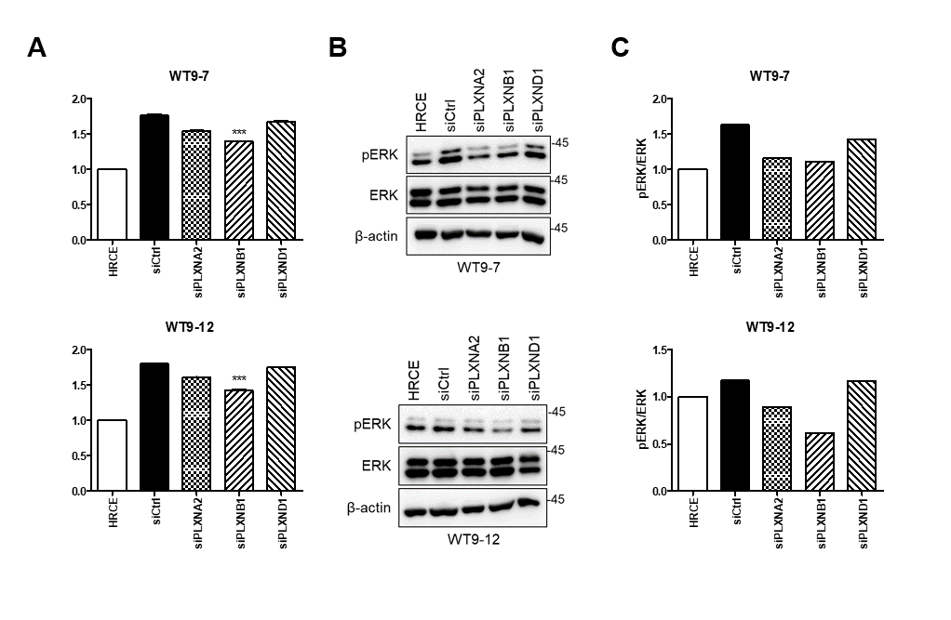
Supplementary Fig. 2. PLXNB1 strongly supports the survival of HRCE and PKD epithelial cells among the SEMA3C-activated PLXNs (A) HRCE and PKD cells were pre-transfected with indicated siRNA. After 24 h, the cells were re-seeded at 5×10³ per well in a 48-well plate. Cell viability was measured by CCK8 72 h after re-seeding. The optical density was normalized with that at 0 h (measured at 4 h after re-seeding). (B) Representative immunoblot images. Protein was extracted from the cells at 48 h after siRNA treatment. (C) Band density was quantified using Image J. Three independent experiments were performed. The graph is presented as the mean ± SD. ***p<0.005.

