Table S1 | Primer sequences for real-time PCR.
Gene | Sequences (5'-3') | Tm | Product lenth
ACTB | F: GTCCACCTTCCAGCAGATGTG | 60.95 | 76
 | R: GCATTTGCGGTGGACGAT | 58.81
RORC | F: AGTAGAACAGCTGCAGTACAAT | 57.46 | 207
 | R: CTGAAGAGCTCCTTGTAGAGTG | 57.89
FOXP3 | F: CCTACCCACTGCTGGCAAAT | 60.32 | 90
 | R: CCTGGCAGTGCTTGAGGAA | 57.89
TBX21 | F: GATGCGCCAGGAAGTTTCAT | 58.9 | 83
 | R: GCACAATCATCTGGGTCACATT | 59.24
GATA3 | F: TTCAGTTGGCCTAAGGTGGT | 58.85 | 98
 | R: CGCCGGACTCTTAGAAGCTA | 58.98
BCL6 | F: GACTCTGAAGAGCCACCTG | 57.17 | 88
 | R: CTGGCTTTTGTGACGGAAAT | 56.91
SPI1 | F: ACAGGCGTGCAAAATGGAAG | 59.69 | 55
 | R: GTCTTCTGATGGCTGAGGGG | 59.82
AIM2 | F: CTGCAGTGATGAAGACCATTCGTA | 60.92 | 196
 | R: GGTGCAGCACGTTGCTTTG | 60.95
NLRP1 | F: CCACAACCCTCTGTCTACATTAC | 58.5 | 157
 | R: GCCCCATCTAACCCATGCTTC | 61.09
NLRP3 | F: GATCTTCGCTGCGATCAACA | 58.72 | 94
 | R: GGGATTCGAAACACGTGCATTA | 59.58
NLRC4 | F: CCAGTCCCCTCACCATAGAAG | 59.23 | 119
 | R: ACCCAAGCTGTCAGTCAGACC | 61.99
PYCARD | F: AACCCAAGCAAGATGCGGAAG | 61.49 | 82
 | R: TTAGGGCCTGGAGGAGCAAG | 61.27
CASP1 | F: GCCTGTTCCTGTGATGTGGAG | 60.95 | 166
 | R: TGCCCACAGACATTCATACAGTTTC | 61.55
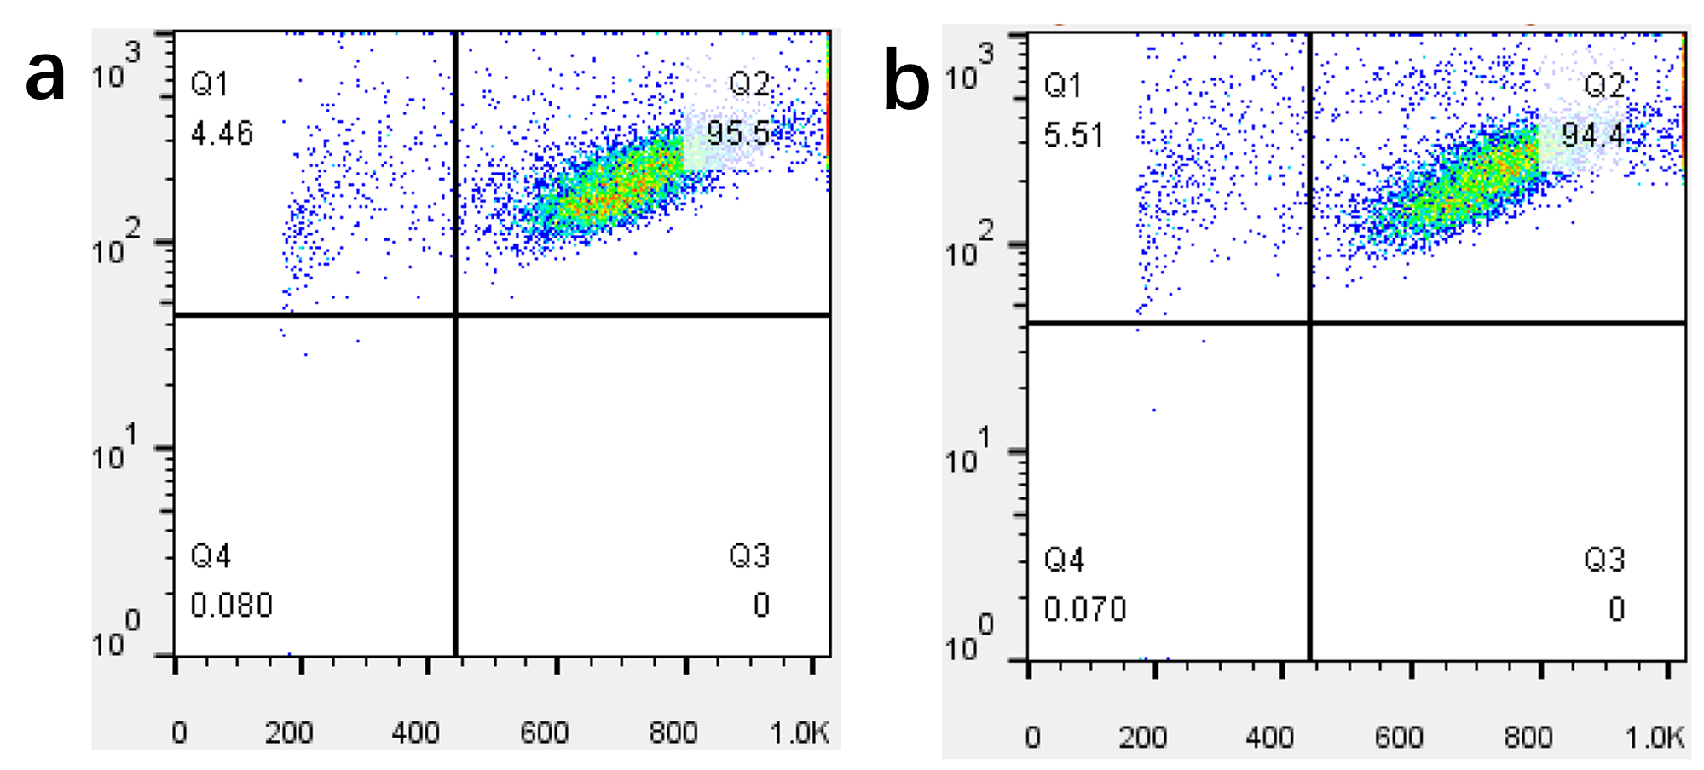Fig. S1 Representative results of flow cytometry for CD4 cell identification. The Q2 quadrant represents CD4 cells. The isolated fraction is typically 94.8 ± 2.3% (mean ± SD).
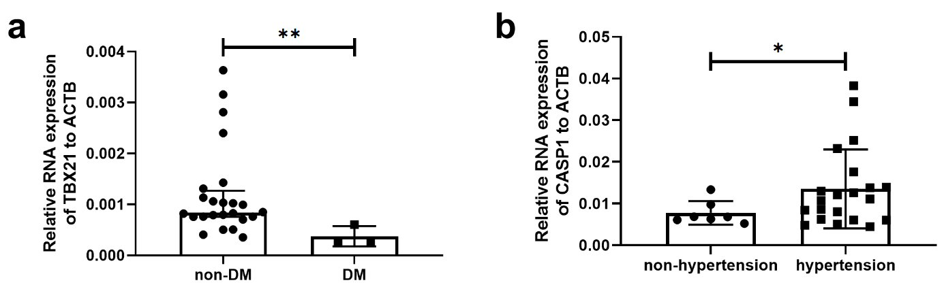
Fig. S2 Hypertension might be a risk factor and Diabetes mellitus (DM) might be a protecting factor for CD4 cell imbalance and inflammasome disturbance. a The difference in TBX21 between patients with and without DM (DM vs. non-DM is 3:24). b The difference of CASP1 between patients with and without hypertension (DM vs. non-DM is 21:7). *P < 0.05, **P < 0.01. The comparison between two groups was performed using Student’s t-test (hypertension) or the Mann-Whitney U test (DM). Samples from 27 patients (DM) or 28 patients (hypertension) were used in this part. Patients were not matched for age and sex due to the big difference of sample sizes between two groups.

