Significance of Neutrophil Gelatinase-associated Lipocalin as a Biomarker for the Diagnosis of Diabetic Kidney Disease: A Systematic Review and Meta-analysis
Peng He, Ming Bai, Jin-ping Hu, Chen Dong, Shiren Sun, Chen Huang

Supplementary data

Item S1 Retrieval strategy of the meta-analysis

PUBMED
(((((((((("Diabetic Nephropathies"[Mesh]) OR Diabetic Nephropathies) OR Diabetic Nephropathy) OR Diabetic Kidney Disease) OR Diabetic Glomerulosclerosis) OR Kimmelstiel Wilson Syndrome) OR Kimmelstiel Wilson Disease) OR Nodular Glomerulosclerosis) OR Intracapillary Glomerulosclerosis)) AND (((((("Lipocalin-2"[Mesh]) OR NGAL) OR Lipocalin 2) OR Oncogene 24p3 Protein) OR Siderocalin Protein) OR Neutrophil Gelatinase Associated Lipocalin)

EMBASE
No. Query Results Results Date
#11. #7 AND #10 439 13 Apr 2019
#10. #8 OR #9 68,662 13 Apr 2019
#9. diabetes AND nephropathy OR (diabetic AND 68,662 13 Apr 2019
glomerulopathy) OR (diabetic AND
glomerulosclerosis) OR (diabetic AND
intercapillary AND glomerulosclerosis) OR
(diabetic AND kidney AND disease) OR (diabetic
AND nephropathies) OR (diabetic AND
nephrosclerosis) OR (glomerulonecrosis, AND
intercapillary) OR (glomerulosclerosis, AND
diabetic) OR (glomerulosclerosis, AND
intercapillary) OR (intercapillary AND
glomerulosclerosis) OR (kimmelstiehl AND wilson
AND syndrome) OR (kimmelstiel AND wilson AND
disease) OR (kimmelstiel AND wilson AND
nephropathy) OR (kimmelstiel AND wilson AND
syndrome) OR (nephropathy, AND diabetic)
#8. 'diabetic nephropathy'/exp 39,442 13 Apr 2019
#7. #2 OR #6 11,395 13 Apr 2019
#6. #3 OR #5 11,395 13 Apr 2019
#5. neutrophil AND gelatinase AND associated AND 8,166 13 Apr 2019
lipocalin
#3. ngal OR (24p3 AND protein) OR (lcn2 AND protein) 11,275 13 Apr 2019
OR (lipocalin AND 2) OR (lipocalin AND 24p3) OR
'lipocalin 2' OR (ngal AND protein) OR (protein
AND 24p3) OR (protein AND lcn2) OR (protein AND
ngal) OR (protein AND sip24) OR siderochalin OR
sip24 OR (sip24 AND protein) OR (superinducible
AND protein AND 24) OR uterocalin
#2. 'neutrophil gelatinase associated lipocalin'/exp 7,781 13 Apr 2019

Cochrane Library
ID Search
#1 MeSH descriptor: [Lipocalin-2] explode all trees
#2 (NGAL) (Word variations have been searched)
#3 (neutrophil gelatinase-associated lipocalin) (Word variations have been searched)
#4 (lipocalin 2) (Word variations have been searched)
#5 MeSH descriptor: [Diabetic Nephropathies] explode all trees
#6 (diabetic nephropathy) (Word variations have been searched)
#7 diabetic nephropathies
#8 diabetic kidney disease
#9 #1 or #2
#10 #9 or #3
#11 #10 or #4
#12 #5 or #6
#13 #12 or #7
#14 #13 or #8
#15 #11 and #14

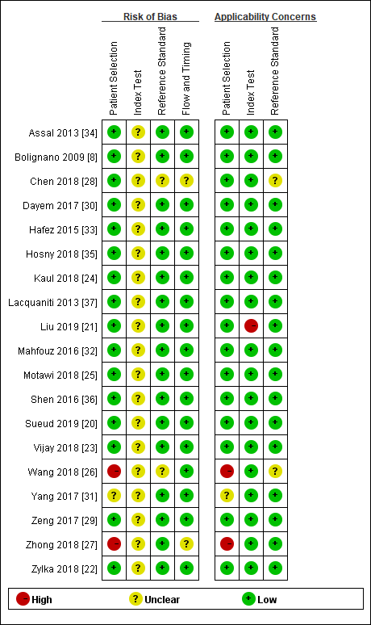
Figure S2 Methodological quality assessment of included studies using QUADAS-2
Abbreviation: QUADAS-2, Quality Assessment of Diagnostic Accuracy Studies 2.

Table S3 Diagnostic value of NGAL for normoalbuminuric diabetes in individual studies

Study | Cutoff value  (ng/ml) | Sensitivity  (%) | Specificity  (%) | TP  （n） | FP  （n） | FN  （n） | TN  （n） | AUC
Serum NGAL
Shen 2016 [36] | 225.5 | 93 | 91 | 25 | 3 | 2 | 32 | 0.960
Lacquaniti 2013 [37] | 77.4 | 88 | 100 | 44 | 0 | 6 | 35 | 0.970
Bolignano 2009 [8] | 88 | 94 | 100 | 15 | 0 | 1 | 18 | 0.969
Urine NGAL
Hosny 2018 [35] | 3.38 | 95 | 100 | 19 | 0 | 1 | 20 | 0.990
Lacquaniti 2013 [37] | 9.3 | 100 | 80 | 50 | 7 | 0 | 28 | 0.956
Bolignano 2009 [8] | 22 | 75 | 100 | 12 | 0 | 4 | 18 | 0.780
Abbreviations: AUC, area under the curve; FP, false-positive; FN, false-negative; NGAL, neutrophil gelatinase-associated lipocalin; NR, not reported; TP, true-positive; TN, true-negative.

Figure S4 The sensitivity, specificity and SROC of Serum and urine NGAL for normoalbuminuric diabetes diagnosis

Serum NGAL
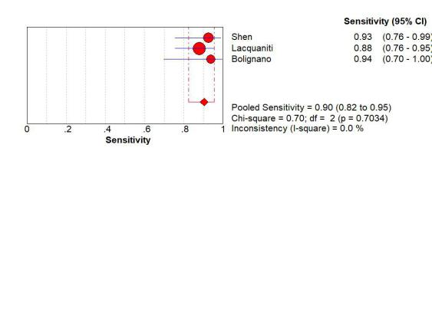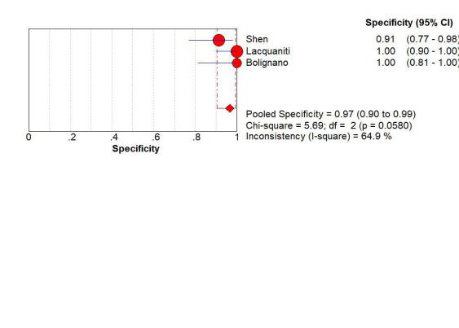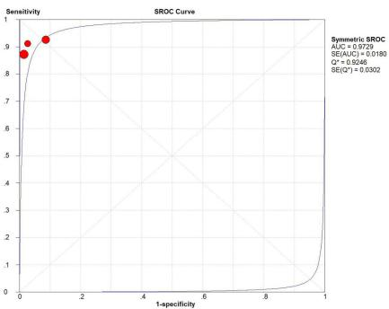
Urine NGAL
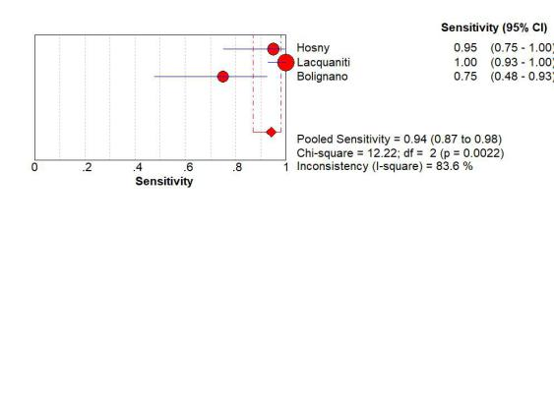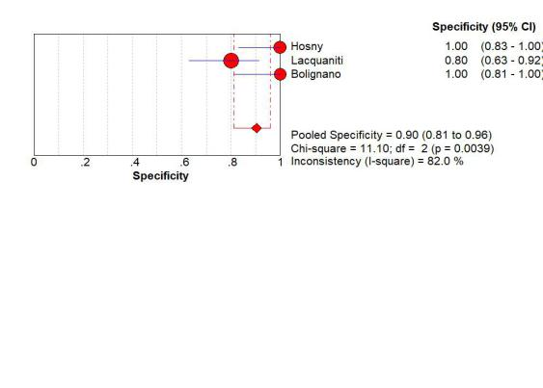

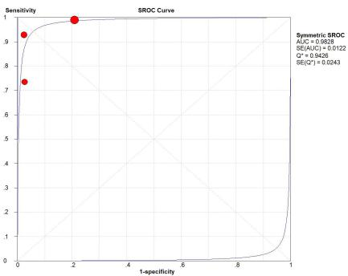
Table S5 Summary of the excluded studies due to insufficient data
Reference | Location | Desigh | Total | Case/control | Target group | Specimen | NGAL assay | AUC
Siddiqui 2019 [38] | Saudi Arabia | Cross-sectional | 92 | 46/46 | DKD/non-DKD | Urine | ELISA | 0.659
Siddiqi 2017 [41] | India | Cross-sectional | 180 | 90/90 | MI/NO | Serum | ELISA | 0.789
 |  |  |  |  |  | Urine | ELISA | 1.000
Su 2018 [39] | China | Cross-sectional | 67 | 32/35 | MI/NO | Serum | TIIA | 0.858
Dai 2018 [40] | China | Cross-sectional | 64 | 26+20/18 | MA+MI/NO | Serum | ELISA | 0.813
Luo 2017 [42] | China | Cross-sectional | 158 | 58+48/52 | MA+MI/NO | Serum | ELISA | 0812
Hao 2016 [43] | China | Cross-sectional | 60 | 40/20 | MA+MI/NO | Urine | ELISA | 0.821
Wang 2015 [44] | China | Cross-sectional | 76 | 50/26 | MA+MI/NO | Serum | TIIA | 0.862
Abbreviations: DKD, diabetic kidney disease; ELISA, electrochemiluminescence immunoassay; MA, macroalbuminuria; MI, microalbuminuria; NGAL, neutrophil gelatinase-associated lipocalin; NO, normoalbuminuria; NR, not reported; TIIA, turbidimetric inhibition immuno assay.

