Supplemental Fig. 1. Boxplot diagram demonstrating statistically significant differences in serum alkaline phosphatase levels on admission between infants with SIP and NEC (p<0.0001).

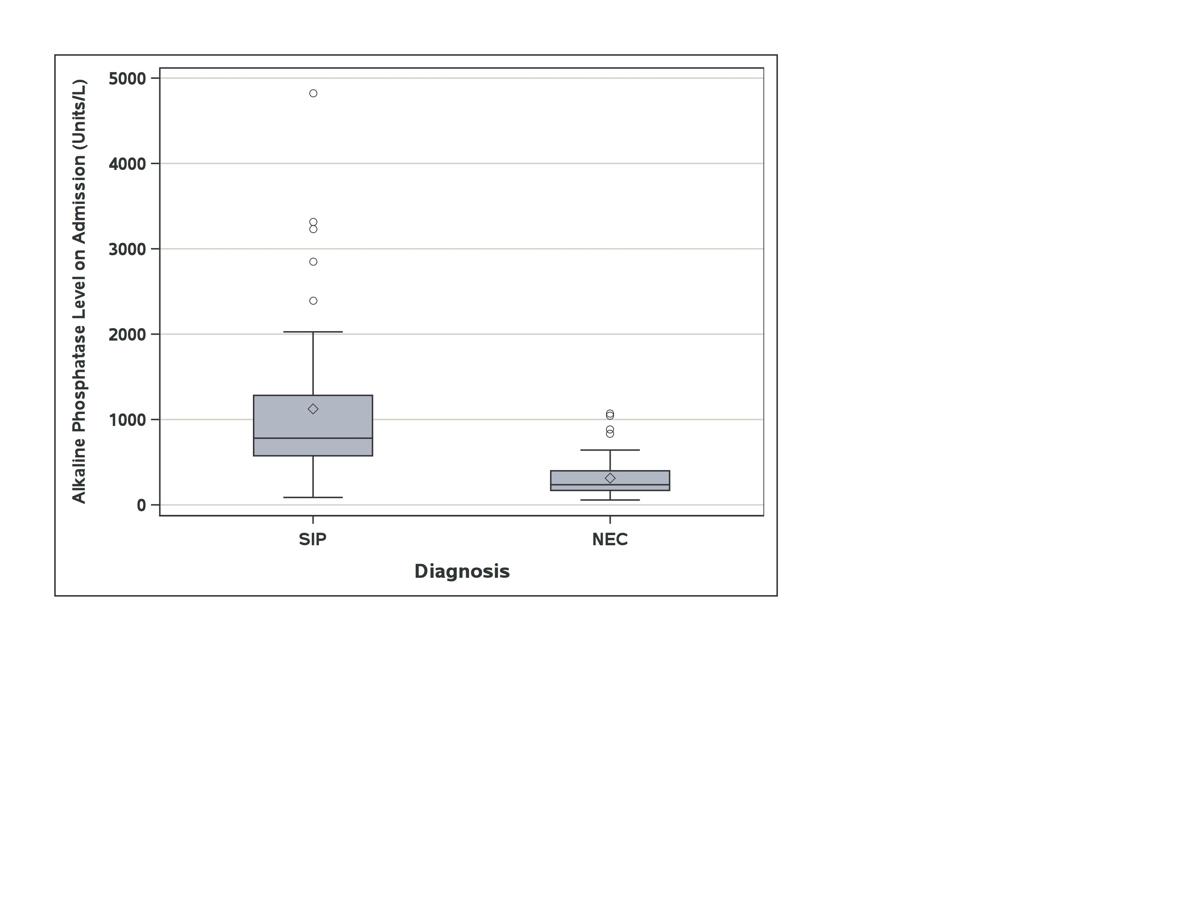

Supplemental Fig. 2. Serial changes in serum alkaline phosphatase level based on diagnosis. Each line represents individual changes in each study subject.

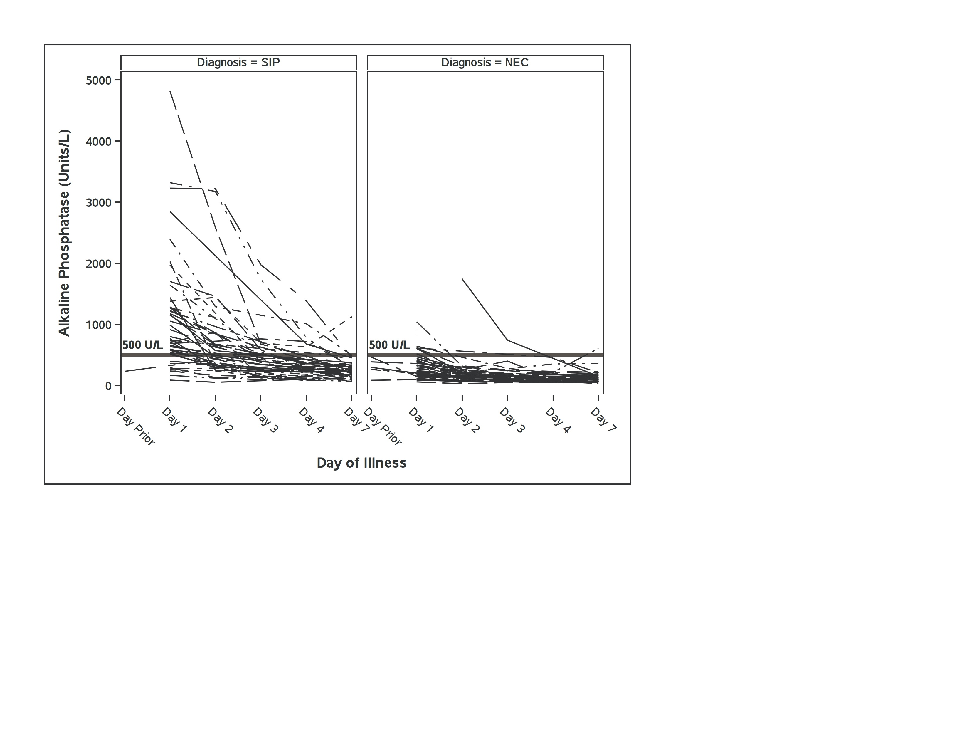

Supplemental Fig. 3. Comparison analysis of receiver operating curves (ROC) of the model including serum alkaline phosphatase level >500 units/L alone (dashed line) and the final multivariate model (solid line) demonstrating significantly improved discrimination of the final model (AUC=0.96, p<0.0001).