SUPPLEMENTAL FILE

Aberrant differentiation of human pluripotent stem cell-derived kidney precursor cells inside mouse vascularized bioreactors.

Parisa Ranjzad¹, Jessica Jinks¹, Amir P. Salahi¹, Ioannis Bantounas¹, Brian Derby², , Susan J. Kimber¹, Adrian S. Woolf^{1,3}, Jason K. F. Wong^{1,4}

¹Division of Cell Matrix Biology and Regenerative Medicine, School of Biological Sciences, Faculty of Biology Medicine and Health, University of Manchester, UK.

²Department of Materials, School of Natural Sciences, Faculty of Science and Engineering, University of Manchester, UK.

³Royal Manchester Children’s Hospital, Manchester University NHS Foundation Trust, Manchester Academic Health Science Centre, Manchester, UK.

⁴Department of Burns and Plastic Surgery, Manchester University NHS Foundation Trust, Manchester Academic Health Science Centre, Wythenshawe Hospital, Manchester, UK.

SUPPLEMENTARY MATERIALS AND METHODS

Immunocytochemistry
Cells in culture were washed twice in PBS and then fixed in 4% paraformaldehyde (PFA) for 20 minutes, followed by another two PBS washes. The fixed cells were blocked and permeabilised for 30 min with 3% bovine serum albumin (BSA)/0.3% Triton-X in PBS before overnight incubation at 4˚C with primary antibodies (Table 1) diluted in three % BSA/PBS. They were then washed three times with PBS/0.1% Triton-X, followed by Alexa-Fluor™-488-conjugated or Alexa-Fluor™-594- conjugated species-specific secondary antibodies (Life Technologies; 1:300 dilution in 3% BSA/PBS). Images were collected on a Zeiss Axioimager.D2 upright microscope using a 63x/Plan-neofluar objective and captured using a Coolsnap HQ2 camera (Photometrics) through Micromanagersoftware v1.4.23. Images were processed and analysed using ImageJ (http://imagej.net/Fiji/Downloads).

Immunohistochemistry

After rehydration, some slides were stained with hematoxylin and eosin. Other slides used for immunohistochemistry. They were boiled in an 800W microwave in 10 mM sodium citrate buffer (pH 6.0). After cooling to room temperature, endogenous peroxidase activity was blocked using 0.3% hydrogen peroxide in PBS for 10 minutes. Sections were permeabilized using 0.2% Triton X-100 (Sigma-Aldrich) for 10 minutes and blocked using 1% bovine serum albumin (BSA) with 10% serum from the species in which the secondary antibody was raised. Sections were incubated overnight at 4°C with the primary antibody and one % BSA. Primary antibodies used are listed in Table 1. Biotin-conjugated species specific secondary antibodies with 1% BSA were incubated at room temperature for 2 hours. Following PBS washes, slides were incubated in avidin-biotin enzyme complex (Vector Laboratories VECTASTAIN Elite ABC Reagent, #PK-6100) for one hour at room temperature. Peroxidase activity was detected with the 3, 3'-diaminobenzidine (DAB) peroxidase substrate solution (Vector Laboratories, #SK4100) in some cases with hematoxylin counterstain. When staining mouse tissue with a mouse antibody was required, Vector MOM Immunodetection Kit (#BMK-2202) was used by following the product datasheet instruction. Sections were dehydrated and mounted with DPX mounting medium. Negative controls omitted primary antibodies. For quantification of CD31 stained areas, images were acquired on a 3D-Histech Pannoramic-250 microscope slide-scanner using an x20 objective (Zeiss) and selected images were captured using the Case Viewer software (3D-Histech). Images were then processed and analysed using Fiji ImageJ (http://imagej.net/Fiji/Downloads). For quantification of hematoxylin and eosin stained tubules, glomeruli and muscle-like cells, images were collected on an Olympus BX63 upright microscope and captured and white-balanced using a DP80 camera (Olympus) in colour mode through CellSens Dimension v1.16 (Olympus). Images were then processed and analysed using Fiji ImageJ (http://imagej.net/Fiji/Downloads). Other sections were stained with 1% PSR solution for one hour, and then washed for five minutes with two changes of acetic acid water. Sections were then dehydrated and mounted. Red birefringence was visualized when PSR-stained sections were viewed under cross-polarised light on an Olympus BX63 upright microscope.

SUPPLEMENTARY FIGURES AND LEGENDS

Supplementary Figure 1. Comparison of immunostaining patterns using two different CD31 antibodies. a. and b. are adjacent sections from a chamber harvested at three weeks after surgery that had received an implant of human KPCs. In each frame, two glomeruli are indicated by g. a. Note the brown immunostaining with the R&D Systems AF3628 antibody. b. No significant signal with the Cell Signalling 3528 antibody that reacts with human but not mouse protein. c. Adult mouse native kidney probed with AF3628 antibody; note signals in the glomerulus (g), a vein (v), and artery (a) and between tubules. d. Native human ten week gestation metanephric kidney probed with the 3528 antibody; note the signal in the tuft of the glomerulus (g). From these experiments we discerned that CD31 expressing vessels in glomerular tufts within implant chambers were of mouse origin. All bars are 50 μm.

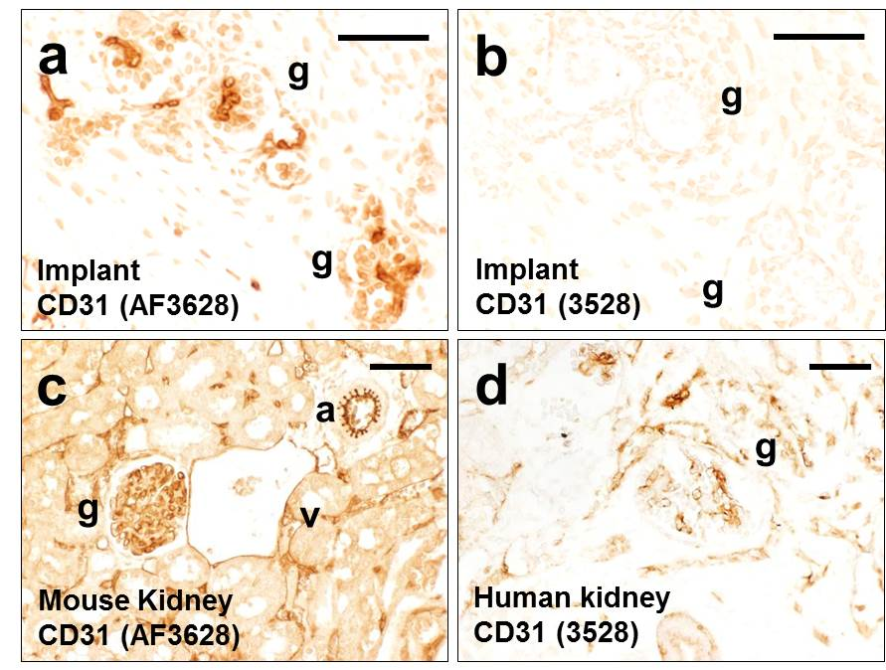

Supplementary Figure 2. HuMt immunostaining. a-d. Sections of three month KPC implants. a. Intense brown signal in a tubule, with subsets of brown cells in surrounding stroma. b. Elongated muscle-like cells were also positive for HuMt. c. and d. When the primary antibody was omitted, no brown signal was detected in similar types of cells. e. Zones of skeletal muscle around the chamber (i.e. presumed mouse host tissues) were unreactive with the HuMt antibody. All bars are 50 μm.

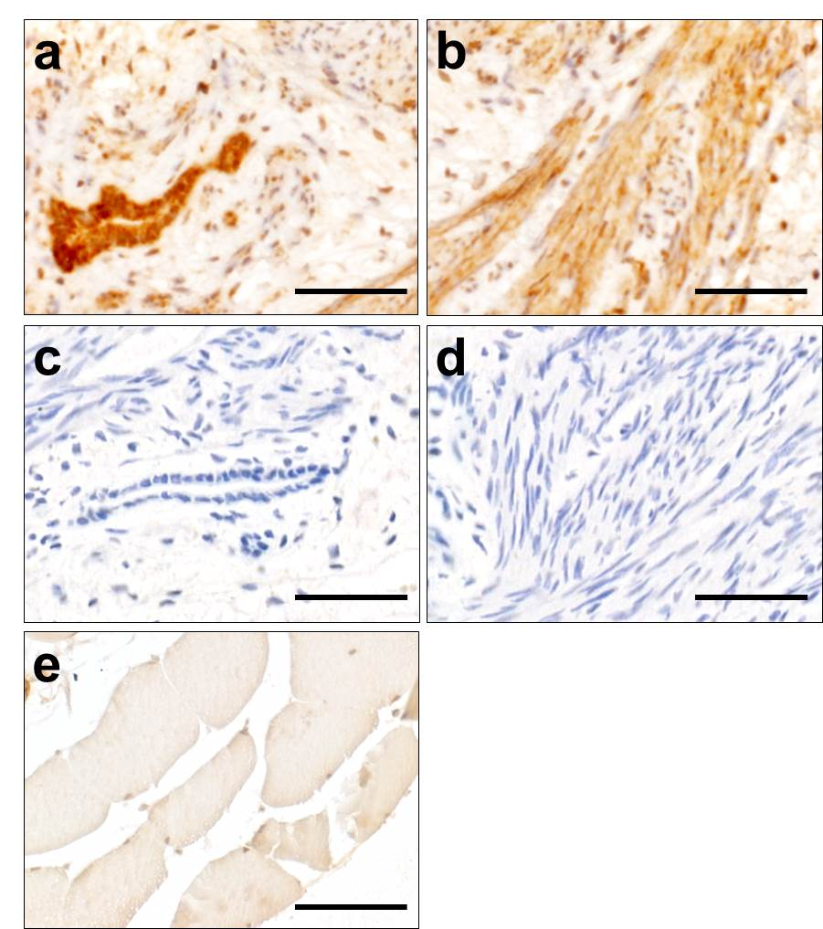

Supplementary Figure 3. PSR staining of three months KPC implants. a. and b. Bright field images. Areas from inside an AVFT chamber (a) and a chamber lacking an AVFT (b) both showing tubule (arrow) surrounded by red stained tissues. c. and d. The same PSR stained areas imaged under polarized light. Note the apparently more prominent signal (red) in the AVFT chamber. All bars are 50 μm




