Pollutant | Time Period | Agency | Concentration | Permitted exceedances per year
PM_{2.5} | Yearly | EU | 25 μg/m³ | N/A
 |  | WHO | 10 μg/m³ | N/A
 | Daily | EU | N/A | N/A
 |  | WHO | 25 μg/m³ | None
PM₁₀ | Yearly | EU | 40 μg/m³ | N/A
 |  | WHO | 20 μg/m³ | N/A
 | Daily | EU | 50 μg/m³ | 35
 |  | WHO | 50 μg/m³ | None
NO₂ | Yearly | EU | 40 μg/m³ | N/A
 |  | WHO | 40 μg/m³ | N/A
 | Hourly | EU | 200 μg/m³ | 18
 |  | WHO | 200 μg/m³ | None
SO₂ | Daily | EU | 125 μg/m³ | 3
 |  | WHO | 20 μg/m³ | None
 | Hourly | EU | 350 μg/m³ | 24
 | 10-minute mean | WHO | 500 μg/m³ | None
Ozone | Maximum daily 8 hour mean | EU | 120 μg/m³ | 25 days averaged over 3 years
 |  | WHO | 100 μg/m³ | None
Supplemental Table 1: European Union and World Health Organisation limits for air pollutants (2019)

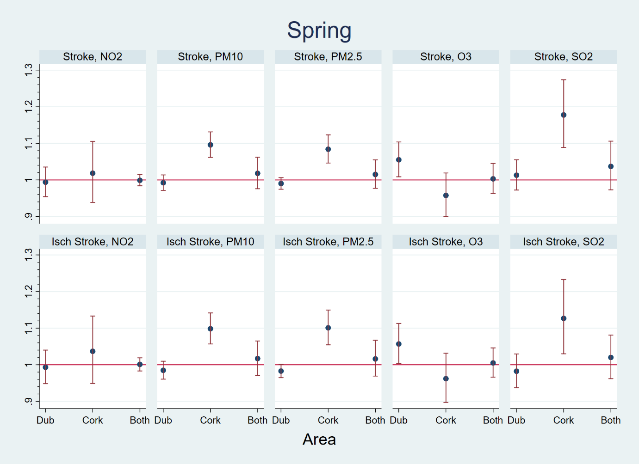
Supplemental Figure 1: Single-pollutant models for the impact of IQR changes in pollution levels for all stroke cases (Stroke) and ischaemic stroke cases (Isch Stroke) in Dublin (Dub), Cork, and both areas together at lag 0-2 days during Spring. Relative risks (blue dots) and 95% confidence intervals (red vertical lines).

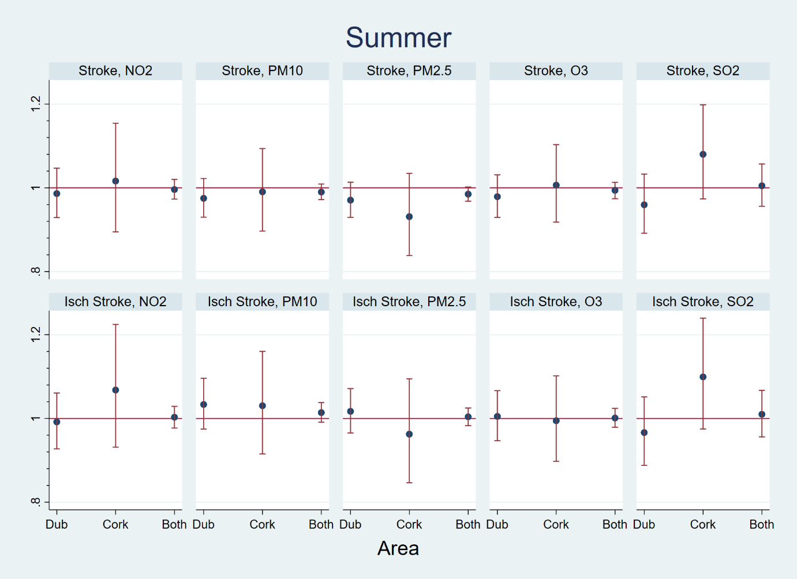
Supplemental Figure 2: Single-pollutant models for the impact of IQR changes in pollution levels for all stroke cases (Stroke) and ischaemic stroke cases (Isch Stroke) in Dublin (Dub), Cork, and both areas together at lag 0-2 days during Summer. Relative risks (blue dots) and 95% confidence intervals (red vertical lines).

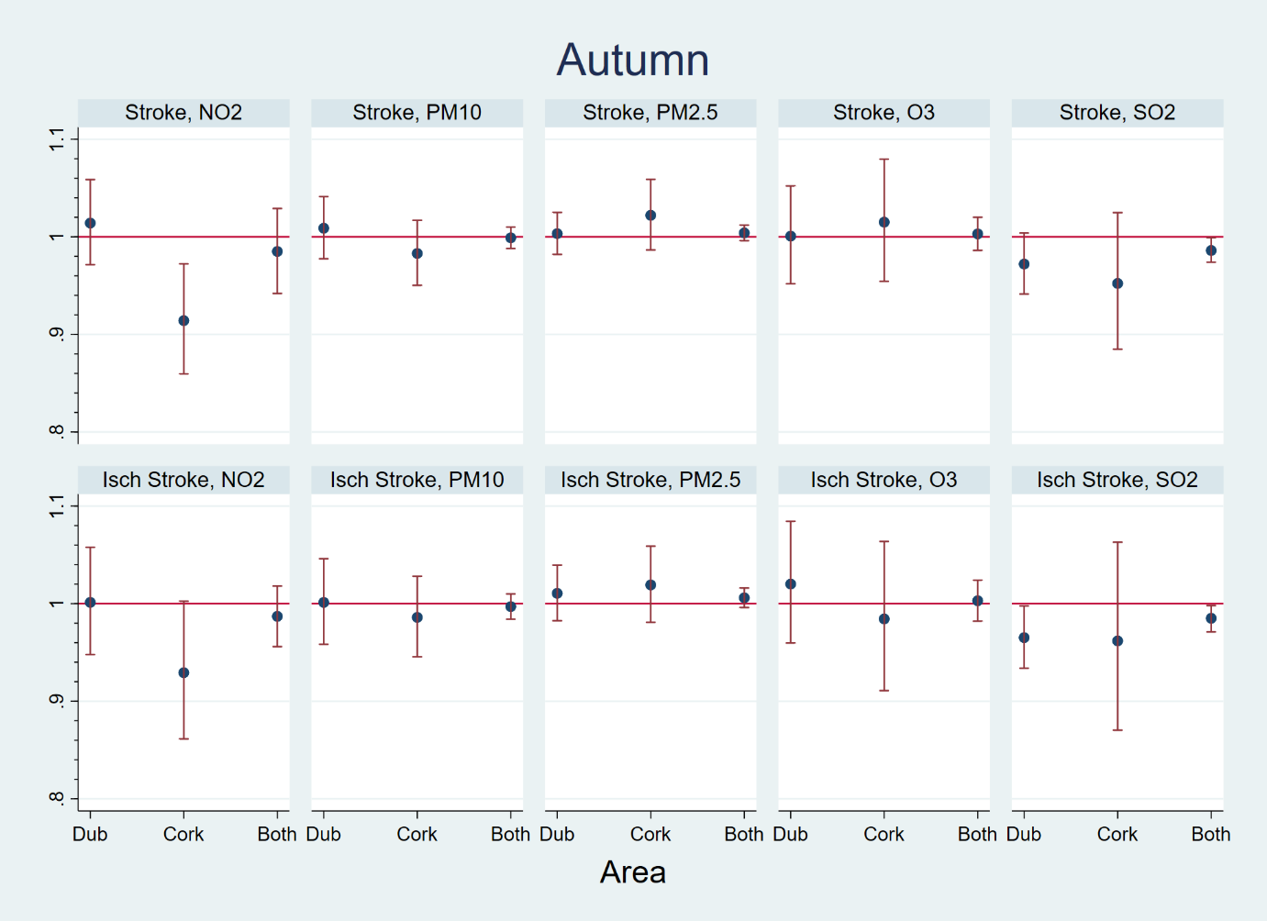
Supplemental Figure 3: Single-pollutant models for the impact of IQR changes in pollution levels for all stroke cases (Stroke) and ischaemic stroke cases (Isch Stroke) in Dublin (Dub), Cork, and both areas together at lag 0-2 days during Autumn. Relative risks (blue dots) and 95% confidence intervals (red vertical lines).

