Supplementary Table 1. Final weight gain and average fed plasma glucose levels over the 28 days after balloon arterial injury in rats.
Treatment  Groups | NFC | HFC | NFR | HFR
Weight Gain  (g) | 96 ± 6 | 133 ± 13*** | 98 ± 7 | 129 ± 9***
Fed Plasma Glucose (mM) | 7.6 ± 0.1 | 7.9 ± 0.1 | 7.6 ± 0.1 | 7.9 ± 0.2

NFC = Normal-Fat Control, n=17; HFC = High-Fat Control, n=9; NFR = Normal-Fat with Resveratrol (RSV), n=17; HFR = High-Fat with RSV, n=8. Data are expressed as mean ± SEM. *** A significant main effect of diet (P < 0.001), with no interaction with RSV, on weight gain was found.

Supplementary Table 2. Fed plasma insulin, triglyceride and free fatty acid levels at 28 days after balloon arterial injury in rats.
Treatment  Groups | NFC | HFC | NFR | HFR
Insulin  (pM) | 188 ± 37 | 110 ± 12 | 151 ± 26 | 121 ± 30
Triglycerides  (mM) | 1.33 ± 0.24 | 0.90 ± 0.14 | 1.10 ± 0.21 | 1.81 ± 0.46
Free Fatty Acids  (μM) | 620 ± 106 | 746 ± 167 | 532 ± 79 | 830 ± 119

Fed plasma levels of insulin, triglycerides and free fatty acids 28 days after vessel injury. NFC = Normal-Fat Control, n=10; HFC = High-Fat Control, n=5; NFR = Normal-Fat with Resveratrol (RSV), n=9; HFR = High-Fat with RSV, n=4. No significant main effect of diet or RSV or interaction of diet with RSV was found.

Supplementary Table 3. Plasma nitric oxide at 28 days after balloon arterial injury in rats.
Treatment  Groups | NFC | HFC | NFR | HFR
Plasma NO  (μM) | 55.2 ± 9.2 | 41.4 ± 5.9 | 71.6 ± 16.7 | 33.5 ± 4.4

NFC = Normal-Fat Control, n=9; HFC = High-Fat Control, n=9; NFR = Normal-Fat with Resveratrol (RSV), n=12; HFR = High-Fat with RSV, n=12. Data are expressed as mean ± SEM. No significant main effect of diet or RSV or interaction of diet with RSV was found.

Supplementary Table 4. Final weight gain and average fed plasma glucose levels over the 28 days after femoral wire injury in SIRT1^{Y/Y} and wild type mice.
Treatment  Groups | WT-HFC | SIRT1^{Y/Y}-HFC | WT-HFR | SIRT1^{Y/Y}-HFR
Weight Gain  (g) | 0.2 ± 0.7 | 2.9 ± 0.7 | 0.4 ± 0.8 | 0.4 ± 1
Fed Plasma Glucose (mM) | 8.4 ± 0.3 | 8.6 ± 0.2 | 9.2 ± 0.1 | 9.0 ± 0.9

WT-HFC = Wild Type mice-High-Fat Control, n=12; SIRT1^{Y/Y}-HFC = mice expressing a catalytically dead SIRT1-HFC, n=8; WT-HFR = WT-High-Fat with Resveratrol (RSV), n=9; SIRT1^{Y/Y}-HFR, n=6. Data are expressed as mean ± SEM. No significant changes induced by RSV were found.

Supplementary Table 5. Final weight gain and average fed plasma glucose levels over the 28 days after femoral wire injury in heterozygous SIRT1-null and wild type mice.
Treatment  Groups | WT-HFC | SIRT1^{+/-}-HFC | WT-HFR | SIRT1^{+/-}-HFR
Weight Gain  (g) | 1.6 ± 0.4 | 1.8 ± 0.9 | 2.8 ± 0.6 | 2.8 ± 0.6
Fed Plasma Glucose (mM) | 9.0 ± 0.9 | 9.3 ± 0.7 | 7.9 ± 0.9 | 8.8 ± 0.4

WT-HFC = Wild Type mice-High-Fat Control, n=5; SIRT1^{+/-} -HFC= heterozygous SIRT1-null mice-HFC, n=8; WT-HFR = WT-High-Fat with Resveratrol (RSV), n=5; SIRT1^{+/-} -HFR, n=11. Data are expressed as mean ± SEM. No significant changes induced by RSV were found.

Supplementary Table 6. Final weight gain and average fed plasma glucose levels over the 28 days after femoral wire injury in AMPKα2-null and wild type mice.
Treatment  Groups | WT-HFC | AMPKα2^{-/-}-HFC | WT-HFR | AMPKα2^{-/-}--HFR
Weight Gain  (g) | 1.2 ± 0.5 | 0.5 ± 1.6 | 1.7 ± 0.3 | 0.8 ± 0.5
Fed Plasma Glucose (mM) | 8.8 ± 0.5 | 9.4 ± 0.7 | 9.7 ± 0.7 | 8.6 ± 0.8

WT-HFC = Wild Type mice-High-Fat Control, n=5; AMPKα2^{-/-}-HFC= AMPKα2-null mice-HFC, n=5; WT-HFR = WT-High-Fat with Resveratrol (RSV), n=4 for weight gain, n=5 for fed plasma glucose; AMPKα2^{-/-} -HFR, n=5. Data are expressed as mean ± SEM. No significant changes induced by RSV were found.

Supplementary Table 7. Plasma nitric oxide at 28 days after femoral wire injury in SIRT^{Y/Y}, SIRT^{+/-} , AMPKα2(-/-) mice and their respective wild type mice.
A.
Treatment  Groups | WT-HFC | SIRT1^{Y/Y}-HFC | WT-HFR | SIRT1^{Y/Y}-HFR
Plasma NO (μM) | 14.0 ± 1.9 | 12.7 ± 2.2 | 16.3 ± 1.8 | 15.9 ± 4.9
WT-HFC = Wild Type mice-High-Fat Control, n=13; SIRT1^{Y/Y}-HFC = mice expressing a catalytically dead SIRT1-HFC, n=12; WT-HFR = WT-High-Fat with Resveratrol (RSV), n=9; SIRT1^{Y/Y}-HFR, n=7. Data are expressed as mean ± SEM. No significant changes induced by RSV were found.
B.
Treatment  Groups | WT-HFC | SIRT1^{+/-}-HFC | WT-HFR | SIRT1^{+/-}-HFR
Plasma NO (μM) | 16.6 ± 3.3 | 13.3 ± 1.5 | 12.9 ± 1.8 | 12.1 ± 1.9
WT-HFC = Wild Type mice-High-Fat Control, n=8; SIRT1^{+/-} -HFC= heterozygous SIRT1-null mice-HFC, n=10; WT-HFR = WT-High-Fat with Resveratrol (RSV), n=5; SIRT1^{+/-} -HFR, n=6. Data are expressed as mean ± SEM. No significant changes induced by RSV were found.
C.
Treatment  Groups | WT-HFC | AMPKα2^{-/-}-HFC | WT-HFR | AMPKα2^{-/-}-HFR
Plasma NO (μM) | 35.6 ± 5.5 | 35.0 ± 7.1 | 27.4 ± 3.0 | 28.6 ± 3.4
WT-HFC = Wild Type mice-High-Fat Control, n=10; AMPKα2^{-/-}-HFC= AMPKα2-null mice-HFC, n=5; WT-HFR = WT-High-Fat with Resveratrol (RSV), n=9; AMPKα2^{-/-}-HFR, n=7. Data are expressed as mean ± SEM. No significant changes induced by RSV were found.

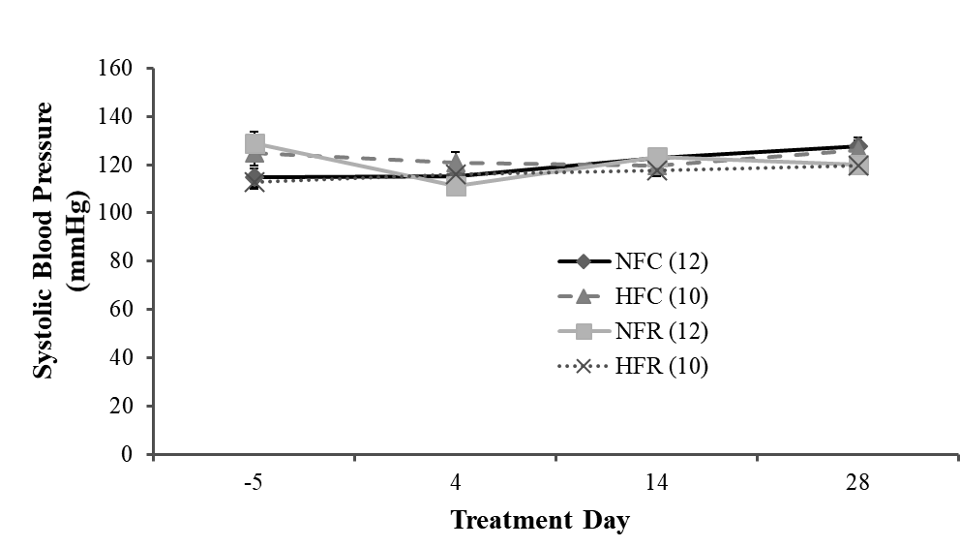

Supplementary Figure 1: The effect of resveratrol (RSV) on systolic blood pressure in rats fed a normal- or high-fat diet. Systolic blood pressures were measured at 3 days before, and 4, 14, and 28 days after carotid arterial injury (corresponding to day 0, 7, 17, and 31 of the treatment, respectively) in rats. NFC = Normal-Fat Control, n=12; HFC = High-Fat Control, n=10; NFR = Normal-fat with RSV, n=12; HFR = High-fat with RSV, n=10. Data are expressed as mean ± SEM. No significant differences induced by diet or RSV were found.

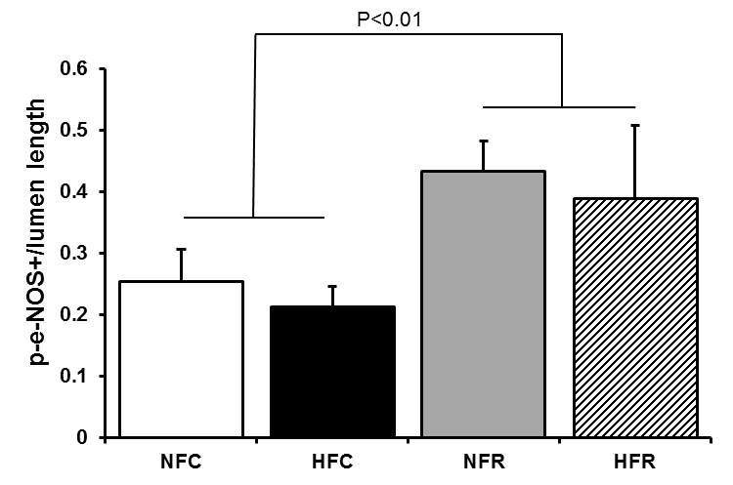
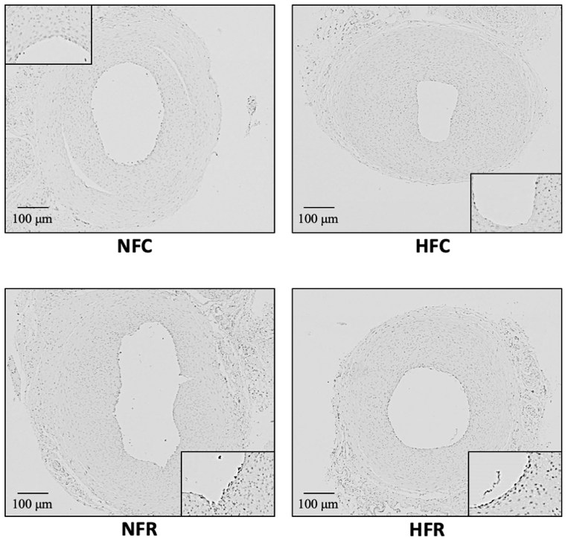
A
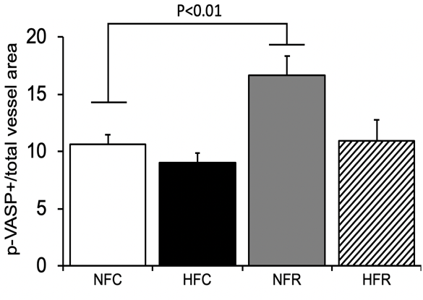
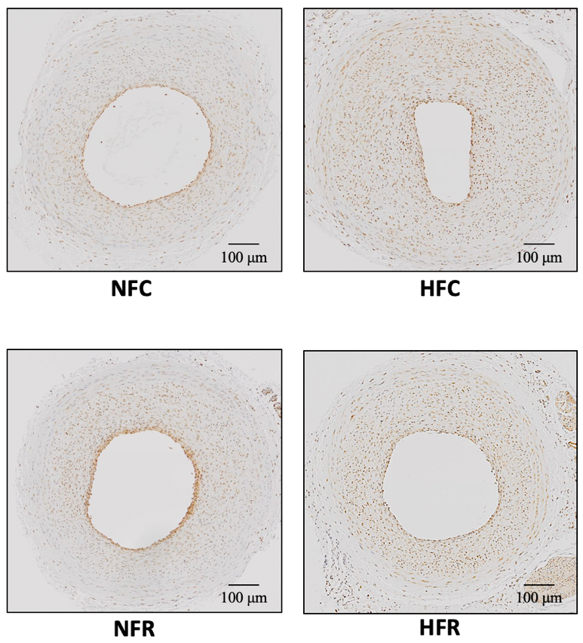
B
Supplementary Figure 2: The effect of resveratrol (RSV) on immunohistochemically determined phosphorylated endothelial nitric oxide synthase (p-eNOS) (A) and phosphorylated vasodilator stimulated phosphoprotein (p-VASP) (B) in rats fed a normal- or high-fat diet. Representative images (×40) are shown on the left. Inserts are ×400. NFC = Normal-fat control, A: n=15, B=10; HFC = High-fat control, A: n=9, B: n=8; NFR = Normal-fat with RSV, A: n=10, B=12; HFR = High-fat with RSV, A: n=5, B=6. Data are expressed as mean ± SEM. A significant main effect of RSV was found in p-eNOS whereas the intergroup differences did not reach significance on Bonferroni’s test. In contrast, there was a significant difference between NFC and NFR groups in p-VASP. Both RSV and diet had significant main effects (P<0.01 and P<0.05 resp., not shown) on p-VASP.
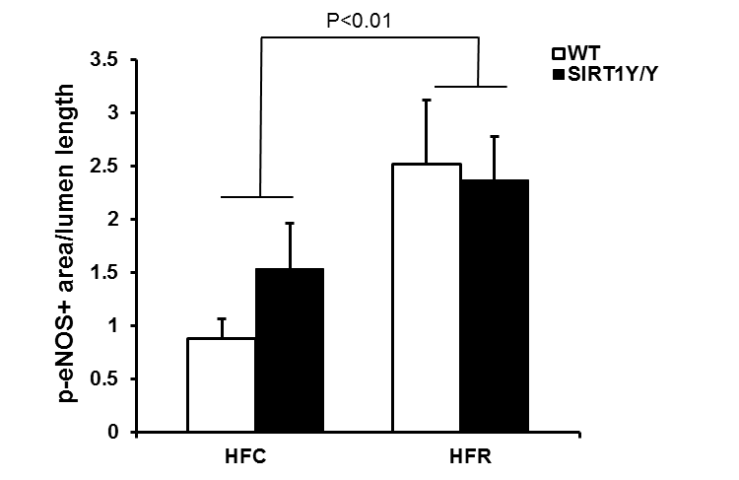
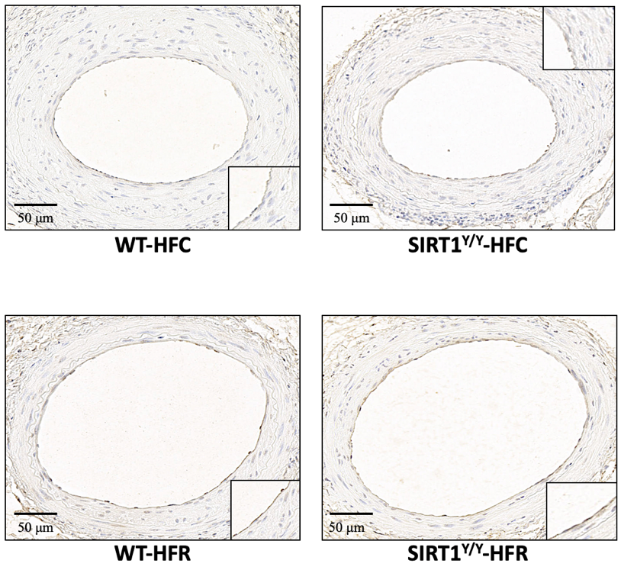
- WT
- SIRT1^{Y/Y}
A
B
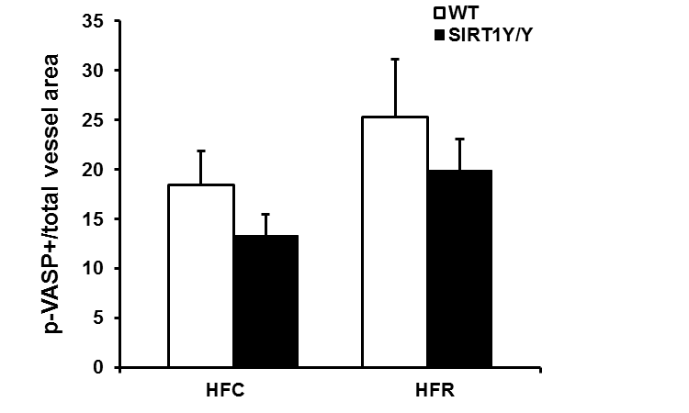
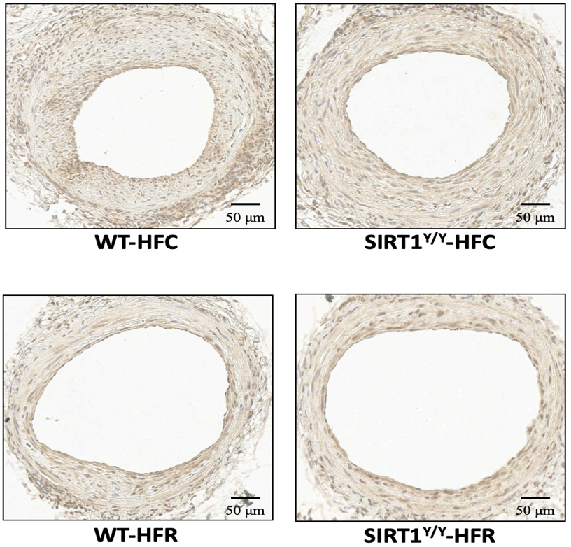
- WT
- SIRT1^{Y/Y}
Supplementary Figure 3: The effect of resveratrol (RSV) on immunohistochemically determined phosphorylated endothelial nitric oxide synthase (p-eNOS) (A) and phosphorylated vasodilator stimulated phosphoprotein (p-VASP) (B) in mice expressing a catalytically-inactive SIRT1 (SIRT1^{Y/Y}) and wild type (WT) controls. Representative images (×200) are shown on the left. Inserts are ×2000. Mice were fed either high-fat diet (HFC, WT: A, n=7, B: n=8; SIRT1^{Y/Y}: A, n=8, B, n=7) or RSV supplemented high-fat diet (HFR, WT: A, n=6, B, n=8; SIRT1^{Y/Y}:A, n=6, B, n=6). Data are expressed as mean ± SEM. A significant main effect of RSV (P<0.01) on p-eNOS was found. No significant intergroup differences were found using post hoc Bonferroni’s test.
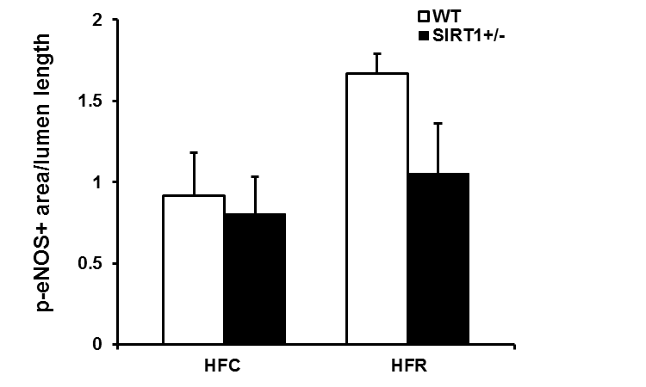
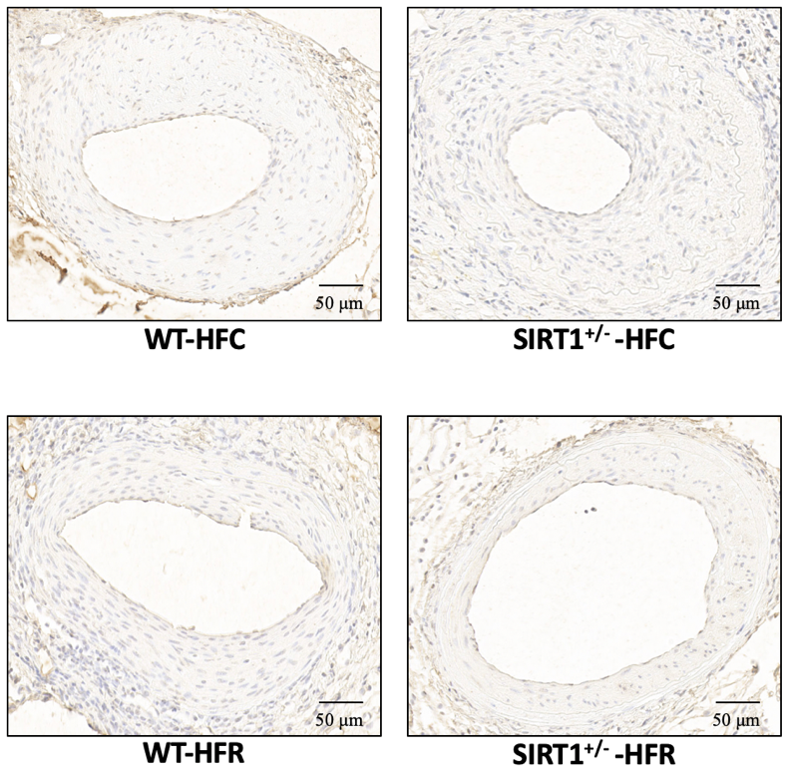
- WT
- SIRT1^{+/-}
A
B
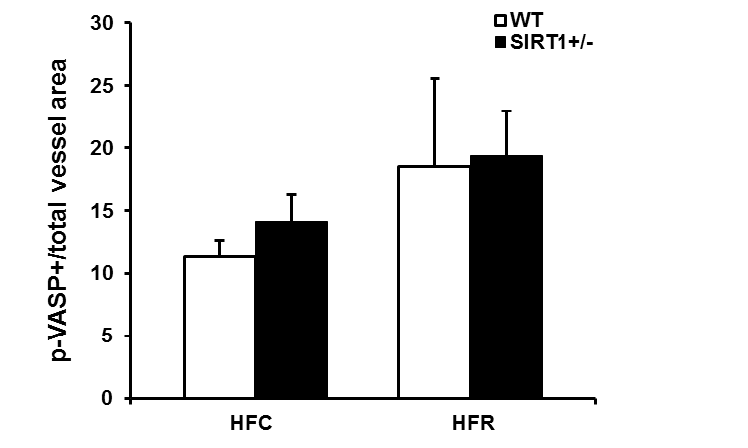
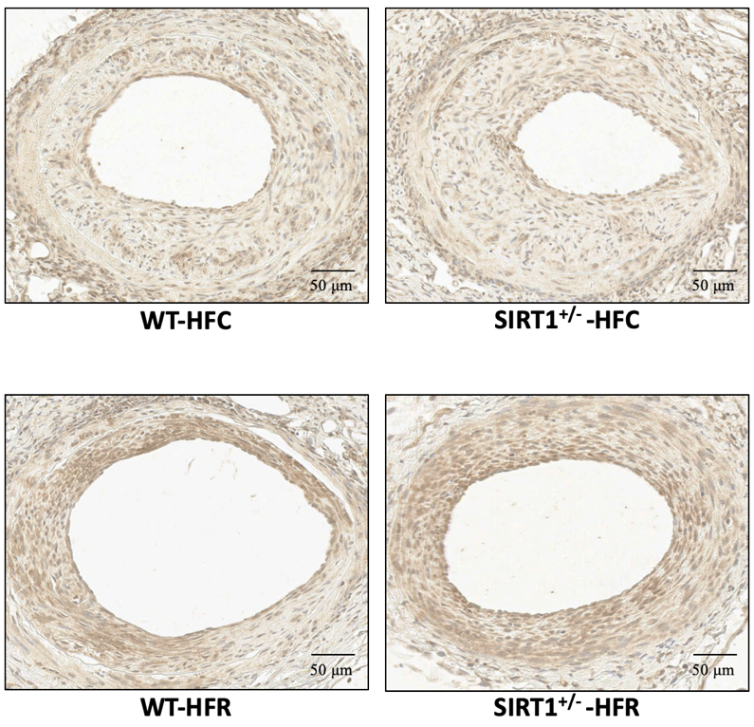
- WT
- SIRT1^{+/-}
Supplementary Figure 4: The effect of resveratrol (RSV) on immunohistochemically determined phosphorylated endothelial nitric oxide synthase (p-eNOS) (A) and phosphorylated vasodilator stimulated phosphoprotein (p-VASP) (B) in heterozygous SIRT1-null (SIRT1^{+/-}) mice and wild type (WT) controls. Representative images are shown on the left. Mice were fed either high-fat diet (HFC, WT: A, n=4, B: n=4; SIRT1^{+/-}: A, n=6, B, n=6) or RSV supplemented high-fat diet (HFR, WT: A, n=6, B, n=4; SIRT1^{+/-}: A, n=6, B, n=9). Data are expressed as mean ± SEM. No significant effects were found.
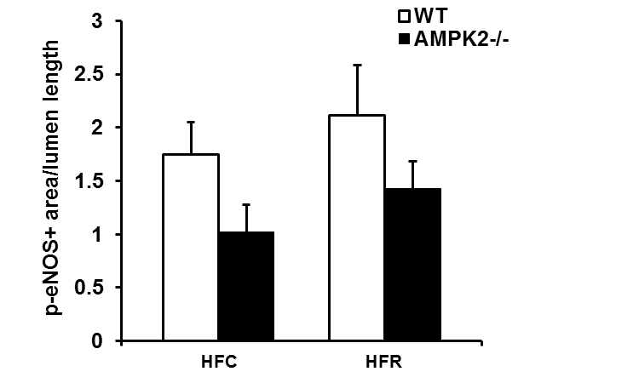
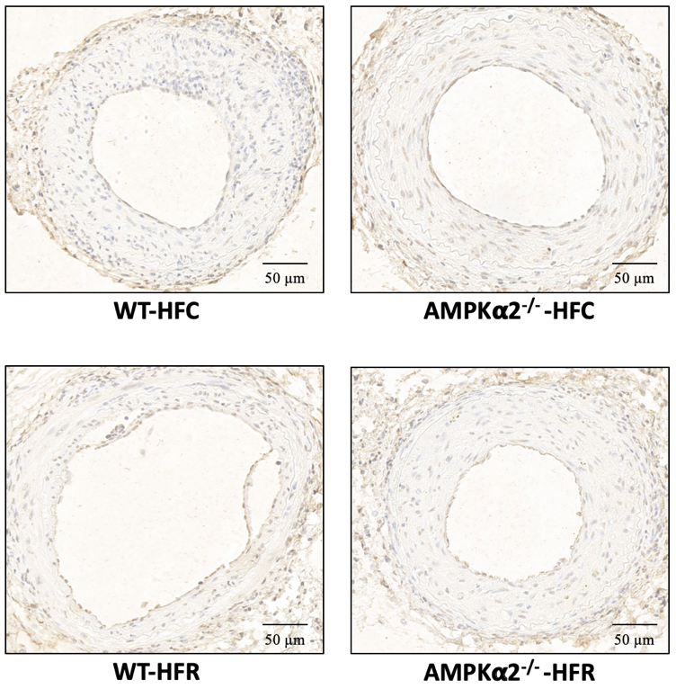
- WT
- AMPKα2^{-/-}
A
B
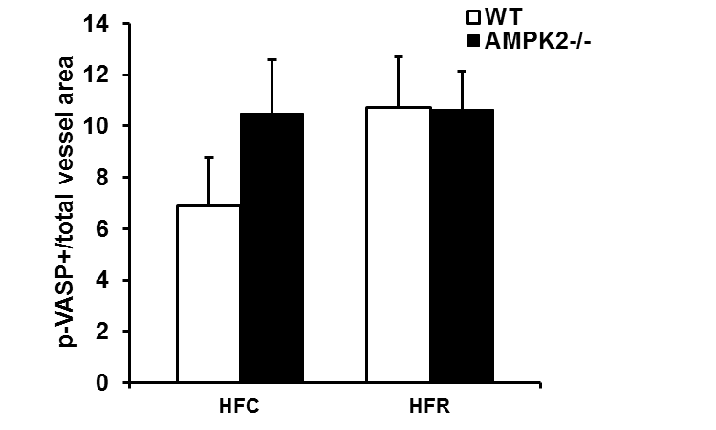
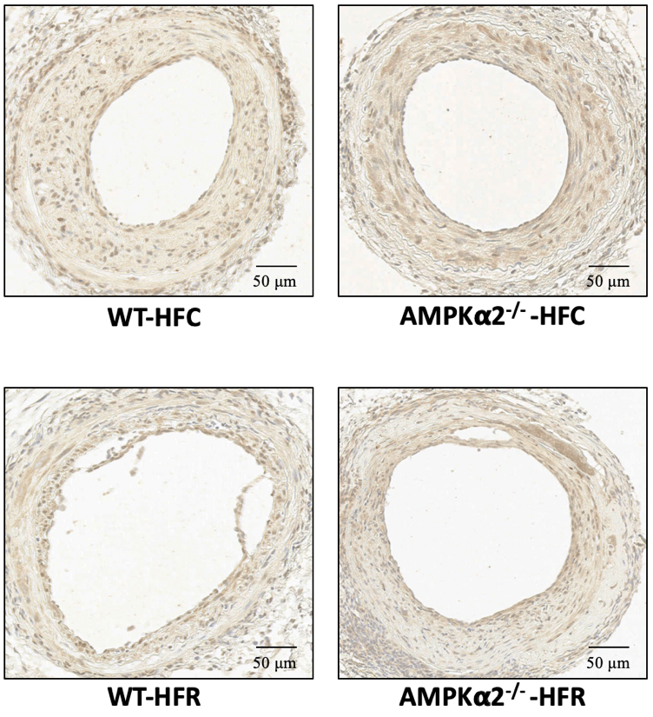
- WT
- AMPKα2^{-/-}
Supplementary Figure 5: The effect of resveratrol (RSV) on immunohistochemically determined phosphorylated endothelial nitric oxide synthase (p-eNOS) (A) and phosphorylated vasodilator stimulated phosphoprotein (p-VASP) (B) in AMPKα2-null (AMPKα2^{-/-}) mice and wild type (WT) controls. Representative images are shown on top. Mice were fed either high-fat diet (HFC, WT: A, n=11, B: n=10; AMPKα2^{-/-}: A, n=5, B, n=5) or RSV supplemented high-fat diet (HFR, WT: A, n=9, B, n=10; AMPKα2^{-/-}: A, n=10, B, n=10). Data are expressed as mean ± SEM. No significant effects were found.

