Supplemental Material

Neuroendocrine Tumor Omic Gene Cluster Analysis Amplifies the Prognostic Accuracy of the NETest

Mark Kidd¹, Alexandra Kitz¹, Ignat Drozdov², Irvin Modlin³*

¹Wren Laboratories, 688 East Main Street, Branford CT 06405, USA
²Bering Limited, London UK
³Yale University School of Medicine, New Haven CT 06510, USA

*Corresponding author:
imodlin@optonline.net

1. Supplemental Figures

1. Tumor location or grade and relationship to omes.
An evaluation by tumor location (pancreatic vs. non-pancreatic) identified significant (p<0.05) differences in expression of the apoptome, fibrosome, GF-signalome and inflammasome (Supplemental Figure 1A). These were all upregulated in non-pancreatic NETs consistent with known pathobiological roles (1, 2). An evaluation by grade (G1/TC vs. G2/AC and G3), identified a significantly higher (p<0.05) apoptome in the higher grade tumors (Supplemental Figure 1B). This is consistent with the known correlation between increased an apoptosis and higher Ki-67 as has been previously described in lung and rectal NETs (3, 4).

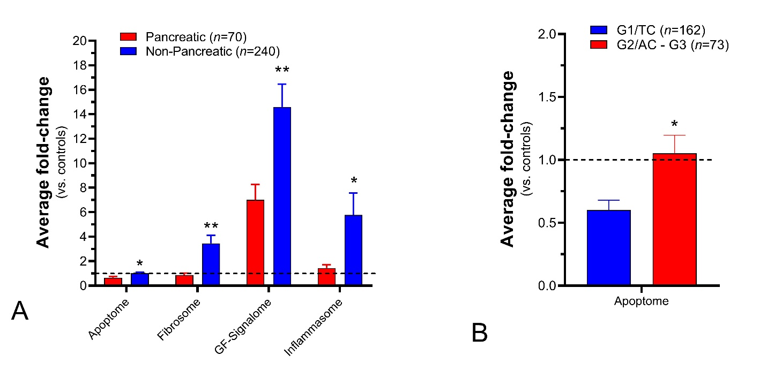
1A. Tumor site: Omic expression of the apoptome, fibrosome, GF-signalome and inflammasome were elevated in non-pancreatic NETs.
*p<0.05; **p<0.001
1B. Histological grade: Expression of the apoptome was increased in G2-G3 and AC tumors compared to G1/TC.
*p<0.05

2. Prognostic comparison between Ki-67 and the NETest
We evaluated the correlation between grade as assessed by Ki-67 or the number of omes and disease progression (Supplemental Figure 2). Ki-67 (G1/TC versus G2/AC) was associated with a hazard ratio of 1.47, which was not significant (p=0.37). In contrast, patients with >3 omes exhibited a median PFS of 6 months and was associated with a hazard ratio of ~4 as a prognostic. The prognostic accuracy of omes alone was ~70% which was better (p=0.07) than for Ki-67 which was 58%.
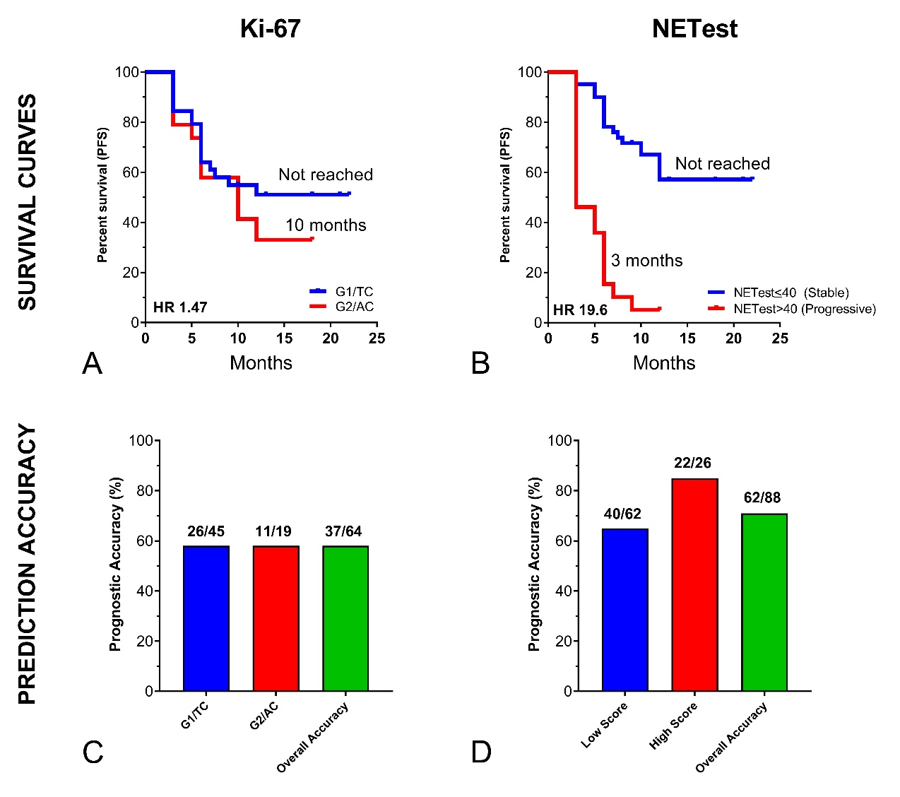
2A-B. Survival Curves in Cohort II.
Kaplan-Meier survival curves were generated for Ki-67/grade (2A) and NETest (2B). For grade, we compared G1/TC versus G2/AC. While this was associated with a median progression free survival (mPFS) of 10 months in high grade lesions vs. not reach for G1/TC tumors, the hazard ratio was 1.47 with a non-significant Chi² (0.8, p=0.37). For NETest, we evaluated low versus high scores (<40 vs. >40). The NETest was associated with significant differences (Chi² = 43.12, p<0.0001) in outcomes: mPFS = 3 months vs. not reached. This demonstrates that the NETest (using low vs. high cut-off) provides highly significantly prognostic information.
2C-D. Accuracy of prediction.
Using Ki-67/grade, the prognostic accuracy was 58% (for G1/TC and for G2/AC) with an overall accuracy of 58% (37/64). For the NETest, a low score was 65% accurate, a high score was 85% accurate, and overall, the prognostic accuracy was 70.5%. A comparison between the NETest and Ki67 identified this trended toward significance (p=0.07, Fisher’s test).

3. Clinical implication of NETest and novel omes
The clinical applications of the NETest are illustrated in Figure 7 (main text).

The first clinical utility is as a biomarker for tumor status (stable or not at the time of blood draw). This has fundamental importance for defining e.g., whether a patient is responding to therapy or, if they are in a watch-and-wait program, whether they require treatment intervention. Under these conditions, the NETest can be used as a dynamic (e.g., every 3 months) measurement of clinical behavior.

The second utility relates to those specifically with a low score (<40). A proportion (~ one third) of these patients will progress and it would be clinically beneficial to predict those in who this would occur. Integration of the epigenome/metastasome (prognosome) data into a low score accurately identified (>90%) those who progressed at an early stage. Early intervention is a critical component of clinical management and identification of this is important given the known difficulties with morphological assessment of slow-growing tumors (5).

4. Biological validation of novel omes
Fibrosome: This included APLP2, BNIP3L, CD59, CTGF. APLP2 is evident in cardiac fibrosis (6) and BNIP3L reported to promote cardiac fibrosis through TGFβ-pathway activation (7). Complement dysregulation via CD59 has also been identified to play a role (8), while CTGF is a well-known profibrotic factor (9). The fibrosome has been independently been demonstrated to be an effective blood-based tool to detect fibrosis in NETs (1).
The inflammasome was not significantly upregulated in NETs compared to controls but was increased in non-pancreatic vs. pancreatic NETs. Genes included CD59, PHF21A, PQBP1, and SMARCD3.
Metastasome: This signature comprises 7 genes, three of which overlap with the fibrosome – APLP2, CD59 and CTGF. The other 4 genes included ARHGEF40 (FLJ10357 or Solo) which is a RhoA-targeting guanine-nucleotide exchange factor involved in mechanical force-induced RhoA activation and stress fiber formation which regulate cell movement (10). Similarly, NUDT3 functions as an mRNA decapping enzyme that orchestrates a subset of mRNAs to modulate cell migration (11). COMMD9 is directly involved in cell migration in non-small cell lung cancers in a TFDP/E2F1-dependent manner (12). ATP6V1H plays a role in bone dynamics and remodeling (13).
NEDome: This comprises 21 genes, 10 of which overlap with the neurome (see Table 2, Figure 2). This was identified as the “C4” signature by Chen and colleagues (14) and was detectable in tissue from CNS tumors and associated with poor prognosis in tumors (including adenocarcinomas) with a neuroendocrine genotype (14). The independent large data set of Chen et al., supports the proposal that the NEDome represent a relevant signature of NET pathology and may be relevant to predicting outcome. In our original transcriptomic NETest pipeline, we did not exclude genes from CNS malignancies (15). Thus, the identification that NECome genes in CNS malignancies suggests that the NETest may identify not only NETs but tumors that have a more dominant neural phenotype. This proposal is supported by the fact that the NETest identifies paragangliomas and pheochromocytomas with a high degree of accuracy (100%) (16).
Neurome: The neurome included 17 genes (one third of the target genes in the NETest) previously associated with neuroendocrine disease like APLP2, ENPP4, TPH1, VMAT1/2 etc. (14, 17, 18).
TFome: This included three transcription factors, ZFHX3, ZXDC and ZZZ3 all reported to be functionally effective especially in neuronal tissue and inflammation (19-21).

5. References
1. Laskaratos FM, Mandair D, Hall A, Alexander S, von Stempel C, Bretherton J, et al. Clinicopathological correlations of mesenteric fibrosis and evaluation of a novel biomarker for fibrosis detection in small bowel neuroendocrine neoplasms. Endocrine. 2019;9(10):019-02107.
2. Alvarez MJ, Subramaniam PS, Tang LH, Grunn A, Aburi M, Rieckhof G, et al. A precision oncology approach to the pharmacological targeting of mechanistic dependencies in neuroendocrine tumors. Nat Genet. 2018;50(7):979-89. doi: 10.1038/s41588-018-0138-4. Epub 2018 Jun 18.
3. Shimizu T, Tanaka S, Haruma K, Kitadai Y, Yoshihara M, Sumii K, et al. Growth characteristics of rectal carcinoid tumors. Oncology. 2000;59(3):229-37. doi: 10.1159/000012166.
4. Laitinen KL, Soini Y, Mattila J, Paakko P. Atypical bronchopulmonary carcinoids show a tendency toward increased apoptotic and proliferative activity. Cancer. 2000;88(7):1590-8. doi: 10.002/(sici)097-0142(20000401)88:7<1590::aid-cncr13>3.0.co;2-c.
5. de Mestier L, Dromain C, d'Assignies G, Scoazec JY, Lassau N, Lebtahi R, et al. Evaluating digestive neuroendocrine tumor progression and therapeutic responses in the era of targeted therapies: state of the art. Endocr Relat Cancer. 2014;21(3):R105-20. doi: 10.1530/ERC-13-0365. Print 2014.
6. Kramer LM, Brettschneider J, Lennerz JK, Walcher D, Fang L, Rosenbohm A, et al. Amyloid precursor protein-fragments-containing inclusions in cardiomyocytes with basophilic degeneration and its association with cerebral amyloid angiopathy and myocardial fibrosis. Sci Rep. 2018;8(1):16594. doi: 10.1038/s41598-018-34808-7.
7. Liu W, Wang X, Mei Z, Gong J, Huang L, Gao X, et al. BNIP3L promotes cardiac fibrosis in cardiac fibroblasts through [Ca(2+)]i-TGF-beta-Smad2/3 pathway. Sci Rep. 2017;7(1):1906. doi: 10.038/s41598-017-01936-5.
8. Su Z, Wang X, Gao X, Liu Y, Pan C, Hu H, et al. Excessive activation of the alternative complement pathway in autosomal dominant polycystic kidney disease. J Intern Med. 2014;276(5):470-85. doi: 10.1111/joim.12214. Epub 2014 Mar 2.
9. Kidd M, Modlin IM, Shapiro MD, Camp RL, Mane SM, Usinger W, et al. CTGF, intestinal stellate cells and carcinoid fibrogenesis. World J Gastroenterol. 2007;13(39):5208-16.
10. Nishimura R, Kato K, Fujiwara S, Ohashi K, Mizuno K. Solo and Keratin Filaments Regulate Epithelial Tubule Morphology. Cell Struct Funct. 2018;43(1):95-105. doi: 10.1247/csf.18010. Epub 2018 Apr 28.
11. Grudzien-Nogalska E, Jiao X, Song MG, Hart RP, Kiledjian M. Nudt3 is an mRNA decapping enzyme that modulates cell migration. RNA. 2016;22(5):773-81. doi: 10.1261/rna.055699.115. Epub 2016 Mar 1.
12. Zhan W, Wang W, Han T, Xie C, Zhang T, Gan M, et al. COMMD9 promotes TFDP1/E2F1 transcriptional activity via interaction with TFDP1 in non-small cell lung cancer. Cell Signal. 2017;30:59-66.(doi):10.1016/j.cellsig.2016.11.016. Epub Nov 19.
13. Jiang F, Shan H, Pan C, Zhou Z, Cui K, Chen Y, et al. ATP6V1H facilitates osteogenic differentiation in MC3T3-E1 cells via Akt/GSK3beta signaling pathway. Organogenesis. 2019;15(2):43-54. doi: 10.1080/15476278.2019.1633869. Epub 2019 Jul 4.
14. Chen F, Zhang Y, Gibbons DL, Deneen B, Kwiatkowski DJ, Ittmann M, et al. Pan-Cancer Molecular Classes Transcending Tumor Lineage Across 32 Cancer Types, Multiple Data Platforms, and over 10,000 Cases. Clin Cancer Res. 2018;24(9):2182-93. doi: 10.1158/078-0432.CCR-17-3378. Epub 2018 Feb 9.
15. Modlin I, Drozdov I, Kidd M. The Identification of gut neuroendocrine tumor disease by multiple synchronous transcript analysis in blood. Plos One. 2013;e63364.
16. Peczkowska M, Cwikla J, Kidd M, Lewczuk A, Kolasinska-Cwikla A, Niec D, et al. The clinical utility of circulating neuroendocrine gene transcript analysis in well-differentiated paragangliomas and pheochromocytomas. Eur J Endocrinol. 2017;176(2):143-57. Epub 2016 Nov 9.
17. Arvidsson Y, Andersson E, Bergstrom A, Andersson MK, Altiparmak G, Illerskog AC, et al. Amyloid precursor-like protein 1 is differentially upregulated in neuroendocrine tumours of the gastrointestinal tract. Endocr Relat Cancer. 2008;15(2):569-81. doi: 10.1677/ERC-07-0145. Epub 2008 Apr 22.
18. Gomez-Villafuertes R, Pintor J, Miras-Portugal MT, Gualix J. Ectonucleotide pyrophosphatase/phosphodiesterase activity in Neuro-2a neuroblastoma cells: changes in expression associated with neuronal differentiation. J Neurochem. 2014;131(3):290-302. doi: 10.1111/jnc.12794. Epub 2014 Jul 10.
19. Fuller TD, Westfall TA, Das T, Dawson DV, Slusarski DC. High-throughput behavioral assay to investigate seizure sensitivity in zebrafish implicates ZFHX3 in epilepsy. J Neurogenet. 2018;32(2):92-105. doi: 10.1080/01677063.2018.1445247. Epub 2018 May 2.
20. Hirvonen EAM, Pitkanen E, Hemminki K, Aaltonen LA, Kilpivaara O. Whole-exome sequencing identifies novel candidate predisposition genes for familial polycythemia vera. Hum Genomics. 2017;11(1):6. doi: 10.1186/s40246-017-0102-x.
21. Mi W, Zhang Y, Lyu J, Wang X, Tong Q, Peng D, et al. The ZZ-type zinc finger of ZZZ3 modulates the ATAC complex-mediated histone acetylation and gene activation. Nat Commun. 2018;9(1):3759. doi: 10.1038/s41467-018-06247-5.

