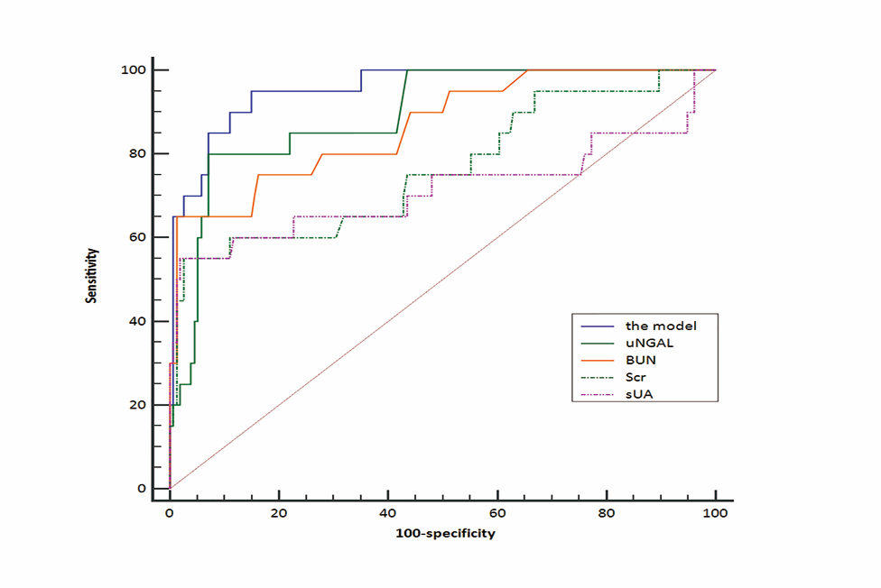
Figure S1: ROC analysis of the prediction model and kidney related indicators for predicting AKI.ROC curves of the prediction model and kidney related indicators were plotted. The greater the displacement above and to the left of the line identified, the greater the likelihood that raised values of the test will identify AKI.

