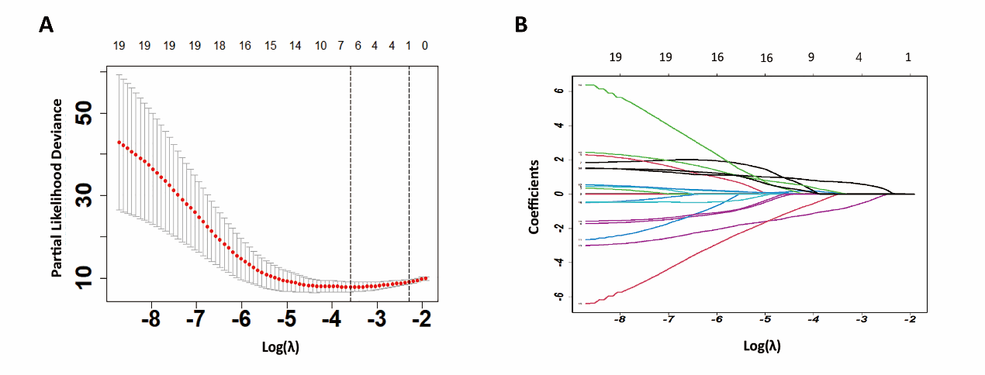
Figure S2: Texture feature selection using the least absolute shrinkage and selection operator (LASSO) binary logistic regression model. A:Tuning parameter (λ) selection in the LASSO model used 10-fold cross-validation via minimum criteria. The area under the receiver operating characteristic (AUC) curve was plotted versus log(λ). Dotted vertical lines were drawn at the optimal values by using the minimum criteria and the 1 standard error of the minimum criteria (the 1-SE criteria). A λ value of 0.076, with log (λ),-2.567 was chosen (1-SE criteria) based on 10-fold cross-validation. (B) LASSO coefficient profiles . A coefficient profile plot was produced against the log (λ) sequence. Vertical line was drawn at the value selected using 10-fold cross-validation, where optimal l resulted in 6 factors.

