Fig. S1 Correlations and distribution of nephrometry scores. Strength of correlation given as pearson’s correlation coefficient. Scatter plots, as well as kernel density plots with rug plots are used to visualize the distribution of each score in the analyzed cohort *** indicates a p-value of less than 0.001

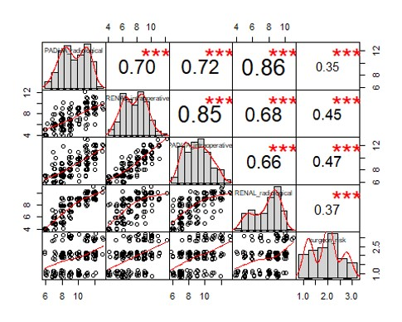

Fig. S2 A-D AUC curves of radiological and intraoperative RENAL and PADUA, surgeon’s assessment and MAP-Score for predicting major complications.
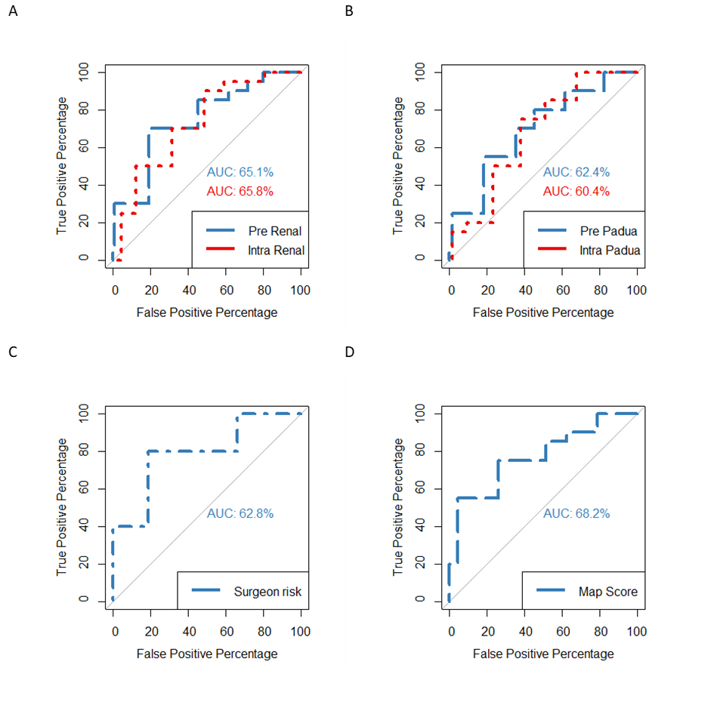

Fig. S3 A-D AUC curves of radiological and intraoperative RENAL and PADUA, surgeon’s assessment and MAP-Score for predicting ischemia time ≥ 25 minutes.
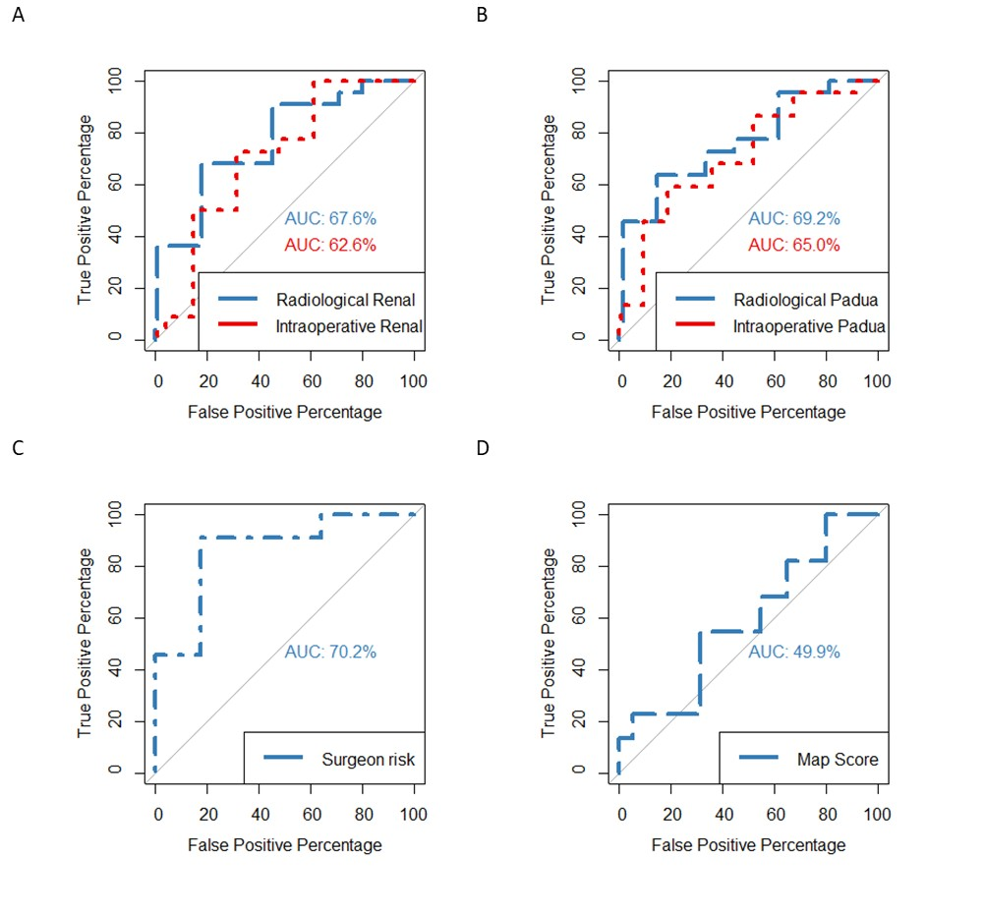

Fig. S4 A-D AUC curves of radiological and intraoperative RENAL and PADUA, surgeon’s assessment and MAP-Score for predicting ischemia time ≥ 20 minutes.
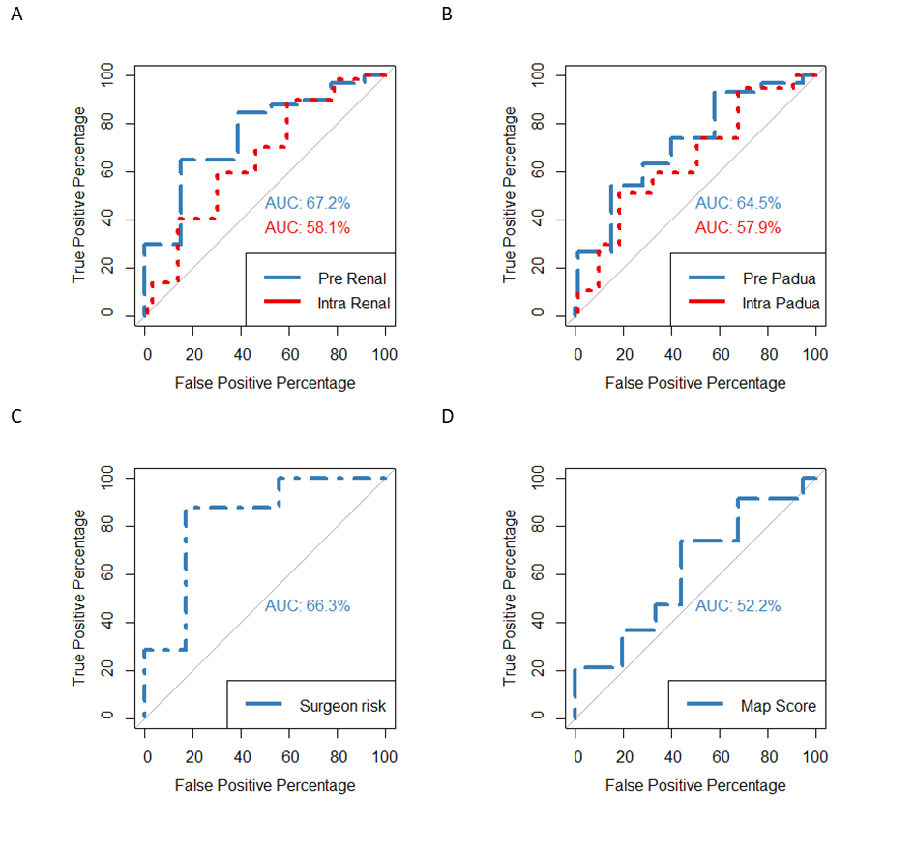

Table S1 Patient characteristics (Values are given as mean and SD in brackets or percentage and number in brackets)
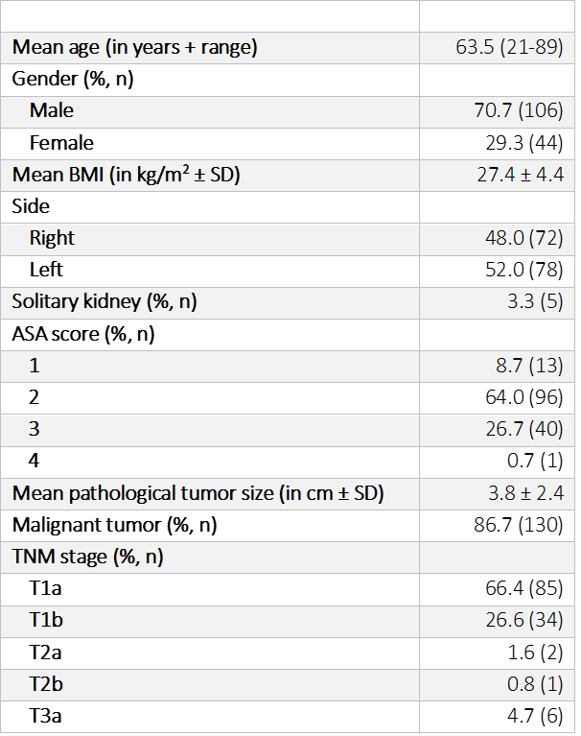
Table S2 Logistic regression model for evaluating the association between nephrometry scores and the occurrence of major complications.
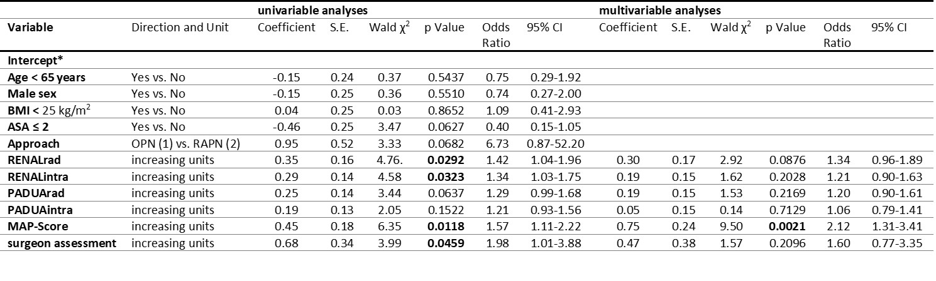
Table S3 Logistic regression model for evaluating the association between nephrometry scores and ischemia time of ≥ 25 minutes.
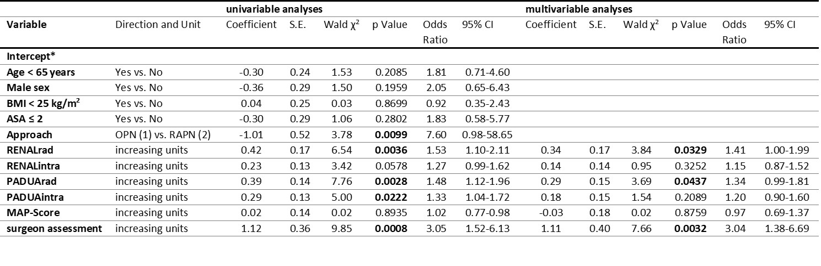
Table S4 Logistic regression model for evaluating the association between nephrometry scores and ischemia time of ≥ 20 minutes.
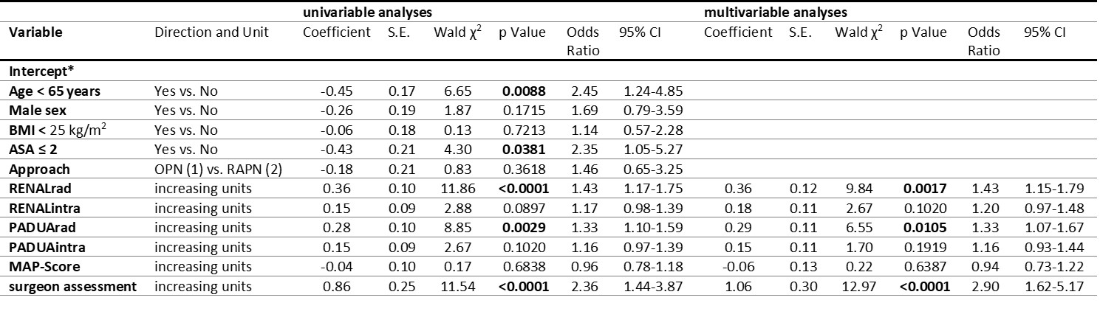
The multivariable models consisted of age, gender, BMI, ASA score, approach and one of the scores at a time (e.g. radiological RENAL). ASA: American Society of Anesthesiologists; BMI: body mass index; CI: confidence interval; S.E.: standard error.
*Intercept is defined as a mathematical constant for each model; not specified for there is no clinical interpretation. Coefficient (β) is defined as the mathematical weighting of each variable in the model. SE is defined as standard error; the estimated error of the mathematical weighting. Wald² is defined as [|coefficient| / standard error]². The higher the value, the higher the predictive value of the variable. Odds ratio is the change in odds of transfusion for each unit change of the variable while controlling for other variables in the model. 95% CI is defined as the 95% confidence interval for the estimated odds ratio [1]).
1. Karkouti K, Djaiani G, Borger MA, Beattie WS, Fedorko L, Wijeysundera D, Ivanov J, Karski J (2005) Low hematocrit during cardiopulmonary bypass is associated with increased risk of perioperative stroke in cardiac surgery. The Annals of thoracic surgery 80 (4):1381-1387. doi:10.1016/j.athoracsur.2005.03.137

