Supplementary information for
The identification of gene expression profiles associated with granulomatous mastitis
Qiang Zhu^{*1}, Lin Wang¹, Pilin Wang*¹
¹Department of Breast Surgery. Beijing Tiantan Hospital, Capital Medical University, Beijing, People's Republic of China

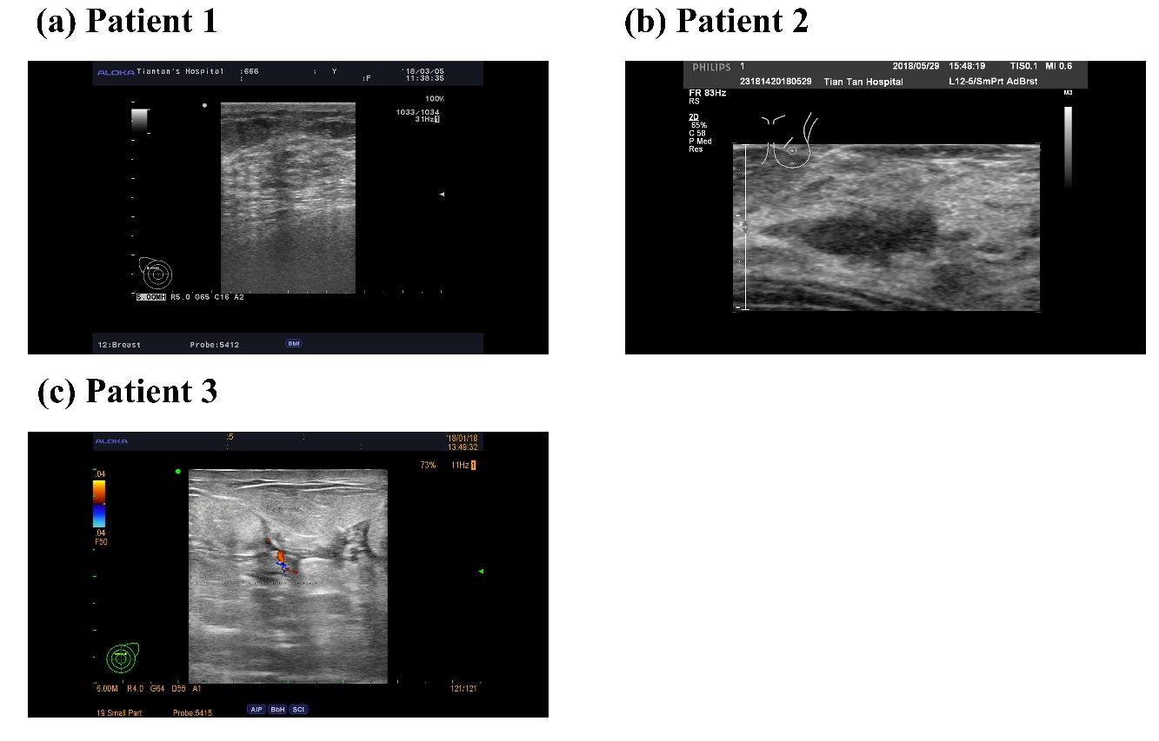
Figure S1. The ultrasonography of three patients

