Table S1. Optimised settings used for the microscopy tissue processor to prepare the samples before resin embedding for transmission electron microscopy (TEM).
Step | Type of solution in the station | Time (min.)
1 | Empty | -
2 | 0.13M Sorensen Phosphate buffer | 10
3 | 0.13M Sorensen Phosphate buffer | 10
4 | 0.13M Sorensen Phosphate buffer | 10
5 | 25% EtOH | 30
6 | 50% EtOH | 30
7 | 70% EtOH | 40
8 | 80% EtOH | 40
9 | 95% EtOH | 40
10 | Lab grade 100% EtOH | 60
11 | Lab grade 100% EtOH | 60
12 | Pure grade 100% EtOH | 60
13 | Pure grade 100% EtOH | 60
14 | Propylene oxide | 20
15 | Propylene oxide | 20
16 | Propylene oxide 75% / Araldite 25% | 30
17 | Propylene oxide 50% / Araldite 50% | 60
18 | Araldite | 150
19 | Araldite | 150
20 | Araldite | 150

Table S2. Model outputs from the linear regression run on axon density. SS; sum of squares, df; degree of freedom, *; significant variables.
Variable | SS | df | F-value | p-value
Species | 681.9 | 1 | 909.3 | < 0.001***
Location | 3729.2 | 1 | 4972.8 | < 0.001***
Species/Specimen | 196.5 | 4 | 65.5 | < 0.001***
Location/Type | 4453.5 | 1 | 5938.6 | < 0.001***
Species:Location | 383.1 | 1 | 510.8 | < 0.001***

Table S3. Outputs of post-hoc Tukey tests for significant interacting terms tested in the linear model for axon density. CP; Chiloscyllium punctatum, CA; Carassius auratus, *; biologically-relevant terms, SE; standard error.
Interaction tested | contrast term* | estimate | SE | p-value (adjusted)
Species*Specimen | CP4 - CP5 | -0.019 | 0.063 | 0.999
 | CP4 - CP2 | 0.769 | 0.066 | <0.001***
 | CP5 - CP2 | 0.789 | 0.059 | <0.001***
 | CA3 - CA2 | -0.184 | 0.058 | 0.018*
 | CA3 - CA4 | 0.205 | 0.057 | 0.005**
 | CA4 - CA2 | -0.389 | 0.052 | <0.001***
 | CA4 - CP4 | 0.208 | 0.063 | 0.013*
 | CA4 - CP5 | 0.188 | 0.057 | 0.012*
 | CA3 - CP4 | 0.413 | 0.069 | <0.001***
 | CA3 - CP5 | 0.393 | 0.063 | <0.001***
 | CA3 - CP2 | 1.183 | 0.063 | <0.001***
 | CA4 - CP2 | 0.978 | 0.057 | <0.001***
 | CA2 - CP4 | 0.597 | 0.064 | <0.001***
 | CA2 - CP5 | 0.578 | 0.058 | <0.001***
 | CA2 - CP2 | 1.367 | 0.059 | <0.001***
Location*Type | UM,ON - UM,OP | 1.200 | 0.043 | < 0.001***
 | M,OP - UM,OP | -3.030 | 0.039 | < 0.001***
Species*Location | CA,ON - CP,ON | -0.211 | 0.064 | 0.001**
 | CA,OP - CP,OP | 1.524 | 0.040 | < 0.001***

Table S4. Model outputs from the linear regression run on axon diameter. SS; sum of squares, df; degree of freedom, *; significant variables.
Variable | SS | df | F-value | p-value
Species | 4.121 | 1 | 16.1 | < 0.001***
Location | 86.435 | 1 | 338.4 | < 0.001***
Species/Specimen | 0.481 | 4 | 0.4 | 0.757
Location/Type | 167.028 | 1 | 653.9 | < 0.001***
Species:Location | 6.686 | 1 | 26.1 | < 0.001***

Table S5. Outputs of post-hoc Tukey tests for significant interacting terms tested in the linear model for axon diameter. CP; Chiloscyllium punctatum, CA; Carassius auratus, *; biologically-relevant terms, SE; standard error.
Interaction tested | contrast term* | estimate | SE | p-value (adjusted)
Location*Type | UM,ON - UM,OP | -0.205 | 0.065 | 0.005**
 | M,OP - UM,OP | 1.668 | 0.065 | < 0.001***
Species*Location | CA,ON - CP,ON | 0.171 | 0.092 | 0.063
 | CA,ON - CA,OP | -0.750 | 0.079 | < 0.001***
 | CP,ON - CP,OP | -1.329 | 0.079 | < 0.001***
 | CA,OP - CP,OP | -0.407 | 0.065 | < 0.001***
 | CA,ON - CP,OP | -1.157 | 0.079 | < 0.001***
 | CP,ON - CA,OP | -0.922 | 0.079 | < 0.001***

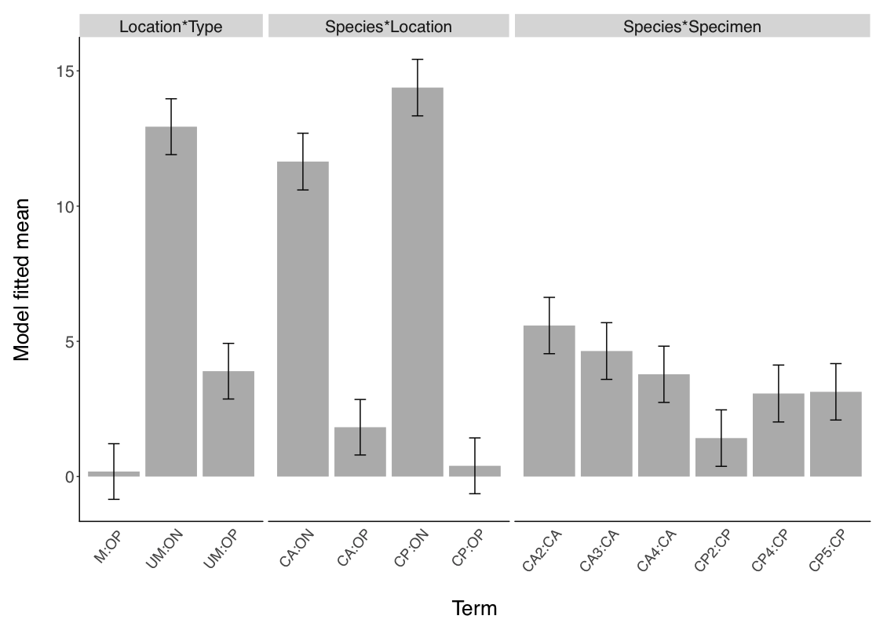
b.
a.
Figure S1. Model fitted mean values for post-hoc Tukey tests run on axon density (a) and axon diameter (b). Error bars indicate standard errors. CP; Chiloscyllium punctatum (n=3, CP2, 4, 5), CA; Carassius auratus (n=3, CA2-4), ON; olfactory nerve, OP; olfactory peduncle, UM; unmyelinated axon, M; myelinated axons.

R code. Custom-written by AR, and used by VCA, to determine the appropriate level of sampling required to detect differences in axon number (UM and M pooled) between the different olfactory tracts of Carassius auratus. Tailored power analysis, based on tract size (how many images can fit in the tract zone), descriptive statistics (mean and variance) of preliminary quantitative results (from N=20 images), and number ‘N_{i}’ of images needed to achieve >99% confidence levels.

##############################################################
### Effect detection simulation
### Author: Alethea Rea
##############################################################

#setwd("~/Documents/Victoria")

rm(list=ls())

## simulation of effect
## compares four populations of photos
## with mean count for each photo (mu1, mu2, mu3, mu4)
## with standard deviations for each pic (sd1, sd2, sd3, sd4)
## with the number of photos that cover each zone (p1, p2, p3, p4)
## with the number of photos that will be sampled (n1, n2, n3, n4)
## simulated s times

ttest_sim <- function(mu1, mu2, mu3, mu4, sd1, sd2, sd3, sd4,
p1, p2, p3, p4, n1, n2, n3, n4, s){

outcome <- mat.or.vec(s,1) ## intialise vector for storage

for (i in 1:s){ ## for each simulation run
z1_simcounts <- rnorm(n = p1, mean = mu1, sd = sd1) ## generate p1 normal vars
z1_sampled_simcounts <- round(sample(z1_simcounts, n1, replace = F))
## sample n of the p vars (i.e. n of the photos)
## round to whole numbers

z2_simcounts <- rnorm(n = p2, mean = mu2, sd = sd2)
z2_sampled_simcounts <- round(sample(z2_simcounts, n2, replace = F))

z3_simcounts <- rnorm(n = p3, mean = mu3, sd = sd3)
z3_sampled_simcounts <- round(sample(z3_simcounts, n3, replace = F))

z4_simcounts <- rnorm(n = p4, mean = mu4, sd = sd4)
z4_sampled_simcounts <- round(sample(z4_simcounts, n4, replace = F))

##goal: detection of at least one difference between zones 1,2,3 & 4
outcome[i] <- summary( aov(c(z1_sampled_simcounts, z2_sampled_simcounts,
z3_sampled_simcounts, z4_sampled_simcounts)
~ factor(c(rep(1,n1), rep(2,n2), rep(3,n3), rep(4,n4)))))[[1]]$`Pr(>F)`[1]

}
return(mean(outcome< 0.05)) ## return the no of sims with a stat sig result
}

# Example on how to run it in R:

> mu_z1m <- … # enter mean axon count values for each zone (tract)
> mu_z2m <- …
> mu_z3m <- …
> mu_z4m <- …
> sd_z1m <- … # enter standard deviation values for each zone (tract)
> sd_z2m <- …
> sd_z3m <- …
> sd_z4m <- …
> p1 <- … # enter the estimated size of each zone (how many images it fits)
> p2 <- …
> p3 <- …
> p4 <- …
> n1 <- 50 # e.g. arbitrary numbers of images to collect for each zone
> n2 <- 50
> n3 <- 100
> n4 <- 20
>
> s <- 1000 # e.g. number of simulations to run for
>
> ttest_sim(mu_z1m, mu_z2m, mu_z3m, mu_z4m, sd_z1m, sd_z2m, sd_z3m, sd_z4m, p1, p2, p3, p4, n1, n2, n3, n4, s)

[1] 0.991 # result to look for, i.e. >90% confidence level to know how many
images to collect per zone. Iterate choosing different n_{i} numbers
until satisfied.

