**MicroRNA profile of cardiovascular risk in patients with obstructive sleep apnea**

Fernando Santamaria-Martos1, Iván Benítez1,4, Lucía Pinilla1,4, Francisco Ortega2,3, Andrea Zapater1,4, Cristina Giron1, Olga Mínguez1, Silvia Gómez1, Rafaela Vaca1, Jose-Manuel Fernandez-Real2,3, Ferran Barbé1,4, Manuel Sánchez-de-la-Torre1,4\*.

**Affiliations:**

1Group of Translational Research in Respiratory Medicine, Hospital Universitari Arnau de Vilanova y Santa Maria, IRB Lleida, Lleida, Spain;

2Department of Diabetes, Endocrinology and Nutrition, Institut d'Investigació Biomèdica de Girona (IdIBGi), Girona, Spain;

3CIBER de la Fisiopatología de la Obesidad y la Nutrición (CB06/03) and Instituto de Salud Carlos III, Madrid, Spain;

4Centro de Investigación Biomédica en Red de Enfermedades Respiratorias (CIBERES), Madrid, Spain.

\*Correspondence to:

Manuel Sánchez-de-la-Torre, PhD, Hospital Arnau de Vilanova-Santa María, IRBLleida, CIBERES, Avda. Rovira Roure 80, 25198, Lleida, Spain; e-mail: sanchezdelatorre@gmail.com

**Keywords:** Obstructive sleep apnea, microRNA, profiling, management, cardiovascular, personalized medicine.

1. TaqMan Low Density Array determinations

1.1. Quality control

1.1.1. Ct distribution of miRNAs

1.2. miRNA normalization

2. qPCR determinations

2.1. Quality control

2.1.1. Ct distribution of miRNAs

3. Correlations between ABPM parameters and miRNAs

**1. TaqMan Low Density Array determinations**

1.1. Quality control

e-Figure 1: Raw Ct distribution of miRNAs.

Macintosh HD:Users:fernandosantamaria:Desktop:AJE Completed files YG52913K:RE__Paper_fenotipos_cajones:e_figure2.pdf

1.2. miRNA normalization.

e-Figure 2: Density plot of miRNA normalization. A) density of raw Cts of each subject. B) Mean-center normalized density plot.

A)

Macintosh HD:Users:fernandosantamaria:Desktop:AJE Completed files YG52913K:RE__Paper_fenotipos_cajones:e_figure3_a.pdf

B)

Macintosh HD:Users:fernandosantamaria:Desktop:AJE Completed files YG52913K:RE__Paper_fenotipos_cajones:e_figure3_b.pdf

**2. qPCR determinations**

2.1. Quality control

e-Figure 3: Raw Ct distribution of miRNAs.

Macintosh HD:Users:fernandosantamaria:Desktop:AJE Completed files YG52913K:RE__Paper_fenotipos_cajones:e_figure5.pdf

**3. Correlations between ABPM parameters and miRNAs**

e-Figure 4: Scatter plot of miR-107 and ABPM 24h parameters.

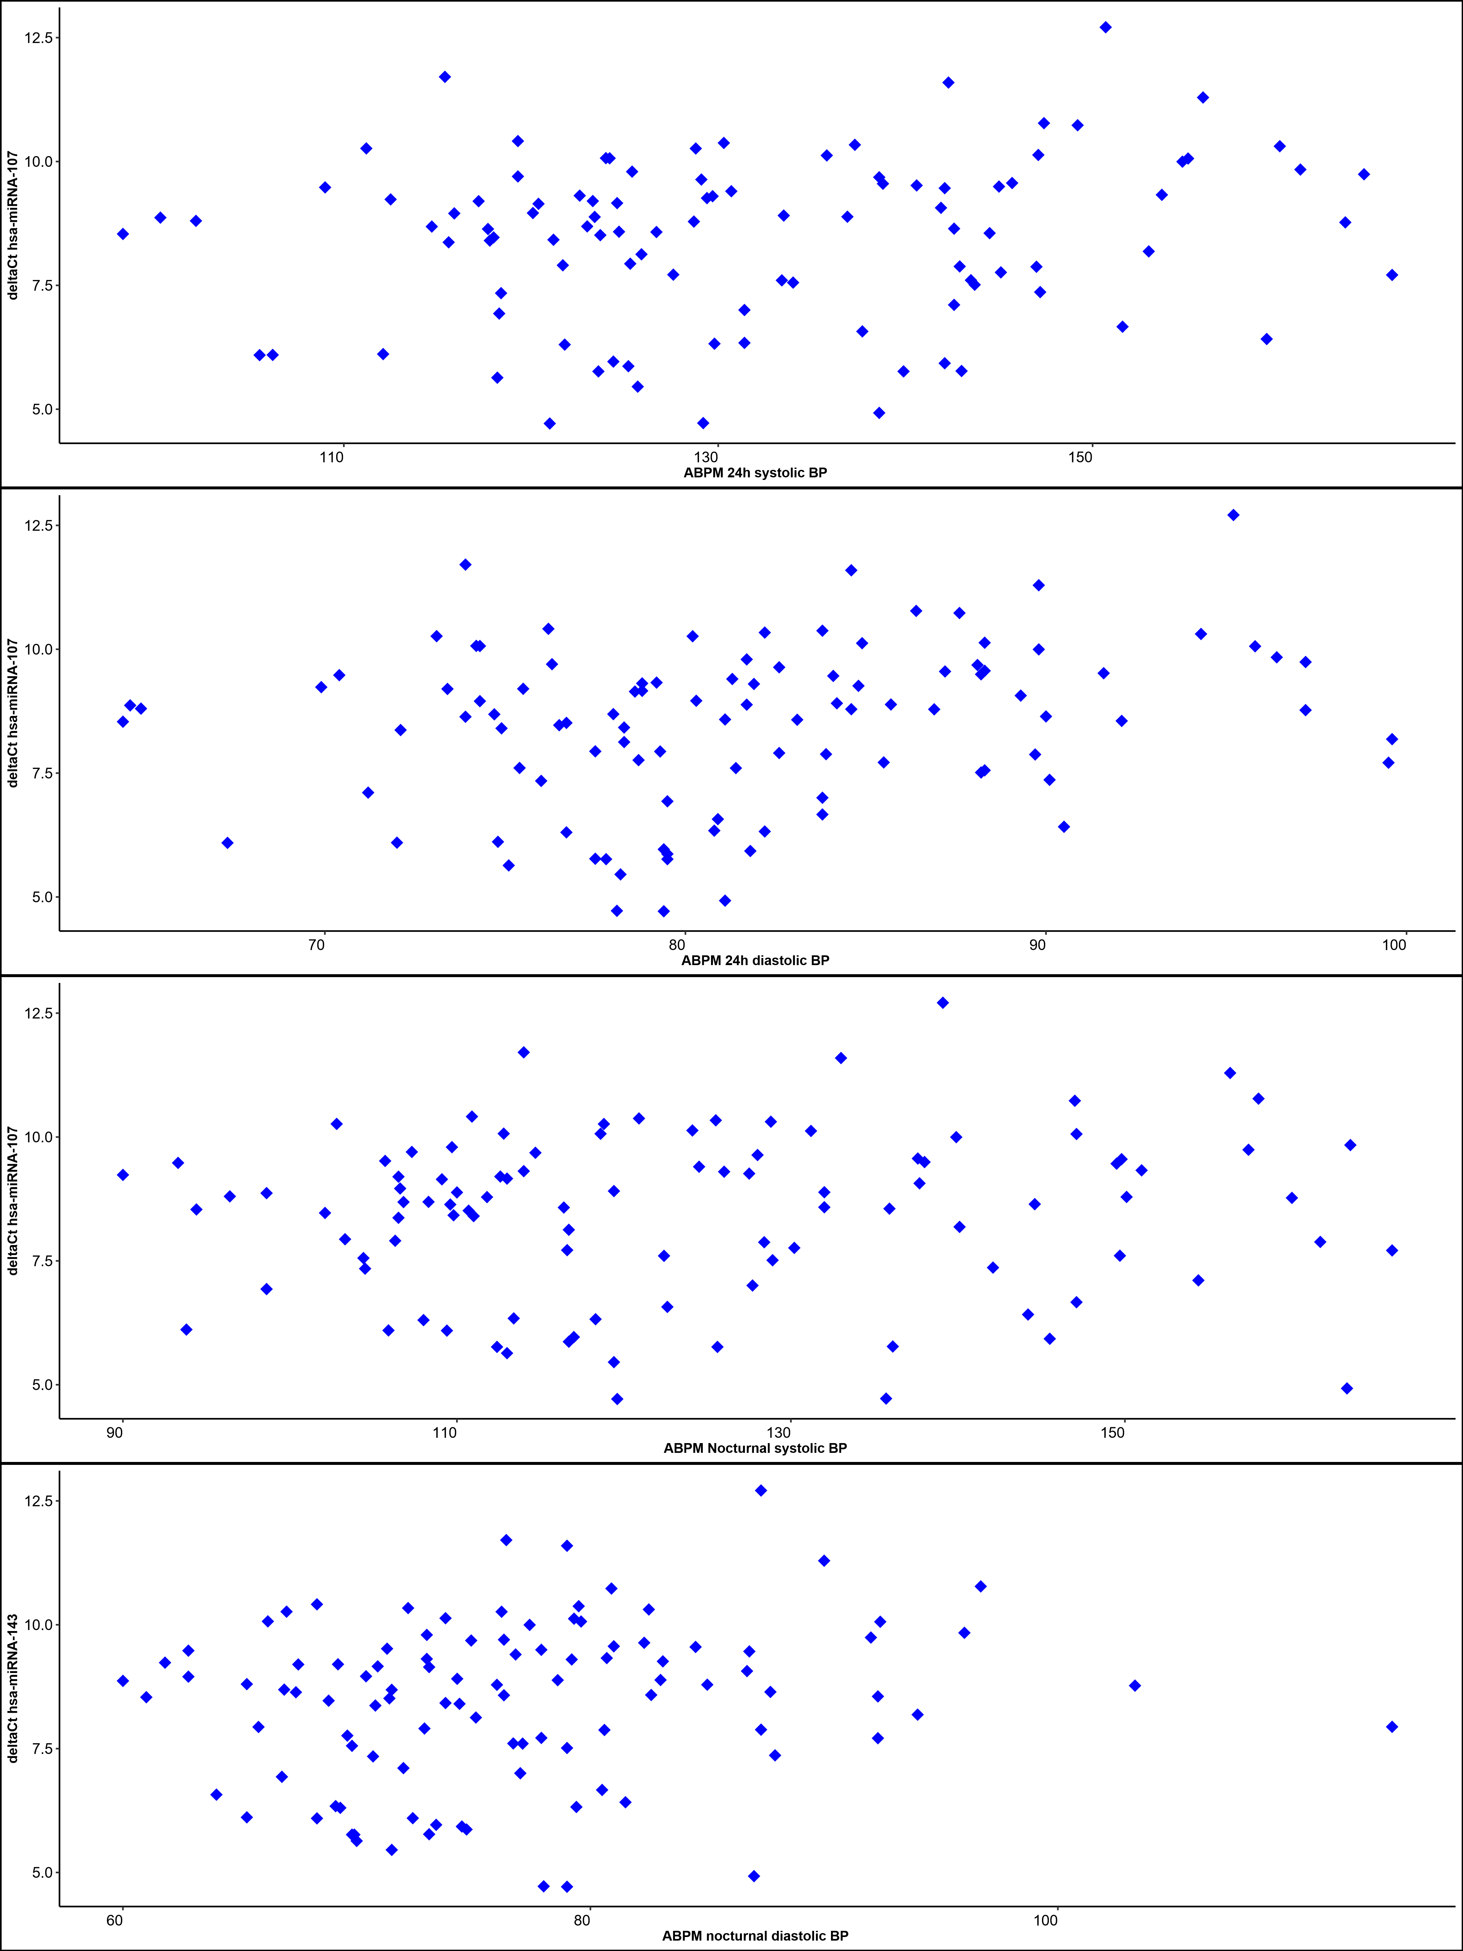

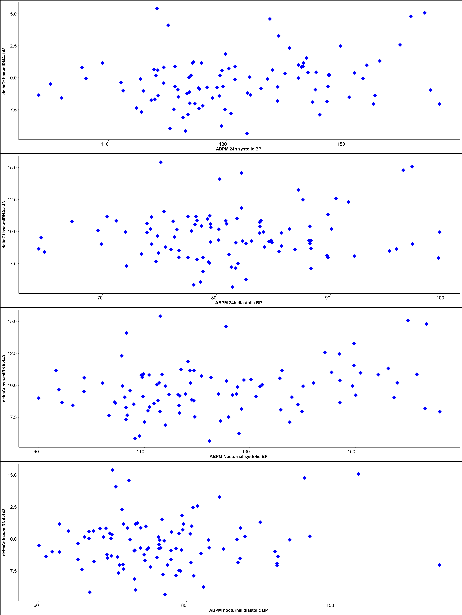e-Figure 5: Scatter plot of miR-143 and ABPM 24h parameters