Table S1. Regression lines of eGFR according to the Mayo Imaging Classification
 | MIC | Total | Male | Female
K=130 mL/m
 | 1A | eGFR = 127.18 - 1.09 x age | eGFR = 117.12 - 0.96 x age | eGFR = 134.73 - 1.19 x age
 | 1B | eGFR = 150.87 - 1.60 x age | eGFR = 140.81 - 1.47 x age | eGFR = 158.43 - 1.70 x age
 | 1C | eGFR = 164.79 - 2.15 x age | eGFR = 154.73 - 2.02 x age | eGFR = 172.35 - 2.25 x age
 | 1D | eGFR = 167.67 - 2.47 x age | eGFR = 157.61 - 2.34 x age | eGFR = 175.23 - 2.57 x age
 | 1E | eGFR = 154.71 - 2.50 x age | eGFR = 144.65 - 2.37 x age | eGFR = 162.27 - 2.60 x age
K=150 mL/m
 | 1A | eGFR = 130.87 - 1.12 x age | eGFR = 120.16 - 0.97 x age | eGFR = 138.91 - 1.23 x age
 | 1B | eGFR = 153.47 - 1.71 x age | eGFR = 142.77 - 1.56 x age | eGFR = 161.51 - 1.82 x age
 | 1C | eGFR = 161.62 - 2.15 x age | eGFR = 150.92 - 2.00 x age | eGFR = 169.67 - 2.26 x age
 | 1D | eGFR = 165.90 - 2.46 x age | eGFR = 155.20 - 2.31 x age | eGFR = 173.94 - 2.57 x age
 | 1E | eGFR = 163.88 - 2.93 x age | eGFR = 156.49 - 2.78 x age | eGFR = 175.23 - 3.04 x age
Regression lines were calculated using mixed-effect models with age, Mayo Class, and sex as fixed effects, and with age * Mayo Class and age * sex as interaction effects. Mayo Class was classified using the initial eHTKV-α calculated using K=130 mL/m and K=150 mL/m. eGFR, estimated glomerular filtration rate; Mayo Class, Mayo Imaging Classification; eHTKV-α, estimated height-adjusted total kidney volume growth rate (α).

Table S2. ROC analysis of initial eHTKV-α cutoff values to predict eGFR decline to 15 mL/min/1.73 m² for censored ages
Censored age (years) | Area under ROC curve (95% CI) |  |  | AHTKV-α cutoff value (%/year) | Sensitivity | Specificity | Positive predictive value | Likelihood ratio
 | K=130 mL/m | K=150 mL/m | P
60 | 0.636 (0.586-0.686) | 0.636 (0.585-0.686) | 0.9808 | 4.31 | 60.2 | 60.0 | 52.8 | 1.50
65 | 0.636 (0.588-0.684) | 0.636 (0.588-0.684) | 0.8646 | 4.09 | 60.9 | 61.0 | 59.2 | 1.56
70 | 0.636 (0.590 -0.681) | 0.636 (0.591-0.682) | 0.8577 | 3.99 | 60.8 | 60.8 | 62.3 | 1.55
The eGFR at 60, 65, and 70 years was estimated using individually calculated eGFR regression lines. Using ROC analyses, cutoff values of the initially measured eHTKV-α to predict eGFR decline to 15 ml/min/1.73m² at censored ages were calculated. As there was no significant difference in the area under the ROC curve between eHTKV-α (K=130 mL/m) and eHTKV-α (K=150 mL/m), only K=130 cutoff values are shown. ROC, receiver operating characteristic curve; eHTKV-α, estimated height-adjusted total kidney volume growth rate; K, K is a constant in the equation of eHTKV-α; CI, confidence interval.

Table S3. Comparison of the hazard ratio of ESRD between high-risk and referent subgroups
K=130 mL/m |  |  |  |  | K=150 mL/m
Comparison subgroup based on initial eHTKV-α |  | Multivariate hazard ratio adjusted by sex (with 95% CI) | P-value |  | Comparison subgroup based on initial eHTKV-α | Multivariate hazard ratio adjusted by sex (with 95% CI) | P-value
(%/year) |  |  |  |  | (%/year)
≤4.0 |  | 1 (referent) | <0.0001 |  | ≤3.5 | 1 (referent) | <0.0001
4.0< |  | 11.43 (5.23 - 24.97) |  |  | 3.5< | 10.40 (4.68 - 23.10)
3.0< ≤4.0 |  | 1 (referent) | <0.0001 |  | 2.5< ≤3.5 | 1 (referent) | <0.0001
4.0 < |  | 6.64 (2.79 - 15.82) |  |  | 3.5< | 7.69 (3.15 - 18.77)
Results were derived from Cox's proportional hazards model. Comparison was made between high-risk ESRD and two referent subgroups. P-values were derived from the chi-square test. eHTKV-α, estimated height-adjusted total kidney volume growth rate α (%/year); ESRD, end-stage renal disease; CI, confidence interval.

Figure S1. Time-dependent area under the curve (AUC) and 95% confidence interval using the entire data set
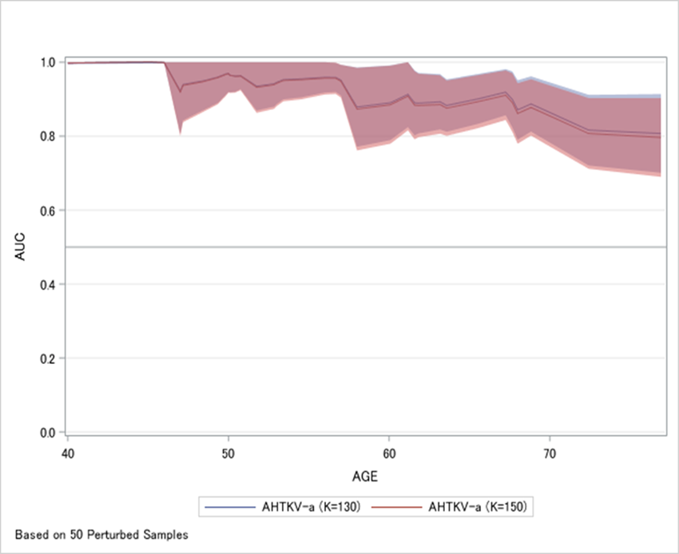
The mean area under the time-dependent receiver operating characteristic curve (AUC) was compared between K=130 mL/m and K=150 mL/m using Uno's Concordance Statistic [23]. The estimated mean difference ± SEM was 0.0044 ± 0.0024 (P=0.0693).

Figure S2. Regression lines of eGFR according to the Mayo Imaging Classification
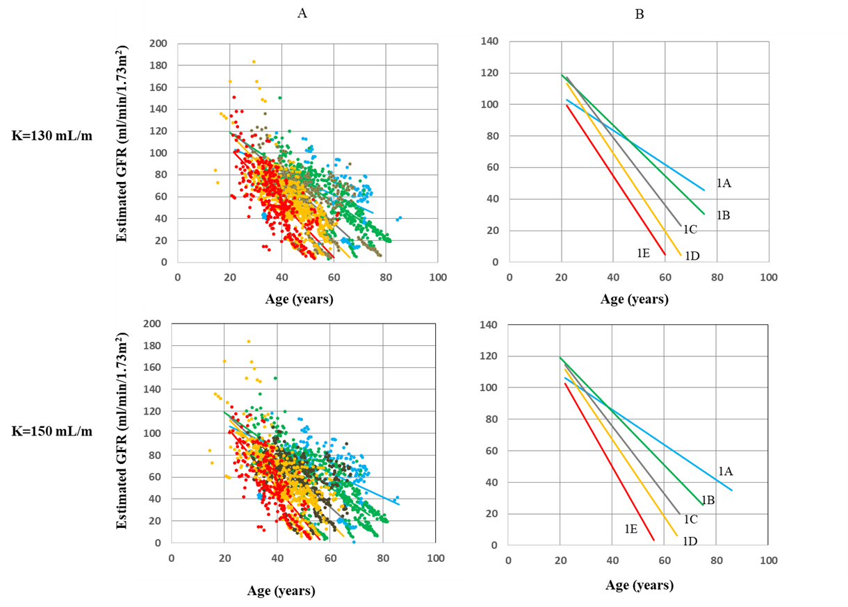
A: Change in the estimated glomerular filtration rate (eGFR) according to five Mayo Imaging Classification (Mayo Class) subgroups, which were divided using eHTKV-α calculated using K=130 mL/m or K=150 mL/m.
B: Comparison of eGFR regression lines of Mayo Class.
Regression lines were calculated using mixed-effect models with age, Mayo Class, and sex as fixed effects, and with age * Mayo Class and age * sex as interaction effects (Table S3). Mayo Class was classified using the initial eHTKV-α.

Figure S3. Renal survival Kaplan-Meier curve until receiving renal replacement therapy according to subgroups divided by the initial eHTKV-α.
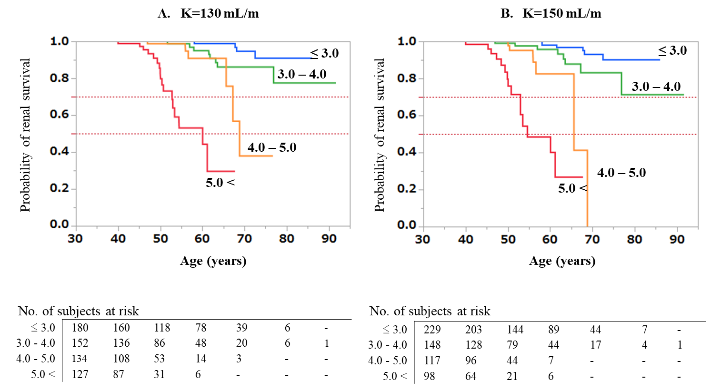

The two dotted horizontal lines indicate renal survival probability of 50% and 70%.

