Fig. S1. Correlation matrix between disease characteristics. Spearman's rank test was used. Only. A significant correlation coefficient (r) is shown. TTT: treatment, HTN: hypertension, CMT: central macular density, VA: visual acuity, pre: pretreatment, post: post-treatment, diff: change difference between pre- and post-treatment.

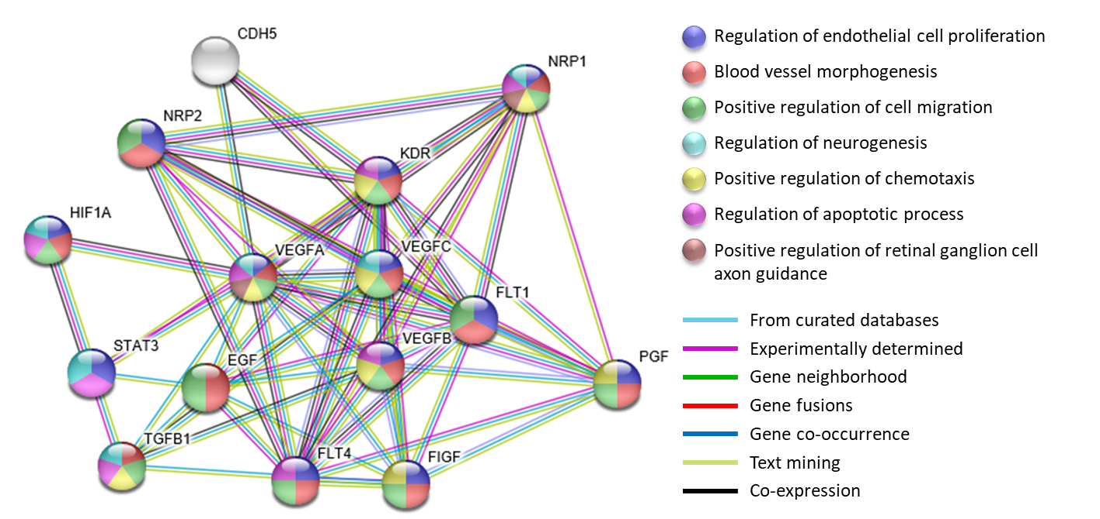
Fig. S2. Protein-protein interaction. PPI were retrieved from STRING database (https://string-db.org) which relies on text mining, experiments, databases, co-expression, gene fusion, and co-occurrence data. Minimum interaction score was set at the highest confidence (0.900). Maximum number of interactors to be shown in the first shell was set to be less than 10 interactors. The network consists of 15 nodes and 64 edges. The average local clustering coefficient is 0.83 and PPI enrichment p-value is <1.0e-16. Line color indicates the type of interaction.
CDH5: Cadherin-5; EGF: Pro-epidermal growth factor; FLT1: Vascular endothelial growth factor receptor 1; FLT4: Vascular endothelial growth factor receptor 3; HIF-1A: Hypoxia-inducible factor 1-alpha; KDR: Vascular endothelial growth factor receptor 2; NRP1: Neuropilin-1; NRP2: Neuropilin-2; PGF: Placenta growth factor; STAT3: Signal transducer and activator of transcription 3; TGFB1: Transforming growth factor beta-1; VEGFA: Vascular endothelial growth factor A; VEGFB: Vascular endothelial growth factor B; VEGFC: Vascular endothelial growth factor C.
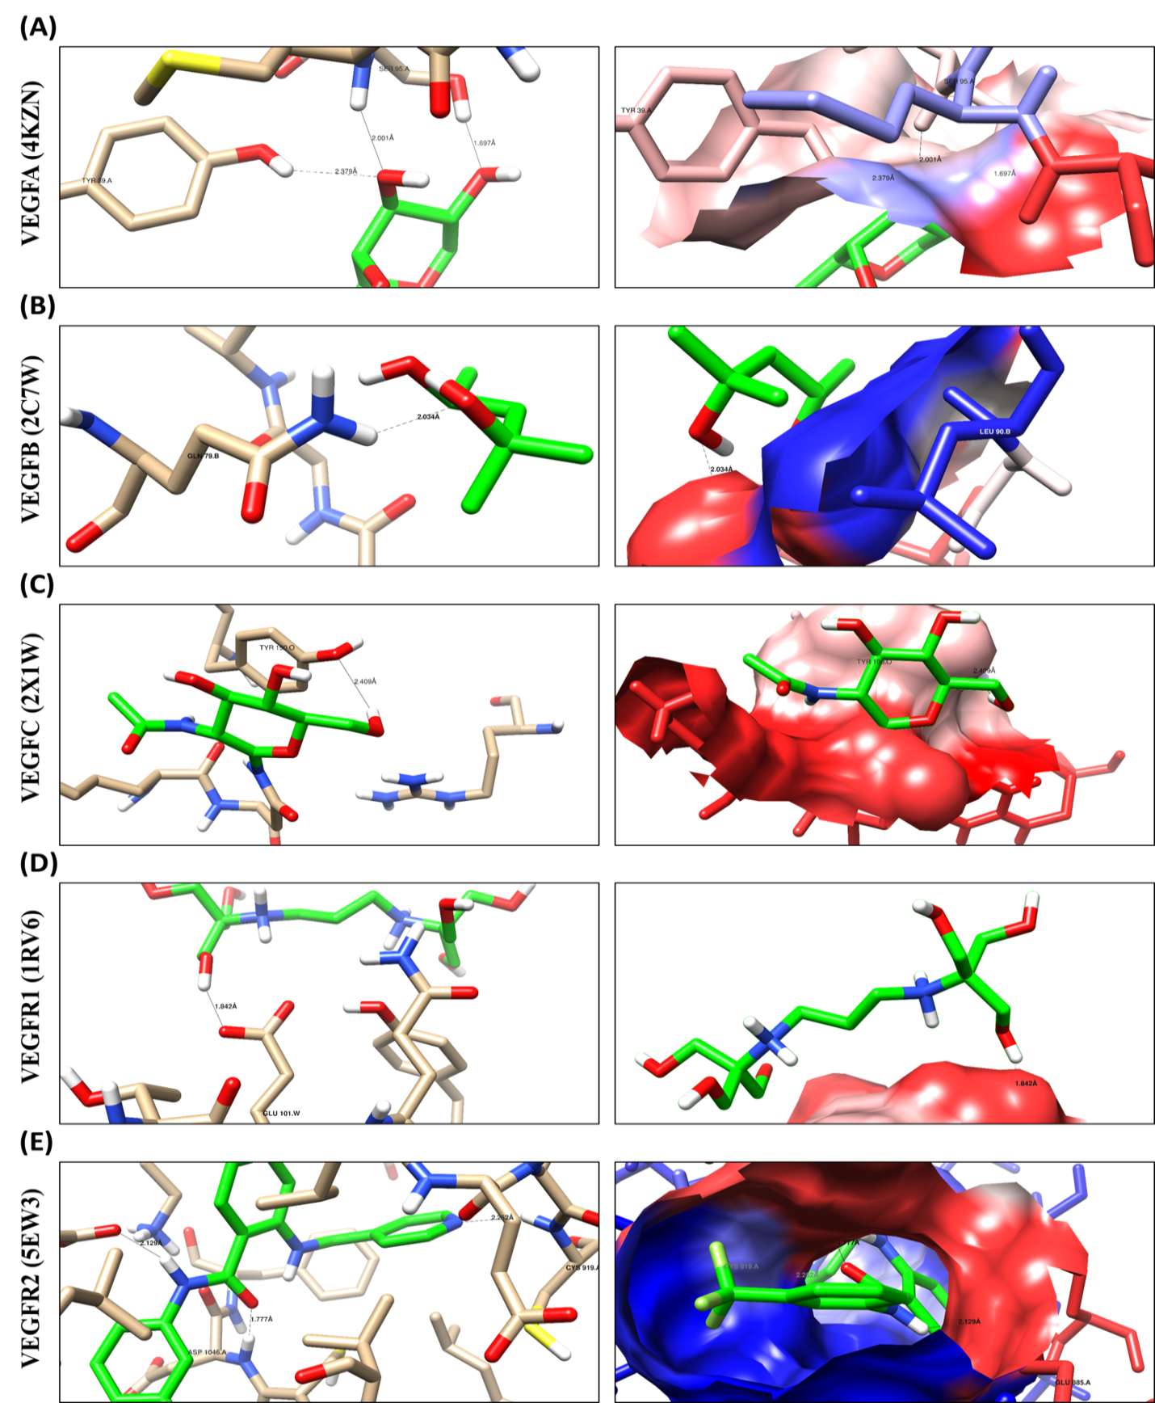
Fig. S3. Binding site disposition and analysis of ligand-receptor interactions for the studied VEGF family genes. Chimera software [22] was applied for the analysis of binding site disposition and the ligand-receptor interactions of 4KZN, 2C7W, 2X1W, 1RV6, and 5EW3. The amino acid disposition of theses receptor binding sites, their chemical nature, and the interactive amino acids as well were defined. For 4KZN; the co-crystallized ligand forms three hydrogen bonds (HB) with the Ser 95A, for 2C7W; it forms 1HB with Gln 79B, for 2X1W; it forms 1HB with Tyr150O, for 1RV6; it forms 1HB with Glu101W, for 5EW3; it forms 3HB with Cys 919A and Asp 1046A. Moreover, the lipophilic interaction with the lipophilic amino acids. Hence, these interactive (key) amino acids have not been subjected to variance (mutation) to maintain the biological function in which they are responsible. Co-crystallized ligand [green skeleton], blue regions for lipophilic areas and the red ones for hydrophilic areas.

