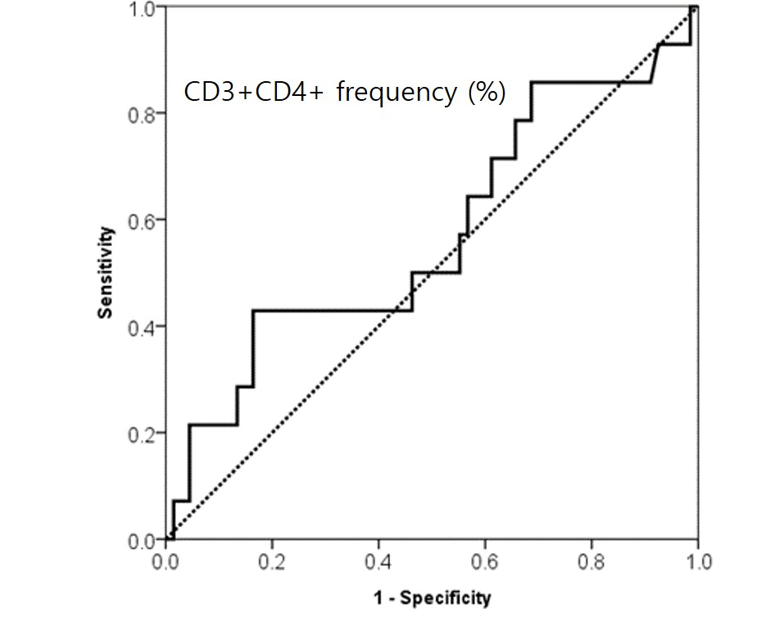
Supplement 1. ROC curve for frequency of CD3⁺CD4⁺ T-cells. The cut-off value is 47.945%, with a sensitivity of 0.429 and a specificity of 0.836.

