Supplementary material

Supplementary Figure 1. Movement processing – visualization of pitch, yaw and roll for analyzing head rotation. Pitch: Rotation of the head leaned towards the shoulder in radians; Yaw: Rotation of the head to the left direction or to right direction in radians; Roll: Rotation of the head towards upward or downwards direction in radians.
Head_Rotation = Sum(distance.euclidean(rotation(x1,y1,z1),rotation(x2,y2,z2)))

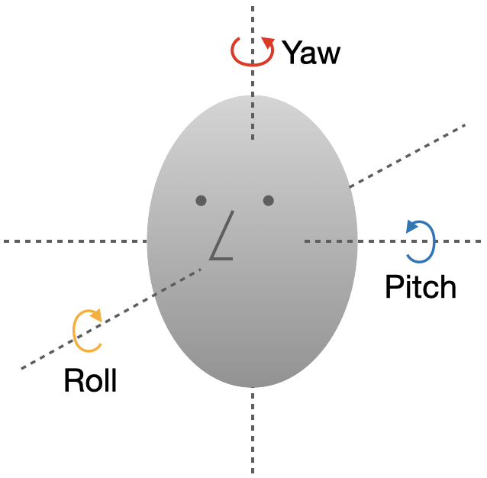

Supplementary Table 1. Descriptive statistics cognitive performance for each cognitive domain.
Cognitive domain |  | Mean | SD | Max | Min
Motor Coordination | 0.034 |  | 2.284 | 9.094 | -4.981
Emotion Bias | -0.359 |  | 0.958 | 1.336 | -2.250
Processing Speed | 0.231 |  | 2.040 | 9.785 | -7.231
Sustained Attention | -0.627 |  | 2.152 | 7.405 | -8.001
Controlled Attention | -0.204 |  | 0.668 | 1.280 | -2.168
Flexibility | 0.559 |  | 2.557 | 8.341 | -6.426
Inhibition | -0.282 |  | 0.679 | 0.741 | -1.968
Executive Function | -0.213 |  | 1.707 | 9.302 | -5.863

Supplementary Table 2. Predictive matrix for motor retardation.
 | Cross-validation results
ML algorithm | R² | MAE | RMSE | MAPE(%) | Ranking
SVM | 0.5611 | 0.0681 | 0.1207 | 6.4 | 3
Random Forest | 0.2560 | 0.0795 | 0.1221 | 9.6 | 5
XG-Boost | 0.5463 | 0.0724 | 0.1246 | 4.5 | 1
Gradient Boost | 0.5423 | 0.0646 | 0.1220 | 5.1 | 2
Elastic net | -0.0109 | 0.0928 | 0.1582 | 22.5 | 6
Ada-boost | 0.3428 | 0.0745 | 0.1269 | 6.5 | 4
Linear regression | 0.2913 | 0.0854 | 0.1324 | 46.4 | 9
lasso regression | 0.2919 | 0.0852 | 0.1324 | 46.3 | 7
Ridge regression | 0.2515 | 0.0847 | 0.1361 | 46.3 | 8

Supplementary Table 3. Predictive matrix for emotion bias.
 | Cross-validation results
ML algorithm | R² | MAE | RMSE | MAPE(%) | Ranking
SVM | 0.5809 | 0.0797 | 0.1534 | 8.4 | 4
Random Forest | 0.5788 | 0.0823 | 0.1545 | 7.5 | 1
XG-Boost | 0.5763 | 0.0724 | 0.1387 | 7.6 | 2
Gradient Boost | 0.5551 | 0.1072 | 0.1420 | 7.9 | 3
Elastic net | 0.1679 | 0.1518 | 0.1942 | 26.7 | 6
Ada-boost | 0.4839 | 0.1239 | 0.1532 | 8.8 | 5
Linear regression | 0.1279 | 0.1559 | 0.1988 | 31.5 | 9
lasso regression | 0.1309 | 0.1552 | 0.1985 | 30.57 | 7
Ridge regression | 0.1977 | 0.1488 | 0.1907 | 30.9 | 8
Supplementary Table 4. Predictive matrix for processing speed norm.
 | Cross-validation results
ML algorithm | R² | MAE | RMSE | MAPE(%) | Ranking
SVM | 0.2412 | 0.0690 | 0.1045 | 4.3 | 3
Random Forest | 0.2321 | 0.0617 | 0.1366 | 9.1 | 5
XG-Boost | 0.4209 | 0.0521 | 0.0997 | 3.0 | 1
Gradient Boost | 0.4532 | 0.0511 | 0.1092 | 3.3 | 2
Elastic net | 0.3087 | 0.0645 | 0.0998 | 6.9 | 4
Ada-boost | -0.0495 | 0.0628 | 0.1232 | 29.8 | 9
Linear regression | 0.2883 | 0.0674 | 0.1012 | 24.1 | 8
lasso regression | 0.3092 | 0.0645 | 0.1078 | 23.9 | 7
Ridge regression | 0.2772 | 0.0628 | 0.1020 | 23.8 | 6

Supplementary Table 5. Predictive matrix for sustained attention norm,
 | Cross-validation results
ML algorithm | R² | MAE | RMSE | MAPE(%) | Ranking
SVM | 0.5282 | 0.0618 | 0.0858 | 4.3 | 1
Random Forest | -0.2724 | 0.0778 | 0.1266 | 44.5 | 8
XG-Boost | 0.5082 | 0.0656 | 0.0897 | 4.4 | 2
Gradient Boost | 0.4587 | 0.0698 | 0.0992 | 5.1 | 3
Elastic net | 0.1216 | 0.0991 | 0.1458 | 5.1 | 4
Ada-boost | -0.2205 | 0.0911 | 0.1458 | 66.3 | 9
Linear regression | 0.2600 | 0.0762 | 0.1036 | 45.2 | 7
lasso regression | 0.2604 | 0.0761 | 0.1036 | 45.2 | 6
Ridge regression | 0.2066 | 0.0748 | 0.1073 | 45.1 | 5
Supplementary Table 6. Predictive matrix for controlled attention norm.
 | Cross-validation results
ML algorithm | R² | MAE | RMSE | MAPE(%) | Ranking
SVM | 0.5019 | 0.1135 | 0.1692 | 7.1 | 2
Random Forest | 0.1428 | 0.1439 | 0.1585 | 8.5 | 4
XG-Boost | 0.4528 | 0.1194 | 0.1476 | 7.2 | 3
Gradient Boost | 0.4812 | 0.1088 | 0.1385 | 6.9 | 1
Elastic net | 0.1765 | 0.1510 | 0.1811 | 9.4 | 5
Ada-boost | 0.1665 | 0.1627 | 0.1869 | 9.7 | 6
Linear regression | 0.2011 | 0.1439 | 0.1784 | 18.9 | 7
lasso regression | 0.2089 | 0.1458 | 0.1775 | 19.0 | 8
Ridge regression | 0.1536 | 0.1543 | 0.1836 | 19.6 | 9

Supplementary Table 7. Predictive matrix for flexibility norm.
 | Cross-validation results
ML algorithm | R² | MAE | RMSE | MAPE(%) | Ranking
SVM | 0.6192 | 0.0834 | 0.1115 | 5.9 | 3
Random Forest | 0.2764 | 0.0903 | 0.1570 | 9.9 | 5
XG-Boost | 0.5724 | 0.0860 | 0.1158 | 5.7 | 1
Gradient Boost | 0.5214 | 0.0915 | 0.1193 | 5.8 | 2
Elastic net | 0.3425 | 0.0985 | 0.1437 | 7.3 | 4
Ada-boost | 0.3250 | 0.0990 | 0.1422 | 11.9 | 6
Linear regression | 0.3476 | 0.0985 | 0.1431 | 16.3 | 8
lasso regression | 0.3428 | 0.0986 | 0.1436 | 16.3 | 9
Ridge regression | 0.3193 | 0.0978 | 0.1462 | 16.2 | 7

Supplementary Table 8. Predictive matrix for inhibition norm.
 | Cross-validation results
ML algorithm | R² | MAE | RMSE | MAPE(%) | Ranking
SVM | 0.4405 | 0.1210 | 0.1502 | 7.4 | 4
Random Forest | 0.3412 | 0.1363 | 0.1822 | 7.3 | 3
XG-Boost | 0.6910 | 0.0912 | 0.1116 | 5.5 | 2
Gradient Boost | 0.6912 | 0.0863 | 0.1241 | 5.3 | 1
Elastic net | 0.1658 | 0.1503 | 0.1834 | 9.1 | 5
Ada-boost | 0.2317 | 0.1459 | 0.1725 | 12.1 | 6
Linear regression | 0.2620 | 0.1371 | 0.1725 | 18.1 | 7
lasso regression | 0.2703 | 0.1400 | 0.1715 | 18.4 | 8
Ridge regression | 0.2094 | 0.1462 | 0.1786 | 18.8 | 9

Supplementary Table 9. Predictive matrix for executive function norm.
 | Cross-validation results
ML algorithm | R² | MAE | RMSE | MAPE(%) | Ranking
SVM | -0.4159 | 0.0638 | 0.0824 | 24.7 | 8
Random Forest | 0.2813 | 0.0405 | 0.0835 | 9.3 | 4
XG-Boost | 0.6078 | 0.0332 | 0.0433 | 2.4 | 1
Gradient Boost | 0.3940 | 0.0406 | 0.0539 | 4.3 | 3
Elastic net | -0.0275 | 0.0480 | 0.0702 | 13.7 | 5
Ada-boost | 0.4414 | 0.0425 | 0.0506 | 3.1 | 2
Linear regression | -0.0271 | 0.0536 | 0.0702 | 24.1 | 6
lasso regression | -0.0837 | 0.0544 | 0.0721 | 24.4 | 7
Ridge regression | -0.0122 | 0.0502 | 0.0697 | 23.8 | 9

