Figure S1. Matrix scatter plots showing correlations between oral health with prospective memory and other background
cognitive assessments for Study 1

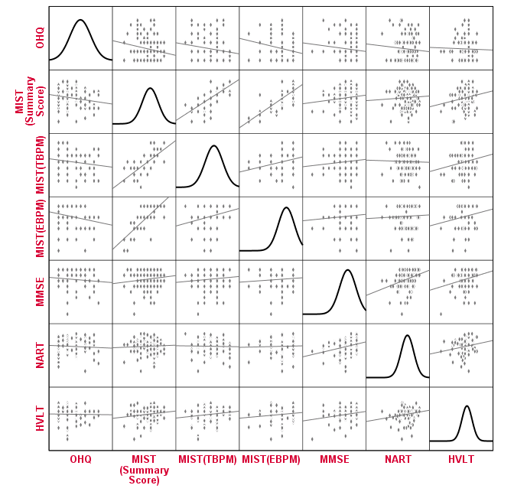
Abbreviations: OHQ, Oral Health Questionnaire; MIST, Memory for Intentions Screening Test; TBPM, time-based prospective memory; EBPM, event-based prospective memory; MMSE, Mini Mental State Examination; NART, National Adult Reading Test; HVLT, Hopkins Verbal Learning Test

Figure S2: Matrix scatter plots showing correlations between oral health and oral care capacity with prospective memory and other background cognitive assessments for Study 2

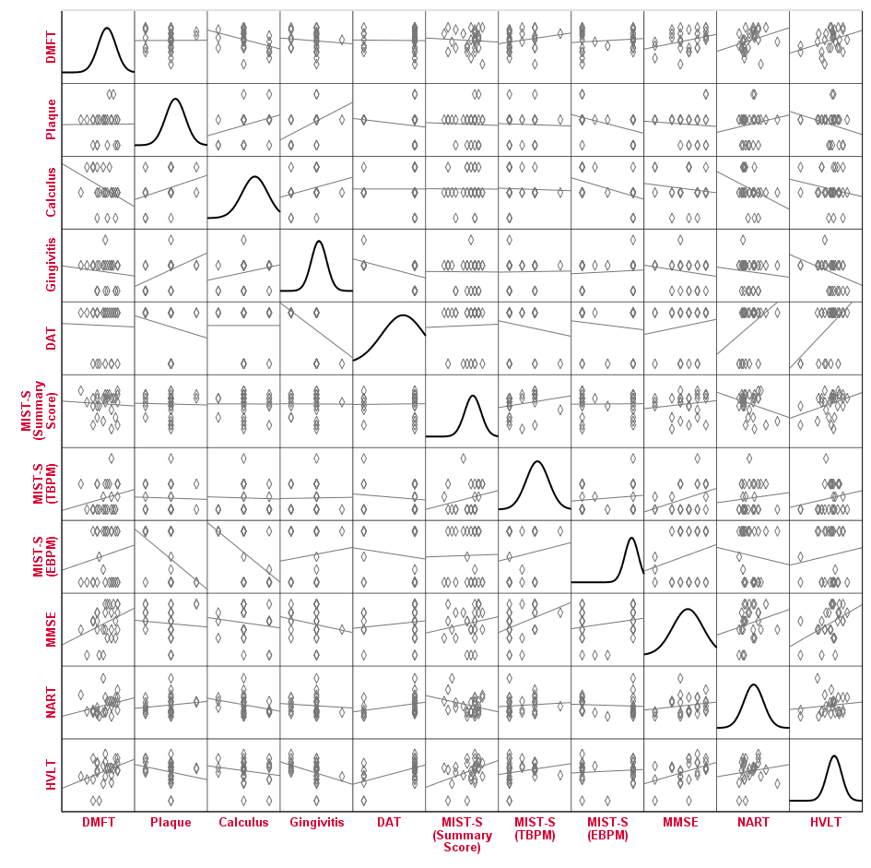
Abbreviations: MIST-S, Memory for Intentions Screening Test (Short Version); TBPM, time-based prospective memory; EBPM, event-based prospective memory; MMSE, Mini Mental State Examination; NART, National Adult Reading Test; HVLT, Hopkins Verbal Learning Test; DMFT, Decayed Missing and Filled Teeth Index; DAT, Dental Activities Test.

