Supplemental Appendix
Influence of including patients with pre-morbid disability in acute stroke trials: the HeadPoST experience
Xia Wang,¹ Tom J Moullaali,² Menglu Ouyang,¹ Laurent Billot,¹ Else Charlotte Sandset,^{3,4} Lili Song,⁵ Candice Delcourt,^{1,6,7} Maree L. Hackett,^{1,8} Caroline L Watkins,⁸ Thompson G. Robinson,⁹ Jie Yang,¹⁰ Pablo M. Lavados,¹¹ Alejandro Brunser,¹¹ Veronica V. Olavarria,¹¹ Paula Munoz Venturelli,^{11,12} Hisatomi Arima,¹³ Sandy Middleton,¹⁴ Octávio M. Pontes-Neto,¹⁵ Jeyaraj Durai Pandian,¹⁶ Kris Rogers,¹ Craig S. Anderson;^{1,5,7,12} on behalf of the HeadPoST Investigators
¹The George Institute for Global Health, Faculty of Medicine, University of New South Wales, NSW, Australia
²Centre for Clinical Brain Sciences, University of Edinburgh, Edinburgh, UK
³Department of Neurology, Oslo University Hospital, Oslo, Norway
⁴The Norwegian Air Ambulance Foundation, Oslo, Norway
⁵The George Institute China at Peking University Health Science Center, Beijing, PR China
⁶The University of Sydney, Sydney, Australia
⁷Neurology Department, Royal Prince Alfred Hospital, Sydney, NSW, Australia
⁸College of Health and Wellbeing, University of Central Lancashire, Preston, Lancashire
⁹University of Leicester, Department of Cardiovascular Sciences and NIHR Leicester Biomedical Research Centre, Leicester, UK
¹⁰Department of Neurology, the First Affiliated Hospital of Chengdu Medical College, Chengdu, China
¹¹Unidad de Neurología Vascular, Servicio de Neurología, Departamento de Neurologíay Psiquiatría, Clínica Alemana de Santiago, Facultad de Medicina, Universidad del Desarrollo, Santiago, Chile
¹²Departamento de Ciencias Neurológicas, Facultad de Medicina, Universidad de Chile, Santiago, Chile
¹³Department of Public Health, Fukuoka University, Japan
¹⁴Nursing Research Institute, Australian Catholic University and St Vincent’s Health Australia
¹⁵Ribeirão Preto Medical School, University of São Paulo, Ribeirão Preto, Brazil
¹⁶Department of Neurology, Christian Medical College, Ludhiana, Punjab, India 141008

Table S
I: Baseline characteristics according to categories of additional disability, defined by change in mRS scores from premorbid estimates to Day 7 (∆mRS)
 | Excluded |  | P value
 | No | Yes
Demographic
Female | 3222/8285 (38.9) | 1207/2808 (43.0) | 0.0001
Age, yr | 67.7 (13.5) | 68.7 (14.6) | <0.0001
Region of recruitment
Australia/UK | 3128/8285 (37.8) | 1633/2808 (58.2) | <0.0001
South America | 657/8285 (7.9) | 253/2808 (9.0) | 0.072
China (incl. Taiwan) | 4019/8285 (48.5) | 633/2808 (22.5) | <0.0001
India and Sri Lanka | 481/8285 (5.8) | 289/2808 (10.3) | <0.0001
Clinical
Time from symptom onset to intervention, hrs | 15.0 (5.0 - 42.0) | 11.0 (5.0 - 25.0) | <0.0001
Time from hospital admission to intervention, hrs | 9.0 (2.0 - 31.0) | 5.0 (2.0 - 16.0) | <0.0001
Clinical diagnosis*
AIS | 1772/8285 (21.4%) | 433/2808 (15.4) | <0.0001
ICH | 240/8285 (2.9%) | 47/2808 (1.7) | 0.0004
NIHSS | 4 (2-7) | 8 (4-14) | <0.0001
GCS score | 15 (14-15) | 15 (13-15) | <0.0001
Systolic BP, mmHg | 154.8 (27.1) | 155.9 (29.3) | 0.255
Diastolic BP, mmHg | 86.5 (16.4) | 86.8 (17.5) | 0.955
Heart rate, bpm | 76 (68-84) | 77 (68-88) | <0.0001
Premorbid mRS 2-5 | 1984/8285 (24.0) | 352/2786 (12.6) | <0.0001
Medical history
Stroke | 2087/8265 (25.3) | 520/2793 (18.6) | <0.0001
Coronary artery disease | 1154/8246 (14.0) | 386/2777 (13.9) | 0.901
Atrial fibrillation | 774/8215 (9.4) | 403/2759 (14.6) | <0.0001
Heart failure | 280/8224 (3.4) | 133/2773 (4.8) | 0.001
Hypertension | 5436/8274 (65.7) | 1715/2787 (61.5) | <0.0001
Diabetes mellitus | 2033/8266 (24.6) | 619/2792 (22.2) | 0.0095
Current smoker | 1625/8211 (19.8) | 500/2764 (18.1) | 0.0503
Aspirin | 3852/8281 (46.5) | 948/2800 (33.9) | <0.0001
Other antiplatelet agent | 1791/8279 (21.6) | 421/2799 (15.0) | <0.0001
Anticoagulation | 683/8277 (8.3) | 268/2798 (9.6) | 0.030
Data are n/N (%), mean (standard deviation) or median (1st quartile – 3rd quartile); P values were from chi-square and Kruskal-Wallis for categorical and continuous variables, respectively
AIS denotes acute ischemic stroke, BP blood pressure, GCS Glasgow coma scale, ICH intracerebral hemorrhage, mRS modified Rankin scale, NIHSS National Institutes of Health Stroke Scale.
*Clinician-reported from brain imaging and other investigations on hospital discharge.

Table SII: Baseline characteristics by pre-stroke function on the mRS
 | mRS score
 | 0-1 | ≥2 |  | P value
Demographic
Female | 2280/6301 (36.2) | 942/1984 (47.5) |  | <0.0001
Age, yr | 66.2 (13.1) | 72.5 (13.4) |  | <0.0001
Region of recruitment
Australia/UK | 2293/6301 (36.4) | 835/1984 (42.1) |  | <0.0001
South America | 478/6301 (7.6) | 179/1984 (9.0)
China (incl. Taiwan) | 3141/6301 (49.8) | 878/1984 (44.3)
India and Sri Lanka | 389/6301 (6.2) | 92/1984 (4.6)
Clinical
Symptom onset to intervention, hrs | 16.0 (5.0 - 43.0) | 14.0 (5.0 - 37.0) |  | 0.013
Hospital admission to intervention, hrs | 9.0 (2.0 - 31.0) | 8.0 (2.0 - 30.5) |  | 0.767
Final diagnosis* |  |  |  | 0.043
AIS | 5471/6299 (86.9) | 1691/1983 (85.3)
ICH | 440/6299 (7.0) | 172/1983 (8.7)
NIHSS score | 3.0 (2.0 - 6.0) | 6.0 (3.0 - 11.0) |  | <0.0001
GCS score | 15.0 (15.0 - 15.0) | 15.0 (13.0 - 15.0) |  | <0.0001
Systolic BP (mmHg) | 154.9 (27.0) | 154.3 (27.6) |  | 0.246
Diastolic BP (mmHg) | 86.9 (16.1) | 85.2 (17.4) |  | <0.0001
Heart Rate (bpm) | 76.0 (67.0 - 84.0) | 76.0 (69.0 - 85.0) |  | 0.0002
Medical history
Previous stroke | 1227/6286 (19.5) | 860/1979 (43.5) |  | <0.0001
Coronary artery disease | 784/6283 (12.5) | 370/1963 (18.8) |  | <0.0001
Atrial fibrillation | 491/6256 (7.8) | 283/1959 (14.4) |  | <0.0001
Heart failure | 148/6267 (2.4) | 132/1957 (6.7) |  | <0.0001
Hypertension | 4019/6293 (63.9) | 1417/1981 (71.5) |  | <0.0001
Diabetes mellitus | 1446/6287 (23.0) | 587/1979 (29.7) |  | <0.0001
Current smoker | 1350/6250 (21.6) | 275/1961 (14.0) |  | <0.0001
Medications
Aspirin | 2849/6299 (45.2) | 1003/1982 (50.6) |  | <0.0001
Other antiplatelet agent | 1260/6299 (20.0) | 531/1980 (26.8) |  | <0.0001
Anticoagulant | 443/6295 (7.0) | 240/1982 (12.1) |  | <0.0001
Data are n/N (%), mean (standard deviation) or median (1st quartile – 3rd quartile); P values were from chi-square and Kruskal-Wallis for categorical and continuous variables, respectively
AIS denotes acute ischemic stroke, BP blood pressure, GCS Glasgow coma scale, ICH intracerebral hemorrhage, mRS modified Rankin score, NIHSS National Institutes of Health Stroke Scale
*Clinician-reported from brain imaging and other investigations on hospital discharge.

Figure SI Associations of mRS scores 3-6 at Day 90, by change from pre-morbid levels

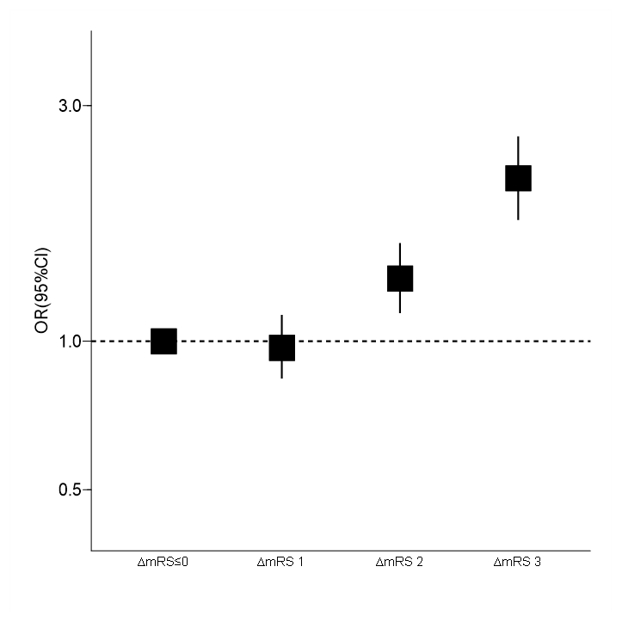
Footnote: CI denotes confidence interval, mRS modified Rankin scale, OR odds ratio
Model adjusted for country, pre-morbid mRS, age, sex, baseline National Institutes of Health Stroke Scale score, time from symptom onset to intervention, and history of stroke, atrial fibrillation, current smoking, and prior antiplatelet and anticoagulant therapy. Solid boxes represent odds ratio for outcome. Vertical lines represent 95% confidence interval.

Figure SII. Sankey diagram of disability, pre-morbid and at Days 7 and 90, on the mRS by recovery pattern
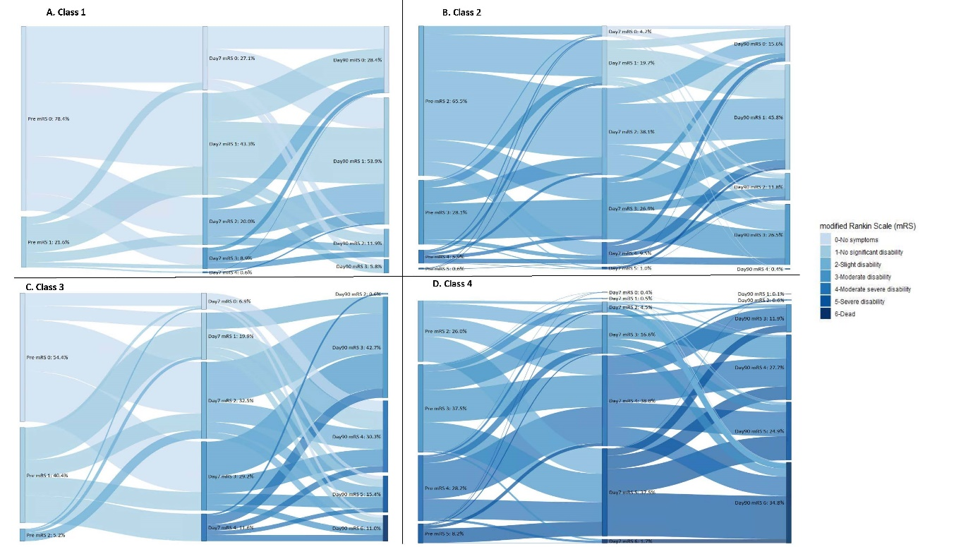
Footnote: mRS denotes modified Rankin scale
Panel A, maintains stable good function; panel B, makes some meaningful recovery; panel C, shows decline; and panel D, maintains disability. Each color represents a different mRS score; the 3 horizontal positions indicate pre-morbid and Days 7 and 90 time points; the vertical ordering shows mRS scores 0 to 6.

