Theoretical session in clinical thoracic ultrasound

- Ultrasound – Background (text)
  - Ultrasound physics
  - Artefacts
  - Settings and knabology, including presets
  - Tranducers, including advantages and disadvantages
  - Preparation of the patient and to-do by the ultrasound operator prior to the ultrasound examination
  - Protocols
- The normal lung ultrasound examination (text and vodcast)
  - A walk-through of a complete ultrasound examination
  - Pitfalls
- The pathological lung ultrasound examination (vodcast)
  - Pneumothorax
  - Pleural effusion
  - Interstitial Syndrome
  - Other pathology in the lung tissue
- Documentation (text)
- Clips and cases (text and ultrasound images)

- Theoretical test (text and ultrasound images)

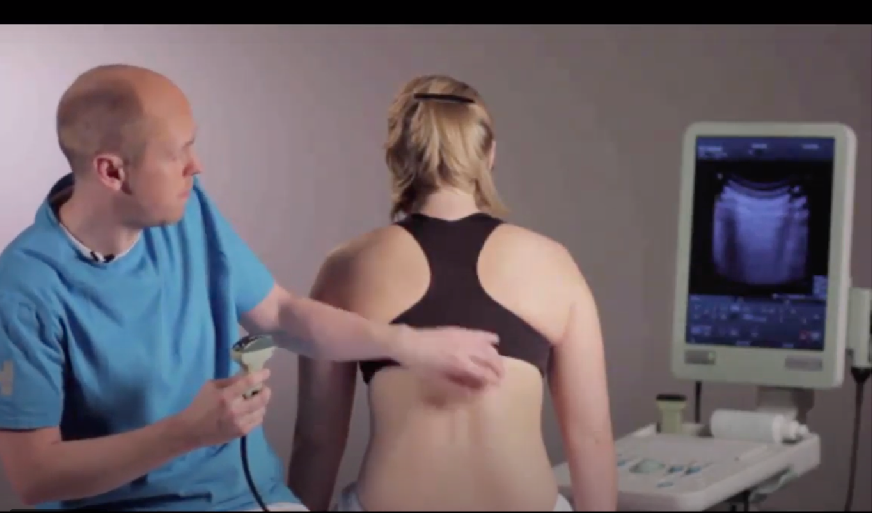

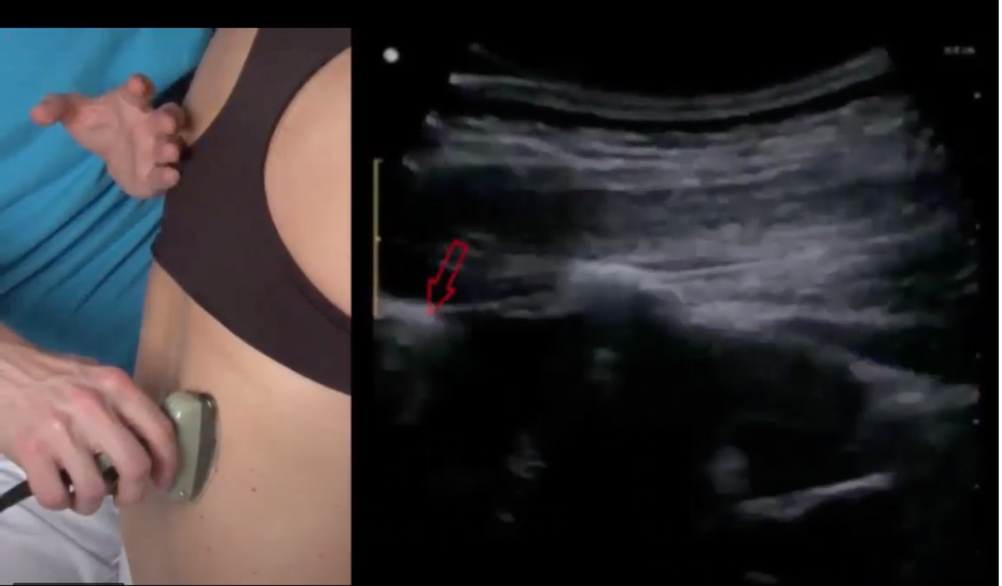

Since ultrasound is a dynamic examination vodcasts was chosen as format. In this figure, two images are shown of the vodcast entitled “The normal lung ultrasound examination”. The combination of two views (the transducer and the ultrasound image) on the bottom image, makes it possible for the trainee to get an understanding of the movements of the transducer, as well as the ultrasound image, and explore the dynamic.

