**Online Resource for Cardiorenal Medicine Submission:**

**Elevated lung sestamibi uptake on myocardial perfusion imaging and mortality in chronic kidney disease**

Julia Bian, BSa

Charles A. Herzog, MDb

Janani Rangaswami, MDc

Ron Wald, MDd

Jennifer A. Stratman, DHSc, MSNe

Arif Asif, MD, MHCMf

Mandeep S. Sidhu, MD, MBAg

Sripal Bangalore, MD, MHAh

Roy O. Mathew, MDa,i,*

a University of South Carolina School of Medicine, Columbia, SC.

b Cardiology Division, Dept of Internal Medicine, Hennepin Healthcare/University of Minnesota, Minneapolis, MN.

c Division of Nephrology, Dept of Medicine, Einstein Medical Center, Philadelphia, PA.

d Division of Nephrology and Li Ka Shing Knowledge Institute, St. Michael's Hospital, University of Toronto, Toronto, Ontario, Canada.

e Education & Research, Columbia VA Health Care System, Columbia, SC.

f Department of Medicine, Jersey Shore University Medical Center, Hackensack-Meridian School of Medicine at Seton Hall University, Hackensack-Meridian Health, Neptune, NJ.

g Division of Cardiology, Dept of Medicine, Albany Medical College & Albany Medical Center, Albany, NY.

h Division of Cardiology, Dept of Medicine, NYU Grossman School of Medicine, New York, NY.

i Division of Nephrology, Dept of Medicine, Columbia VA Health Care System, Columbia, SC*

*Correspondence:

Roy O. Mathew, MD, FASN

Columbia VA Health Care System

6439 Garners Ferry Road

Columbia, SC 29209

(803)776-4000x4513

Fax- (803)647-5714

[Roy.mathew@va.gov](mailto:Roy.mathew@va.gov)

Table S1: STROBE statement

|  |  |  |  |
| --- | --- | --- | --- |
|  | Page | Item No | Recommendation |
| **Title and abstract** | 2 | 1 | (*a*) Indicate the study’s design with a commonly used term in the title or the abstract |
| 2 | (*b*) Provide in the abstract an informative and balanced summary of what was done and what was found |
|  | Introduction | | |
| Background/rationale | 4 | 2 | Explain the scientific background and rationale for the investigation being reported |
| Objectives | 4 | 3 | State specific objectives, including any prespecified hypotheses |
|  | Methods | | |
| Study design | 4-6 | 4 | Present key elements of study design early in the paper |
| Setting | 4 | 5 | Describe the setting, locations, and relevant dates, including periods of recruitment, exposure, follow-up, and data collection |
| Participants | 4 | 6 | (*a*) Give the eligibility criteria, and the sources and methods of selection of participants. Describe methods of follow-up |
| n/a | (*b*)For matched studies, give matching criteria and number of exposed and unexposed |
| Variables | 5 | 7 | Clearly define all outcomes, exposures, predictors, potential confounders, and effect modifiers. Give diagnostic criteria, if applicable |
| Data sources/ measurement | 4-6 | 8* | For each variable of interest, give sources of data and details of methods of assessment (measurement). Describe comparability of assessment methods if there is more than one group |
| Bias | 6 | 9 | Describe any efforts to address potential sources of bias |
| Study size | fig1 | 10 | Explain how the study size was arrived at |
| Quantitative variables | 6 | 11 | Explain how quantitative variables were handled in the analyses. If applicable, describe which groupings were chosen and why |
| Statistical methods | 6 | 12 | (*a*) Describe all statistical methods, including those used to control for confounding |
| 6 | (*b*) Describe any methods used to examine subgroups and interactions |
| n/a | (*c*) Explain how missing data were addressed |
| n/a | (*d*) If applicable, explain how loss to follow-up was addressed |
| 6 | (*e*) Describe any sensitivity analyses |
|  | Results | | |
| Participants | Fig1 | 13* | (a) Report numbers of individuals at each stage of study—eg numbers potentially eligible, examined for eligibility, confirmed eligible, included in the study, completing follow-up, and analysed |
|  | (b) Give reasons for non-participation at each stage |
| Fig1 | (c) Consider use of a flow diagram |
| Descriptive data | Table1 | 14* | (a) Give characteristics of study participants (eg demographic, clinical, social) and information on exposures and potential confounders |
| Table1 | (b) Indicate number of participants with missing data for each variable of interest |
| Table 3 | (c) Summarise follow-up time (eg, average and total amount) |
| Outcome data | Table 3 | 15* | Report numbers of outcome events or summary measures over time |
| Main results | Table 3 | 16 | (*a*) Give unadjusted estimates and, if applicable, confounder-adjusted estimates and their precision (eg, 95% confidence interval). Make clear which confounders were adjusted for and why they were included |
| 6-8 | (*b*) Report category boundaries when continuous variables were categorized |
|  | (*c*) If relevant, consider translating estimates of relative risk into absolute risk for a meaningful time period |
| Other analyses | 7 | 17 | Report other analyses done—eg analyses of subgroups and interactions, and sensitivity analyses |
|  | Discussion | | |
| Key results | 7-8 | 18 | Summarise key results with reference to study objectives |
| Limitations | 8 | 19 | Discuss limitations of the study, taking into account sources of potential bias or imprecision. Discuss both direction and magnitude of any potential bias |
| Interpretation | 9 | 20 | Give a cautious overall interpretation of results considering objectives, limitations, multiplicity of analyses, results from similar studies, and other relevant evidence |
| Generalisability | 8-9 | 21 | Discuss the generalisability (external validity) of the study results |
|  | Other information | | |
| Funding | 10 | 22 | Give the source of funding and the role of the funders for the present study and, if applicable, for the original study on which the present article is based |

Table S2: Baseline Characteristic by dialysis status

|  |  |  |  |  |
| --- | --- | --- | --- | --- |
|  | **All** | **CKD-ND** | **ESKD** | **p** |
| N | 289 | 144 | 145 |  |
| Age (mean years (SD)) | 64.7 (8.27) | 66.5 (7.06) | 62.9 (8.99) | <0.001 |
| Gender = Males (N(%)) | 275 (95.2) | 136 (94.4) | 139 (95.9) | 0.774 |
| Race (N (%)) |  |  |  | <0.001 |
| African American | 155 (55.4) | 50 (36.0) | 105 (74.5) |  |
| White American | 120 (42.9) | 86 (61.9) | 34 (24.1) |  |
| Other | 5 (1.8) | 3 (2.2) | 2 (1.4) |  |
| **BMI** |  | 31.4 (5.7) | 29.4 (5.3) | 0.002 |
| **Medical History (N (%))** |  |  |  |  |
| CKD stage |  |  |  | NA |
| 3a | 98 (33.9) | 98 (68.1) | 0 (0.0) |  |
| 3b | 32 (11.8) | 34 (23.6) | 0 (0.0) |  |
| 4 and 5 | 12 (4.2) | 12 (8.3) | 0 (0.0) |  |
| ESKD | 145 (50.2) | 0 (0.0) | 145 (100.0) |  |
| Hypertension | 276 (95.5) | 131 (91.0) | 145 (100.0) | 0.001 |
| Diabetes Mellitus | 204 (70.6) | 91 (63.2) | 113 (77.9) | 0.009 |
| Congestive Heart Failure | 49 (17) | 16 (11.1) | 33 (22.8) | 0.013 |
| Prior Coronary Artery Disease | 84 (29.1) | 46 (31.9) | 38 (26.2) | 0.345 |
| History of Stroke or TIA | 36 (12.5) | 15 (10.4) | 21 (14.5) | 0.385 |
| Pulmonary Disease (COPD, Emphysema) | 65 (22.5) | 54 (37.5) | 11 (7.6) | <0.001 |
| **Medications (N (%))** |  |  |  |  |
| Dihydropyridine CCB | 110 (38.1) | 43 (29.9) | 67 (46.2) | 0.006 |
| Non-Dihydropyridine CCB (Verapamil or Diltiazem) | 7 (2.4) | 6 (4.2) | 1 (0.7) | 0.124 |
| Angiotensin Converting Enzyme Inhibitor | 103 (35.6) | 71 (49.3) | 32 (22.1) | <0.001 |
| Angiotensin Receptor Blocker | 55 (19) | 25 (17.4) | 30 (20.7) | 0.568 |
| Mineralocorticoid Receptor Blocker | 14 (4.9) | 9 (6.3) | 5 (3.4) | 0.396 |
| Beta Blocker | 179 (61.9) | 79 (54.9) | 100 (69.0) | 0.019 |
| Statins | 219 (75.4) | 110 (76.4) | 108 (74.5) | 0.811 |
| ASA | 154 (53.3) | 85 (59.0) | 69 (47.6) | 0.067 |
| Clopidogrel | 16 (5.5) | 7 (4.9) | 9 (6.2) | 0.808 |

Table S3: Stress Characteristics by chronic kidney disease stage

|  |  |  |  |  |  |  |
| --- | --- | --- | --- | --- | --- | --- |
|  | **All** | **3a** | **3b** | **4 and 5** | **ESKD** | **p** |
| N | 289 | 98 | 34 | 12 | 145 |  |
| BMI (kg/m2) | 30.4 (5.6) | 31.3 (5.9) | 30.6 (4.9) | 34.6 (5.6) | 29.4 (5.3) | 0.003 |
| Days from dialysis start to stress test (mean (SD)) | NA | NA | NA | NA | 1077.46 (1352.42) | NA |
| Hemodialysis treatment <24h prior to stress test |  |  |  |  |  | <0.001 |
| NA | NA | 98 (100.0) | 34 (100.0) | 12 (100.0) | 104 (71.7) |  |
| No | NA |  |  |  | 16 (11.1) |  |
| Yes | NA |  |  |  | 25 (17.2) |  |
| Reason for Stress test (N (%)) |  |  |  |  |  | <0.001 |
| Atypical Chest Pain | 89 (30.8) | 51 (52.0) | 17 (50.0) | 3 (25.0) | 18 (12.4) |  |
| Dyspnea on Exertion | 44 (15.2) | 20 (20.4) | 5 (14.7) | 5 (41.7) | 14 (9.7) |  |
| No Reason Listed | 7 (2.9) | 2 (2.0) | 0 (0.0) | 0 (0.0) | 5 (3.4) |  |
| Other | 58 (20.1) | 19 (19.4) | 8 (23.5) | 3 (25.0) | 28 (19.3) |  |
| Pre-Operative Risk Stratification | 86 (29.8) | 4 (4.1) | 3 (8.8) | 1 (8.3) | 78 (53.8) |  |
| Typical Chest Pain | 5 (1.7) | 2 (2.0) | 1 (2.9) | 0 (0.0) | 2 (1.4) |  |
| Qualitative Result (N(%)) |  |  |  |  |  | <0.001 |
| Attenuation Artifact | 33 (11.4) | 26 (26.5) | 4 (11.8) | 2 (16.7) | 1 (0.7) |  |
| Fixed Defect/Scar | 47 (16.3) | 19 (19.4) | 9 (26.5) | 2 (16.7) | 17 (11.7) |  |
| No reversible ischemia or infarct | 163 (56.4) | 41 (41.8) | 17 (50) | 6 (50) | 99 (68.3) |  |
| Peri-infarct reversible ischemia | 10 (3.5) | 5 (5.1) | 0 (0.0) | 0 (0.0) | 5 (3.4) |  |
| Reversible ischemia | 36 (12.5) | 7 (7.1) | 4 (11.8) | 2 (16.7) | 23 (15.9) |  |
| Location N (%) |  |  |  |  |  | 0.01 |
| Anterior | 14 (12.0) | 5 (8.8) | 2 (11.8) | 2 (50.0) | 5 (12.8) |  |
| Anterolateral | 9 (7.7) | 0 (0.0) | 1 (5.9) | 0 (0.0) | 8 (20.5) |  |
| Anteroseptal | 9 (7.7) | 8 (14.0) | 0 (0.0) | 0 (0.0) | 1 (2.6) |  |
| Apex | 12 (10.3) | 5 (8.8) | 2 (11.8) | 0 (0.0) | 5 (12.8) |  |
| Inferior | 51 (43.6) | 31 (54.4) | 10 (58.8) | 1 (25.0) | 9 (23.1) |  |
| Inferolateral | 15 (12.8) | 6 (10.5) | 1 (5.9) | 1 (25.0) | 7 (17.9) |  |
| Lateral | 5 (4.3) | 2 (3.5) | 0 (0.0) | 0 (0.0) | 3 (7.7) |  |
| Septal | 2 (1.7) | 0 (0.0) | 1 (5.9) | 0 (0.0) | 1 (2.6) |  |
| Quantitative Results (mean (SD)) |  |  |  |  |  |  |
| SSS | 5.39 (6.97) | 4.54 (6.55) | 7.00 (9.29) | 4.17 (4.11) | 5.68 (6.78) | 0.274 |
| SRS | 2.98 (5.88) | 2.34 (5.88) | 4.06 (8.16) | 2.25 (2.96) | 3.22 (5.42) | 0.435 |
| SDS | 2.16 (2.44) | 1.97 (1.92) | 2.59 (3.28) | 1.75 (2.30) | 2.23 (2.55) | 0.556 |
| TID | 0.98 (0.11) | 0.98 (0.10) | 0.98 (0.12) | 0.95 (0.11) | 0.98 (0.11) | 0.719 |
| EF | 0.54 (0.12) | 0.58 (0.12) | 0.54 (0.13) | 0.56 (0.14) | 0.52 (0.12) | 0.013 |
| LHR | 0.31 (0.09) | 0.31 (0.08) | 0.29 (0.04) | 0.31 (0.08) | 0.32 (0.10) | 0.402 |

Table S4: Outcomes:

|  |  |  |  |  |
| --- | --- | --- | --- | --- |
|  | **ALL** | **CKD-ND** | **ESKD** | **p** |
| N | 289 | 144 | 145 |  |
| Primary Outcome | 67 (23.2) | 35 (24.3) | 32 (22.1) | 0.756 |
| Mortality | 52 (18) | 26 (18.1) | 26 (17.9) | 1 |
| Hospitalization for MI/UA | 6 (2.1) | 4 (2.8) | 2 (1.4) | 0.674 |
| Revascularization | 12 (4.2) | 8 (5.6) | 4 (2.8) | 0.37 |
| Number of Days to event (mean days (SD)) |  |  |  |  |
| Primary outcome | 965.2 (287) | 947.19 (309.30) | 983.06 (262.78) | 0.289 |
| Mortality | 1009.4 (227.43) | 1003.90 (238.45) | 1014.86 (216.63) | 0.683 |
| Hospitalization for MI | 1081.9 (97.95) | 1078.34 (108.16) | 1085.41 (86.88) | 0.54 |
| Revascularization | 1057.8 (183.83) | 1042.77 (217.54) | 1072.78 (141.92) | 0.166 |

Figure S1a: Example of lower tertile LHR (LHR = 0.24)



Figure S1b: Example of Middle Tertile LHR (LHR = 0.32)



Figure S1c: Example of Upper Tertile LHR (LHR = 0.39)



Figure S2: Distribution of LHR across renal function at MPI using sestamibi tracer and regadenoson stress agent, performed at Columbia VA Health Care System between 2010 and 2015



CKD: Chronic Kidney Disease; stages: Normal: estimated glomerular filtration rate - eGFR >=60, stage 3a: eGFR 45-59, stage 3b: eGFR 30-44, stage 4/5: eGFR < 30, stage 6: requiring dialysis.

Figure S3a: Variability in primary outcome for LHR category by ESKD status

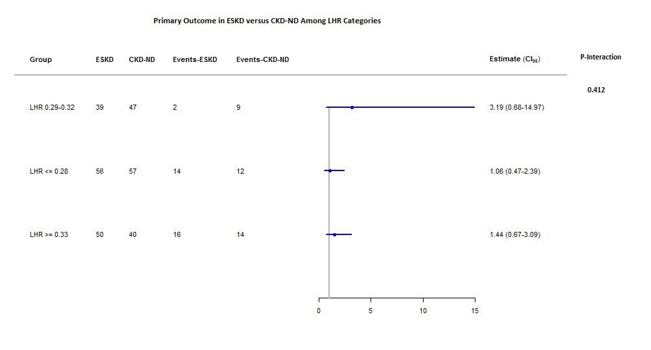

Figure S3b: Variability in mortality for LHR category by ESKD status

