Title: Novel pancreatic cancer therapy targeting cell surface glycans by liposomes modified with rBC2LCN lectin
Journal: European Surgical Research
Authors:
Sota Kimura¹, Tatsuya Oda¹, Osamu Shimomura¹, Tsuyoshi Enomoto¹, Shinji Hashimoto¹, Yukihito Kuroda¹, Yang Yu¹, Ko Kurimori¹, Tomoaki Furuta¹, Yoshihiro Miyazaki¹, and Hiroaki Tateno²

Affiliations:
1: Department of Surgery, Clinical Sciences, Faculty of Medicine, University of Tsukuba, 1-1-1 Tennoudai, Tsukuba, Ibaraki 305-8575, Japan.
2: Biotechnology Research Institute for Drug Discovery, National Institute of Advanced Industrial Science and Technology, 1-1-1 Umezono, Tsukuba, Ibaraki 305-8568, Japan.

Corresponding author:
Tatsuya Oda, Department of Surgery, Clinical Sciences, Faculty of Medicine, University of Tsukuba, 1-1-1 Tennoudai, Tsukuba, Ibaraki 305-8575, Japan.
Phone: +81-298-53-3221
Fax: +81-298-53-3222
E-mail: tatoda@md.tsukuba.ac.jp

Supplementary materials and methods
Characterization of Lec-Doxosome
The particle size and polydispersity index (PDI) of Lec-Doxosome and Doxosome were measured by dynamic light scattering method using Zeta-sizer Nano ZS analyzer (Malvern Instruments, Worcestershire, UK). In addition, the concentration of inserted lectin was measured by the BCA protein assay (Takara Bio Inc., Shiga, Japan), according to the manufacturer’s protocol.

Binding of the rBC2LCN lectin to Capan-1 and SUIT-2 cells
Capan-1 and SUIT-2 cells were seeded into 24-well plates at 2 × 10⁴ cells/well and incubated for 48 h at 37 ºC. Fluorescent-labeled rBC2LCN lectin (rBC2LCN-FITC, FUJIFILM Wako Pure Chemical Corporation, Osaka, Japan) at 1 µg/mL was added to the cells and incubated for 1 h at 37 ºC. The cells were washed thrice with PBS, and the nuclei were stained with 5 µg/mL Hoechst 33342 (Thermo Fisher Scientific, Inc., MA, USA) for 15 min. Thereafter, fluorescent images were obtained using a BZ-X710 microscope (Keyence Corporation, Osaka, Japan).

Confirmation of lectin insertion into the liposomal surface
SDS-PAGE was performed under non-reducing conditions to determine whether the rBC2LCN lectin was inserted into the liposomal surface. Samples were loaded onto a 12 % SDS-polyacrylamide gel and separation was performed at 300 mV for 30 min. Finally, the gel was stained with Oriole Fluorescent Gel Stain (BioRad, CA, USA) for visualization.

Histochemical staining of rBC2LCN lectin in cell line-derived subcutaneous tumor
The tumors collected from cell line (Capan-1 and SUIT-2 cells)-derived xenografts were fixed with 10 % formalin and embedded in paraffin blocks. The formalin-fixed, paraffin-embedded blocks were sliced into 2-µm-thick sections, and antigen retrieval was performed by autoclaving at 120 ºC for 20 min in citrate buffer (pH 6). The endogenous peroxidase activity was then blocked with 3 % H₂O₂ in methanol, and 1 µg/mL horseradish peroxidase-labeled rBC2LCN lectin—donated by the National Institute of Advanced Industrial Science and Technology (Ibaraki, Japan)—was applied, followed by incubation for 1 h at room temperature. The reaction was visualized by applying the chromogen diaminobenzidine and counterstaining with hematoxylin.

Confirmation of toxicity profiles of Lec-Doxosome treatment methodologies in xenografts
In the in vivo antitumor study, the hematological examination of blood samples from the abdominal great vein and histopathological evaluation of excised organs (heart, lung, liver, kidney, pancreas, and spleen) were conducted at the end of the study.

Supplementary Tables
Supplementary Table S1 Characteristics of liposomes
 | Liposome | Diameter (nm) | PDI | Modified lectin concentration
 | Doxosome | 90.08 ± 0.07 | 0.090 ± 0.002 | -
 | Lec-Doxosome | 90.22 ± 0.03 | 0.079 ± 0.002 | 71.0 ± 6.6 µg lectin/µmol PL
PDI, polydispersity index; PL, phospholipid content of liposomes.
Each value represents the mean ± SEM of triplicate samples.

 |  | WBC (×10²/µL) | RBC (×10⁴/µL) | HGB (g/dL) | HCT (%) | PLT (×10⁴/µL)
 | Lec-Doxosome | 22 ± 16* | 872 ± 57 | 14.9 ± 1.0 | 40.5 ± 3.2 | 97 ± 17
 | Doxosome | 23 ± 4* | 867 ± 25 | 15.0 ± 0.3 | 39.6 ± 0.9 | 94 ± 6
 | Free doxorubicin | 23 ± 10* | 925 ± 83 | 15.8 ± 2.0 | 42.1 ± 3.9 | 63 ± 18
 | Vehicle | 42 ± 6 | 925 ± 59 | 15.8 ± 1.0 | 42.7 ± 2.9 | 86 ± 17
WBC, white blood cell; RBC, red blood cell; HGB, hemoglobin; HCT, hematocrit; PLT, platelet.
Each value represents the mean ± SEM for 5 mice. * P < 0.05: Significant difference compared to the vehicle group.
Supplementary Table S2 Hematological parameters of Capan-1 xenografts

Supplementary Table S3 Biochemical parameters of Capan-1 xenografts
 |  | AST (U/L) | ALT (U/L) | T-BIL (mg/dL) | BUN (mg/dL) | CRE (mg/dL) | AMY (U/L)
 | Lec-Doxosome | 74 ± 5 | 35 ± 9 | 0.30 ± 0 | 27.5 ± 7.5 | 0.14 ± 0.05 | 2020 ± 60*
 | Doxosome | 79 ± 8* | 33 ± 3 | 0.46 ± 0.09 | 28.0 ± 3.9 | 0.12 ± 0.04 | 1853 ± 157*
 | Free doxorubicin | 84 ± 14* | 26 ± 4 | 0.45 ± 0.13 | 26.3 ± 1.8 | 0.15 ± 0.06 | 1702 ± 114
 | Vehicle | 64 ± 6 | 32 ± 4 | 0.40 ± 0.07 | 23.2 ± 2.4 | 0.14 ± 0.05 | 1659 ± 131
AST, aspartate transaminase; ALT, alanine transaminase; T-BIL, total bilirubin; BUN, blood urea nitrogen; CRE, creatinine;
AMY, amylase. Each value represents the mean ± SEM of 5 mice. * P < 0.05: Significant difference compared to the vehicle group.

Supplementary Figures
Supplementary Fig. S1
Representative fluorescence images of Capan-1 and SUIT-2 cells incubated with rBC2LCN-FITC. Green spots reflect rBC2LCN lectin binding and were observed in Capan-1 cells only. Nuclei are visualized in blue. Scale bar = 100 µm.

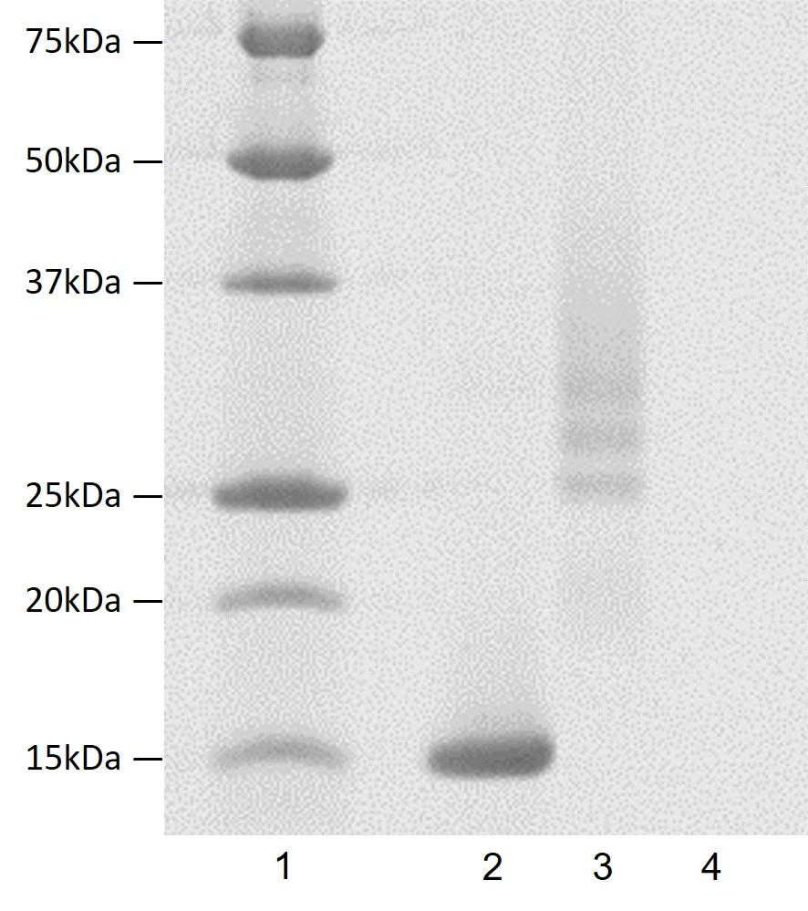
Supplementary Fig. S2
Confirmation of rBC2LCN lectin insertion into the liposomal surface by non-reducing SDS-PAGE. To confirm ligand insertion into the liposomal surface by SDS-PAGE, band upshifts, reflecting changes in ligand molecular weight due to their binding to lipid linkers, were examined [1-3]. Specifically, rBC2LCN lectin, which has a theoretical molecular weight of 15.807 kDa, migrated as a protein of approximately 15 kDa before modification, whereas in the lane of lectin-modified liposomes, a band upshift and the disappearance of the original 15-kDa band were observed. Lane 1: molecular weight marker; lane 2: rBC2LCN lectin; lane 3: lectin-modified liposomes; lane 4: unmodified liposomes.

Supplementary Fig. S3
Histochemical staining of rBC2LCN lectin in cell line-derived subcutaneous tumors. Positive reactivity to the rBC2LCN lectin in the Capan-1-derived tumor was observed, in contrast to the negative reactivity to that in the SUIT-2-derived tumor. The cells were observed at 200× magnification.
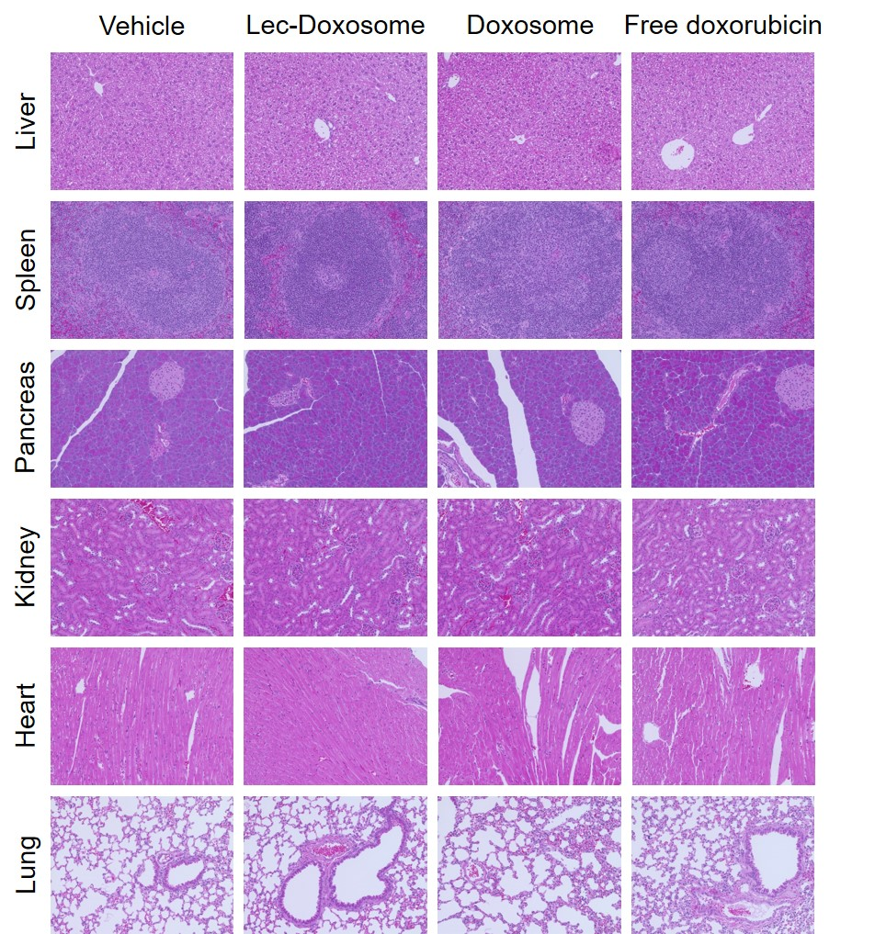
Supplementary Fig. S4
Pathological findings of organs excised from Capan-1 xenografts after treatment with normal saline (Vehicle), Lec-Doxosome, Doxosome, and free doxorubicin. The images were obtained using a digital microscope at 200× magnification. No organ toxicity after the administration of Lec-Doxosome, Doxosome, and free doxorubicin was observed.

Supplementary References
1. Lin C, Wong BCK, Chen H, Bian Z, Zhang G, Zhang X, et al. Pulmonary delivery of triptolide-loaded liposomes decorated with anti-carbonic anhydrase IX antibody for lung cancer therapy. Sci Rep. 2017 Apr:7:1097.
2. Gao J, Zhong W, He J, Li H, Zhang H, Zhou G, et al. Tumor-targeted PE38KDEL delivery via PEGylated anti-HER2 immunoliposomes. Int J Pharm. 2009 June:374 (1–2):145–52.
3. Urey C, Hilmersson KS, Andersson B, Ansari D, Andersson R. Development and in vitro characterization of a Gemcitabine-loaded MUC4-targeted immunoliposome against pancreatic ductal adenocarcinoma. Anticancer Res. 2017 Nov:37(11):6031–39.

