Supplementary Figure 1.

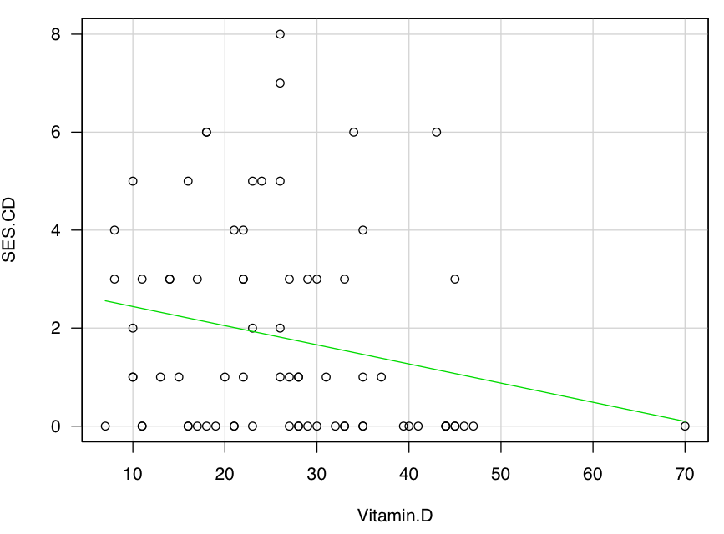

A scatter plot of vitamin D and SES-CD score

