Supplemental Material and Methods

Mouse Strains
Endothelium-specific transgene expression was achieved using the mouse Tie2 promoter. Potential transgenic founders were screened by PCR of genomic DNA from tail tips, using primers specific for murine Tie2 promoter sequence (forward, 5’-GGGAAGTCGCAAA-GTTGTGAGTT-3’) and for human GTPCH (reverse, 5’-GAACCCATTGCTGCACCTGG-3’), producing a 150-bp PCR product (Supplemental Figure 1).
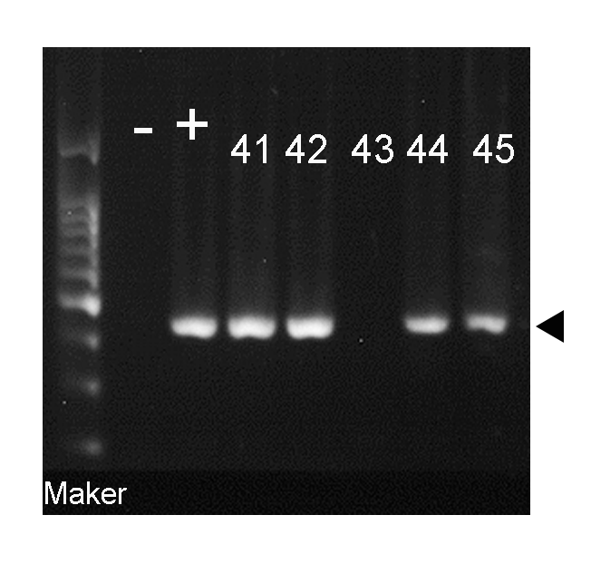
Supplemental Figure 1. Genomic DNA analysis of potential founders. The top panel shows PCR reactions performed on DNA isolated from tail biopsies. The expected 150-bp product (filled arrowhead) was identified in founder mouse 41, 42, 44, and 45; linearized pTie2-GTPCH I plasmid DNA was used as a positive control.

Supplemental Figure 2. Levels of GTPCH 1 in wild-type young and aged mice. Three samples per each group were used for the Western blot analysis, and representative images are shown. β-Actin were used as loading controls.

